Summary of the talk by Professor C. Fritz Foley, 11/13/03

Why do we care for the financial mix of the firm? We study it, because we can use it so that we minimize the cost of capital (that is the idea behind “optimal” capital structure). One main advantage that we can get from higher levels of leverage is the tax shield on interest payments, as we know from the corporate finance theory. This factor is even more important when we talk about MNE choice of capital structure (why?) So, in his talk Professor Foley would address the specific advantages of the differing tax incentives that MNE face. Also, he would speak of why and how the different level of development of financial markets around the world would impact the financial structure (mix) of MNE. Here is a brief summary of the results of a very recent study by Professor Foley for which he will talk at end of class today. Using unique data he & coauthors studied the determinants of the capital structure of the MNE affiliates. In a nutshell here are the main results are:

- Affiliates of US MNE choose capital structure in response to tax incentives overseas: a 4 % increase in the tax rate overseas would on average bring 1% increase in debt-to-total assets ratio (results are based on calculations for 1982-1994).
- In illiquid capital markets where creditor rights are weak, US MNE affiliates tend to borrow more often from the parent companies. (why?)
- Higher levels of political risk are associated with higher external borrowing & greater overall leverage (why?)
- Higher inflation is associated with greater external borrowing and reduced internal borrowing.
To illustrate, here is a figure from Professor Foley’s study:
Figure I: the relationship between affiliate leverage (i.e. ratio of debt to total assets) and the tax rate of the country where affiliate is located.
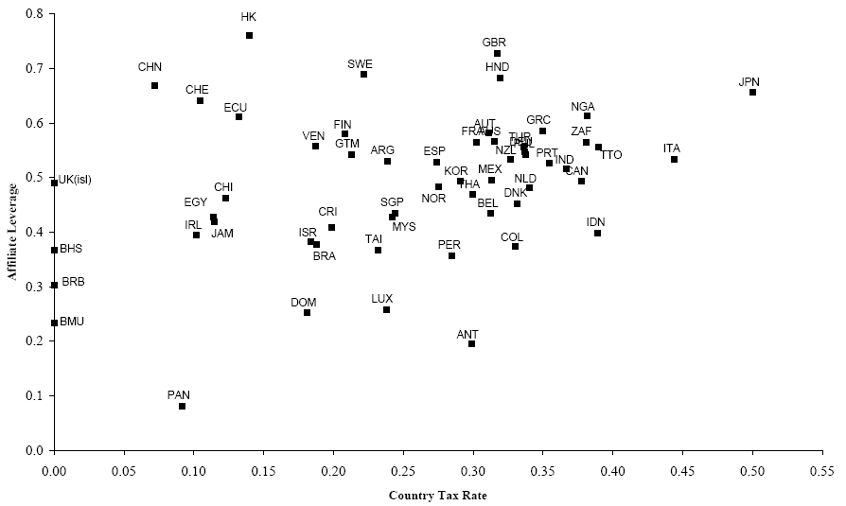

When going through the figure, notice that indeed US MNE affiliated in countries w/ higher tax rates tend to have more debt (e.g. in Japan, Italy, Canada)! On the other side, notice that there are several locations (countries) where the tax rates are zero – these are the so called off-shore tax havens. Examples of these are: the isle of Mann (UK), Bermuda islands, the Bahamas, etc.

Figure II: the relationship between the level of development of the local credit market and the level leverage of US MNE affiliates in that market.
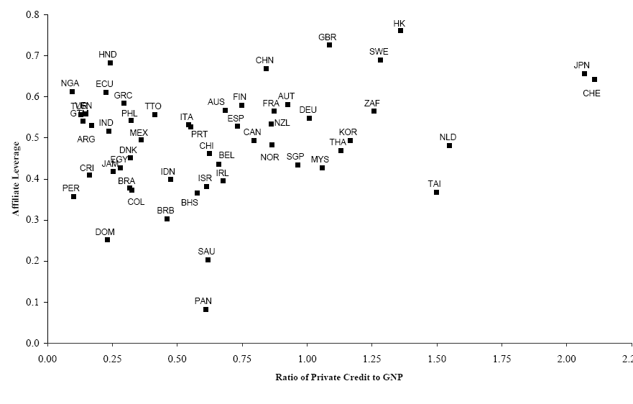
Source: figure two of the study.

Now, look at figure two. As you can see from it, affiliates of US multinationals in countries with less developed credit markets (the level of development of that market is measured by the ration of private credit to GNP – the higher the credit level as percentage of the GDP, the more developed is that country’s debt market) tend to use less credit.

Desai, M., C. Fritz Foley, and J. Hines Jr, “A Multinational Perspective on Capital Structure Choice and Internal Capital Markets”, forthcoming, Journal of Finance.

