Replies 10/06/03

Dear Students,

Following are the replies to your questions of last Thursday.

What is the difference between an open outcry and the bid/ask quotes?

Open outcry is the mechanism of price formation in the pit of a futures exchange where traders bid on the price of the futures. While bid/ask quote is the system of quoting different rates on the purchase and sale of a currency.

I see the difference between futures and forwards, but would you still consider them to be very similar? I do.

Indeed they are similar, but futures are standardized as compared to forwards.

Why don’t traders/ brokers just use options instead of futures if it gives them the right to buy/sell their currency under contract?

Because options can be more expensive than the futures contract. Note that oftentimes traders/ brokers use what is known as options on futures, i.e. options where the underlying asset is actually a futures contract.

Are futures like European options in that they are exercised only at maturity?
Yes, but unlike European options they are a commitment to buy/sell the underlying asset, while options imply no commitment for the holder to buy/sell the asset.

You said that at maturity an option should be at the money. My question is what is the purpose of holding an option knowing that there is no arbitrage?

This statement is true for exchange-traded options when you take into account the premium paid for the option. In general, this statement is not true for all options. For example, suppose that you purchased an European cal option on the Yen, giving you the right to purchase the Yen at $0.09/Yen in three months, where you paid a premium of $0.01/Yen to purchase that contract. If, at maturity, the yen appreciate to $0.12/Yen, then the option will expire in the money, in the sense that you can exercise the contract and purchase yens at $0.09/Yen, paying premium of $0.01/Yen for a total cost of Yen 0.10/$. However, you can sell the yens you purchased in this way for $0.11/Yen, making a profit of $0.01/Yen.

Now, oftentimes market participants hold options for the purpose of hedging risk exposures, as we will see in Chapter 8.

Because you can exercise an American option during the life of the option, you have more flexibility. How is this flexibility priced into the value of an American option?

That’s right, the fact that you have the flexibility to exercise the option before expiration increases the price of the American option. However, here is an important caveat. It is never optimal to exercise American call option before expiration. Why? Because if you exercise the American call before expiration, you lose the insurance value in the option. Also, since you exercise a call option (that is you buy the underlying currency) you will have to realize a cash outflow before the maturity date, so you lose the interest on this cashflow for the period till maturity. For these reasons exercising an American call option on foreign currency is not optimal. So, the price of an American option shall be the same as the one of an European call option on the same asset with the same maturity and strike price.

However, it could be optimal to exercise early an American put option. Why? Of course, if you exercise early you still lose the insurance value of the option, however, since this is a put option, that is you sell foreign currency and receive cash inflow, you can deposit this cash amount to receive interest till maturity. So, since the American put gives you this flexibility, it must be the case that it is more expensive than an European put option on the same currency with the same maturity and strike price ☺.

Can you further explain how futures are quoted?

Let’s take the example of the Chicago Mercantile Exchange quotes. Check this one out: http://www.cme.com/prd/fx/ , it is really very useful! Say, we wish to take a look at the quotes on the British pound, http://www.cme.com/prd/overview_BP2451.html . As you can see from the link, the quotes are in US$ per British Pound, so here are the latest quotes, as shown in
http://www.cme.com/dta/del/delayed_quote.html?ProductSymbol=BP&ProductFoiType=FUT&ProductVenue=R&ProductType=cur
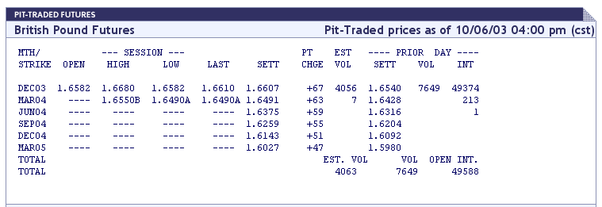Source: Chicago Mercantile Exchange.

We have learned that the futures market is liquid if the open interest is at least 5,000. Has the market ever been in danger of illiquidity? If so, what are the measures that can be taken to ensure liquidity?

I do not know of cases when the market for futures has been in danger of illiquidity, but I know that during the week following September 11th 2001, the market for options was really dried up for liquidity – even though there was demand for option contracts almost no financial institutions were offering it.

Is it generally more beneficial to engage in a futures contract or a forward contract?

It really depends on the investor’s objectives, and on the cost of the futures contract versus the cost of the forward contract.

How much do you normally pay for an option?

The price of the option depends on the type of the option (put or call, American or European), your position (short or long), the current spot price of the currency, the domestic and foreign interest rates, the strike price, the maturity of the contract, and the volatility of the exchange rate in point. Let us take an example. If you look into the Philadelphia Exchange as of today, 10/06/03, the following are the details for a European call option contract on Japanese Yen:

- Current Spot price of Yen: or $0.0901/Yen.
- Premium: $ 0.00087/ Yen (bid) and $ 0.00096/ Yen (ask).
- Strike price: $0.0895/ Yen.

When doing out the position, do you have to ensure that the maturities of the long and short have to match? If the maturities are different, how do you lock in a profit?

I assume that your question relates to futures. Yes, you have to ensure that the maturities are the same. If they are not the same, then the investor will have to deliver on both maturity dates.

Do you always have to enter into an offsetting position in order to get your money out of the futures market, or only when your contract proves to be not profitable? Can you give an example, showing the profit/loss of this offsetting position? Why offsetting? I don’t understand how this leads to a profit, or why someone would want to do this.

An investor has to offset her position, unless she intends to deliver the underlying asset (in our case – the foreign currency). Now, let us consider an example of offsetting a futures contract. Suppose we are trading on futures contract on the Mexican peso with maturity in March 2004. Suppose that close price on the March futures for the Mexican peso is $ 0.11/ PS (Mexican Peso). The size of the contract is PS 500,000. Suppose now that we take a long position in one contract, today, 10/06/03. That means that we must purchase PS 500,000 in March 2004. Now, suppose that in two months, on December 6th, 2003, the Mexican peso appreciated and that at that day the closing price on the March 2004 Mexican Peso futures contract is $0.14/PS. Then, we can decide to exit the market at that point, and take one short futures contract on the Mexican peso, with maturity in March 2004, at the current price $0.14/PS. This means that at maturity we have sell PS500,000 at the locked rate $0.14/PS. However, since we have already assumed a long position for the same maturity and the same number of contracts, our positions offset each other, so the clearinghouse of the futures exchange will only credit our account with the profit from our contract:

($0.14/PS - $0.11/PS) x 500,000 = $15,000.

