Replies to memo questions, 12/01/03

Dear Students,

Here are the replies to your questions. As for the answer to my question (if interest rates are expected to go up, what is better: enter into a pay floating/ receive fixed swap, or pay fixed/ receive floating swap?) is that it is better to enter into pay fixed/ receive floating swap.

What is the difference between interest rate futures and caps?

First, interest rate cap is a derivative, that includes several European call options (or caplets) on a specified reference interest rate, e.g. LIBOR. The buyer of a cap receives money if at maturity the reference rate (e.g. LIBOR) is above a pre-specified rate. Interest rate futures are standardized contracts that call for delivery of the underlying security at maturity. However, one can offset such a position shortly before maturity to exit it. So, interest rate futures are different from the interest rate cap in that they provide different cash flow structure.

Can you explain slide #10: interest rate futures again? How does this hedging strategy work?

Interest rate futures are standardized contracts for delivery at a future date of an underlying interest rate instrument (e.g. Eurodollar futures).

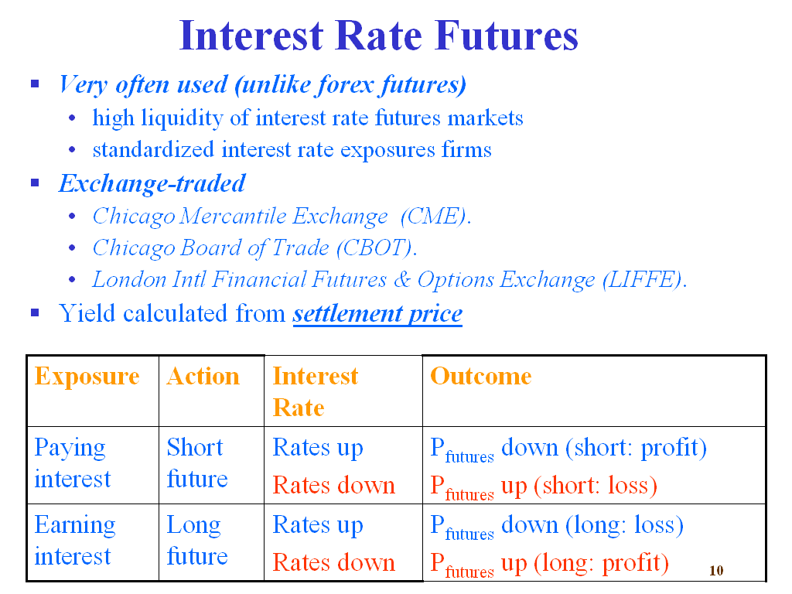

The hedging strategy is described in the table above. In essence, the strategy is designed so that the profit/loss on the underlying position (paying or receiving interest) is exactly offset by the profit/loss on the futures position.
So, suppose that we are to pay interest on a debt instrument. The hedging strategy would then involve entering into a short futures position. If interest rates go up, we would have to pay higher interest. However, interest rates being up implies that the price of the interest rate futures will go down (interest rate futures are quoted on a discount basis). So, a short position would be in the money. Exactly so to offset the increased debt service burden. Vice versa, if rates go down, then we have to pay less interest, but rates down implies higher prices on the interest rate futures, which we have shorted. So, we lose money on the interest rate futures position. However we lose exactly as much as to offset the gain we have realized paying less interest. Basically, this strategy results in paying out a fixed interest rate (the rate on the interest rate future).

The same reasoning applies to the case of earning interest. Then, the appropriate hedging position is long futures. So, for example, if rates go up, then we benefit by earning more interest. However, higher interest rate implies lower price on the interest rate futures, that is a loss for the long futures position. The loss on the futures position exactly offsets the gain on the underlying position (earning interest) to result in receiving fixed interest rate (the yield on the futures).

In the example used in class regarding the forward rate agreement (FRA), if 6.5% is locked, & I see that the rate in the market is 6.5 %, are you saying since that is above 5%, I have to get an extra 1.5% from the lender? But I locked 6.5%, not 5%.

Actually, no, the 6.5% above refer to the total payment (including the credit premium paid by lender of 1.5%). So, if the LIBOR is above 5% it means the total interest rate payment would be LIBOR+1.5% > 5%+1.5% = 6.5 %. So, entering into a FRA @ 5% would lock in the rate of 5% on the floating part + 1.5 % credit spread. Here is slide #9.
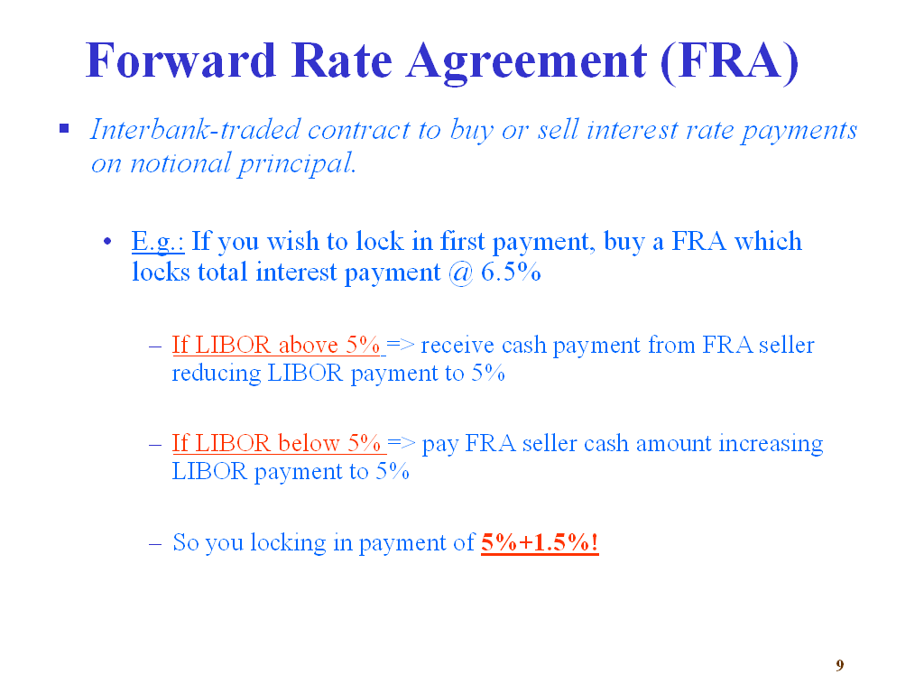
The hedging strategy involves buying a Forward Rate Agreement to lock a total payment of 6.5% (notice that this is the total payment: that is payment including spread above LIBOR -- this example is a continuation of the example of floating rate loan from slide #7).

Can you explain again about interest rate swaps strategies? I’m little bit confused.

Here is the slide for the interest rate swap strategies.
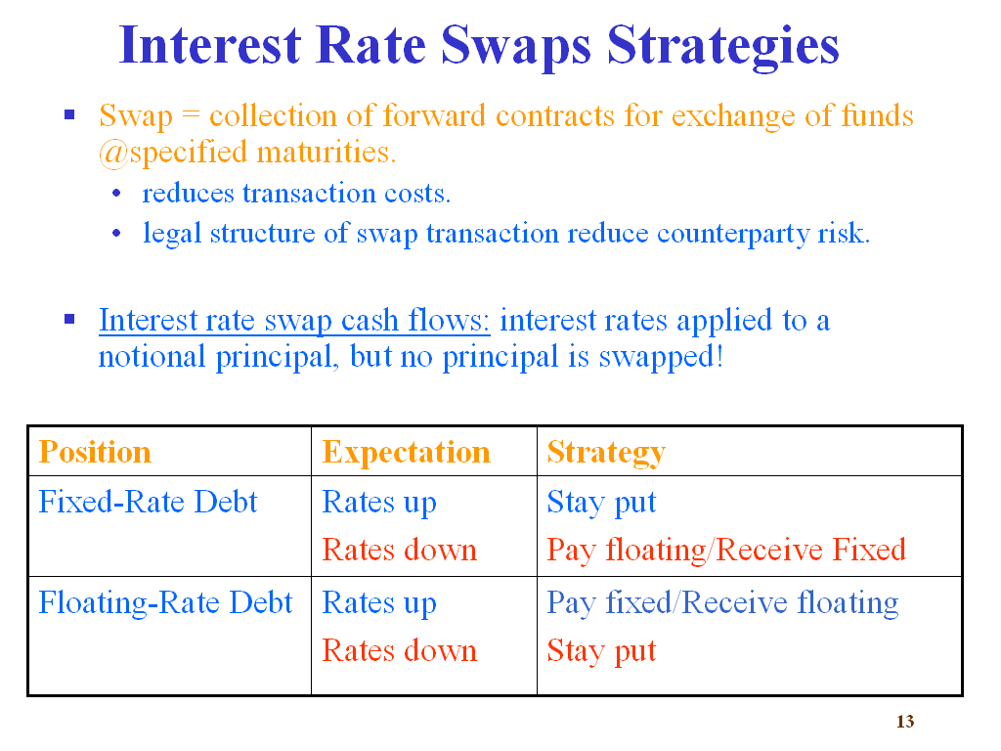
So the essence of the strategy is as follows. If you currently hold debt that is w/ a fixed interest rate, and you expect that rates would go down (compared to the fixed interest rate you pay), then you are better off entering into a swap, where you would pay the floating interest rate (which you expect will be lower than the fixed rate today) and receive a fixed payment. Notice this way you would use the fixed payment received to pay debt service, in exchange of which you would be paying the floating interest rate (which will be presumably lower than the fixed rate, in future).

Now, if you hold a fixed rate debt, but you expect that the interest rate would go above the fixed rate you have on your debt, then you need not enter into an interest rate swap, since you are better off paying the fixed rate.

If you hold a floating interest rate debt, and you expect the floating rate to increase in future, then entering into “pay fixed/ receive floating” is the way to go: you pay the fixed rate, but you receive the floating rate (which is presumably higher than the fixed rate, in future).

If I were to take a long position + short for any single hedging security (swaps, forwards, etc) would the risk come out to be similar between all of them?

Anuj, I am not sure I understand the questions. In general, if you hedge the uncertainty from interest rate fluctuations, then the residual risk will be the same (i.e. other risks, not hedged). If my answer makes little sense, please ask your question again, so I can answer it completely.

