Replies to memo questions, 12/02/03

Dear Students,

Here are the replies to your questions. The answers to my questions (1. what is meant by counterparty risk when discussing interest rate swaps; 2. Is the notional principal part of the currency swap agreement), are: for question 1, counterparty risk is the risk that one of the parties (also referred to as legs) to the contract does not deliver its payment. The answer to the second question is: the notional principal is included into the currency swap agreement.

Why would you want to swap currency with one that is more risky (target currency)?

In general, a counterparty might wish to swap into a more volatile currency because it might have a different level of risk tolerance (i.e. “risk appetite”). On the other side, notice that more volatile currencies would require a higher compensation to the holder of the currency to invest into it -- i.e. it might offer higher interest rate to reflect (or “price in”) the higher risk. Again the intuition of the CAPM works- higher risks comes with higher expected returns.

What is a development bank? My friend works for one but it doesn’t exactly function like a normal bank. Instead they operate more like an economic research organization. Thought?

Development banks usually have as a main goal not to maximize their profits. Examples are the World Bank (www.worldbank.org), the Asian Development Bank (http://www.adb.org/), the Inter-American Development bank (http://www.iadb.org/), and many others.

What favors could BAT get in Russia?

I was referring to companies that would prefer setting up a subsidiary in a particular country, because they could receive special concessions (or “favors”). Now, in the case of Russia, BAT (British American Tobacco, one of the largest cigarette producers in the world) managed to obtain at very reasonable (read bargain) price one of the best Russian factories for cigarette production.

When you consolidate do you do a weighted average based on % of ownership?

Yes, affiliates are consolidated with the parent on a pro rata basis (i.e. proportionate to the percent ownership by parent).

Can you describe (slide #20) the real exposure as mark-to-market differentials?

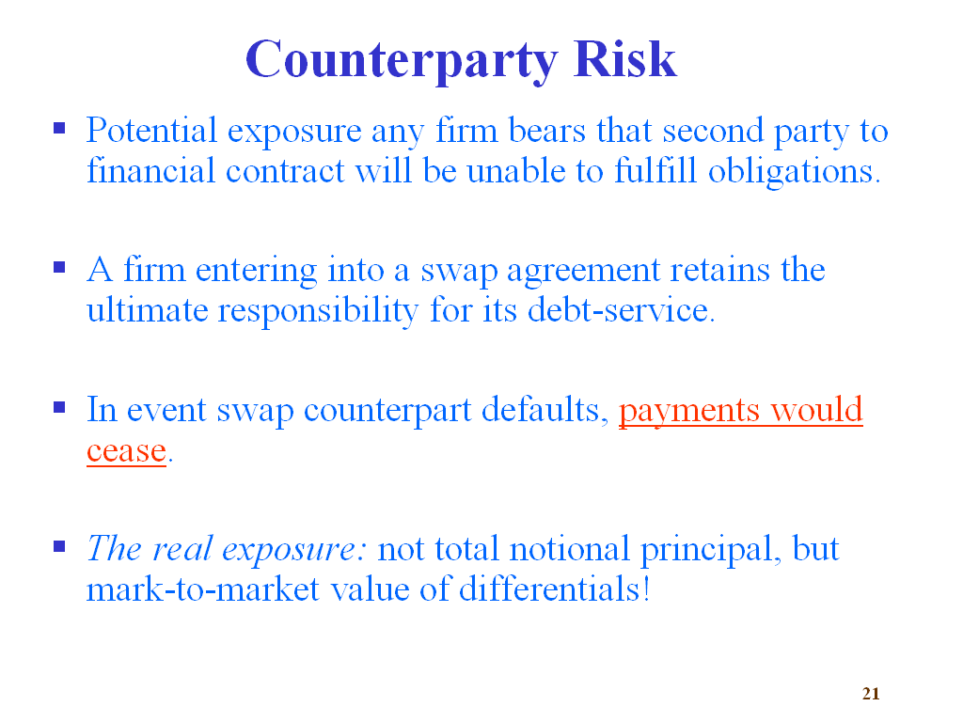
The meant that the real exposure is not that the counterparties will not reverse each other the notional principal, but rather the marked-to-market differentials between the value of the two currency interest remittance flows (i.e. in the target and home currency). This differential is approximately the same (at any moment of time during the life of the swap) as the gain/loss realized in the event of unwinding the swap at that particular moment, and this differential comes into being because of fluctuations in the interest rates in both the home and target currency, as well as fluctuations in the exchange rate between the two.

What is the difference between the currency swap in chapter #14 & the swap we did earlier?

The currency swap we studied in chapter 14 was and the currency swap we studied as part of the hedging strategies for operating exposure are essentially the same, in the nature of their structure – on both cases two or more parties agree to borrow in one currency and then swap the proceeds w/ debt proceeds from another currency, so that effectively change the currency of debt service (this might be desired because the new currency of debt service might also be the currency of cash inflows). The difference is that in the case of the cross-currency swap example in chapter 14, we had three different parties involved (as opposed to two before) that approach the swap dealer (in this case Goldman Sachs) to accomplish the transaction.

Can you please elaborate on the notional principal?

In general for any debt instrument, the notional principal is the principal amount on which interest rates are contracted. In the case of interest rate swaps, the notional principal is the amount on which we will have to exchange the interest payments. In the case of currency swaps, the notional principal is the amount in the target currency which will be exchanged at the time the currency swap is entered to, and eventually reversed, at maturity of the swap or at the time the swap is unwound.

What if the Swiss franc depreciates? Would the firm engaging in unwinding the swap would actually realize a gain?

I assume your question refers to the example on unwinding currency swaps in class. Yes, if the Swiss franc depreciates, the firm that engages in unwinding the swap from the US$ side will actually realize a gain.
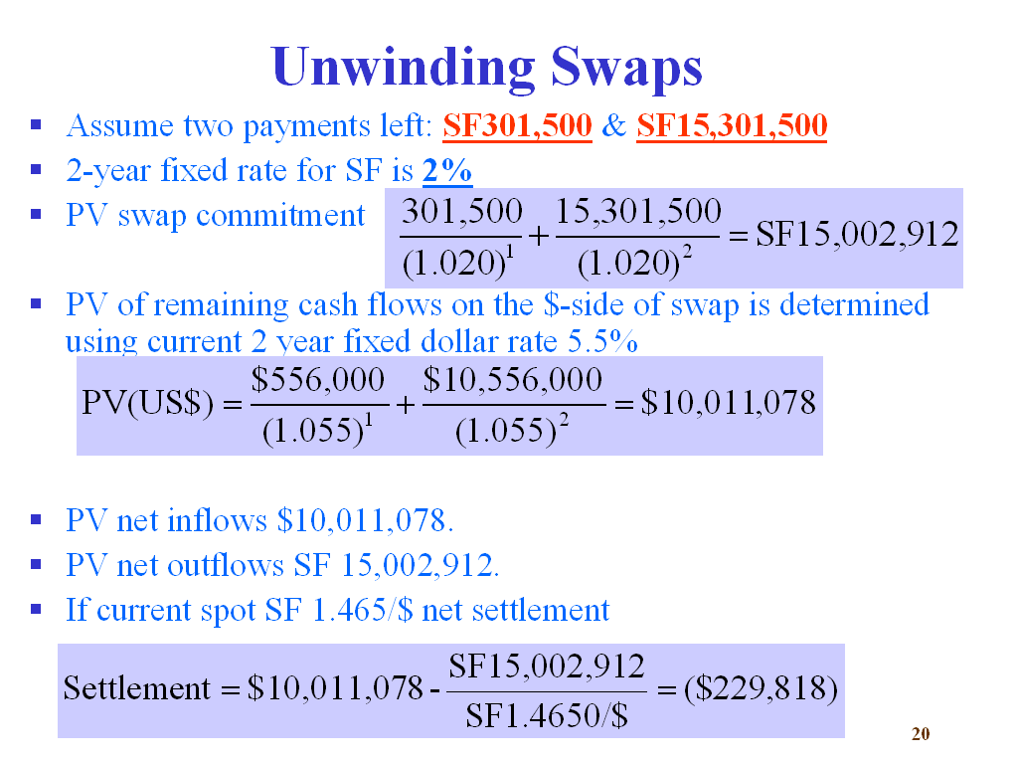

Notice that if the exchange rate went to, say SF 1.6/$, then the settlement will be $\text{Settlement}=\text{\$10,011,078-}\frac{\text{SF15,002,912}}{\text{SF1}\text{.}\text{60/\$}}=\$\text{623},\text{180}$, i.e. a profit.

