Replies to memo questions, 12/09/03

Dear Students,

Here are the replies to your questions. Good luck in all finals!

1. Will we be required to do the calculation in the spreadsheets today in class?

If I require any capital budgeting calculation, it will be very simplified: e.g. it might involve computing/ or just setting up the computation (i.e. giving me the formula and showing where to plug the numbers) for a NPV calculation where I would provide you with the details on the cash flow.

2. Answer to Qs 1 of sample exam (in class) was not clear? Can you send solutions to last sample questions?

I apologize. I have enclosed the answer in the sample solutions. Sure, I have posted the sample questions solutions on Blackboard, under “Session 28”.

3. Why can real option analysis result in recommending a negative NPV project? Why are not real options as conservative as DCF?

When the investments under consideration has a really long live, or its cash flow is going to come only in the later years, or the risk is higher the risk of the other projects of the firm, the traditional DCF analysis would give us a very low NPV. Why? Because DCF analysis cannot capture the value of the strategic options through time as the project develops. What are these options/ future choices?
- option to defer or abandon the project (timing option).
- option to alter the capacity of the project (expansion options).
- option to start up/ shut down to other projects (switching).
- option to learn more as you go and eventually make a more informed capital budgeting decision.
Real option analysis allows capturing the value of these “real options”, prices them, and adds their value to the NPV value that we would otherwise obtain by DCF valuation. So, this increases the value of the project today, and oftentimes, even though we might have a negative NPV project, based on the DCF valuation, once you account for the real options value, then actually the project’s total present value becomes positive, and we would accept such a project. It is in that sense that I said DCF is very conservative method of valuation: real option analysis treats cash flows in terms of future value in a positive sense whereas DCF treats future cash flows negatively (on a discounted basis).

4. Can you post the answers to problem set online?

All problem set solutions are available through the “Assignments” section of Blackboard ☺.

5. In computing the total cost of debt for Cemex
25%( ? ) + 75%( ? ) = weighted cost of debt. What numbers go in there?

Here is the slide your question refers to:
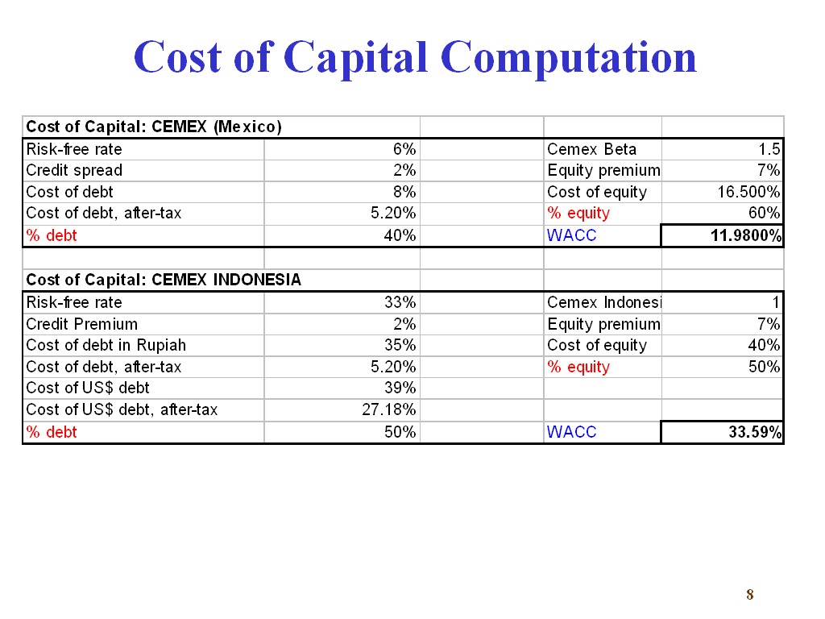
So, in computing the cost of debt for the Indonesian subsidiary, Cemex Indonesia, we have to use the formula:

25% * (cost of debt by Indonesian government) + 75% (cost of debt by Cemex Mexico).

The weight come from the assumption that RP 2,750,000,000 are extended as debt by a consortium backed by the Indonesian government and RP 8,250,000,000 are extended as US$ (current rate is RP10,000/$) by Cemex Mexico.

The cost of debt by the Indonesian government is 35% & the cost of debt by Cemex Mexico is 39%. Furthermore the tax rate in Indonesia is 30%. So, the after tax cost of debt by the Indonesian government is 35%*(1-0.3) = 24.5% & the after-tax cost of debt by Cemex Mexico is 39%*(1-0.3) = 27.1845%. So we plug in this number in the weighted average above, and the after-tax cost of debt for the subsidiary is:

0.25 * 24.5% + 0.75 * 27.1845% = 26.5134%.

6. Can you explain the monetary approach (in the asset market approach to exchange rate determination)?

So, the monetary approach states that foreign exchange is an asset, so the exchange rate is its price. This price is then determined by the demand and the supply for that asset: So money supply & money demand for a given currency will determine its exchange rate. I have discussed in some detail the impact of the changes in different factors (according to the monetary & portfolio-balance approach) on the forex rate in the replies of 09/29.

7. Can you explain the forward quotes (on a point basis?) – I don’t understand how we would do a problem (maybe give another example of how to solve).

Here is the slide from the discussion on chapter 6 that you refer to:
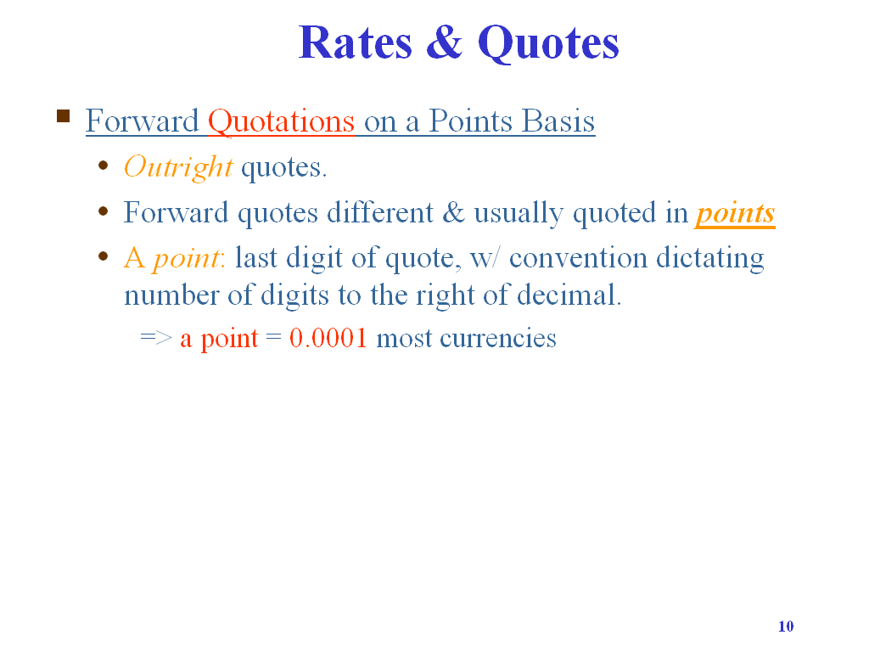
So, basically, forward rates are oftentimes quoted using outright quotations, e.g. 3-month forward Euro contract is traded at Euro0.81912/$. This is an outright quotation. However, oftentimes these quotations could be given on a relative basis (relative to the current spot price). The difference is of course small enough, so we use basis points. For most currencies, we would use a definition of the point as 0.0001 of the currency. The exception is the Japanese yen, where we would use 0.001.

8. What exactly do we have to know for MNE capital budgeting (project vs. parent). All the steps you talked about? With Cemex?

You need to know the steps that are involved in the preparation of the capital budget, e.g. obtaining the discount rates, obtain the cash flows (i.e. which cash flows are relevant to use), constructing the capital budget, and finally computing the internal rate of return on it.

9. Can you repeat what a sinking fund is?

Sinking fund is a credit facility where you would retire part of the principal throughout the life of the instrument, so that by the end of the day, all of it is retired.

For more on sinking funds, check this source http://www.taxopedia.com/terms/s/sinkingfund.asp .

