Salomon Brothers Inc

Understanding Duration and Volatility

September 1985

C. 1985 Salomon Brothers, Inc.
Reprinted with permission, UNDERSTANDING DURATION AND VOLATILITY, R. W. Kopprasch, pp. 1-29

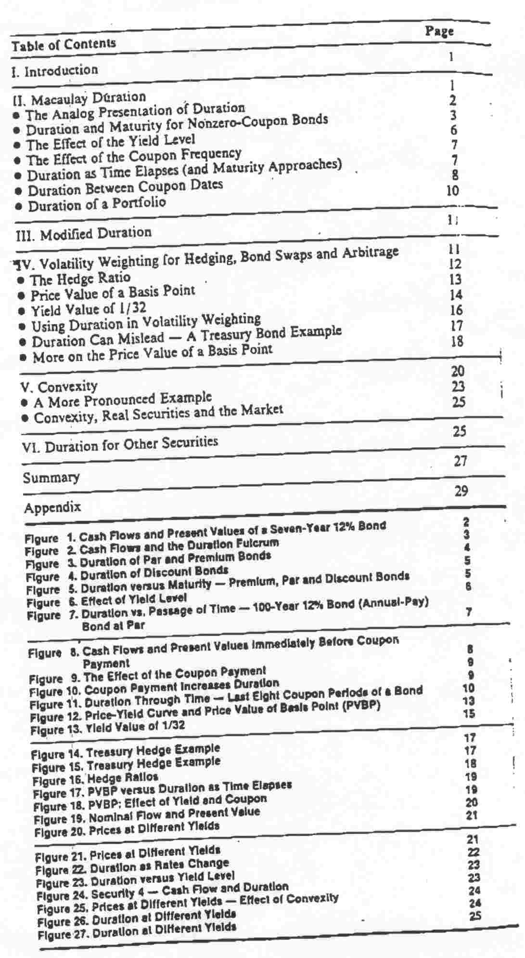
Understanding Duration and Volatility

1. Introduction

Duration is not a new concept. It was first described by Frederick Macaulay in 1938.¹ After being "rediscovered" in the 1970s, duration has become one of the most commonly used tools of fixed-income managers. One use is immunization when a portfolio of assets is selected such that its duration equals the duration of the liability portfolio. With a slight modification, duration provides a good estimate of the volatility or sensitivity of the market value of a bond portfolio to changes in interest rates.² Many managers measure the "risk" of their portfolios by reference to the duration. And, as a volatility measure, duration is often used in constructing hedges and in weighting arbitrage trades.³

Despite its wide use, duration is not always fully understood. As a result, trades are sometimes incorrectly weighted, and portfolio volatilities are misestimated. This report will provide a basic review and reference document on duration and trade weighting. Wherever possible, a nonmathematical approach is used. Section II describes Macaulay duration, which is used in immunization, both by reference to a formula and a graphic presentation. This section also discusses how duration varies with maturity, yield and coupon level, and how it changes over time. Section III presents modified duration, which is more appropriate for volatility measures and trade weighting. Section IV shows the mechanics of volatility weighting. The relationship of duration to both the “price value of a basis point” and the “yield value of 1/32 (or 1/8)” is described in this section. Section V discusses convexity, which is related to the change in duration introduced by yield changes. Section VI discusses duration with respect to nonbond and complex bond securities.

II. Macaulay Duration

In the bond market, securities are commonly referred to by their maturities. While this is a useful benchmark, it is deficient, because it measures only when the final cash flow is paid and ignores all of the interim flows.
Frederick Macaulay attempted to create a better measure than maturity of the interest rate risk of a portfolio. He described a measure he called duration, which measures the weighted average time until cash flow payment. The weights are the present values of the cash flows themselves. The formula for duration follows:⁴
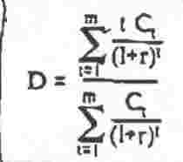

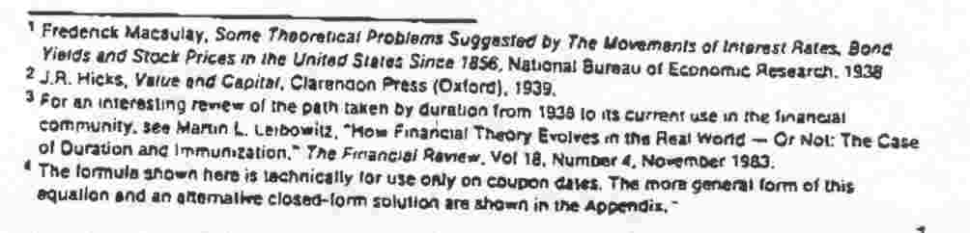
The formula is simply a weighted-average calculation. The time until the receipt (t) of each cash flow is multiplied by the present value⁵ of the cash flow (C₁/(1+r)^{t}). The sum of these components is divided by the sum of the weights, which is also the full price (including accrued interest) of the bond.⁶

Some useful insights can be drawn by examining the formula. For example, consider a zero-coupon bond. For a zero-coupon bond, all of the C₁s are zero, except for the final payment, and the formula reduces to:

that is, the duration equals the maturity.⁷

The Analog Presentation of Duration

Despite the potential insights that can be drawn from the formula, it is probably more helpful to pictorially look at duration. Figure 1 shows the cash flows of a seven-year 12% bond: The shaded area of each cash flow represents the present value of that cash flow. (These values are used in the calculation of duration.) We can extend this diagram into an imaginary physical device that will reveal many of the properties of duration without involving mathematics.

Figure 1. Cash Flows and Present Values of a Seven-Year 12% Bond
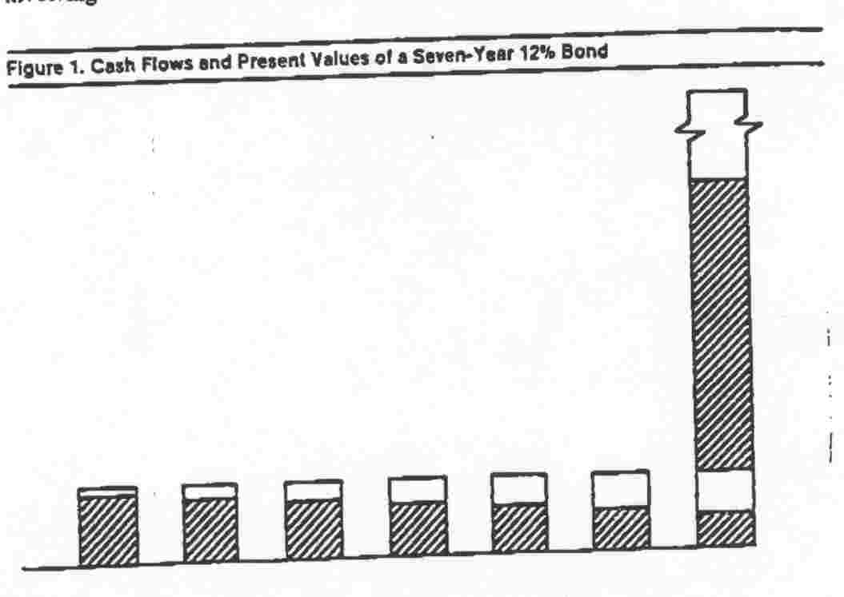

I

I
I

I
I

5 This version of duration uses the periodic yield of the security as the discount rate for all of the present-value calculations, rather than spot rates for the particular maturities. As a result, it is frequently referred to as the “flat yield curve” duration.
6 Because r is a periodic rate (for example, a semiannual discount rate) and t = number of periods, the formula provides a duration in periods, not years. The result must be converted to years. See the Appendix.

We can view Figure 1 as a series of containers resting on a board or seesaw. The size (capacity) of each container is the nominal amount of the cash flow to be received at that time, and each is filled to the present value of its cash flow. The distance between the centers of each cash flow container represents the amount of time between the cash flows. Thus, horizontal distance is actually a measure of time. If an investor was evaluating the “bond” on a coupon date, the first container would be placed one full period from the investor, the second two periods, etc. The duration would be the distance from the investor to the point at which we could place a fulcrum and balance the whole system (see Figure 2). The duration of this seven-year 12% annual pay bond is approximately 5.1 years.

Figure 2 Cash Flows and the Duration Fulcrum
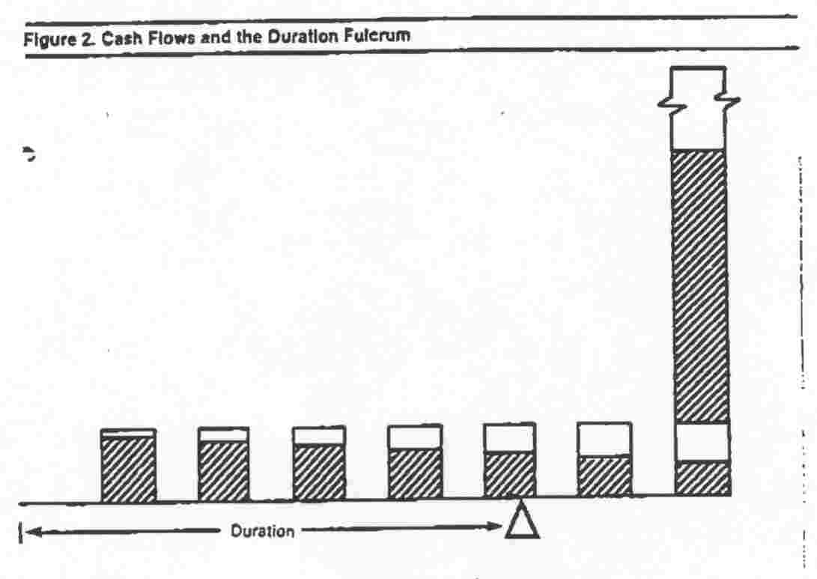

These present-value diagrams can also demonstrate that the duration of a zero-coupon bond is equal to its maturity. Because there is only one cash flow, the balance point must lie at that cash flow. Changes in yields and the elapsing of time will not change this "duration equals maturity" relationship for zero-coupon bonds.

This approach to understanding duration offers some insights that are not available without resorting to mathematics, and we will return to this type of diagram throughout the paper.

Duration and Maturity for Nonzero-Coupon Bonds

Consider what happens as the maturity of the bond in Figures I and 2 is lengthened to eight years, nine years and so on. Each lengthening adds another coupon payment at the new maturity and moves the redemption payment out one period. The present value of the redemption payment also declines, because the time to maturity increases. The balance point starts moving to the right: The duration increases as the redemption payment is

3

moved, but by less and less for each additional year because of the diminishing weight of the redemption payment. (The duration of a 100-year annual-pay 12% bond at par is only 9.33.) As the maturity is lengthened further, the bond begins to look more like a perpetual annuity, the duration of which is given by;⁸
1+r
D= -------
r
This duration versus maturity pattern is shown in Figure 3; however, this applies only to par and premium bonds.
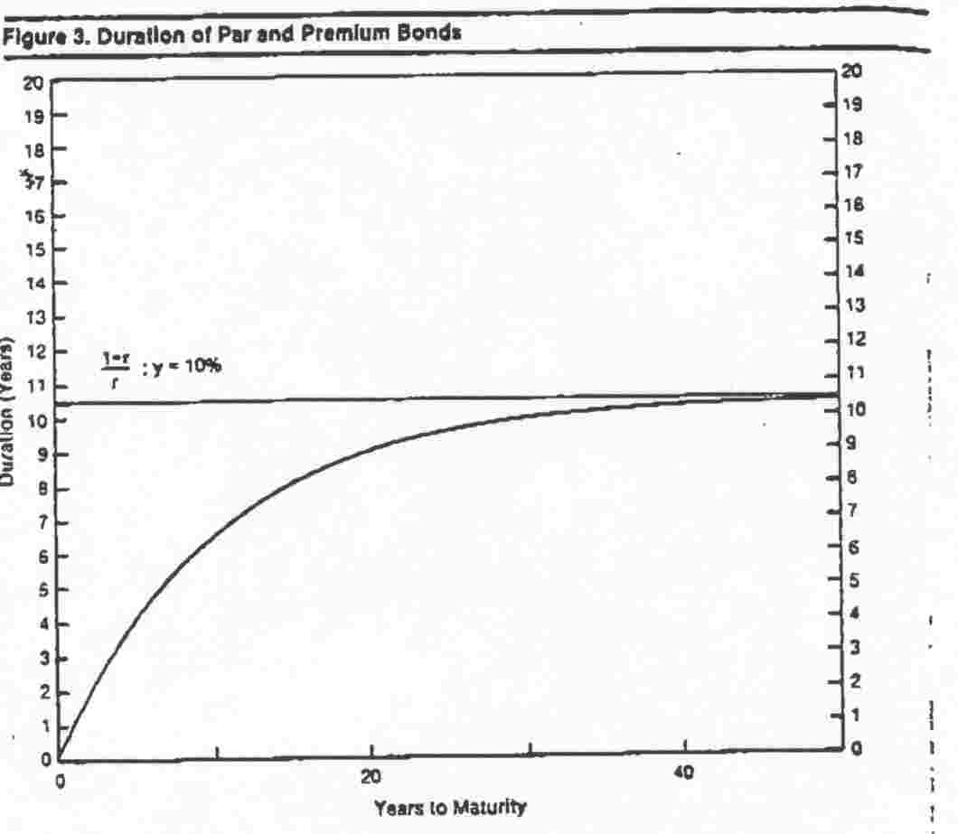

The duration pattern for discount bonds is more complex. Very low coupon bonds have a duration pattern that lies close to the zero-coupon pattern (D=m) up to a reasonably long maturity. For very long maturities, however, even a low-coupon bond begins to resemble a perpetual annuity. For an extreme example, consider a 1/2% coupon bond. If the maturity was 20 years, the duration would be approximately 17 years at 10% yield, because the coupons are relatively insignificant, compared with the redemption payment. If the maturity was 100 years, however, the bond would act like an annuity, because the redemption payment would be so distant. The duration would be 10.6 years, very close to the perpetual annuity duration of 10.5 years. Thus, the duration can actually decrease with increasing maturity, approaching the duration of a perpetual annuity from above. This pattern is shown in Figure 4. Note, however, that the maturity range that can exhibit a decreasing duration is fairly long, although not quite as long as the longest utility bonds. Within the more usual range of bond maturities, the basic pattern (though not the level) shown in Figure 3 applies even to discount bonds. Therefore, we will refer to Figure 3 as the basic duration versus maturity pattern, even though long maturity discount bonds can behave differently. For comparison, the patterns of premium, par and discount bonds are shown in Figure 5.

⁸ see footnote 6

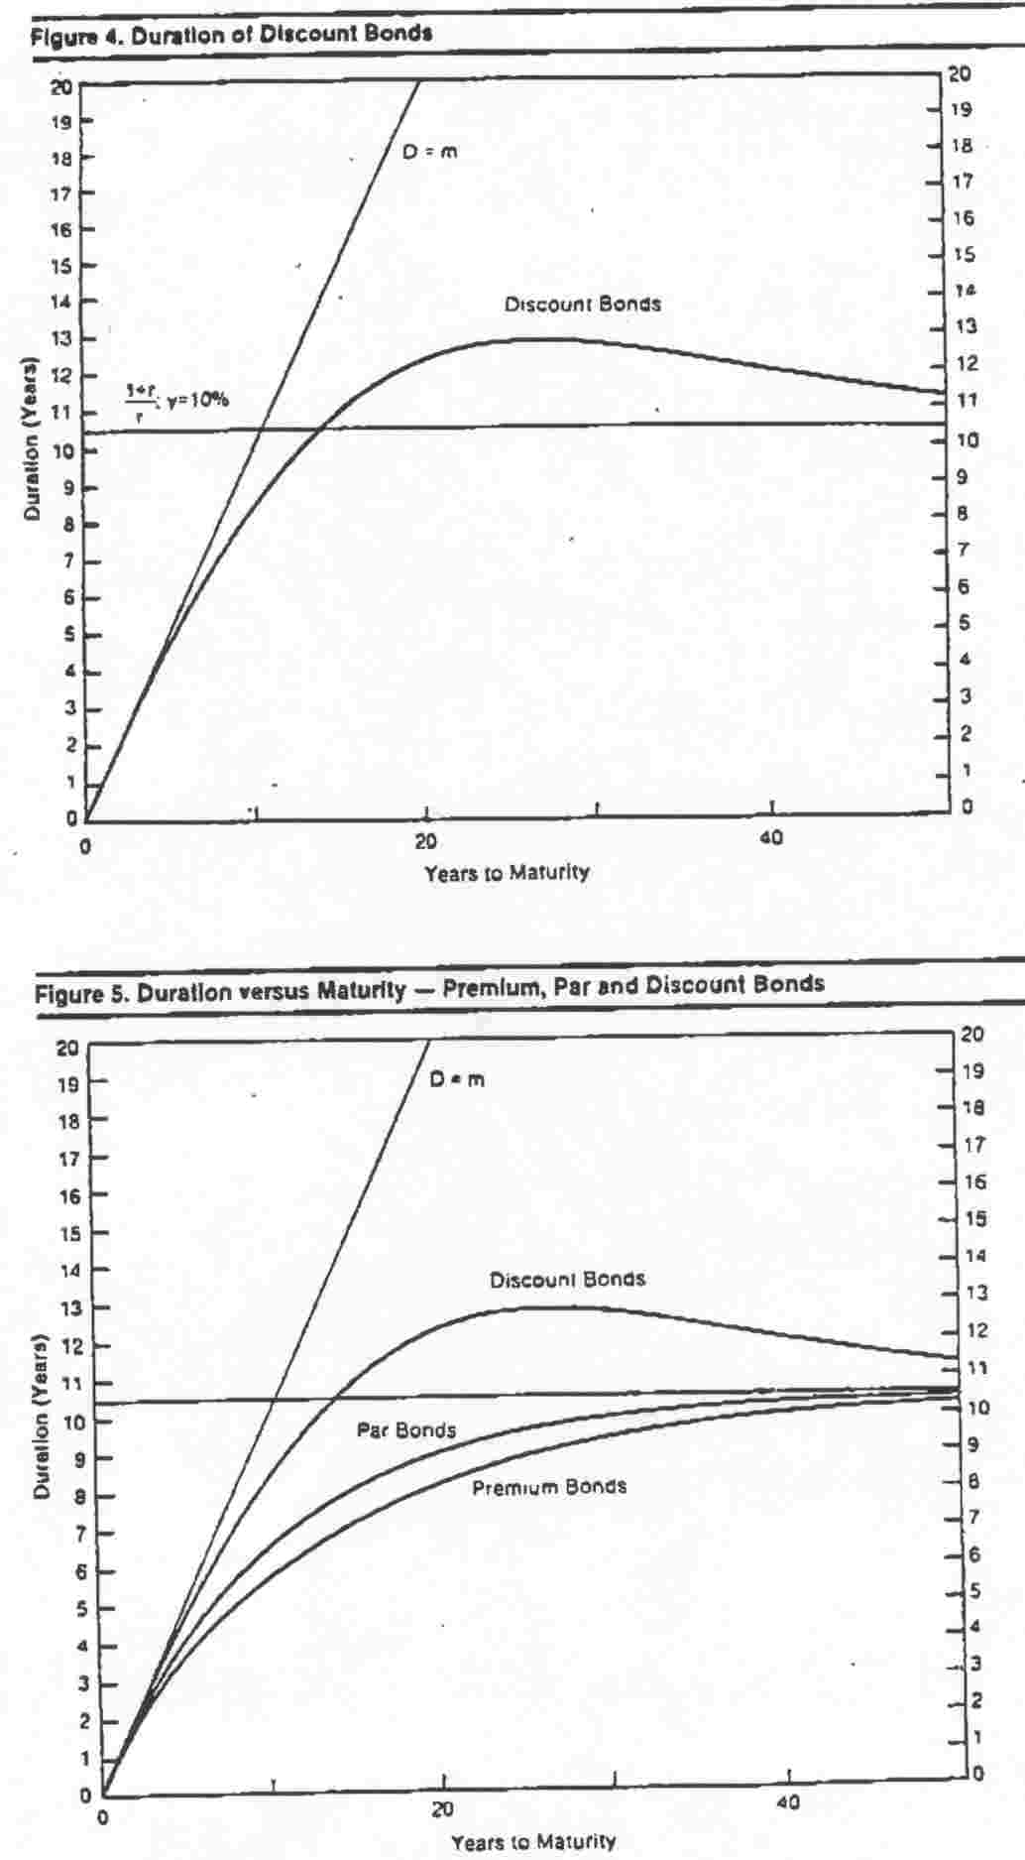
The Effect of the Yield Level
The equation for Macaulay duration shown in Equation [1] includes a yield term; thus, it is natural to expect that the yield level will affect duration. Using Figure 2 as a guide, consider how the figure would change as the yield increased. All of the present values would decline, but the cash flows that are the farthest away would show the largest proportional decrease.⁹ As a result, the early cash flows would have a greater weight relative to the later cash flows, and the fulcrum would have to be moved to the left (shorter duration) to keep the system in balance.

As rates decline, the opposite effect occurs. All of the cash flows increase in value, but the longest ones increase at the greatest rate. At the extreme of 0% yield, the present values equal the cash flows, and the redemption payment has a much greater effect, moving the balance point further to the right (longer duration). It may help to remember that duration changes in the same direction as price when yield changes.

Another indication of the effect of the yield level is Equation 3, which was given earlier for the duration of a perpetual annuity. This is the limiting value for duration for bonds, and it depends solely on the yield level (D = (1+r)/r). When r is smaller, (1+r)/r is larger, and the maximum duration is longer than at higher yield levels, as shown in Figure 6 for par bonds.
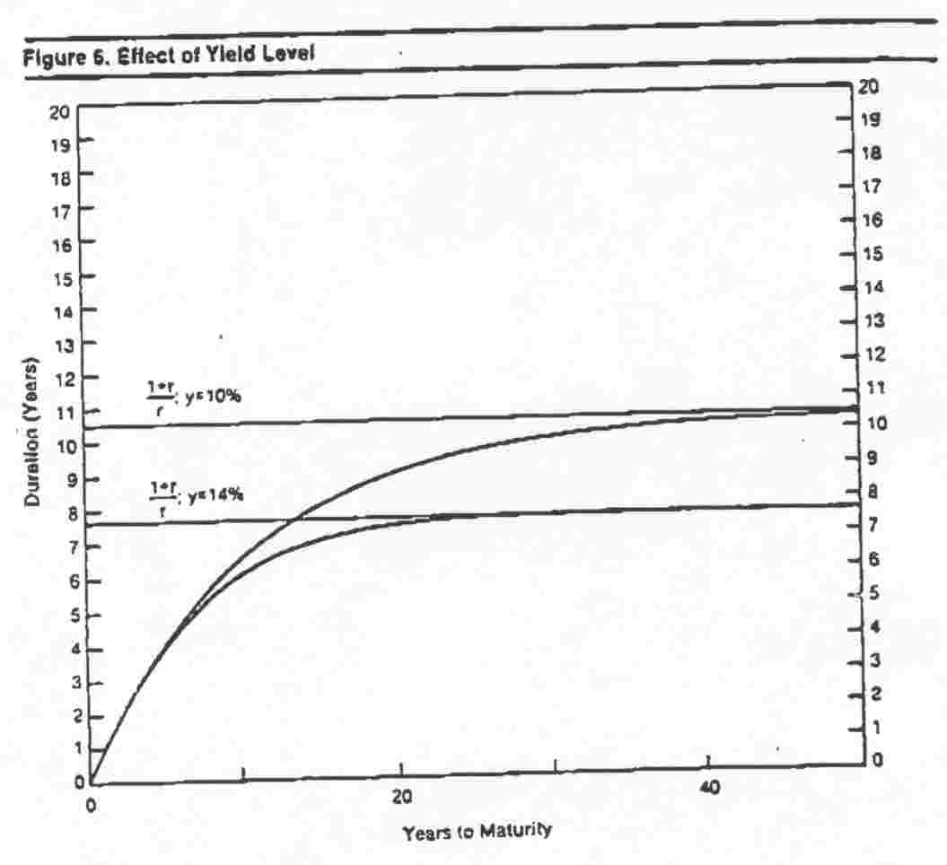

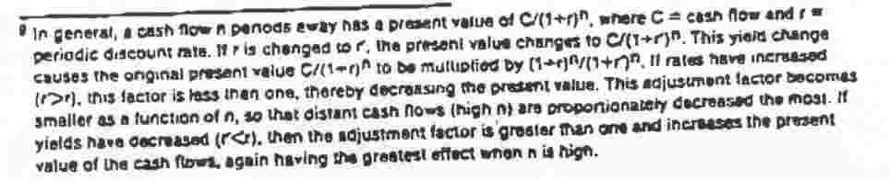

The Effect of the Coupon Frequency

While most domestic corporate bonds have coupons that are paid semiannually, other securities may pay annually (Eurobonds, for example), quarterly or monthly. How does the coupon payment frequency affect the duration? Referring to the seesaw diagrams, imagine that every coupon was divided into two parts and that one of the parts was paid one-half period earlier than the other. On the diagram, this represents a shift of weight to the left, as part of each coupon is paid earlier. This shift to the left moves the balance point to the left; thus, increasing the coupon frequency shortens the duration. Decreasing the frequency lengthens the duration.

Duration as Time Elapses (and Maturity Approaches)
Consider the duration of a par bond as time elapses and the bond's maturity decreases (holding yield constant). Using Figure 3 as a guide, we can see that duration will initially decline slowly, and then at a more rapid pace as the bond approaches maturity. Using the example from above of a 12% annual-pay bond at par, during the first 93 years of a 100-year bond’s life, the duration drops from 9.33 to 5.11, or by only about 4.2 years. Yet the duration must decline to zero in the next seven years (when the bond matures), so the duration drop in the last seven years (5.11) exceeds the decline in the first 93 years. This is shown in Figure 7, which is similar to Figure 3 with the lower scale (X-axis) reversed.
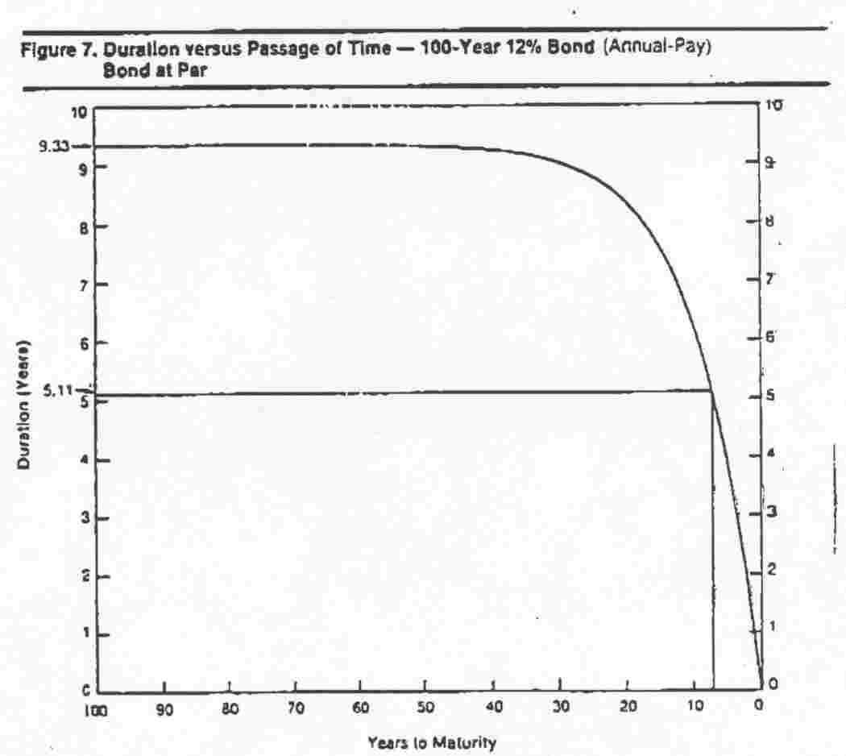
Charts similar to those in Figures 3 and 7 are often used as standard illustrations of the duration versus maturity and duration through time relationships, but they are not complete. The curves are actually drawn through a series of duration values for coupon dates, so we must determine whether the curve is an accurate reflection of duration values for the time between coupon payments. 7

Duration Between Coupon Dates

We will return to the analog device to determine what happens to duration as time elapses between coupon payments (with no change in yield). Using Figure 2 as a guide, consider what happens as one day elapses. Each cash flow and the original duration fulcrum are now one "day" closer to the investor. If the position of the fulcrum does not change relative to the cash flows, then the duration (the time from the "investor" to the fulcrum) will have decreased by one day. As we will show, this is the case: The fulcrum's position will not have changed relative to the cash flows.

As one day elapses (with no change in yield level), all of the cash flows will increase in present value, because the discounting period is being shortened. An equivalent way to view this is to say that the original present value of each cash flow increases at the yield rate for one day. Thus, each present value is multiplied by (1+r)^{t}, where r is the periodic rate and t is the fraction of the coupon period that has elapsed. While the values will not expand by the same dollar amounts, they will all increase in proportion to their original values. In other words, the original diagram of present values is still accurate, except that the scale has changed slightly. As the original diagram remains an accurate picture of the present values, the duration fulcrum will lie in the same position (relative to the cash flows) as the original fulcrum, except that now the investor is one day closer to the fulcrum. Thus, as time elapses between coupon dates (or any cash flow dates), duration shortens by the same amount of time that elapsed. After each day, the duration will be one day shorter.

We now have to consider what happens as the coupon date approaches. As before, each day that elapses brings the fulcrum one day closer (that is, duration shortens by one day). Figure 8 shows the situation immediately before the coupon date, when the duration has shortened by almost the whole coupon period, which is typically six months. Figure 9 shows the

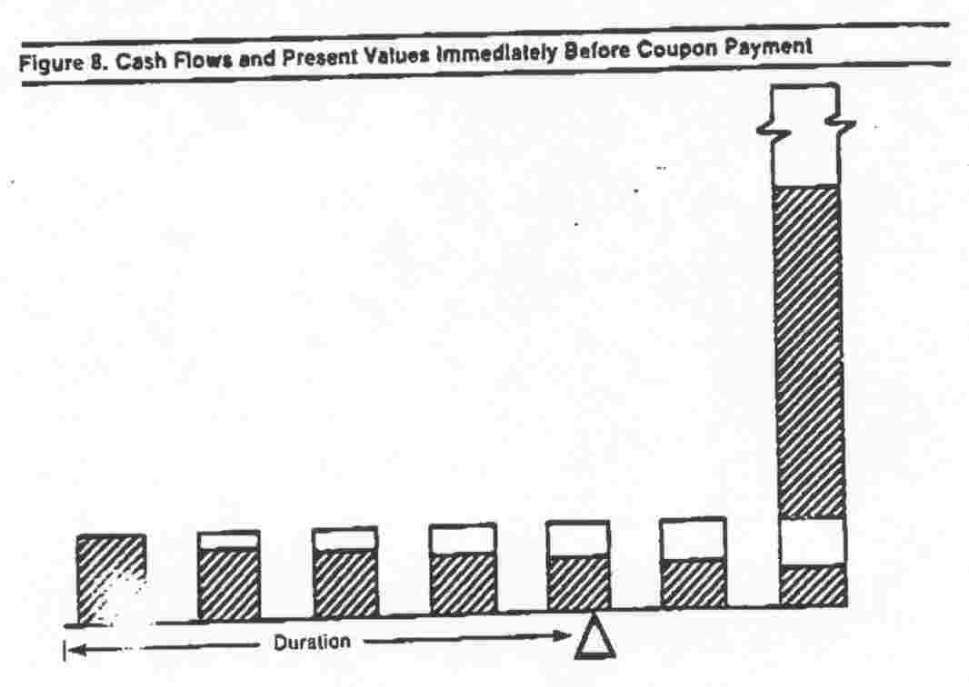
effect of the payment of the coupon. The coupon is no longer part of the bond's cash flows and thus, is not a factor in its duration.¹⁰ To bring the system into balance after the coupon is paid, the fulcrum must be moved to the right (as shown in Figure 10) and the duration increases. Except for the extreme maturity range of Figure 4, this increase is less than the time between coupon payments. Thus, the duration shows a slight decline from one coupon date to the next (as in Figure 7).

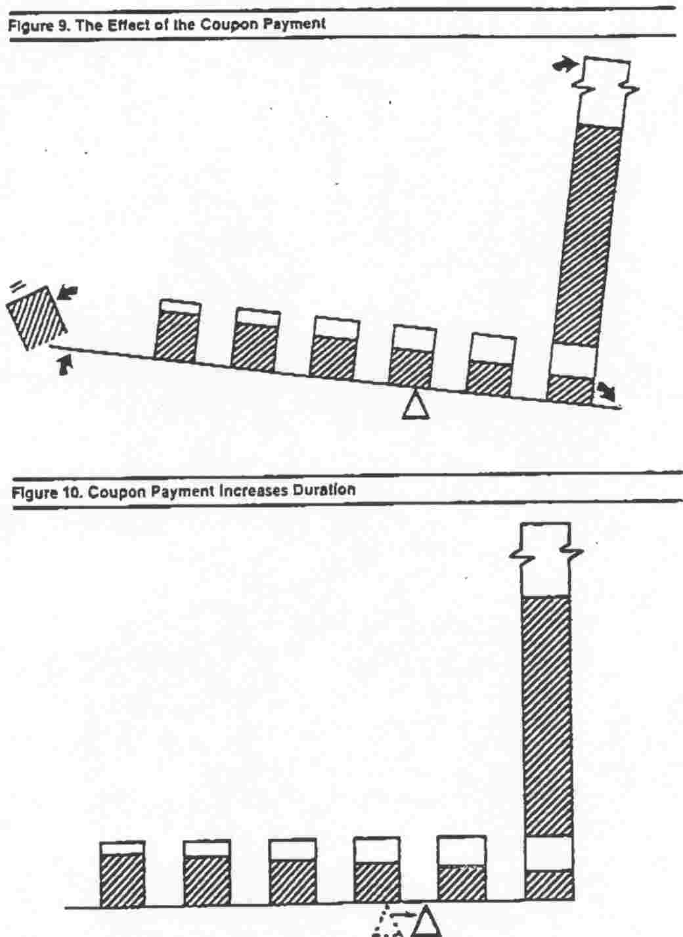

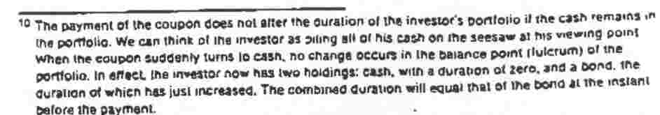
With this new information, the duration versus time pattern can now be redrawn more accurately (see Figure 11 for an example of a semiannual bond). The downward sloping straight-line segments represent the duration decreasing between coupon dates, with the upward jumps occurring on the coupon dates. This sawtooth duration pattern normally evokes a question about the volatility of the bond, namely whether the volatility follows a similar pattern.¹¹ As described more fully in Section IV, the answer is no: Volatility follows a smooth path as time elapses (at constant yield).
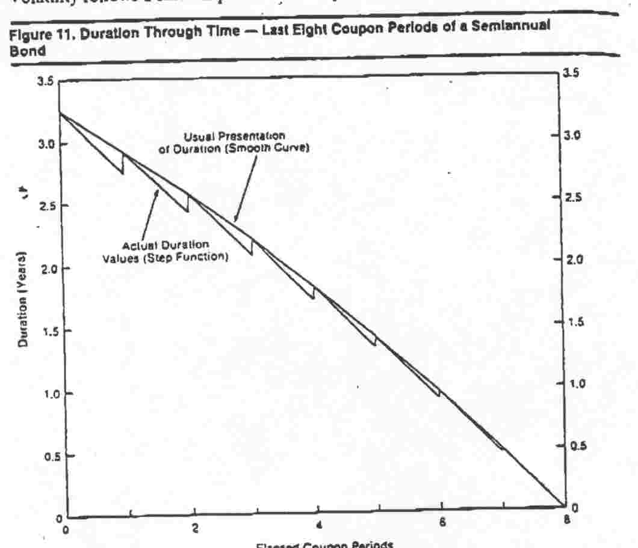

Duration of a Portfolio
Portfolio duration is a weighted average of the durations of the individual security durations. The weights are the present values (full prices) of the securities divided by the full price of the entire portfolio, and the duration that results is often referred to as a "market-weighted" duration. This approach is actually very similar to the determination of duration of a single bond, in which the bond is considered a portfolio of zero-coupon instruments. The duration of each payment (time to maturity) is multiplied by its present value divided by the value of the whole bond.

The duration of a portfolio has the same application as duration for in individual security: It can be used in structuring immunized portfolios and (when modified) to estimate percentage volatility. It is quite likely, however, that a portfolio may exhibit more convexity than individual securities. This will he covered in SectionV.
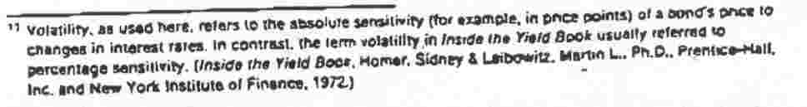

III. Modified Duration

While Macaulay duration is appropriate for use in immunization, another measure - modified duration - is better as a volatility measure. Modified duration appears to be a slightly modified form of Macaulay duration, but it was actually developed by Hicks in 1939 without any reference to duration. The formula for modified duration is:

D
D_{mod} = ------- [4]
1+y/f

where D = Macaulay duration
y = yield to maturity (in decimal form)
f = discounting frequency per year
y/f = periodic yield (in decimal form)

For semiannual pay bonds, this formula becomes:
D [5]
D_{mod}= -------
1+y/2

Modified duration can be used to estimate the percentage price volatility of a fixed-income security. The relationship follows:

ΔP
----- = 100 = -D_{mod} x ΔY [6]
P

percentage price change = - modified duration x yield change (in absolute percentage points)

The following section illustrates its use in trade weighting. At this point, however, it is useful to point out several important features about duration and volatility. As mentioned above, modified duration, not Macaulay duration, is appropriate for volatility measurements. Second, modified duration provides a measure of percentage price volatility, not absolute dollar volatility. Third, the percentage volatility applies to the full price of the security (including accrued interest), not the quoted (flat) price. These points will be explained more fully in the following section.

IV. Volatility Weighting for Hedging, Bond Swaps and Arbitrage

The motivations for entering hedging, bond swaps and arbitrage transactions are usually quite different. The hedger is usually attempting to minimize a risk that cannot otherwise be conveniently eliminated. The bond swapper is attempting to increase return by swapping into a security that is expected to outperform (even in the absence of a general market move) the original position over some specified time horizon. The arbitrageur is creating

an entirely new position to capitalize on an expected realignment of yield spreads. Despite these differing motivations, however, volatility weighting is similarly used in all three cases.¹²

In its simplest form, hedging attempts to offset price changes in one security (resulting from a change in the level of rates) with equal changes in another. Because most securities in the debt market are positively correlated with one another in terms of price movement, a short position normally offsets a long position. However, as the securities may not have identical price changes even if they experience identical yield changes, some ratio of the short to the long other than 1:1 is usually necessary.

Many bond swaps and arbitrage transactions attempt to capitalize on an expected realignment of yield spread relationships. Unless these trades are properly weighted, however, it is possible to suffer a loss even when the spread moves in the predicted manner within the time horizon specified. These losses usually result from the realization of the target spread at a different level of the market, causing the differential bond price movements from one market level to another to far outweigh the spread movement. As a result, the trade must be insulated from changes in market level by volatility weighting.

Volatility weighting is occasionally and unfortunately referred to as "duration weighting," leading some to assume - incorrectly - that the ratio of the durations is the proper hedge ratio. Duration can be used to weight trades, but it is more complex than the simple ratio of the durations. In the sections that follow, we determine the correct weighting for one bond versus another. This ratio is appropriate for hedging one bond with the other, swapping from one to another (except for rate-anticipation swaps) or establishing an arbitrage position.

We will discuss three different methods of weighting a transaction. The methods to be analyzed include: Weighting by price value of a basis point, yield value of 1/32 (or 1/8) and the correct use of duration. An example will confirm that the three methods are equivalent.

The Hedge Ratio

The objective of weighting the position is to equalize the total changes in value of the two offsetting positions. We can state this symbolically as follows:
Δ P₁ = HR x Δ P_{h} [7]

where ΔP₁ = the price change of the target security (to be hedged)
ΔP_{h} = the price change of the hedge vehicle
HR = the hedge ratio

HR x Δ P_{h} is, therefore, the total change in value of the position in the hedge vehicle. This value must equal the change in the target security.
Equation 7 can be rewritten as:

ΔP_{t}
HR= -------
ΔP_{h}

¹²Obviously, the weighting is different for a rate-anticipation swap, in which the investor hopes to capitalize on a market move rather than be insulated from it.

We can expand this to:

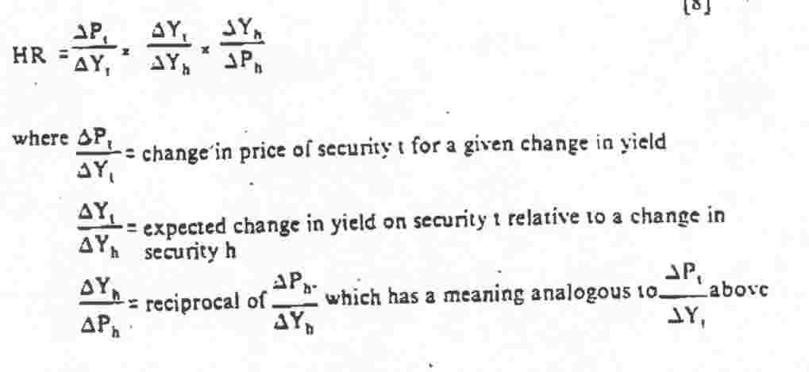

How is this formula related to hedge ratios determined using the price value of a basis point, yield value of 1/32 (or 1/8) or duration? As shown below, this formula can be utilized regardless of which approach is deemed easier or more convenient by the hedger.

Price Value of a Basis Point

The measure known as the price value of a basis point (PVBP) or, alternatively, as the dollar value of a 0.01 (DV.01), is simply the change in price for a bond that corresponds to a change in yield to maturity of one basis point (0.01 %). Figure 12 shows the price-yield curve pattern that is common to noncallable bonds and expands this to present the graphic interpretation of PVBP, which is a direct measure of price volatility relative to yield change. Figure 12 also demonstrates that a given bond has a greater price sensitivity to a given yield change when rates are low.

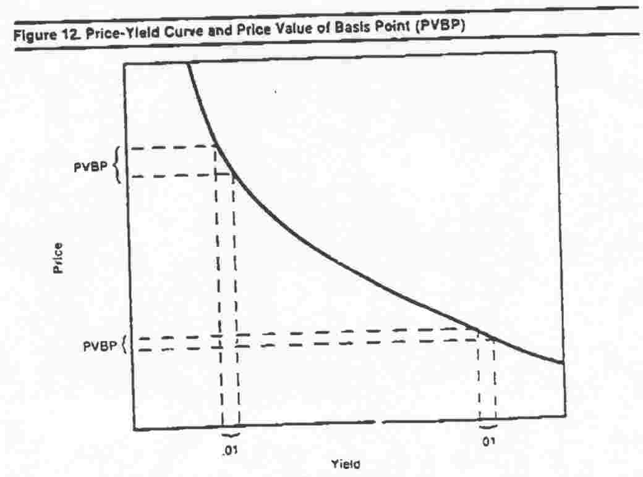
We can use the PVBP to determine the appropriate volatility weighting for trades. For example, assume that the price of one bond would change by 0.08 (from 98.60 to 98.68, for example) if its yield moved by one basis point, and we wished to hedge that change by taking a position in a security that would change by 0.06 per basis point. If we assume that both securities will change by the same number of basis points, then it is obvious that we need 1.3333 units of the hedge vehicle per unit of target security. Thus, if yields changed by ten basis points, we would expect that the target security would change by approximately 0.80, and 1.3333 hedge vehicle units, changing by 0.60 each for ten basis points, would also change by 0.80 (that is, 1.3333 x 0.60). How does this intuitive approach compare with equation [8] above?
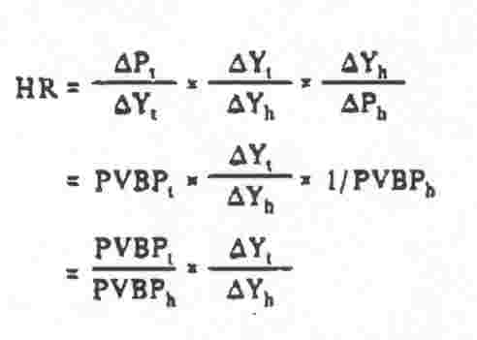

Δy_{t}/ΔY_{h} is simply the change in yield of security t relative to the change in yield of security h. We will use the term "yield beta" to express this value and will write it as B_{t}. In this example, the two securities are assumed to have the same yield changes, so B_{t} equals one. Therefore,
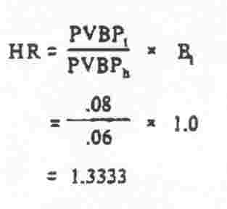

Equation [9] is the general form of the hedging equation when the weighting is done by price values of one basis point.

Yield Value of 1/32

Many Treasury bond traders use yield value of 1/32 for weighting trades (Weighting by yield value of 1/8 seems to be most common in the corporate bond area and probably dates back to the use of yield books. In a yield book, prices were listed by 1/8s, and then the yields for those prices were shown. It was quite easy to determine the yield change for a 1/8 change in price, but there was no direct way to determine the price value of a basis point.) Figure 13 presents the yield value of 1/32 and shows that this is an inverse measure of volatility. A high value indicates low price volatility (and vice versa), because it means that a large yield change is necessary to produce a 1/32 price change.

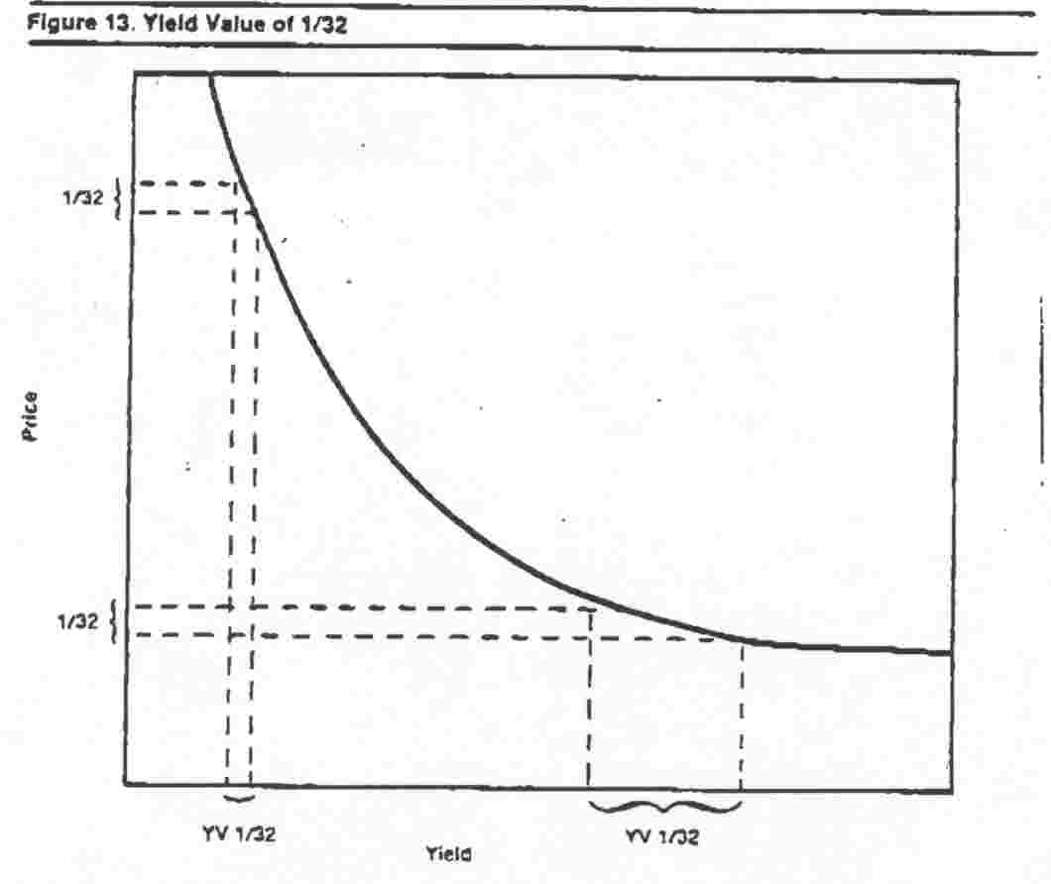

The hedge ratio is determined by dividing the yield value of 1/32 (YV1/32) of the hedge security by the yield value of the target security. Note that the positions of the hedge vehicle and the target security are reversed (from denominator to numerator, and vice versa) when compared with the PVBP method (because YV1/32 is an inverse measure of volatility). We can also return to equation [8] to see why this occurs.
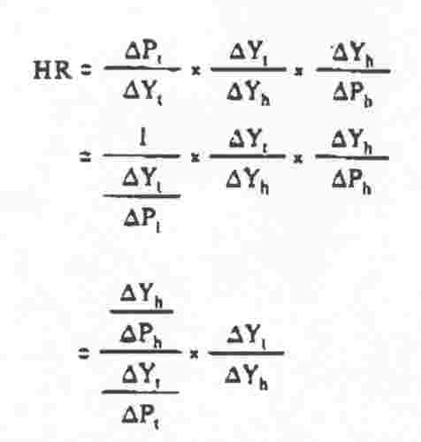
ΔY_{h}/ΔP_{h} is the change in the yield of security h for a given change in the price of h (see Figure 13). If we choose to make the price change by 1/32 (or 1/8), then Y_{h} will be the yield value 1/32 (or 1/8). Thus,
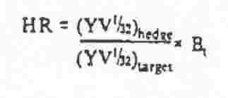

Using Duration in Volatility Weighting
As mentioned earlier, duration can be used to determine hedge ratios, but the procedure is somewhat more cumbersome than using PVBP or YV 1/32. Several aspects of duration must be considered when using duration to determine a hedge ratio:

(1) Neither Macaulay duration nor modified duration are measures of absolute price volatility. However, modified duration is a measure of percentage price volatility.

(2) Modified duration is a measure of the percentage price volatility of the full price (including accrued interest).

Because the goal of a hedge ratio is to equate the dollar price changes in two positions, several steps must be taken to determine the hedge ratio with duration. First, the modified duration must be determined. Second, the full price of the bond must be determined. Third, the percentage price volatility must be turned into a dollar price volatility. As an example, consider a bond trading at par, with three points of accrued interest, which has a Macaulay duration of 8.23 years and a yield of 12%. In order to determine the dollar price volatility for one basis point, we will use Equation 6. (Because we are concerned only with the magnitude of the price change, and not the sign, we have dropped the minus sign shown in Equation 6.)

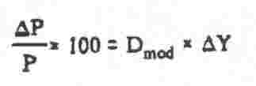
Remember that ΔY is expressed in absolute percentage points and that P represents the full price.

Rearranging, we obtain:

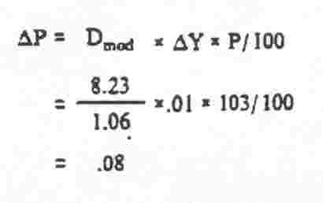
Note that this could be the same bond as was used earlier, which had a PVBP of 0.08. Since most investors use computer software to determine the duration, it would be far simpler to have the software provide the PVBP, which can be used directly in a hedge ratio calculation.

The same process is required to determine the price volatility of the hedge vehicle. The ratio of the two values (see Equation 9) is the hedge ratio. The process takes several extra steps to determine the same ratio given directly by use of PVBP.

We can modify the hedge ratio equation on the bottom of page 12 by substituting equation 11 for each ΔP:
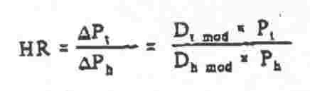

Duration Can Mislead - A Treasury Bond Example

In this section, hedge ratios for several different pairings of Treasury bonds are calculated. In most hedging or arbitrage examples, at least one of the bonds used is an "on the run" issue - a recently issued, current-coupon bond. The examples that are presented below were not selected to be realistic; rather, they make a point about duration. The four Treasury bonds are shown in Figure 14.

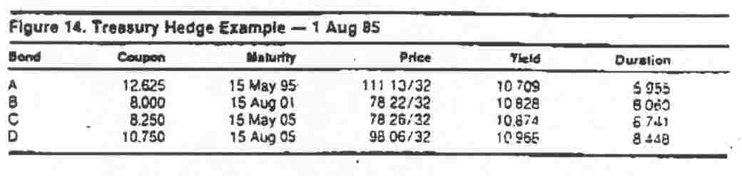
Assume that an investor holding Bond B wishes to hedge it by shorting Bond D. Of the securities shown, this does not appear to be a bad choice because the two bonds have similar maturities (and, therefore, low yield curve reshaping risk) and similar durations. The closeness of their durations might lead the investor to believe that the bonds have similar price volatility and that a hedge ratio near 1.0 (that is, 1.0:1) would be appropriate. However, use of the methods discussed in the previous sections results in a hedge ratio of 0.79, rather than 1.0.

Suppose that the investor wanted to hedge bond B with bond A, a bond having a duration two years shorter. Must he use a hedge ratio greater than 1.0 to counter the "low volatility" of bond A as indicated by its duration? The answer is no, because the hedger is interested in dollar volatility, not percentage volatility. The hedge ratio is 0.977 (see Figure 16).

Figure 15 repeats Figure 14 but adds some important information for hedging. The PVBP column provides a direct indication of the dollar volatility of each bond, which is exactly the figure that the hedger needs. As shown earlier, the same figure can be obtained in several steps by using duration. As long as duration is used correctly, the results will be the same (Because duration is often available to only two decimal places, there may be some rounding error.)

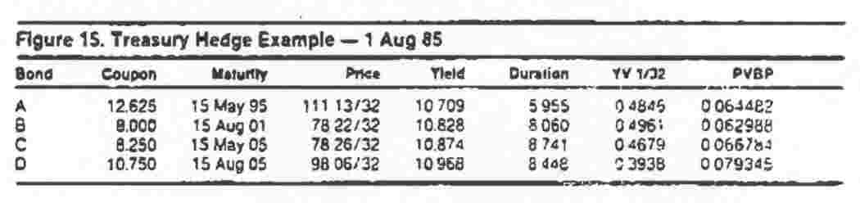
Using the information in the PVBP column, we can verify that the hedge ratio for hedging B with D is 0.79 (0.062988/0.079345). Similarly, the ratio for hedging B with A is 0.977 (0.062998/0.064482).

A matrix of hedge ratios is shown in Figure 16. The target securities are shown across the top, and the hedge vehicles are down the side. The hedge ratio for hedging bond D with bond A is the top right value, or 1.23. Note that all of the values on the diagonal (top left to bottom right) are 1.0, indicating simply that to hedge a bond with a short position in the same bond, the long and short positions would be the same size.

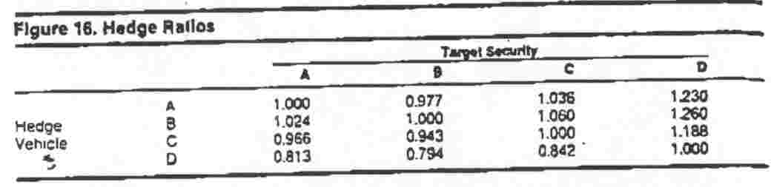

A helpful check for hedge-ratio calculations is to determine which bond has more absolute price volatility (higher PVBP, not necessarily duration). If it is the target security, then the hedge ratio should be greater than one, and if it is the hedge security, it should be less than one.

More on the Price Value of a Basis Point

As shown in Section II, Macaulay duration (and thus modified duration) declines linearly through time until a cash flow, if yield is held constant. On cash flow dates, the duration jumps up to a higher value. The question is, if duration and modified duration are measures of risk and volatility does volatility decline through time and then increase on the cash flow dates?

As time passes and duration decreases, at constant yield, the bond is accruing interest and possibly changing in price (for example, accreting toward par) to reflect the passage of time. The full price (including accrued) is following a pattern opposite that of duration, because it increases through time and then declines on the cash flow date when the accrued drops to zero. Equation 11 shows that the major determinant of the PVBP is the product of the duration and the full price. The PVBP is actually a smooth curve through time, reflecting the decrease in duration coupled with the increase in full price. This is shown in Figure 17 for a premium bond.

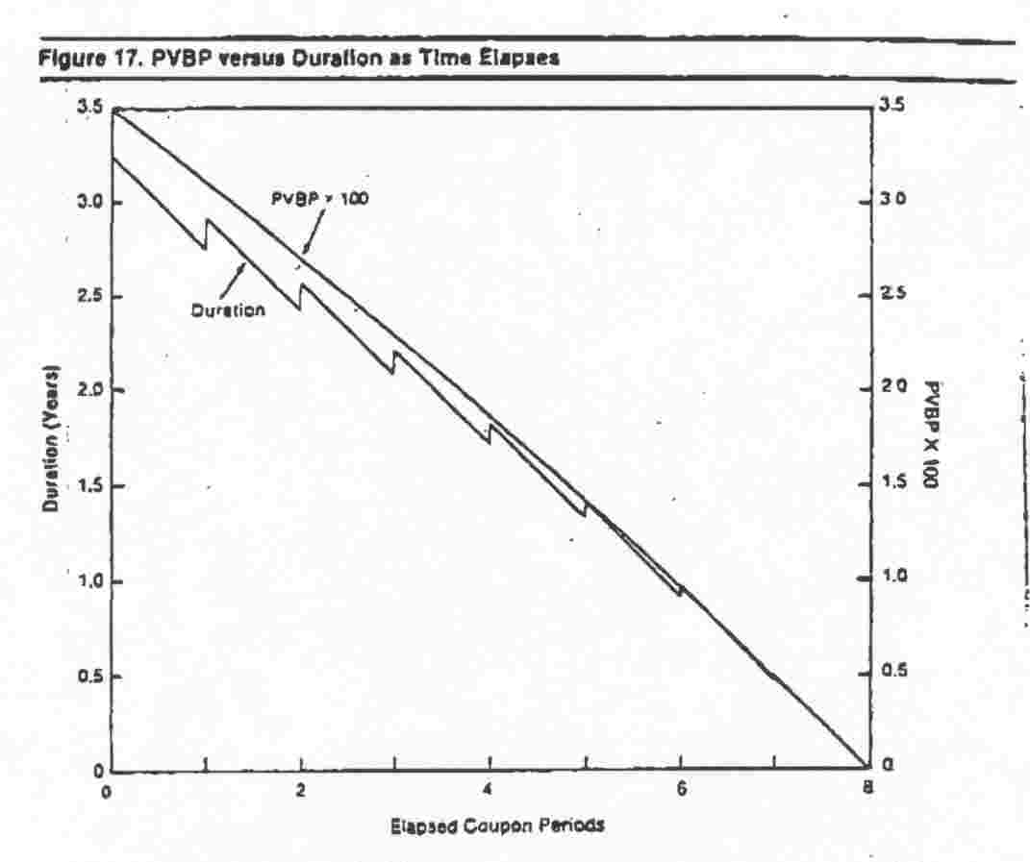

Another aspect of PVBP that should be mentioned is its relation to coupon level. A higher coupon results in a lower duration - all other factors held constant - but also in a higher price. The higher price is the overpowering factor here, and the volatility, as measured by PVBP, is higher for higher-coupon bonds. Figure 18 shows the PVBPs of 20-year bonds with different coupon rates across a variety of yield levels.

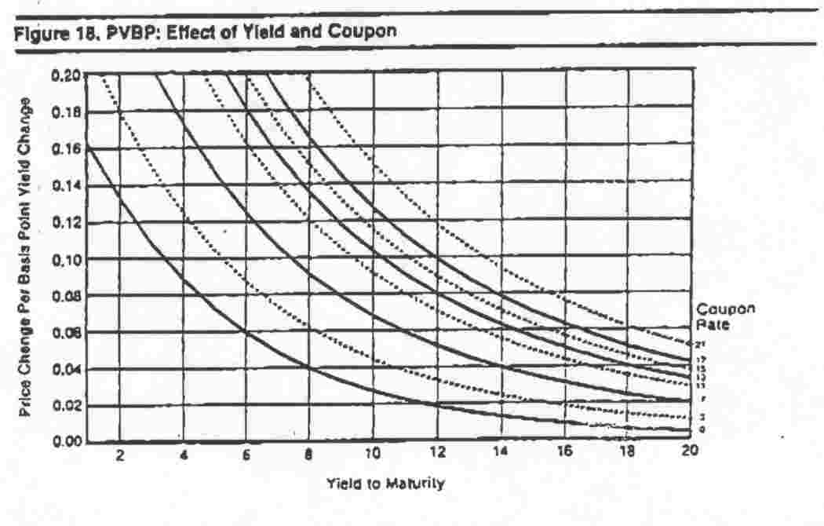

V. Convexity

The basic price-yield pattern of a straight bond (for example, no options, noncallable, no sinking fund) is shown in Figure 13. Because of its shape, it is referred to as convex: The degree of curvature is loosely referred to as the convexity. Convexity is the reason that estimates of price changes using duration or price value of a basis point increase in error as the yield change increases. We will describe a number of aspects of convexity – magnitude, cost, impact on hedging and arbitrage, etc - in a forthcoming paper.¹³ This section explains why convexity exists.

Let us compare the price (and duration) changes that occur to three different investments for equal yield moves. The three securities are structured as follows: The first pays a single payment of 162.89 in five years, the second pays 67.00 in three years and 98.99 in seven years, and the third pays 55.13 in one year and 120.33 in nine years. While these securities seem to be quite different, they have at least two characteristics in common - a present value at 10% (discounted semiannually) of 100 and a Macaulay duration of 5.0. The cash flows of the securities, along with the duration fulcrums, are shown in Figure 19.

¹³Convexity of Fixed-Income Securities, Richard Klotz, Salomon Brothers Inc, forthcoming.
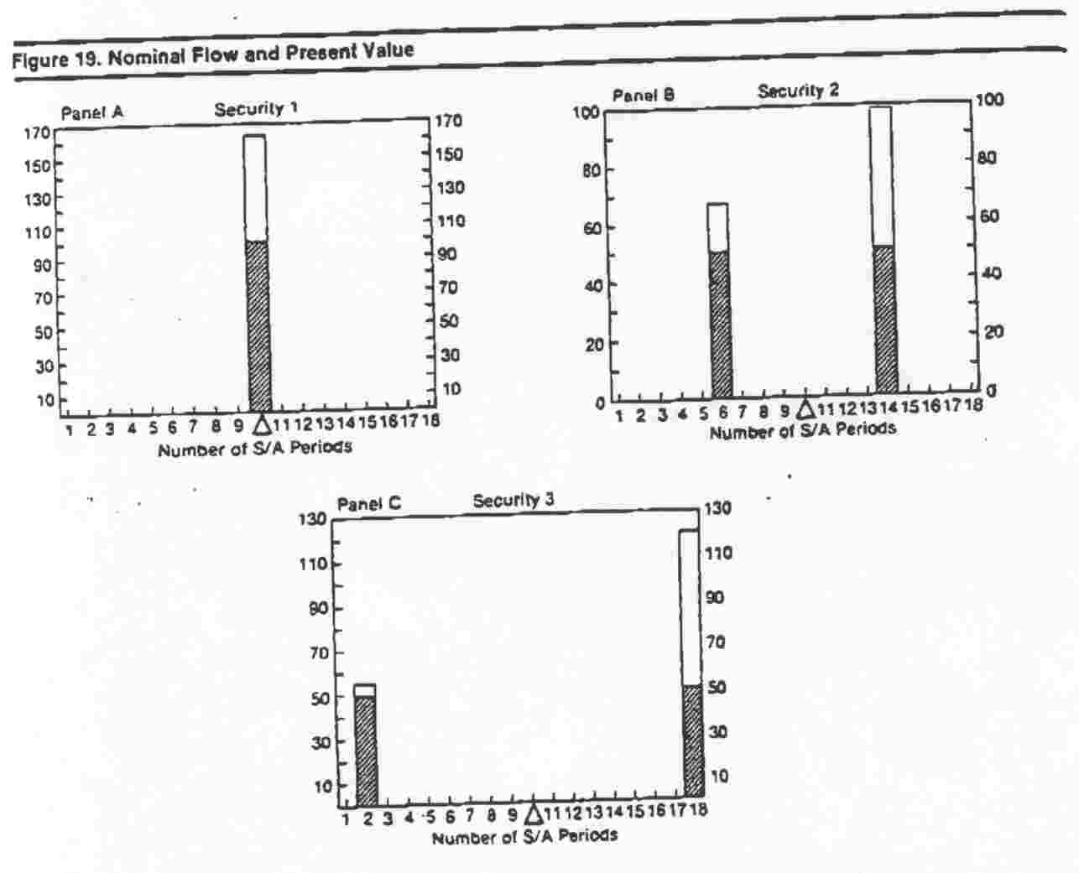

The duration of Security 1 is obviously five years, because it is a zero-coupon bond with a maturity of five years. The duration of Security 2 is also five years, because the present values of each cash flow are the same (50) and are equal distances from the five-year point, so the balance point is five years. A similar argument shows that the duration of Security 3 is also five years.

For small changes in yield, the prices of the three securities change almost identically. For example, if the yield (discount rate) changes to 11%, the prices of securities 1, 2 and 3 become 95.36. 95.38 and 95.43, respectively. If the rate drops to 9%, the prices become 104.89, 104.91 and 104.97, respectively. Note that security 3 shows the smallest price decline (4.57) and the largest price increase (4.97). When viewed over a greater range of yield levels, as shown in Figure 20, security 3 shows that its superiority over the other two securities is not a “local” phenomenon, but is actually more pronounced for greater yield moves. A summary of values for different yields is shown in Figure 21.

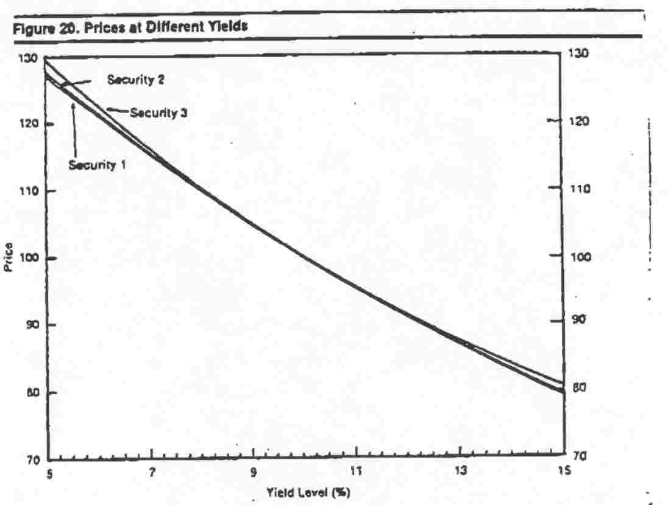

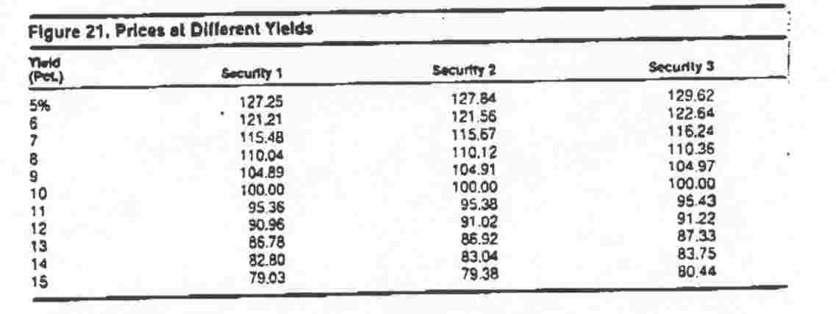

Figures 20 and 21 demonstrate the convexity patterns of the three securities, but they do not explain why convexity occurs. For this, we will return to the seesaw diagrams. We begin by examining what happens to security I (the least convex), compared with security 3 (the most convex).

As soon as the discount rate changes from 10%, both securities start to change in value. For security 1, with all of the cash flow at only one point, the duration (Macaulay) does not change and remains at 5.0 years. Security 3, with two cash flows, reacts somewhat differently. As the rate changes, the two cash flows change in present value, but the longer flow changes by a greater amount. (Security 3 can be thought of as a portfolio of two zero-coupon bonds. When rates change, the longer zero-coupon bond has a greater proportional price change).

When rates decline, the longer cash flow of security 3 increases in value more than the shorter one, causing the duration fulcrum to move further to the right to keep the system in balance. As a result, each downward notch in rates has two effects: The price moves more than a comparable (same duration, same present value) zero-coupon bond, and the duration gets longer. This causes the next downward change in rates to have an even greater effect, due to the slightly longer duration and the slightly higher starting price. ¹⁴ For example, at 9%, the duration of security 3 is 5.12, versus 5.0 for security 1. The higher duration results in a greater percentage price move and, because the starting price is now higher, a greater dollar price move. The opposite occurs when rates rise. The longer cash flow declines by more than the shorter one, causing the duration fulcrum to move to the left (shorter). This shorter duration dampens the effect of the next slight upward move in rates. The changes in duration of security 3 are represented in Figure 22, which is exaggerated for illustration purposes.

¹⁴ The durations from the seesaw diagrams are Macaulay durations, not modified durations, so they do not give a direct measure of percentage volatility. However, all of the securities in this example have identical yields: thus, the security with the higher Macaulay duration will also have a higher modified duration.

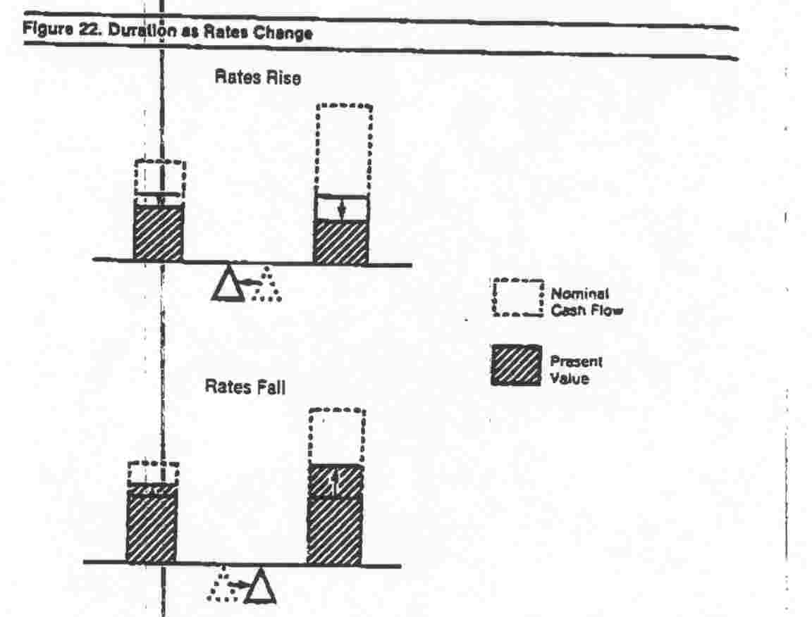

The duration values for different yield levels are shown in Figure 23. Security 3 has the highest duration if rates decline and the lowest if rates rise, giving it the best performance in either market.

The prices of security 4 for a variety of yield levels are shown in Figure 25, along with the values for securities 1, 2 and 3. Security 4 is shown to be much more convex than the other securities. The reason is that the two cash flows are spread out much further from the duration point and have (relative to each other) very different reactions to changes in yield level. The result of this dispersion of the present values about the duration point is greater convexity, which is caused by a more rapid change in the duration for a change in yield. The duration of security 4 for different yield levels is shown versus the other securities in Figures 26 and 27. Figure 27 is shown with the same scale as Figure 23 for comparison.

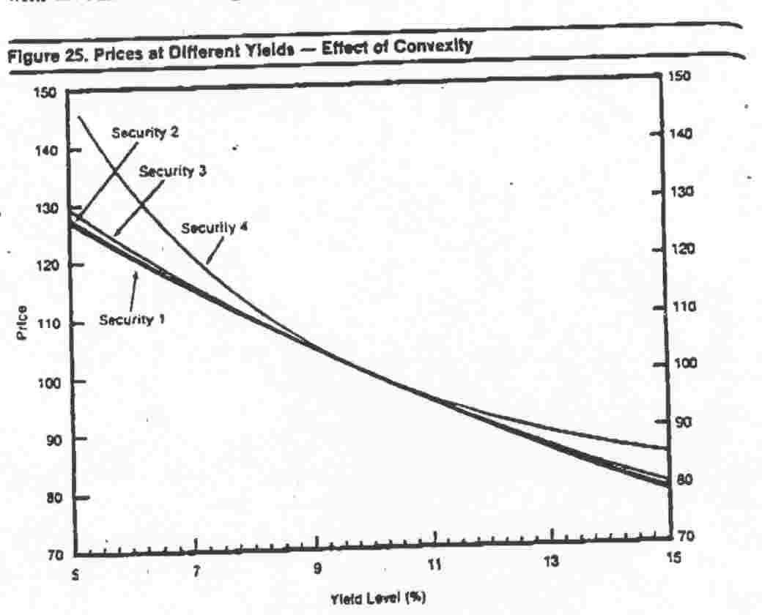

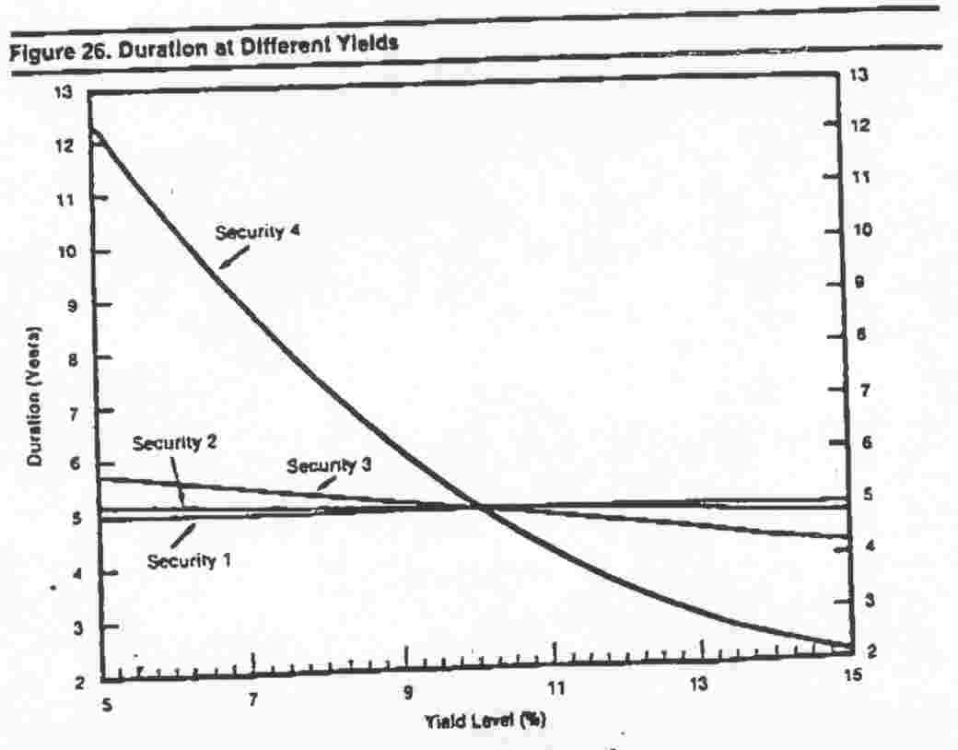

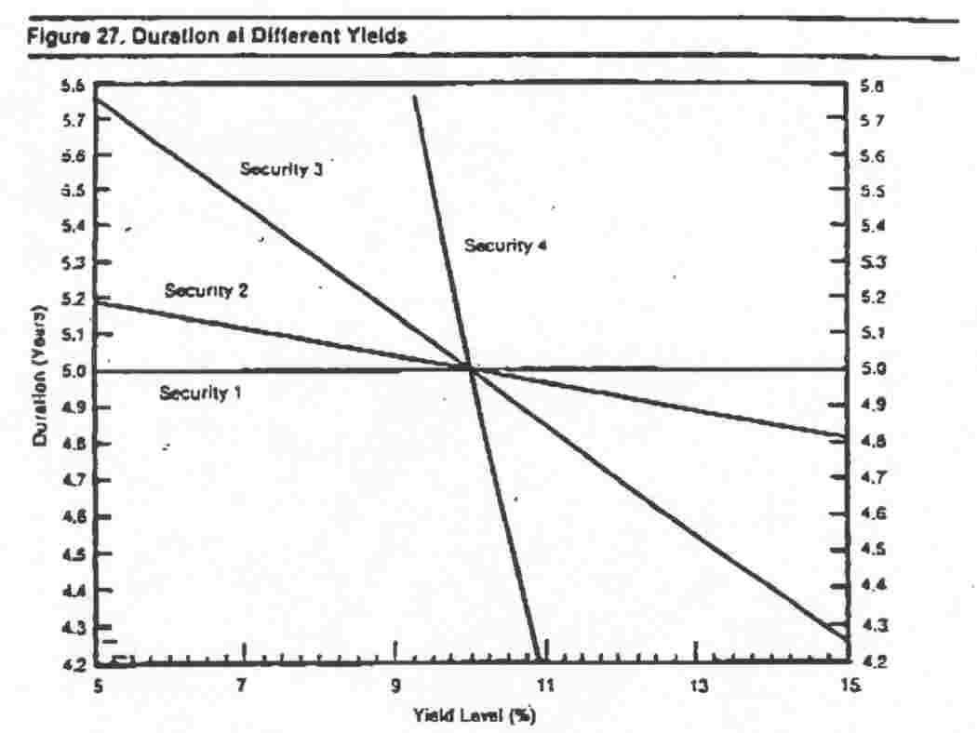

Convexity, Real Securities and the Market

Security 4 demonstrates the extreme of convexity: It is an extreme type of security. It is an exaggerated "barbell," with the cash flows at the limits of the maturity spectrum for most securities. While it is possible to create such a portfolio, several other factors become involved. The yields of 30-year zero-coupon bonds and one-year zero-coupon bonds are often not the same, and the yield on that portfolio may be lower than the yield on a five-year zero-coupon bond, so the extra convexity over a single five-year zero-coupon bond may not be without "cost." It is also difficult to find securities with as much convexity as security 4. Normal bonds have cash flows that are spread out but not nearly to the extent of security 4, so they do not exhibit as much convexity. Finally, in all of the examples in this section, the yield on all maturities moved by the same amount. While parallel shifts in the curve occur often enough, they cannot be counted on to deliver the apparent convexity. These and other issues will be explained in greater detail in the previously mentioned paper on convexity to be published soon.

V1. Duration for Other Securities

Except for the convexity section, the securities that have been discussed have been straight bonds, with regular, known coupon payments, without call or put provisions, without sinking funds, etc. Duration can be determined for other securities - easily for some and with more difficulty for others.

Money Market Instruments: Most money market securities, like commercial paper, bankers’ acceptances and Treasury bills can be treated as short-term, zero-coupon bonds. As such, their durations are equal to their maturities.

Securities with Embedded Options: Many securities contain various types of options that affect their price behavior. Callable bond prices tend to cap out by as they go much above par, particularly if the call date is near. Putable bonds tend to trade near par (or above) as put dates approach, because the bonds are redeemable. Duration calculations are made difficult by the uncertainty of the cash flows associated with the bonds, in addition to the problem of determining the appropriate yield (to call, maturity or first put date) to use.

Securities with embedded options must be analyzed with a model of price behavior to properly determine duration. For putable and callable bonds, the model may simply combine the value of the underlying bond with the positive (put) or negative (call) value of the option position. The duration of the combined security is usually determined implicitly by estimating its price response to a change in yield level and then determining the duration that would lead to the same price change. The appropriate yield may still be difficult to determine, however. One suggestion for dealing with problem is mentioned below.

Mortgages: The duration of mortgage securities is even more difficult to determine than that of callable bonds. While mortgages could be treated like callable bonds,¹⁵ several complicating factors affect the valuation of the call. First, the cash flows of the mortgage are even more uncertain than those of a callable bond, reflecting the unknown pattern of prepayments that may prevail. Second, the call feature of mortgages is not as totally yield driven as it is for callable bonds, and many prepayments occur even when the option is out of the money.

Because of the difficulties in determining the cash flows, it is difficult to calculate the duration in the traditional sense - the "present-value-weighted time to receipt of cash flow."¹⁶ However, it is more likely that the search for duration is driven by the need to estimate the sensitivity of the mortgage to changes in the market level of rates. One method is to attempt to model the price or yield behavior of the mortgage versus a benchmark for the market, for example, ten-year Treasury notes. This relationship would allow the investor to predict price movements of the mortgage for changes in the market. This type of approach provides a volatility measure that can be substantially lower than the result of the standard calculation for current- and high-coupon mortgages.

Futures Contracts: The duration of a futures contract cannot be determined using the standard calculation. There are no definable cash flows associated with a futures contract. We can view a contract as pure volatility, and because there is no cash outflow (price) paid to enter the contract, its percentage volatility (and, thus, its modified duration) is infinite. A long position adds volatility, and a short position reduces volatility in a portfolio.¹⁷ Using the market-weighted approach to duration of a portfolio containing futures, the required calculation would attempt to incorporate a security with an infinite duration and a zero market weight.

A more useful approach is to determine the dollar volatility of the futures contract relative to yield changes in the underlying security or portfolio. This volatility can be added to portfolio volatility for a long position or subtracted for a short position, and the result will be net portfolio volatility. From this value, an implied duration may be computed. Thus, it is not necessary to have an actual duration value of the futures contract, yet the effect on portfolio duration can be determined.

15 The prepayment option held by the homeowner –borrower is nothing more than an option to call any portion of the outstanding debt at par.
16 This definition is merely an interpretation of the formula. Another “definition” often heard is that duration is “The time it takes to receive one half of the present value”. This is simply incorrect – and can
be shown to be incorrect by references to Security 4, shown in Figure 24.
17 This is true if the portfolio has “long” price sensitivity. Naturally, if the portfolio is net short, a long position in futures will reduce volatility.

Floaters: Floating-rate securities defy attempts at the standard duration calculation because of the unknown level of the future cash flows. If a sensitivity to rate changes is the objective, however, then a duration can be inferred. If a particular floater is reset every quarter to the then-prevailing three-month rate based on some index, the primary volatility of the floater will be the same as that of a three-month instrument. As time elapses and the coupon payment approaches, the implied primary duration will approach zero and will reset to three months on the coupon date. This measure is independent of the maturity of the floater.

Another aspect of the price sensitivity of a floater is a function of the maturity. If market spreads change for floaters, then the price change will vary according to the maturity. For example, consider a floater resetting at LIBOR flat, and assume that the market for new floaters from issuers of similar quality is also LIBOR flat. The floater would be priced near par. If the market began demanding new issues (and repriced old ones) at LIBOR + 20 basis points, then the price of this old floater would reflect the number of remaining quarters in which the investor would receive the lower "historic" rate rather than the new rate of LIBOR + 20. In essence, the investor gives up an annuity of 20 basis points, and the price should decline by the present value of this annuity.

In a sense, two volatility measures are needed for floaters: The simple duration, which is the time until next coupon payment and reset, and a "spread duration," which is a function of the maturity and, the starting yield level.

Interest Rate Swaps: An interest rate swap can be analyzed as essentially an exchange of two securities, usually involving a fixed-rate and a floating-rate component. In a manner similar to futures contracts, an interest rate swap contract adds (or subtracts) volatility without involving a purchase "price." As a result, it is impossible to determine duration as a percentage volatility measure, but it is possible to estimate the volatility characteristics of the swap and how entering into the swap affects the duration of an existing portfolio. As a combination of long and short positions in a fixed-rate instrument and a floater, the volatility of the interest rate swap can be determined by netting the volatilities of each component. This volatility can then be aggregated with the volatility of the portfolio to back into the duration of the portfolio including the swap.

In practice, many "risk-controlled" arbitrages¹⁸ involving swaps are "duration weighted", using only the fixed-payment side of the swap. This is because the floating side is already offset by floating-rate liabilities in the arbitrage portfolio. Thus, the primary volatility at issue is the value of the fixed-rate side of the swap versus the value fixed-rate mortgages, for instance. If the market values of these components are equal and have the same duration, then the position is considered to be properly weighted.

Summary

We had several objectives in writing this report. The first was to explain duration and convexity in a nonmathematical, almost intuitive, framework. The second was to illustrate the correct use of duration for hedging, swapping and arbitrage, and to demonstrate alternative, more convenient, weighting tools (price value of a basis point and yield value of 1/32).

We did not attempt to discuss the nuances of hedging, swapping or arbitrage ¹⁹ - or the effect of taxes. ²⁰ We did not discuss the statistical procedures for estimating a “yield beta.” Improper estimation can cause significant profit or loss variation. Indeed, so can bad luck - the estimate based on past history can be statistically correct, but market action may not continue to exhibit the relationship. As a result, a judgment factor can be more important than statistics. Despite these potential problems, the various volatility measures are important tools for all fixed-income managers. Correctly used, they can minimize the risk in achieving specific return objectives.

- See Risk-Controlled Arbitrage for Thrift Institutions. Michael Waldman and Thomas B. Lupo. Salomon Brothers, October 1983.
- See Strategies for The Asset Manager, Solomon Brothers Inc, forthcoming.
- The After Tax Duration of Original Issue Discount Bonds, Andrew J. Kalolay, Salomon Brothers Inc, August 8, 1983.
Appendix A

The formula (1) given in the text for duration can be used only for evaluation on a coupon date. A more general form that works for any date is:

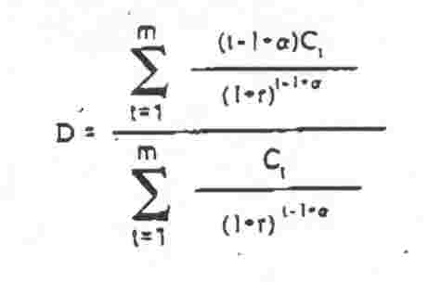

where C₁ = the t^{th} cash flow
r = periodic discount rate (in decimal form)
a = fraction of a period remaining until the next cash flow anniversary date (a = 1 on a cash flow anniversary date)
m = number of cash flow anniversary dates

The formula above gives duration in periods, not years. To convert to years, multiply the duration by 1/f, where f = frequency of coupon payment.

Appendix B

A closed form solution for duration, which can be used for any date, is given by: ²¹

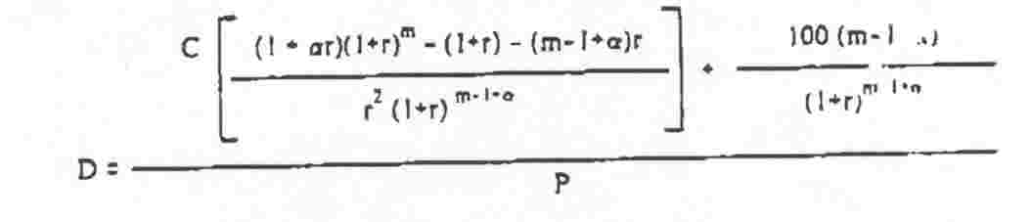
21 The author would like to thank Richard Klotz for providing this solution.

