VOLUME 1: SUMMARY

ASSESSING.
EMERGING MARKET
CURRENCY RISK



Fundamentals
Financial Factors
Global Environment
Contagion Effects
Econometric Models of Crises
Emerging Markets Risk Indicator
Risk assessment
Trading Strategies

APRIL 1998

EMERGING MARKETS GROUP

Table of Contents

Page

I Summary of Methodology 2

II Dimensions of Currency Risk 3

III Explanatory Variables 4

IV Estimation Methodology 5

V Sample and Data 6

VI Contagion Effects 7

VII Empirical Results 8

VIII Forecasting Accuracy 10

IX Application of Results 11

X Changes in Crisis Probabilities 12

XI country Rankings 13

XII Contribution of Factors 14

XIII Confidence Intervals and Relative Risk Zones 16

XIV Assessment of Risk-Return Trade off 17

XV Brady Spreads and Risk Probabilities 17

XVI Trading Strategies 18

Index of Charts

Page

Chart 1 Number of crises (total number of crises= 186) 3
Chart 2 Crisis Probabilities (crisis definition based on unanticipated depreciation) 11
Chart 3 Change in Crisis Probabilities: "Unanticipated Depreciation" (Feb 98 to Mar 98) 12
Chart 4 Change in Crisis Probabilities: "Unanticipated Depreciation" (Sept 97 to Mar 98) 12
Chart 5 Risk and Returns 17
Chart 6 Brady Spreads and Crisis Probabilities 17
Chart 7 Excess return from long strategy 18
Chart 8 Profits per transaction from long strategy 18

Index of Figures

Figure 1 Steps in Methodology 2
Figure 2 Explanatory variables for currency crisis models 4
Figure 3 Sample of Countries 6
Figure 4 Probability Cut Off -2 % monthly (Model 1; depreciation cut-off 101%) 10

Index of Tables

Table 1 Import Growth 7
Table 2 Estimates of "Overa/1"and "Unanticipated" Depreciation Models 9
Table 3 Country rankings: Model of "Unanticipated" Depreciation 13
Table 4 Relative Contribution of Variables ("Unanticipated" Depreciation Model) 15
Table 5 Confidence Intervals and relative Risk Zones 16

Emerging Market Currency Risk

This volume summarises a framework which has been developed for assessing and quantifying currency risk in emerging markets. lt.also provides a sample of the main results obtained by applying this framework. The results can be of assistance as early warning indicators of currency risk, and may be used as inputs to trading and portfolio allocation decisions.

A detailed discussion of the framework, methodology, data and results is provided in the accompanying Volume 11.

The framework we have developed assesses currency risk by examining a range of emerging market specific economic and financial factors. These factors take into account real economy variables such as GDP growth and inflation, monetary and fiscal developments, financial market variables, and balance of payments factors. In addition, global factors such as commodity prices and international financial market environment are taken into account. In all over 30 variables are considered in the analysis.

The main output consists of the following:

  - An assessment of the evolution of key factors likely to have a bearing on currency vulnerability

  - Results of estimating a variety of econometric models which allow the simultaneous assessment of a large number of variables

  - Computation of probabilities of currency crisis for each of the emerging markets

  - Assessment of changes in currency vulnerability over time

  - Computation of confidence intervals for the probabilities

  - Construction of emerging markets risk indicator "EMRI", with countries delineated into three risk zones

  - Assessment of contribution of different factors to crisis probabilities

  - Comparison of country risk with rating agencies' assessment

  - Comparison of crisis probabilities with returns on local and foreign currency denominated debt

  - Assessment of trading strategies based on WRI

I Summary of Methodology

The main steps leading to the above analysis and output are illustrated in the following figure:

The first step entails the assessment of a variety of factors in determining the value of currencies. Based on this assessment we select a range of variables to include in our models to explain crises. Contagion or spill-over effects are also taken into account.

- We use monthly data, pooled across 32 emerging markets and over thirteen years.

- We use discrete choice dependent variable models which means that we focus on specific level of depreciation or "cut-off": for instance 5% or 10 % and so on. A wide variety of cut-offs can be incorporated.

- After the model estimates have been computed, their economic and statistical significance is examined and their prediction power is investigated.

- The estimated results are used to obtain future probabilities of devaluation for individual emerging markets; an index of country risk is developed and confidence intervals for probabilities are computed.

Figure 1 Steps in Methodology
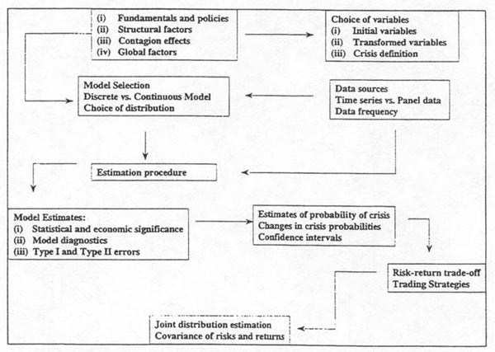

II Dimensions of Currency Risk

• The chart below shows the number of currency "crises” over the past thirteen years among a sample of 32 emerging markets. Crisis here is defined as a depreciation of dollar value of the exchange rate in any given month relative to the preceding month of 5 %, which was also more than twice the rate of depreciation over the preceding month.

• Over the period 1985 to 1988, there were 62 such episodes and over the following
tour years the number of crises increased to 72. From 1993 to March 1998, there
were 52 crises.

• In the empirical estimation below, a range of cut-off values (2.5, 5, 10 and 15%) are
utilised.

• Definition of crisis based on the extent to which interest rate differential between
domestic and foreign rates compensates for the likelihood of a fall in the value of
currency is also considered. This is termed “unanticipated" crisis.

• There were 180 unanticipated crises in emerging markets over the last thirteen years,
with a considerable overlap in the “overall” and “unanticipated” cases.

• Models are developed for both "overall" and "unanticipated" depreciation, and
probabilities based on the latter definition are reported in this volume.

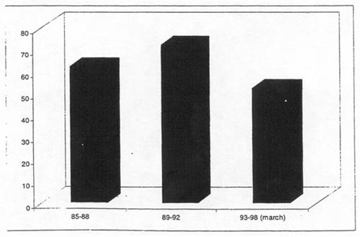

III Explanatory Variables

• Theoretical and empirical analysis reveals that there are a large number of factors which are likely to influence the probability of a sharp decline in the value of a currency. Several of these factors are often interrelated.

• We have put these factors into the following twelve categories and selected from them in the empirical estimation. In addition, we have taken into account contagion or spill-over effects whereby crisis in one economy can increase the vulnerability of another country’s currency.

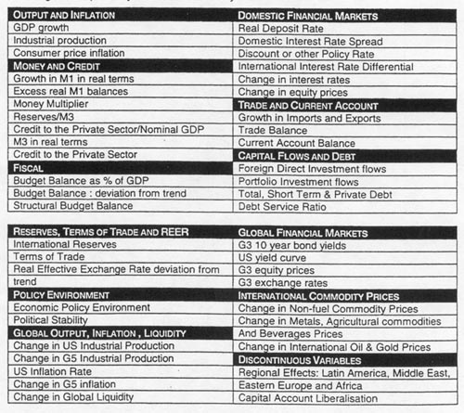

IV Estimation Methodology

  - The key step in the methodology is to construct models which are. capable of explaining the likelihood that a country with given economic and financial characteristics, and operating in a particular global environment, will have a currency devaluation.

  - The framework for such a model is based on the fact that there are two economic states in any given period for any given country: either a country has a crisis. or it does not.

  - The definition of crisis can be completely flexible: we can designate a depreciation of 1 percent in a given month, and a doubling of the rate of depreciation, a crisis; or we can limit it only to a depreciation of 10 percent or higher, without considering changes in the rate of depreciation.

  - For any definition and at any given time, some countries would have a stable currency-denoted by crosses in the diagram below on the bottom horizontal axis, while others would have a crisis-denoted by small triangles on the top horizontal axis.

  - The Logit model (given by the equation below the diagram) allows us to estimate a functional relationship between the underlying characteristics and these two sets of countries.

  - Analysis using a number of other functional forms yields similar results and is reported in Volume 11

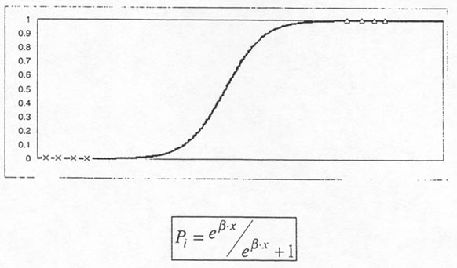

V Sample and Data

  - The empirical analysis below has focused on the largest and medium sized 32 countries noted below.

  - The sample was selected to provide a fair representation of countries in terms of level of economic development, economic structure and size of financial market in each of the five regions noted below.

  - The estimated models can be applied to obtain crisis probabilities for other emerging markets.

Figure 3 Sample of Countries
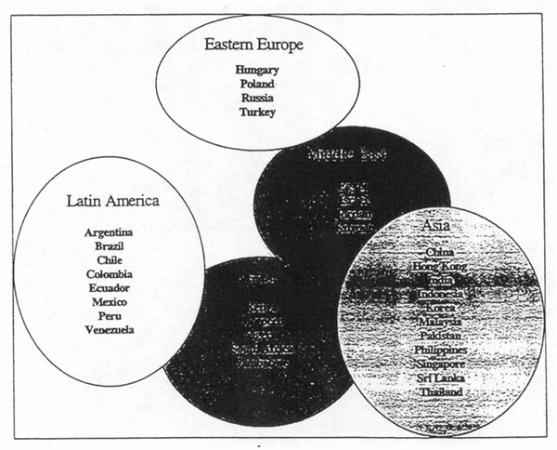

Data

The models are estimated using pooled cross-section time-series data for 32 markets using monthly observations from January 1985 to November 1997. This provides over 150 observations for each country, and around 4000 observations overall, which helps in modelling the underlying structure and processes determining crises.

The bulk of the data are obtained from readily available sources, including national sources, IMF and World Bank.

VI Contagion Effects

• There are a number of different aspects of contagion effects which are taken into account in assessing the vulnerabilities of a currency. The contagion effect implies spill-overs of pressures from one currency to another and as seen in Asia over the past year, the magnitude of the contagion effects can be quite significant. We separate four channels for the spill-over effects in the models below:

• The first channel is via the competitiveness effect; when one currency is devalued, the trading partners, position deteriorates vis a vis that economy. This is taken into account by the real effective exchange rate variable which would appreciate for the trading partners.

• A second channel for contagion effects is through similarity in underlying factors which can have a bearing on the currency vulnerability. The chart below shows correlations for import growth-similar analysis was undertaken for a wide range of variables and the magnitude of the correlations was considered in assessing the impact through this second channel (Granger causality tests were also undertaken to supplement this analysis).

• The third and fourth channels respectively consist of perceived similarity in underlying weaknesses and pure sentiment driven flows. The former is implicitly captured by the conditioning variables, while the latter was proxied by variables relating to similarities in regional location.

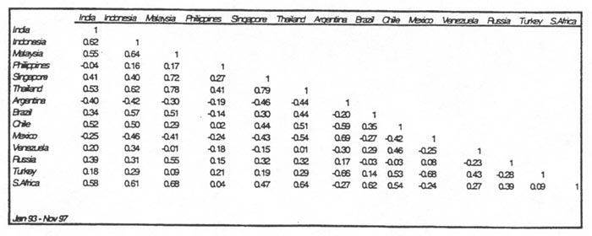

VII Empirical Results

The framework outlined above is flexible and allows the estimation of a variety of econometric models to assess currency risk.

The choice of variables provides one of the most important elements of flexibility. From the twelve sets of factors discussed earlier, a wide range of models can be estimated depending on the traders' or investors' preferences and risk appetites.

- A second type of flexibility is provided in the cut-offs for the crisis definition itself: we have utilised four cut-offs: 2.5%, 5%, 10% and 15%.

- A third aspect is the length of lags involved in estimation giving flexibility in the forecast horizons.

- We can also estimate models for specific regions or for specific categories of countries. The models can also be estimated over different time periods depending on traders' priors.

- In Table 2 we present results for a "parsimonious" model based on "overall" depreciation (columns 1 and 2) as well as "unanticipated" depreciation (columns 3 and 4) for the 5 and 10% crisis "cut-offs". For each of the variables, the results show the value of the estimated parameter, with the "t-statistic" shown in italics underneath (t-values of 1.28 and 0.84 are significant at the 10 and 20% level for a one-tailed test).

- These results suggest that real GDP below trend in general increases the likelihood of crisis (parameter estimate of -0.22 for the "overall" 5% cut-off). Similarly, a decline in exports, foreign direct investment, portfolio investment and reserves increases the crisis likelihood. (Detailed discussion and interpretation of the results is provided in Volume 11).

- The results also suggest that the higher the budget surplus (or lower the deficit), the lower is likely to be vulnerability to crisis. The reserves to import ratio played a role only in the overall depreciation model, but was significant with the expected sign (higher the import cover, lower the crisis probability) for the 10% cut-off.

- The international variables indicated that the higher the global liquidity the lower the likelihood of crisis across all emerging markets. Higher non-fuel commodity prices also tended to have a beneficial impact, and may be acting as a proxy for global activity.

- Contagion or "spill-over" variables based on underlying variables such as import growth or current account imbalance appeared to have a significant effect. Contagion variables based on region were also significant, so that even when the key fundamental variables are taken into account, crisis in a particular region appears to exercise a significant effect on vulnerability of other currencies in that region.

- Results using alternative distributions (in particular, those based on "Poisson" distribution) are discussed in Volume 11. They suggest that many of the above variables continue to exercise a robust influence on crisis probabilities even when some of the basic elements of the estimation procedure are changed.

- The "Poisson" estimation also takes into account the contagion effects and finds them to be statistically significant.

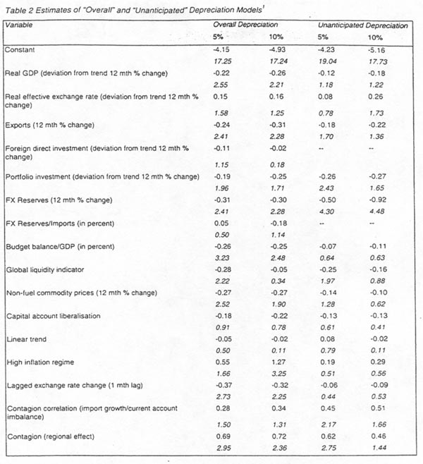

VIll Forecasting Accuracy

  - An evaluation of the statistical properties and accuracy of the various models is, of course, important in assessing their usefulness.

  - There are a number of criteria which can be used to assess their validity.

  - The t- statistics noted above suggest that the underlying variables in general have a good explanatory power.

  - Another test relates to how well the models perform with regard to actual predictions. Here there are two types of hypotheses to consider the first one is that if there is a crisis, the model predicts it accurately. The second hypothesis is that it there is no crisis, the model predicts that there would not be a crisis.

  - Clearly to assess the accuracy of the model, both these hypotheses need to be tested. One can always obtain perfect accuracy according to the first hypothesis, but at the expense of the second.

  - The results suggest that under both hypotheses the model performs quite well: according to the first (Type I error), depending on the cut-off values the model predicted between 70 to 75 percent of the crises -a statistically significant result. Under the second hypothesis (Type 11 error), the model predicted 60 to 80 percent of the non-crises. Given that there were around 3600 "non-crisis" periods, this result is also highly significant.

Figure 4 Probability Cut Off -2 % monthly (Model 1; depreciation cut-off 10%)

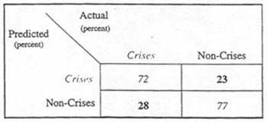

IX Application of Results

The charts below show the evolution of probabilities of crises for four countries, based on the unanticipated" depreciation model. Crisis probabilities based on the "overall" model are illustrated in Volume 11. The chart for Thailand shows how the probability of crisis began to increase significantly from the third quarter of 1996 onwards and just before the onset of the crisis in July 1997 had exceeded over 45 percent A similar pattern is found for Korea, with some easing of the currency's vulnerability in February and March. In the case of Mexico, the model shows a very marked increase in probabilities in the run-up to the crisis in December 1994. These probabilities continue to increase subsequently, highlighting the ensuing depreciations of the peso. These charts illustrate also the importance of changes in probabilities of crises as well as in the levels.

Chart 2 Ciisis Probabilities (crisis definition based on unanticipated depreciation)

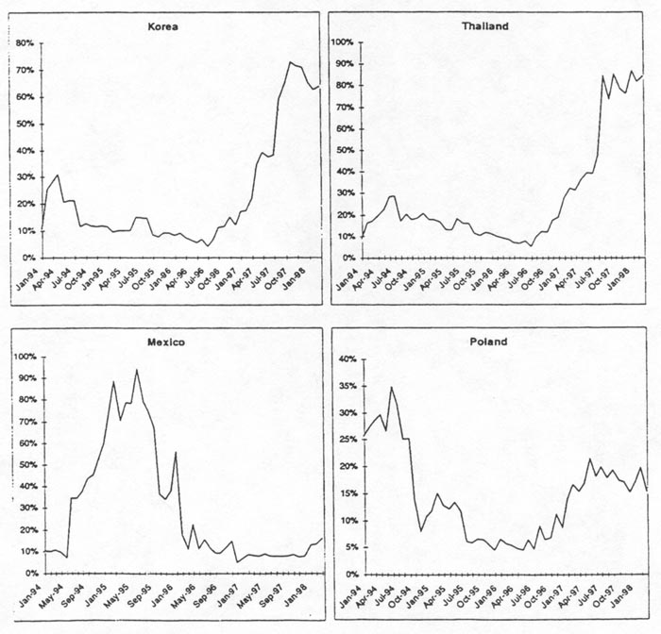

X Changes in Crisis Probabilities

The following charts show changes in crisis probabilities between February and March 1998, and between September 1997 and March 1998.

Chart 3 Change in Crisis Probabilities: "Unanticipated Depreciation" (Feb 98 to Mar 98)

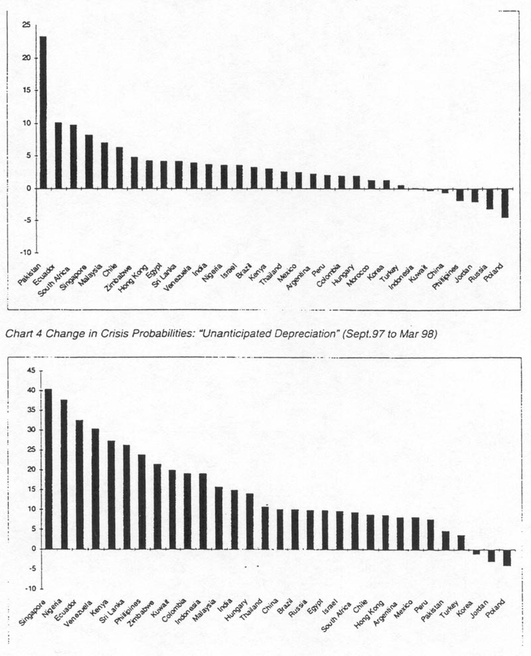

X1 Country Rankings

  - By considering the probabilities of crisis from any given model, one can obtain a relative assessment of the currency risk in countries.

  - This is presented in the Table below which shows the rankings based on Model 11 (estimated using data up to March 1998). Note that Malaysia and Zimbabwe appeared to have the highest risk while Mexico and Poland had the lowest.

  - Rankings based on alternative definition of crisis and alternative models are presented in Volume 11.

  - Based on confidence intervals for the probabilities, the countries can be delineated into a number of risk zones.

Table 3 Country rankings: Model of "Unanticipated Depreciation (5% cut-off)

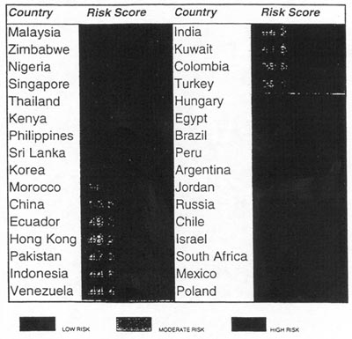

XII Contribution of Factors

- In order to obtain an indication of the relative importance of different factors, we can utilise a straightforward decomposition to compute the contribution of individual factors to the probability of crisis,

- The contributions shown in the following Table are based on the average values of the variables over the past twelve months, and thus should be regarded as explaining the average value of the probability over the twelve months.

- However, the methodology is perfectly general and can be used to assess the contribution over different time periods, as well as the change in the contribution of different factors to the change in probability.

- Table I notes the relative contribution of each of the continuous variables included in Model It for some of the main emerging markets. In the case of China, the positive value of 4.4 under the column headed GDP shows that the growth variable led to an increase in the probability of crisis. Note that the parameter estimate for growth was negative (see Table 2), showing that growth below trend increases the likelihood of crisis. Thus the positive sign for the contribution means that over the twelve months to March, this variable was negative; that is, growth was below trend, which increased the crisis probability.

- The real effective exchange rate has a value of -6.2: that is, this factor contributed to reducing the likelihood of crisis. Since the parameter estimate for this variable obtained earlier was positive, this means that the real effective rate for China was below trend over this period.

- The next two variables, exports and reserves, both have negative signs, indicating that they contributed to reducing the crisis probability. Again note that the parameter estimates for these variables had negative signs indicating that values of these variables above trend reduced the likelihood of crisis. Thus over this period, these variables were above trend. Conversely, portfolio investment was below trend and increased the crisis likelihood.

- Of course, in addition to indicating whether the variables contributed to increase or reduce the crisis probability, the values in the Table also allow an assessment of the relative influence of each factor. Thus in China's case, the effect of a slowdown in portfolio flows (relative contribution of 35.8%) was significantly greater than that of the slowdown in GDP growth (relative contribution of 4.4%).

- Similarly a cross-country comparison of the relative impact of different factors can be undertaken.

- It- is interesting to note that although the contribution of variables differs when alternative distributions are used (for instance the "Poisson" distribution), many of the above key factors continue to exercise a robust influence. (See Volume 11 --Section 8.4)

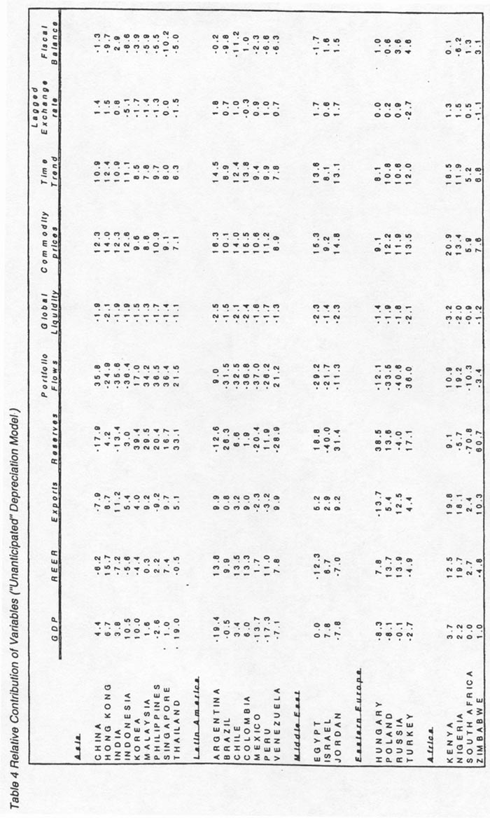

XIII Confidence Intervals and Relative Risk Zones

- The probabilities obtained above are point estimates and subject to sampling variation. In order to provide an indication of this variability we have computed confidence intervals for the probabilities. The Table below provides the upper and the lower bound confidence interval for probabilities obtained from the unanticipated model (Model 11) at the 80% level. Given that the confidence intervals are computed on the Logit scale and then translated back to the probability scale, the intervals will in general be non-symmetric.

- We can use the values of the non-overlapping confidence intervals to obtain relative risk zones. Since there can be a fairly high degree of certainty that the non-overlapping intervals differ significantly from each other, the procedure can be seen to include considerably more information than a pre-specified categorisation. Three zones, low, medium and high risk, based on this procedure, are identified in the table below.

Table 5 Confidence Intervals and relative Risk Zones

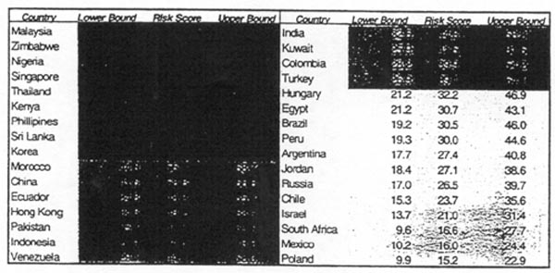

XIV Assessment of Risk-Return Trade off

The chart below provides an illustrative comparison of the spreads on local currency instruments (in US dollar terms) with the crisis probabilities (horizontal axis). Clearly it the spreads in any given market are higher than another for a given level of risk, risk-return nexus would favour that market. Off-diagonals, one needs to take into account the trade-off between higher risk and higher returns.

Chart 5 Risk and Returns

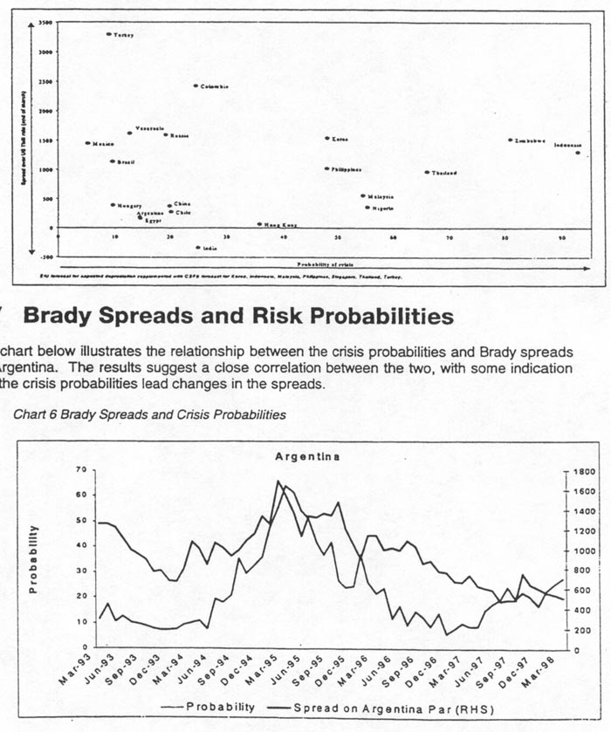

XVI Trading Strategies

- There are many different types of trading strategies which could be evaluated using the different models and different lag structures.

- The chart below illustrates the returns which could be obtained from following a simple trading strategy: that is, to go long it crisis probability is below a certain threshold. In computing the returns in US dollar terms, We take into account the associated cost

- Assuming a holding period of just one month, the results suggest that this trading strategy would have yielded significant returns over the period January 1994 to November 1997. These returns are cumulative, but not compounded. Of course, the number of transactions varies very significantly at different probability cut-offs. Chart 8 shows the excess returns per transaction. In reality, of course, traders would supplement the strategy suggested by the model with their own assessment of the market and with analysts' views.

Chart 7 Excess returns from “Iong” strategy

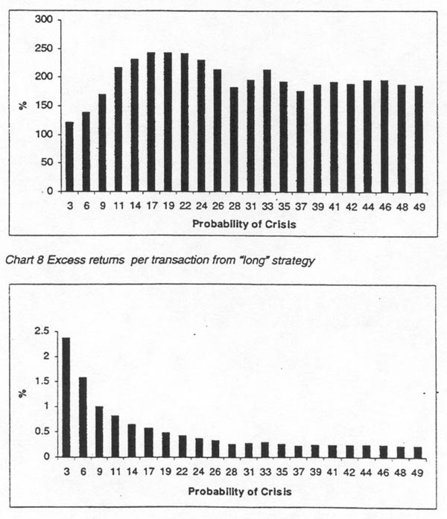

AUTHORS

London

Manmohan S. Kumar

William Perraudin*

Vincenzo Zinni

*Consultant. Uma Moorthy and Paul Northrop, also Consultants, provided significant assistance in econometric estimation and statistical analysis.

CONTACTS

London - Glen Mifsud

Japan - Shinji Yamada

Hong Kong - Anthony Lam

U.S. - Allan Nalder

Or please contact your local representative

ACKNOWLEDGEMENTS

Neil Rabinowitz, Amlan Roy, Andrew Hinchcliff and others in the portfolio and risk analysis group derived Poisson estimation results discussed in Sections 7.4 and 8.4 in Volume 11.

We would like to thank Andrew lpkendanz, Giles Keating, Ben Weston and Jonathan Wilmot for extensive advice and suggestions. Brian Nolan, Jean-Marc Bottazzi and Kasper Bartholdy also provided constructive suggestions. Helpful comments were received from Paul Buckley, Glen Mifsud, Joe Prendergast and Ilesh Kotecha. We are grateful to Lucia Lorenzoni, Bilal Khan and Daniel Stem for research and programming assistance, and to Gina Dunlop for editorial advice.

