INTRODUCTION TO MSCI

1A. HISTORY OF MORGAN STANLEY CAPITAL INTERNATIONAL

The history of the MSCI Indices goes back to 1969. Capital International S.A. (CISA), an international management company fully owned by The Capital Group Companies, Inc. of Los Angeles, had been managing international portfolios since 1955. The Capital Group recognized that investment opportunities outside the U.S. market would become increasingly important and that a better understanding of the world's individual markets would strengthen investment management capabilities. In 1969, they launched the Capital International World Indices (CIWI) and publications in order to provide a consolidated source of information about the investment universe in international equities, and to provide a benchmark for investing internationally At that time, there was no other single source of comparable data across countries, in either printed or electronic form. In 1985, CISA created a subsidiary, Capital International Perspective, S.A. (CIPSA), based in Geneva, Switzerland to manage the CIWI and publications business separately from the investment management business.

In 1986, Morgan Stanley & Co., an international investment banking and securities brokerage firm, acquired the rights to the CIWI Indices, including the underlying data, from CIPSA and the indices were renamed MSCI. 7his acquisition allied the international distribution, sales, and marketing expertise of Morgan Stanley with Capital International's proven success in gathering international data and constructing global equity indices. The full responsibility for the management and maintenance of the MSCI Indices, including index methodology, remains with CIPSA in Geneva, Switzerland. Morgan Stanley has no responsibility for, or influence over, decisions regarding inclusion or deletion of index constituents.

The MSCI World Index, the MSCI EAFE' (Europe, Australasia, Far East) Index, the MSCI EMF (Emerging Markets Free) Index, and the MSCI AC (All Country) World Index are now the premier benchmarks for investment managers to measure the performance of stock markets around the world. In addition the MSCI company database of valuation ratios and company-level fundamental data is a valuable analytical resource for the international investor. The goal of MSCI products has always been to provide the most valuable information for international investing—across both the developed and emerging markets—from one source.

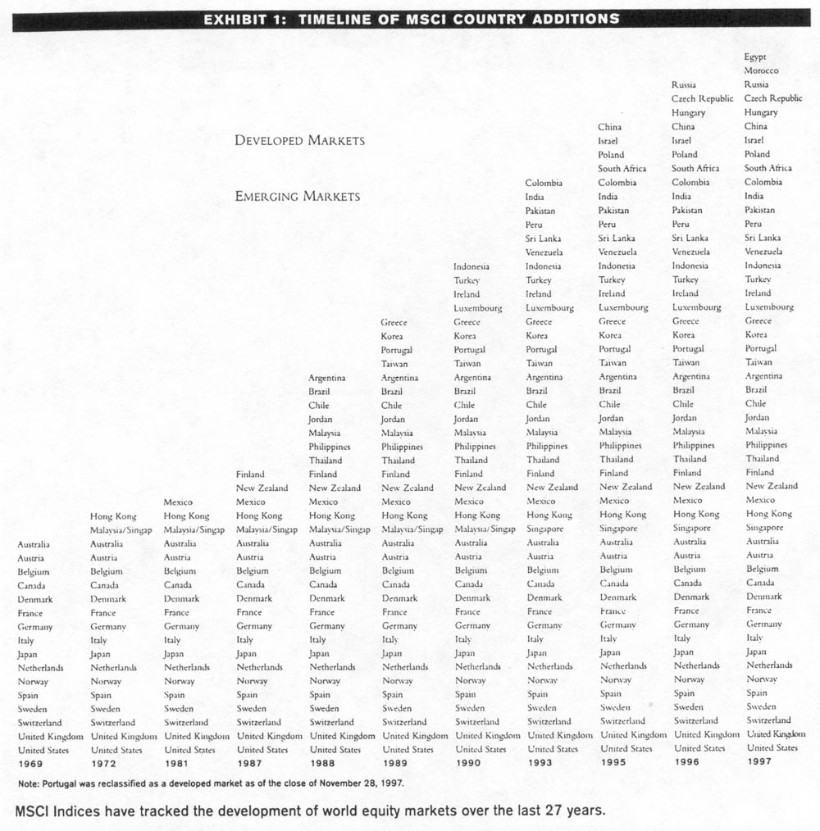

MSCI Indices are constructed to provide benchmarks that accurately represent the opportunities available to the institutional investor. While an all-share index (all listed companies at their full market cap weight) represents the theoretical opportunity set available to the global investor, this is not a fair performance benchmark in practice, since it cannot be fully replicated due to illiquidity of either shares or volume. Thus, MSCI creates indices which capture the spirit of an all-share index, but are actually subsets of shares which are truly replicable. The NISCI Free index series tracks the performance available to the non-domestic investor in certain markets with restrictions on foreign investment.

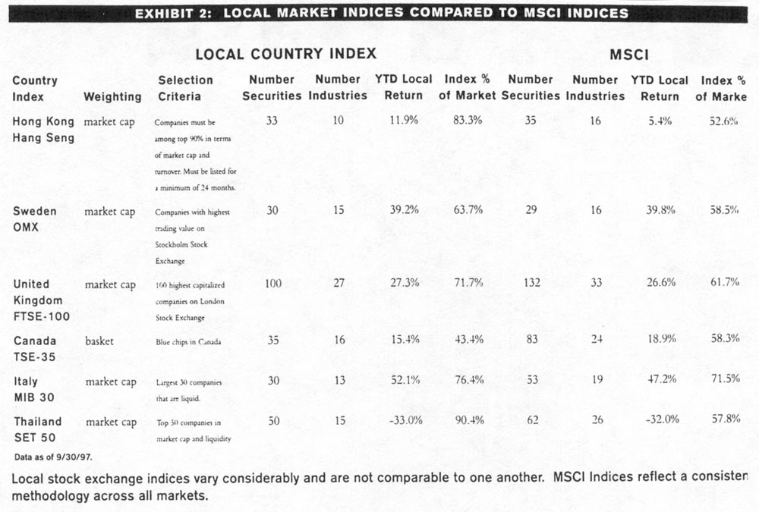

1B. MSCI INDICES AS PERFORMANCE BENCHMARKS

The real-world investment-opportunity set available to the international investor is filled with subtle discrepancies and contradictions. Cross-ownership, for instance, may overstate the opportunities in a market if companies that own one another are both included in the same index. This double counting of securities would distort valuation ratios and performance data, not to mention market capitalization. Each MSCI country index is constructed so as to minimize cross-ownership, assuring that all industry groups are proportionately represented, and that each country's contribution to the global or regional index is accurately based on its true market capitalization. While the methodology behind the MSCI Indices has evolved over their 27-year history to capture the growth of global equity markets, the index philosophy has never been compromised to simplify the complicated process of investing internationally. MSCI products are based on detailed analysis to make it easier for the international investor to measure equity performance.

EXHIBIT 3: MAJOR REGIONAL MSCI INDICES

Index Name Description Number of Countries
The World Index All developed markets in the world 23
Kokusai (The World Index ex Japan) All developed markets in the world excluding Japan 22
EAFE® Europe, Australasia, Far East - developed markets only 21
EASEA (EAFE® ex Japan) Europe and South East Asia - developed markets only 20
Europe AN developed markets in Europe 15
Pacific All developed markets in the Pacific lkirn 6
North America USA and Canada 2
EM (Emerging Markets) All emerging markers in the MSCI universe 26
EMF (Emerging Markets Free) All emerging markets in the MSCI universe, with Free versions of
countries where they exist 26
EMF Asia All emerging markets in the Asian MSCI universe. with Free
versions of countries where they exist 10
EMF Latin America All emerging markets in the Latin American MSCI universe, with
Free versions of countries where they exist 7
EM Europe All emerging markets in the European MSCI universe 6
ACW1 (All Country World Index) All developed and emerging markets in the MSCI universe 48
ACWI Free ex USA AU developed and emerging markets in the MSCI universe
excluding the USA, with Free versions of countries where they exist 47
ACWI Free ex Japan All developed and emerging markets in the MSCI universe excluding
Japan, with Free versions of countries where they exist 47
AC Europe All developed and emerging markets in the European MSCI universe 21
AC Far East Free ex Japan All developed and emerging markets in the Far Eastern MSCI 9
universe excluding Japan, with Free versions of countries where
they exist

MSCI Indices are calculated across developed markets, emerging markets, and All Country regions.

2A. CONSTRUCTING COUNTRY INDICES: THE FIVE-STEP PROCESS

MSCI Country Index Selection Criteria:
1. Define the total market.
2. Sort the market by industry groups and target 60% for inclusion.
3. Select stocks with good liquidity and free float.
4. Avoid cross-ownership.
5. Apply the full market capitalization weight to each stock.

1. Define the total market: The initial research for the MSCI Indices covers the full breadth of each equity market it the universe. Country specialists track the evolution of both listed and unlisted shares of domestically listed companies it 51 markets that, combined, account for over 99% of the world's total market capitalization. Based in Geneva, these teams of country specialists collect data on shares, pricing, ownership, float and liquidity for effectively all companies worldwide. Sources for this information include local stock exchanges and brokerage firms, newspapers, and company contacts. All of the companies within this research coverage are eligible for inclusion in the MSCI Indices except non-domiciled companies, investment trusts and mutual funds.

The MSCI index construction process is illustrated in a spreadsheet (Exhibit 4) covering Sweden. These spreadsheets arc an abbreviation of the complete analysis used in Geneva for index construction and maintenance. The factors which are used in the process are:

• Market capitalization by share class and by overall company
• Industry group
• Average monthly traded value (6- and 12-month periods)
• Estimated free float
• Estimate of significant owners of the shares

Exhibit 4 (opposite page) shows the 25 securities by market capitalization in Sweden. Ericsson, at USD 35 billion, is the largest stock in Sweden and in the MSCI Index. It is almost 65% of its industry, 12.5% of the total Swedish market. It has, on average, USD 1.9 billion traded per month (and this volume has been fairly steady over time). In Exhibit 4, only a few months are shown for spacing constraints; but usually both short-term (6 months) and long-term (12 months) trading value is evaluated. The estimated free float for Ericsson is 77%. Wallenberg Sphere is the largest shareholder and owns 5.2%.

By contrast, the 5th largest security, Sparbanken is not in the MSCI Index, although it is in the research database. Sparbanken was privatized in October 1995, along with Nordbanken, increasing the market cap of the banking industry group in Sweden. MSCI needed to increase the coverage of this industry, but neither Sparbanken nor Nordbanken were, included since both derived their revenues from commercial banking and this aspect of the industry was already well covered in the existing Sweden Index. Another bank, Stadshypothak (not listed in Exhibit 4), was included since its revenues were derived from mortgages. The 10th largest security, Sandvik is also excluded from the MSCI Index due to cross-ownership with Skanska, which owns 20% of Sandvik and Skanska is already in the index.
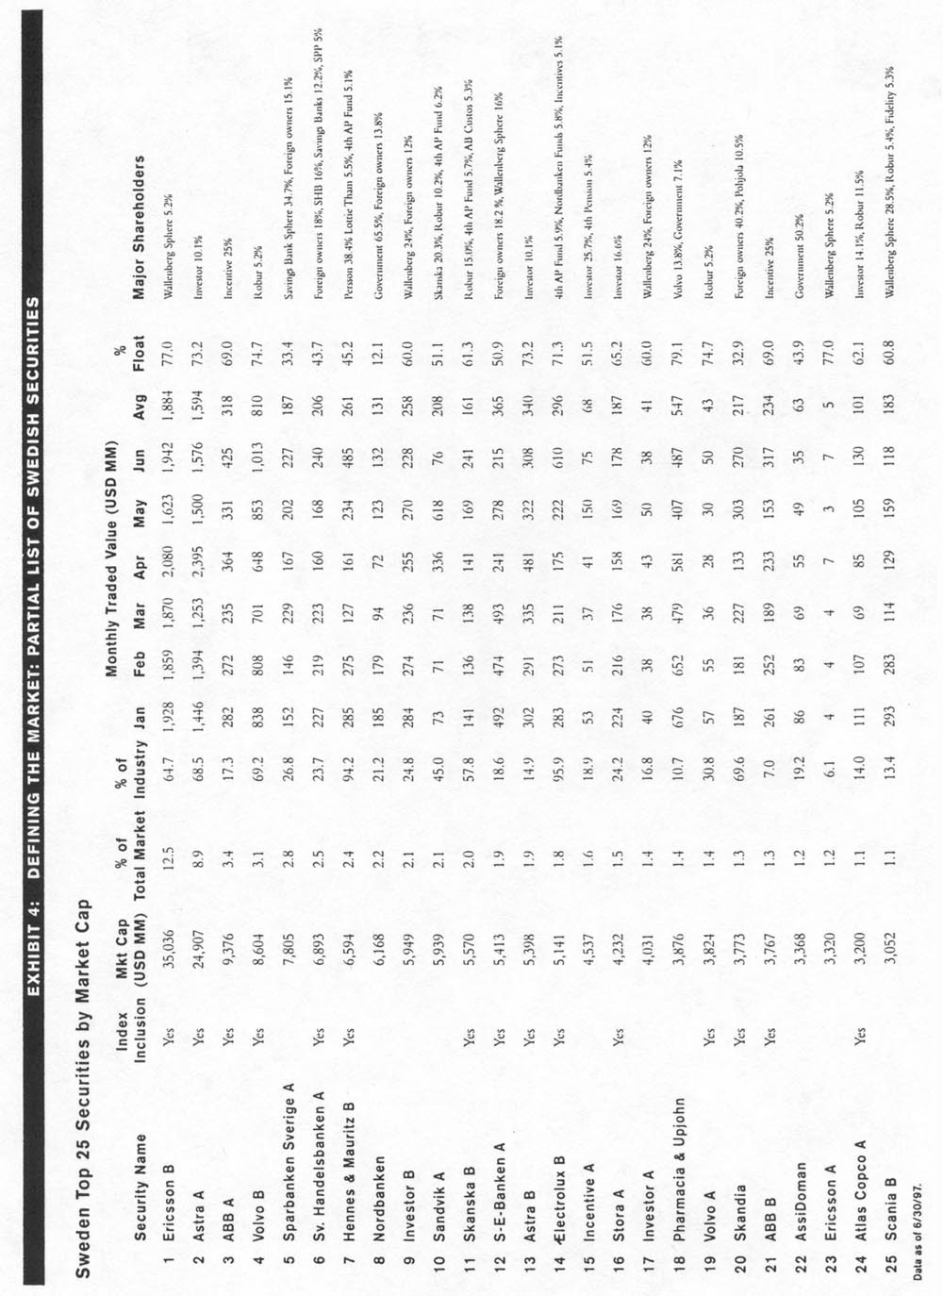

2. Sort the total market by industry groups and target 60% for inclusion: Once information on the total country market capitalization is analyzed, 60% of the capitalization of each industry group, and thus 60% of the entire market, is targeted for inclusion in each MSCI country index. This process ensures that the index reflects the industry characteristics of the overall market, and permits the construction of accurate regional and composite industry indices.

With the uniform target of capturing 60% of the each country's total market capitalization, each country carries its proportional weight in the regional and composite indices. A 60% target has been found sufficient to maintain a high level of tracking while still providing for an investable universe across all countries (the "highest common denominator" which can be captured, while still having an investable index in each country).

The USA Beverages & Tobacco Industry (Exhibit 5 below) illustrates the complexities of maintaining accurate industry weights in an index. Five large and liquid companies, each with a distinct main product line, dominate the industry: Coca Cola and Pepsico (soft drinks), Philip Morris and PJR, Nabisco (tobacco), and Anheuser-Busch (beer). As of December 31, 1996, four were in the index and as part of the restructuring of the USA index in Ma-y 1997, Pepsico was deleted to bring down the coverage closer to the 60% target while keeping one company in each sub-industry.

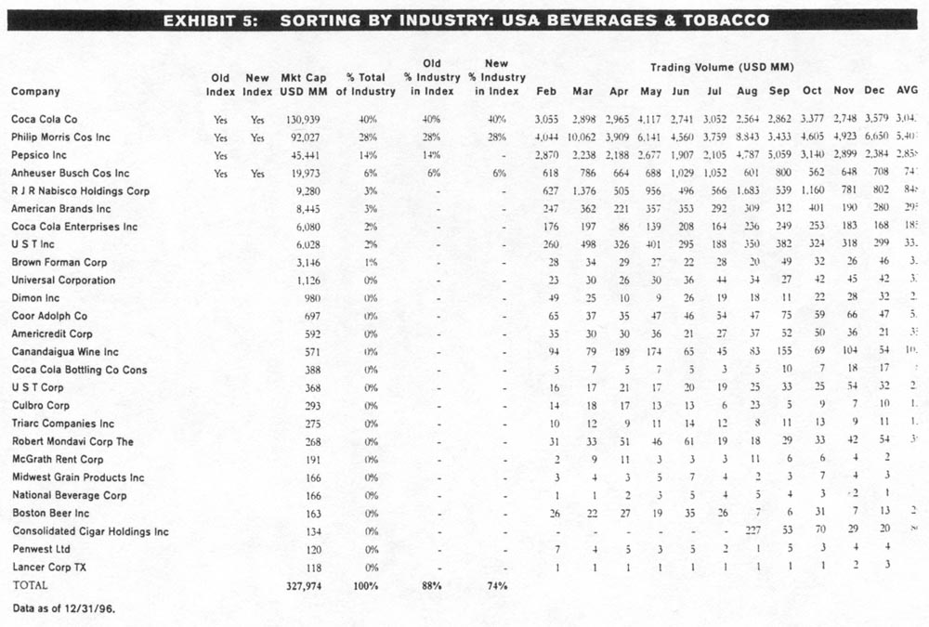

3. Select stocks with good liquidity and free float: A goal of the MSCI index construction process is to select the most liquid stocks within each industry group, all other things being equal, since liquidity is necessary but not the sole determinant for inclusion in the index. Liquidity is monitored by monthly average trading value over time in order to determine normal levels of volume, excluding temporary peaks and troughs. A stock's liquidity is significant not only in absolute terms, but also relative to its market capitalization and to average liquidity for the country and the industry as a whole. Liquidity is not used as an absolute measure to select constituents because:

An absolute minimum level of liquidity would be arbitrary and would have different meanings in different markets. For example, Exhibit 6 below shows that in 1996 the monthly average trading value for the 20 largest stocks in Germany was USD 1.68 billion; in Portugal the average was approximately USD 28 million.

EXHIBIT 6: LIQUIDITY IS RELATIVE

Monthly Average Trading Value Monthly Average Trading Value
for the 20 Largest Companies for the Country
Country (USD MM) (USD MM)
Germany 1,683 81
Portugal 28 5

Note. The methods for calculating Trading values may vary from one country to another and am therefore not directly comparable; e.g.. in German% each trade is counted twice (one for the buy and one for the sell). The German data only includes the trades on the Frankfurt Stock Exchange and may therefore be somewhat different from other sources.
Date as of 1996.

Liquidity is partly a function of the cyclicality of markets and industries. Limiting index constituents to only the most liquid stocks would introduce a bias against those stocks and sectors that are temporarily out of favor with investors. An inflexible rule might also dictate a pattern of constituent additions and deletions that would introduce unnecessary turnover in the index.

3. Select stocks with good liquidity and free float: (continued)

The free float (percentage of shares freely tradable) of every security in the market is monitored and an estimate is calculated, and low float may exclude a stock from consideration in the index. In the developed markets and some emerging markets, "low" float is considered under approximately 25%, as estimated by the country specialists at CIPSA in Geneva. However, in many emerging market countries, the average float is below 25%, so float is measured relative to the stock's own industry and country.

Exhibit 7 below shows examples of companies with less than 25% float that are included in the MSCI Indices.

EXHIBIT 7: LOW-FLOAT COMPANIES IN MSCI INDICES

Average
Mkt Cap % % % Trading Volume
Country Company (USD MM) Industry Market Float (USD MM)

Indonesia Indah Kiat Pulp & Paper 2,763 35.8% 2.5% 19.0% 21.8
This company is the largest in the wood, pulp and paper industry and has very good trading volume.

Indonesia Putra Surya Perkasa 1,067 14.0% 1.0% 18.0% 14.9
This company is the largest in the real estate industry and has good trading volume.

These two companies above are in the MW Indonesia Index because the country's average float is only around 22%, so companies with less than 25% float can be included.

Turkey Turkiye Is Bankasi 4,022 30.0% 9.2% 19.0% 111.0
This is the largest company in the banking industry and in the market, with large trading volume.

Turkey Arcelik 1,344 60.0% 3.1% 21.0% 24.8
This is the largest company in the cement industry.

Turkey also has a lower than average float in the country, so 'low"-float companies are included in the Index.
Data as of 6/30/97.

But float can be a difficult number to determine. In sonic markets, reliable data sources are generally not available; in other markets, information on smaller and less prominent issues can be subject to error and time lags. Additionally, government ownership and corporate share crossholdings can change over time and are not always made public. The precise definition of "float" also tends to differ depending on the data source. Thus, evaluations of float run the risk of penalizing those markets that have higher standards for company disclosure, regardless of the actual degree of availability of shares. As with liquidity, sufficient float is an important consideration, not an inflexible rule.

4. Avoid cross-ownership: Cross-ownership occurs when one company has a significant ownership stake in another company, and both are included in the index. Substantial cross-ownership can skew industry weights, distort country level valuations (such as Price/Earnings and Price/Book Value) and overstate a country's true market size.

An integral part of the index construction process is to identify corporate share crossholdings in order to avoid or minimize cross-ownership in the MSCI Indices. Country analysts in Geneva separate cross-ownership stakes into two categories. The first consists of stakes which are considered immaterial. In these cases, such cross-ownership does not represent something significant in terms of having distortionary effects on the index even if both companies are included. The second category is stakes which could materially distort an industry- or country-level index by significantly overstating the index's market capitalization if both companies are included. Other ownership stakes (such as government, family, other institutional holdings) are also included in the estimated free float. Exhibits 8-10 show examples of how cross-ownership is avoided in the MSCI Indices.

EXHIBIT 8: AVOIDING CROSS-OWNERSHIP IN MSCI INDICES

Country Company Index Inclusion Cross-Ownership Considerations
Singapore Sembawang Corp. No Sembawang Corp is the largest Singaporean company in ship repair and
engineering. It holds a 35% stake in Sembawang Maritime which is already
in the index.
Far East Levingston No Far East Levingston Shipbuilding is the second-largest ship repair and
engineering company. It is 56%-owned by Keppel Corp, which is already in
the index.
Singapore Land No Singapore Land, the third-largest real estate company is not included
because it is 56%-owned by United Industrial Corp., which is already in the
index.
Germany SKW Trostberg No SKW Trostberg is not in the index because it is 31%-owned by VIAG.
Hong Kong Paliburg Holding No Paliburg Holding, the third-largest leisure and tourism company, holds 67%
of Regal Hotels, which is in the index.

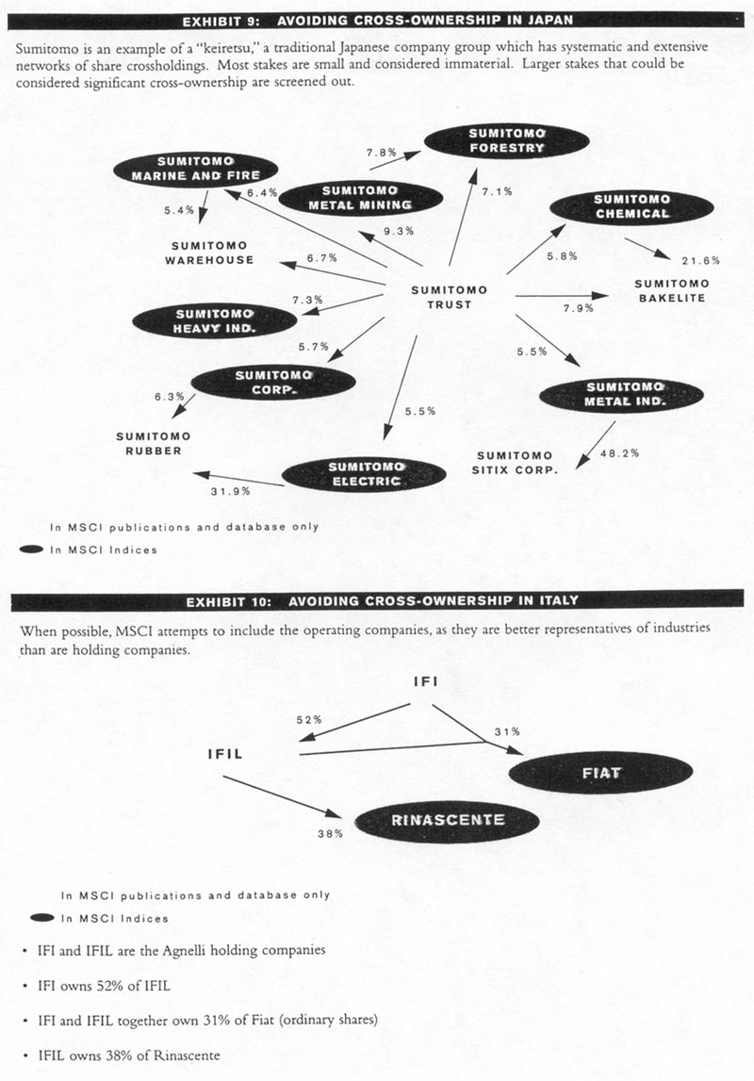

5. Apply the full market capitalization weight to each stock: All standard MSCI indices are weighted by each company's full market capitalization (both listed and unlisted shares). This approach has the advantage of objectivity-the number of shares outstanding is consistently defined for companies around the world and is a readily obtainable figure. This approach also minimizes turnover. MSCI does not adjust share weights for either free float or cross-holdings. The most serious consequence of float limitations is illiquidity, which can be monitored objectively. Full market capitalization weighting is favored to float-weighting schemes for both theoretical and practical reasons:

• It is impossible to judge whether a position which is currently in firm hands might be available in the future.

• The quality and timeliness of information on float varies from market to market. Adjustments penalize those markets with the highest standards of company information disclosure.

• Float adjustments incur index turnover as the float of a company changes. However, the precision of a float-adjusted index may not yield a more "investable" index. For instance, when the float of a stock increases from 55% to 60%, it may not be necessarily 5% more investable on a practical basis. In fact, it was probably fully replicable at a full market cap weight and the increase in turnover did not result in a "better" index, only an increase in transaction costs.

• Float adjustments on a country level may not result in materially different country weights from market capitalization weights. Exhibit 11 on the next page lists MSCI's estimation of average float, based on all listed companies in Japan. Germany, Switzerland and Hong Kong. The average float is relatively similar across these larger markets. If the largest 20 stocks were taken as a proxy for the market, again the average float is approximately between 55% and 60% for each market. Thus, adjusting for free float would result in similar country weights as when using full market capitalization, since the float-adjusted market caps would be proportional to the full market caps.

EXHIBIT 11: ESTIMATED FREE FLOAT OF DEVELOPED COUNTRIES

Country  Germany  Hong Kong  Japan  Switzerland  Average | Estimated Free Float  (based on all listed securities)  51%  49  50  73  56% |  | Country  Austria  Belgium  France  Germany  Hong Kong  Ireland  Italy  Japan  Malaysia  Norway  New Zealand  Singapore  Spain  Sweden  Switzerland  UK  Average | Estimated Free Float  (based on all listed securities)  58%  46  64  55  49  56  48  69  47  41  51  47  59  65  86  70  56%

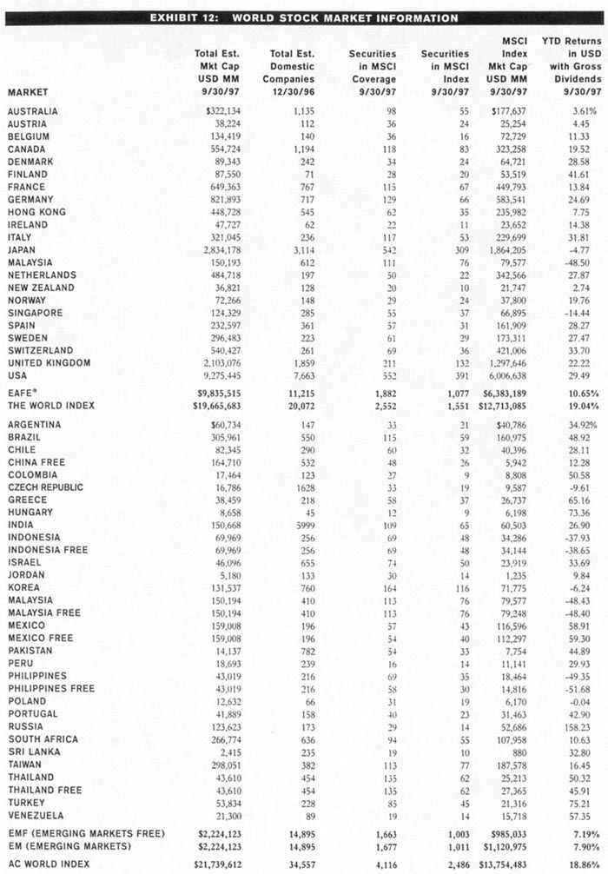

2B. PARTIAL INCLUSION POLICY AND MARKET CAP FACTORS

Since the normal MSCI index policy is to include index constituents at 100% of market capitalization, large issues with low float—a characteristic of many privatizations—pose a dilemma for index construction. Including such companies at full market cap weight can overwhelm an index and overstate the true size of market opportunities; yet excluding them also results in an incomplete picture of the market. A company is included or excluded on a case-by-case basis, where the contributing factors include the expected change in float (especially for first-time government privatizations), stability of the liquidity and importance of the company in its local economy.

A growing number of very sizable companies have been or will be brought to market with modest tranches initially made available to the public. By virtue of their size and visibility, these companies are obvious candidates for inclusion in a portfolio. To reflect this new market trend, MSCI index construction rules do allow for the possibility of including company at a portion of its total market capitalization. This occurs only in exceptional cases when very large companies come to market with very modest initial float.

The guidelines are as follows:

- This partial inclusion policy is used only in cases of overwhelming importance. Only companies that comply with all other inclusion criteria, and assume at least a 5% weight in their country index after the adjustment (2% for cases in Japan and the U.S.), are considered.
- The minimum float for inclusion in the indices at full market capitalization is set at 25% for the majority of countries. A lower limit may be used in some emerging markets where low-float percentages are still a basic pattern of the country.
- For companies that do not meet the minimum float requirements, the portion of market capitalization included in the index, the Market Cap Factor (MCF), is set to approximate the ratio between the company's current float and the minimum float for full inclusion. To reduce turnover, only three MCFs are used: 40%, 60%, and 80%.

In addition to float limitations, other circumstances or unique situations may also lead to the utilization of an NICE In these situations, the appropriate MCF is determined on a case-by-case basis. For example, an MCF might be used when foreign ownership ceilings are lower than the minimum float required for full inclusion.

Market cap factors are reviewed periodically. However, in order to minimize turnover, only substantial modifications in float are taken into account to determine a change in the MCF of a company once the MCF has been announced. Changes in MCFs are part of MSCI's regular quarterly structural changes.

While the above considerations serve as guidelines to determine a company's MCF, this remains an extraordinary procedure for use only in unusual situations (Exhibit 13, opposite page).

EXHIBIT 13: EXAMPLE OF PARTIAL INCLUSION POLICY: DEUSTCHE TELEKOM

Deutsche Telekom had a free float of 23.5% when listed. The minimum float in Germany for a company to be included at full market cap weight is 25%. It was added to the MSCI Indices as of December 1, 1996 at 80% of its market capitalization weight. Even at 80% weight, Deutsche Telekom immediately became the largest constituent of the MSCI Germany Index.

Approximate Ratio of Free Float to Minimum Float for Full Inclusion = 23.5% / 25.0% = rounded down to 80% ¹

There are eight companies included in the MSCI Indices under this partial inclusion policy as of9/30/97:

Company Country MCF
1. Deutsche Telekom Germany 80%
2. EDP Electricidade Portugal 60%
3. Gudang Gararn Indonesia 40A
4. NTT Corp. Japan 80%
5. Pakistan Telecom Pakistan 40,
6. Singapore Telecom Singapore 40%
7. SPT Telecom Czech Republic 80%
8. Gazprorn ADR Russia 5%²

1 Only three market cap factors (MCFs) are used: 40%, 60%, 80%.
² Gazprom's 5% inclusion represents an exceptional MCIF due to a unique situation in the Russian market. Gazprom is by far the largest company in Russia, but the AORs included in the MSCI Russia Index represent only 1.15% of Gazprom's capital. Therefore a 0.05 MCF was exceptionally used in this case.
Note: Other companies have MCFs, but for reasons other than application of the partial inclusion policy.

2C. FREE MARKET CAP FACTORS

In some countries, significant foreign ownership limits exist for certain companies and/or industries. When this limit is reached, foreigners may only trade with each other, frequently at a price higher than that available to domestic investors, and a premium arises. In certain cases where there is enough long-term liquidity at the foreign price, MSCI uses the Free Market Cap Factor (FMCF) to align the weightings of these stocks in the Free and non-Free versions of the country index. Currently, FMCFs are used in only Thailand, Indonesia, Malaysia and Singapore. These FMCFs are incorporated into the Free index calculation as follows:

Market Capitalization in Free Indices = Foreign Price (when used) * Total Shares * FMCF

The FMCF represents the approximate ratio of the domestic price to the foreign price rounded to five possible levels: 1.00, 0.85, 0.70, 0.60, 0.50. The specific FMCFs have been selected to provide similar ceilings of market capitalization for each premium range to minimize weight distortions in the Free vs. non-Free indices by reducing the impact of foreign

2D. STRUCTURAL CHANGES

In changing the constituents of the MSCI Indices, accurate representation is balanced with minimizing turnover. An index must represent the current state of an evolving marketplace while at the same time minimizing turnover, which is costly as well as inconvenient for investment managers. Restructuring an index involves a balancing of constituent additions and deletions. The primary concern when considering additions and deletions is the continuity of the indices. Of secondary concern are the turnover costs associated with these changes.

There are two broad categories of changes to the MSCI Indices: structural changes and market-driven changes.

Structural changes reflect the evolution of a market due, for example, to a change in industry composition or regulations Industry restructurings generally take place every 18 to 24 months for any given country. However, the structural change to the country index may occur on only four dates throughout the year: as of the close of the last business day of February, May, August and November. MSCI index additions and deletions are announced two weeks in advance. There are absolute firewalls oil any price-sensitive decision until there is a public announcement. These changes are communicated to subscribers both electronically and by fax. They are simultaneously posted on public Reuters pages (starting on MSCIA) and public Bloomberg pages (MSCN). The Reuters and Bloomberg MSCI pages are updated by Capital International Perspective, S.A. in Geneva. The pages include the security names, the action to be taken and, when necessary, the context of the change.

A more detailed announcement service is available for a fee (and provides the weightings, shares outstanding, security identifiers and industry classification).

EXHIBIT 14: SCHEDULE OF QUARTERLY STRUCTURAL CHANGES TO THE MSCI INDICES

Source Rebalancing Action Frequency/Timing

CIPSA Examine each country index; Quarterly
Re-align those indices which need reconstitution; Every 18-24 months for each country
Announce changes on: Reuters, Bloomberg, other media Two weeks before the last business day of
February, May, August, November;
approximately 2/15, 5/15. 8/15 11/15

CIPSA Pre-announcement service to clients Approximately 2/15, 5/15. 8/ 15, 11/15
Alert MS&Co of changes After announcement is public

MSCI, MS&Co. Provide supporting documentation on changes Approximately 2/15, 5/15, 8/ 15, 11115
Call clients to alert them of changes After announcement is public

CIPSA Implement Quarterly Structural Changes As of the close of the last business day of
February, May August, November; approximately
2/28, 3/31, 8/31, 11/31

During the examination of each country index, the market cap and business function coverage of each industry group is measured against the underlying market. The investability (free float, cross-ownership, long- and short-term trading volume and turnover) of each constituent is also monitored. In the event that an industry is over- or under-covered, or that there are stocks in the index which are no longer investable (here both long-term and short-term liquidity is examined), or a large privatization has altered the capitalization of the market, a structural change may be necessary.

The MSCI indices reflect the opportunity set to the global investor on an ongoing basis-and should thus mirror the fundamental changes in the market's structure, and correspond to the situation of the average institutional investor. These structural changes are designed and timed to minimize turnover to the indices. If possible, several unrelated changes to a country index are grouped together, minimizing disruption.

EXHIBIT 15: AUSTRALIA: ADDITION OF GAMING INDUSTRY TO INDEX FOR JUNE 3, 1996

Leisure and Tourism

-add Crown Operates a casino complex and is developing a new casino as well as a hotel complex
-add Sydney HBR Casino Runs a casino in Sydney
-add Tabcorp Holdings Gaming and wagering activities

The gaming industry, which had developed over the prior year, was now added to the MSCI index under the Leisure and Tourism group.

In Exhibit 16 below, the Bank of Tokyo/ Mitsubishi merger prompted a realignment of the Japanese banking industry, where Dai-Ichi Kangyo Batik was deleted to maintain 60% coverage of the industry. This was grouped with a reconstitution of the overall Japanese index.

EXHIBIT 16: JAPAN: OVERALL RECONSTITUTION OF INDEX FOR JUNE 3, 1996

 | USD MM |  | USD MM |  | USD MM
Local Index Mkt Cap: | 2,281,000 | Net Mkt Cap Change: | 8.647 | Gross Mkt Cap Change: | 273,453
Total Additions: | 141,050 | % Net Turnover in MSCI Japan | 0.4% | % Gross Turnover in MSCI Japan | 12.0%
Total Deletions: | 132,403 | % Net Turnover in EAFE | 0.2% | Gross Turnover in EAFE | 4.9%
Data as of 4/30/96 (continued)

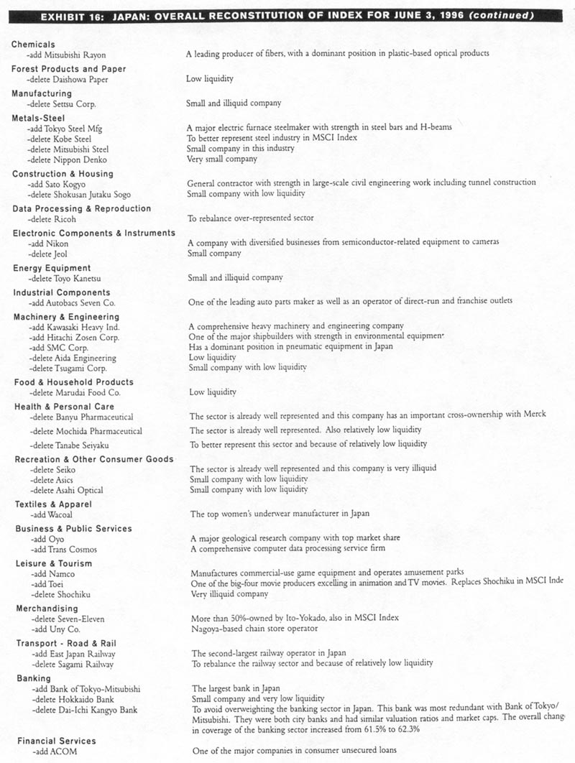
Structural Change Additions: As markets grow because of privatizations, investor interest, or the relaxation of regulations, index additions (with or without corresponding deletions) may be needed to bring industry representations up to the 60% target. Companies are considered not only with respect to their broad industry, but also with respect to their sub-sector, in order to represent if possible a broader range of economic activity.

Structural Change Deletions: The indices must represent the full-investment cycle, including bear as well as bull markets. Out-of-favor stocks may exhibit declining price, market capitalization, and/or liquidity; and yet continue to be good representatives of their industry. Deleting constituents because their liquidity has declined introduces a bias against out-of-favor companies or industries, especially those in the trough of a business cycle. For this reason, low liquidity is never an automatic trigger for deleting a company from the index.

Companies may be deleted because they have diversified away from their industry classification, because the industry has evolved in a different direction from the company's thrust, or because a better industry representative exists (either a new issue or an existing company). In addition, in order not to exceed the 60%, target coverage of industries and countries, adding new index companies may entail corresponding deletions.

2E. MARKET-DRIVEN CHANGES

Market-driven changes consist of new issues, mergers, acquisitions, bankruptcies, and other similar corporate events. These changes are announced and implemented as they occur.

Additions - New Issues: New issues may not be automatically eligible for immediate inclusion in the MSCI Indices. Many factors must be considered, such as market capitalization, float and liquidity. Some new issues undergo a seasoning period of six to twelve months between index restructurings until a trading, pattern and volume are established. After that time, they are eligible for inclusion, subject to the standard selection criteria discussed.

However, sometimes a new issue, usually a privatization comes to market and substantially changes the country's industry profile. In this case, where even temporarily excluding it would distort the characteristics of the market, it may be immediately included in the MSCI Indices. An example is YPF, Argentina's privatized oil company, which at USD 3.04 billion is Latin America's largest privatization to date. In these cases, however, an announcement is made in the first few days of official trading for the security, since the country specialists do not want to influence the primary placement of the issue.

In other cases, a large new issue may not be included even in the normal process of restructuring, despite substantial -size and liquidity. The primary reasons for non-inclusion of a large new issue are as follows:
- A large stock, if it has low float and is also illiquid, can overwhelm an index and over-represent the true opportunities in the market.
- The index may be at the limit of industry representation-including the new issue would seriously over-weight an industry in the index.
- In some cases, it is necessary to defer inclusion of a new issue until the next opportunity for index restructuring.

Deletions - Suspended Companies: In the case of suspension for bankruptcy or near bankruptcy, the suspended company is deleted at the smallest price (unit or fraction of the currency) at which a security could have traded in a given market.

More complex are the cases where the suspension is due to a major restructuring, which results in the company being ineligible (at least for an important period of time) for normal listing and trading on the stock exchange. The MSCI policy is to remove these companies from the index only after there is little likelihood the company will return to normal trading. In this situation, the key issue is determining the price at which the company can be removed from the index. Unofficial market prices may be used as a base to determine that exit price. In exceptional circumstances, average indicative prices from reliable sources may be used.

Mergers & Acquisitions: Any case of mergers and acquisitions, or capital restructuring, which cart affect a company within the MSCI universe is monitored. Depending on whether the active companies are, or are not, constituents of the MSCI Indices, a number of factors must be considered. If either the acquiring or the acquired firm is a constituent of the index, the first consideration is the impact of the acquisition on the index. The second consideration involves structural changes to the index. When a non-constituent company acquires a constituent company, either the acquiring company can replace the constituent company in the index, or another company altogether may be chosen as a better representative of the industry. If two medium-sized, non-constituent companies merge, the merged company may also be considered for inclusion in the indices. However, this change would occur only through a structural review.

Spin-Offs: A spin-off is the distribution to existing shareholders of a part of the company's business through the issuance of shares in the newly-established company. The decision to include the newly-established company in the index is based on several factors including estimated market value, market capitalization, and float. The market value of the spin-off is estimated through a consensus of industry analysts, grey market prices, and statistics on revenues and earnings.

Turnover Statistics: Below is listed the turnover of the MSCI Indices, by year. The turnover statistics include additions and deletions of securities in the indices. However, distortions may occur due to the reclassification of securities, which are reflected in deletion, but are then added to the number of shares of an already existing security.

EXHIBIT 17: DEVELOPED MARKETS INDEX TURNOVER 1992-1996

MSCI EAFE® Index MSCI World Index

Security Movements Security Movements
Market Cap Market Cap
Added Deleted Average Added Deleted Average

1996
USD Billion 348.9 274.4 5,468 413.6 354.2 9,803
Index Turnover 6.38% 5.02% 4.22% 3.61%

1995
USD Billion 90.9 40.8 4,868 152.3 97.5 8,341
Index Turnover 1.87% 0.841% 1.83% 1.17%

1994
USD Billion 191.5 63.3 4,644 47/0.4 100.0 7,522
Index Turnover 4.12% 1.36% 6.25% 1.33%

1993
USD Billion 205.7 80.4 3,808 229.1 86.2 6,405
Index Turnover 5.40% 2.11% 3.58% 1.35%

USD Billion 47.5 50.5 3,149 61.1 56.1 5,525
Index Turnover 1.51% 1.60% 1.11% 1.02%

1992-96 Average
USD Billion 176.9 101.9 4,387 265.3 138.8 7,519
Index Turnover 3.86% 2.19% 3.40% 1.70%

EXHIBIT 18: EMERGING MARKETS INDEX TURNOVER 1995-1996

MSCI Emerging Markets Index MSCI Emerging Market Free Index

Security Movements Security Movements
Market Cap Market Cap
Added Deleted Average Added Deleted Average
1996
USD Billion 89.0 15.5 979 117.1 12.3 786
Index Turnover 9.09%¹ 1.58% 22.54%² 1.56%

1995
USD Billion 136.5 10.0 853
Index Turnover 16.00% 1.18%
¹ 9/3/96: Czech Republic and Hungary added to EM.
² 9/3/96: Czech Republic and Hungary added to EMF. Taiwan added at 50%. Korea increased from 20% to 50%

3A. DEVELOPED, EMERGING, ALL COUNTRY INDICES

Individual MSCI country indices are aggregated into regional indices (e.g., MSCI Europe) and composite indices MSCI Emerging Markets). Market capitalization weighting and a consistent 60% target inclusion of each market help ensure that each country's weight in the regional and composite indices is proportional to its weight in the total universe. Exhibit 19 below shows the various designations used to classify the MSCI family of indices.

EXHIBIT 19: DEFINITION OF TERMS FOR MSCI INDICES

Developed: A country; regional, or composite index comprising developed markets only e.g., USA, Europe, EAFE' (all regional indices are considered developed unless designated EM or EMF)
Emerging: A country, regional, or composite index comprising emerging markets only e.g., Brazil, EM Eastern Europe, EMF
All Country: A regional or composite index consisting of developed and emerging markets e.g., AC Europe, AC Far East Free ex Japan. AC World Index
Free: An index that includes constituents as available to non-domestic investors (all MSCI indices are considered Free unless a non-Free version also exists)
Non-Free: An index that includes constituents as available to domestic investors only (label not used in index names)
Industry: An index of companies aggregated by one of 38 primary industries
Sector: An index of companies aggregated by one of eight economic sectors
Hedged: An index hedged to the US dollar to eliminate foreign exchange effects
GDP-weighted: A regional or composite index where individual countries are weighted by their GDP (as opposed to market capitalization)
Standard: An index that aims to capture 60% of the total universe of stocks in each country
Value: The cop 50% market cap of Standard indices as ranked by ascending P/BV
Growth: The bottom 50% market cap of Standard indices as ranked by ascending P/BV
Small Cap: An index that aims to capture 40% of the Small Cap universe (companies with USD200-800 million market cap in each country); (for Developed Markets only)
Extended: An index that aims to capture 70% of the total universe of stocks in each country; (for Developed Markets only)

MSCI country indices span the range of equity markets around the world-developed and emerging. The designation of a market as either developed or emerging arises from several factors, the most common of which is GDP per capita. Markets develop as economic growth accelerates, companies begin to raise capital in the public markets trading mechanisms are set in place, regulations are liberalized, and investor interest grows. While the MSCI World Index of 23 developed markets started from 1969, as more equity markets have evolved, MSCI expanded its universe of countries to include emerging markets in 1988. These emerging markets share some or all of the following criteria:

- Gross Domestic Product (GDP) per capita substantially below the average for developed economies. This is consistent with the World Bank's classification criteria. As shown in Exhibit 20 (opposite page), the average emerging market covered by MSCI has a 1996 GDP per capita of USD 3,944, in contrast to USD 25,311 for the developed markets covered by MSCI. GDP figures must be approached with caution, however, because they can be distorted by inflation and exchange rates.

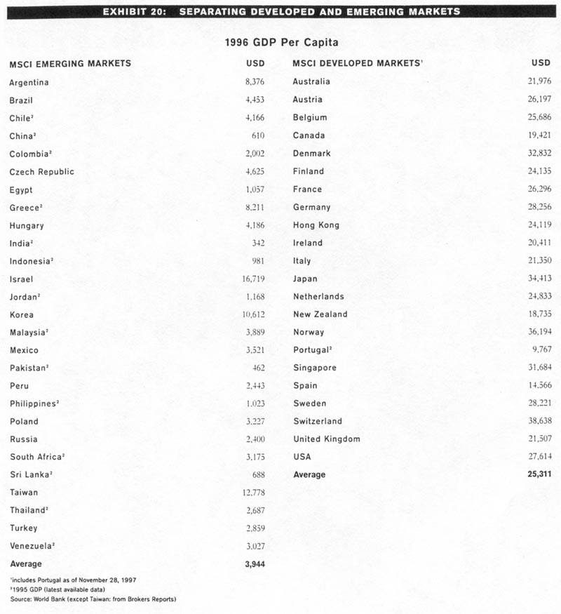

- In emerging markets, government regulation limiting or banning foreign ownership in industries and companies is substantially greater than in developed markets. For example, Taiwan has among the highest GDP per capita in the emerging markets and is strictly regulated, In fact, when looking at GDP per capita alone, Taiwan appears to be a developed market. However, the government restrictions, as well as several of the following factors, make it a better fit with the emerging markets:

- An inadequate (either too lax or overzealous) regulatory environment and/or less sophisticated back office operations, including clearing and settlement capabilities;

- Restrictions on repatriation of initial capital, dividends, interest, and/or capital gains. For example, capital invested in the Chilean equity market must remain in that country for a minimum of one year, regardless of when the equity positions were liquidated;

- Greater perceived investment risk than in the developed markets;

- A general perception by the investment community that the country should be considered emerging. An interesting example is Israel, where many characteristics could argue for the inclusion of Israel in the developed markets indices. The majority of our clients, however, are more comfortable with the classification of Israel as an emerging market. This, combined with Israel's ranking along other criteria such as political risk, has resulted in the decision to include Israel as an emerging market.

- Maintaining a consistent methodology with both the developed and emerging markets is crucial in the calculation of combined emerging and developed indices i.e., the All Country series of regional indices.

