Trade strategy brief
Emerging Markets Trade Sheets

- Trade Sheets synthesize risks and returns on emerging markets trading positions

- Results are evaluated as returns on new dollars invested (Investment Strategies) or as excess returns resulting from the reallocation of assets (Swap Strategies)

- Possible structures include outright positions, spread trades and relative value trades

Trade strategy applications
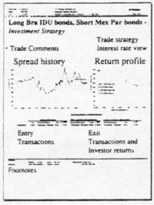
The Trade Sheet is a product designed to complement J.P. Morgan's relative value analysis of U.S. dollar-denominated emerging market securities. The product builds upon our analysis of expected returns, incorporating our interest rate and sovereign spread forecasts, which are published on a weekly basis in the Emerging Markets Outlook.

The Trade Sheet is designed to provide a comprehensive and rigorous analytical framework through which the risks and returns of both simple and complex trading strategies can be objectively evaluated. This framework should be particularly useful in a market without widely available and generally accepted analytical platforms. The development of the Trade Sheet further confirms J.P. Morgan's commitment to being a leader in the application of developed market analysis to the emerging markets.

Our trade strategy analytics cover over 40 issues from Argentina, Brazil, Bulgaria, Ecuador, Mexico, Morocco, Nigeria, the Philippines, Poland and Venezuela. Assets include Brady bonds, local market instruments, bonds trading on a when-, as-, and if-issued basis, and Eurobonds over $500 million outstanding with liquidity comparable to Bradys. Trades include outright positions, positions hedged with respect to interest rates, and more complex trades combining long and short sovereign positions.

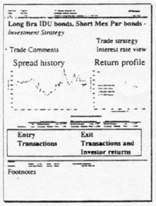
Examining an outright position
Entry and exit cash flows, and expected returns
A sample outright position is presented in Attachment 1, a long position in Mexico Par bonds. Under the heading "Entry transactions," we indicate the face value, sovereign spread, blended spread, price and market value upon the trade's entry. To the right of the entry transactions, under the heading "Exit transactions, " the results of the trade are presented for two different exit conditions:

- Forecast: sovereign spreads evolve as estimated by J.P. Morgan for 3- or 12-month horizons
- Current: sovereign spreads remain at today's levels.

The Investment Strategy shown in the attachment evaluates the return on a new dollar invested. Holding period return is calculated as exit cash flows divided by entry cash flows, minus one.

Spread history and return profile graphs
The Trade Sheet illustrates historical spread movements and return sensitivity graphically. The spread history graph at the upper left puts the current spread and J.P. Morgan sovereign spread forecast in historical perspective. Arithmetic averages are shown for the past 30, 90 and 360 calendar days. To the right of the spread history is the trade's return profile, which plots the sovereign spread at exit (Y-axis) against the resulting return on investment (X-axis). The return profile, reproduced as Exhibit 1, evaluates four distinct spread scenarios at exit:

- [F] Forecast: spreads move to levels estimated by J.P. Morgan
- [C] Current: spreads remain at today's levels
- [T] Tightest: spreads move to the tightest level observed over the last 90 or 360 days
- [W] Widest: spreads move to the widest level observed over the last 90 or 360 days.

Sovereign spread is plotted on the Y-axis for both the spread history and return profile graphs, simplifying the comparison of potential outcomes at the right with historical data on the left.

Trade summary and footnotes
The trade strategy and interest rate view are printed at the upper right. The trade strategy indicates whether or not interest rate risk has been hedged. The interest rate view indicates under which of the following three interest rate scenarios the analysis is performed
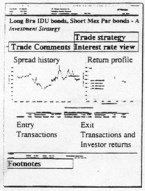
- Standstill rates: assumes an unchanged yield curve
- Forecast: yield curve evolves linearly over trade horizon to levels forecast by J.P. Morgan
- Implied forwards: yield curve evolves linearly over trade horizon to levels implied by the current yield curve.

Trade comments summarize the trade's outcome in three bullet points:

- Trade's expected return
- Forecast sovereign and blended spread tightening or widening underlying the expected return
- Returns achieved under exit spreads at widest and tightest levels.

The footnotes detail bid-ask spreads, interest rate and spread durations, and other key variables and assumptions used to structure the trades and estimate returns.
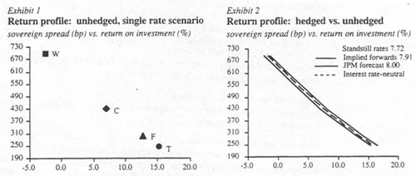

Using the Trade Sheet to evaluate and manage interest rate risk
An outright position in Mexico Par bonds is actually a bet on two individual variables: sovereign spreads and interest rates. Without an interest rate hedge, spread tightening may not necessarily generate profits. If Mexican spreads tighten but interest rates rise simultaneously, outright Par bond prices could actually fall, while a properly hedged Par bond position could still be profitable.

To help investors evaluate interest rate risk, we can expand the return profile graph shown in Exhibit I to compare return profiles under different interest rate scenarios. The solid lines in Exhibit 2 plot the return profiles based on standstill, implied forward, and J.P. Morgan forecast interest rates, with the indicative long bond at exit shown for each case. The dispersion between the lines will depend on the interest rate duration of the sovereign asset and the divergence of the three rate forecasts.

Hedging interest rate risk by structuring spread trades
Investors seeking to capitalize only on an expected move in spreads could hedge the position's interest rate exposure by simultaneously selling short a position in U.S. Treasuries, as detailed in Attachment II. This hedging approach is sometimes known as a "spread trade." The dotted line on the graph in Exhibit 2 shows the returns under the "interest rate-neutral" case. The hedged trade eliminates the return variability exhibited by the unhedged cases when interest rates change.

Structuring relative value trades
Profitability on a long position depends on absolute spread tightening, and hence a bullish outlook for the sovereign issuer. A less directional view can be taken by implementing a relative value trade, which consists of a long and short position in emerging markets assets. Properly structured, relative value trades rely on a tightening of the spread difference between two assets to generate positive returns. A relative spread tightening of one asset versus another can occur in a variety of spread environments (e.g. absolute spread levels widen or tighten) and as such, may have more predictability and less risk than outright positions. A typical relative value trade (long Argentina Par, short Argentina Discount) is shown in Attachment III.

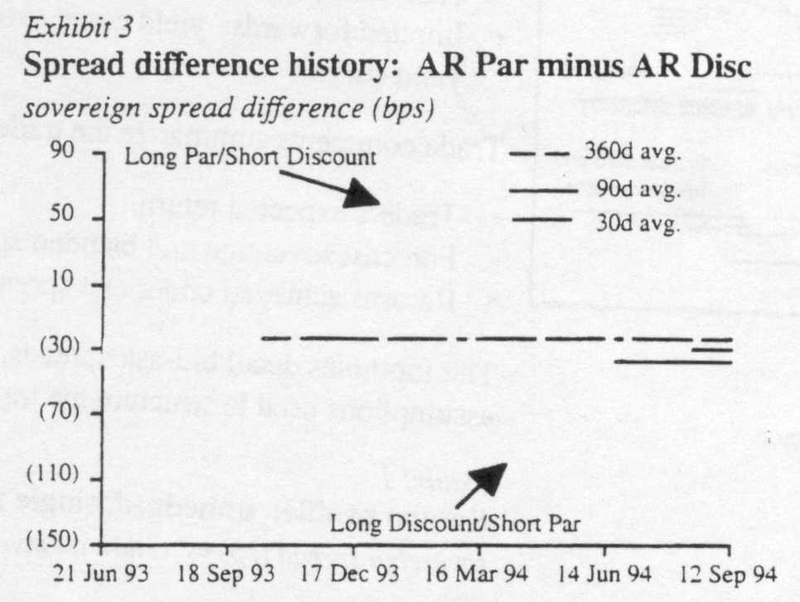
The historical relationship between sovereign spreads provides the analytical framework for establishing expected differentials at which one is "cheap" or "expensive" relative to another. The spread difference between Argentina Par and Discount bonds is reproduced in Exhibit 3.

The spread difference between these two instruments, which have similar spread durations, has tended to trade within a stable range around historical averages. As a result, an investor would consider buying Pars and selling Discounts when the spread difference rises towards the top end of the range, and executing the opposite trade when the spread difference falls toward the lower end of the range.

Differences versus outright positions
Two concepts unrelated to long positions are required to structure relative value trades: executing short sales and spread-neutrality.

Short positions in sovereign issues
The short position in the sovereign issue is structured via the same repo sale approach used to structure a short position in Treasuries. Collateral is assumed to be initially posted in an amount equal to 102% of the market value of the security sold short; the investor receives a sub-Libor return on the collateral, a rate which represents the cost of borrowing the short and which varies with each bond.

Spread neutrality
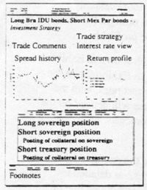
The face values of two instruments in a relative value trade are often set to be "spread duration-neutral." Spread duration measures the price sensitivity of a bond's market value to changes in sovereign spreads. Just as bonds vary with respect to their sensitivity to interest rates, bonds also vary with respect to their sensitivity to changes in spreads. Like interest rate-neutrality, spread-neutrality seeks to link the expected return primarily to movements in the spread difference.

Without spread neutrality, investors are not guaranteed to profit from correctly forecasting a netspread tightening, and could inadvertently create net Iona or short sovereign spread positions. A long Brazil IDU/short Brazil C trade, for example, would have to incorporate a much larger investment in the short-duration IDU for every $ 1.00 of long-duration C to avoid a net short Brazil position.

In Attachment III, the implementation of spread neutrality requires that only $6,300 of face value of Argentina Discounts need to be sold against a $10,000 face value position in Argentina Pars. When combined with a $4,700 short position in Treasuries, an investor would have neutralized exposure to both interest rates and absolute Argentina spread levels, betting only on a net spread tightening.

For investors actively seeking to implement directional sovereign or interest rate views, trades can also be analyzed based upon combinations that are not spread- or interest rate-neutral. Common configurations are trades structured based on equivalent face or market values.

Trade sheet formats: Swap Strategy vs. Investment Strategy
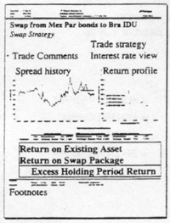
An alternative to the Investment Strategy format is the Swap Strategy, designed for investors seeking to maximize returns by "swapping" from an expensive asset already in their portfolio to a cheaper asset. In this instance, no new investor capital is required, and returns are expressed as excess holding period returns over the "do-nothing" case.

Attachment IV addresses the same Arg Par/Arg Discount trade as Attachment III, expressed as a swap instead of an investment. The format of the Swap Strategy is similar to the Investment Strategy, with the exception that the short position is simply the sale of an asset. The investor does not incur the incremental costs of having to borrow the security and post collateral, as the investor already owns it.

Another important distinction is that the investor does not contribute new capital. In the example, in order to maintain spread and interest rate neutrality, the investor finances that portion of the Par bonds position not funded by the sales proceeds on the Discounts. Conversely, if more cash were generated through a sale than was needed to purchase the new position, the excess would be reinvested in a U.S. dollar money-market account over the trade's horizon.

Leverage
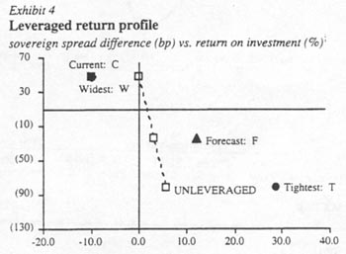
The increased predictability of relative value trades may justify the leveraging of trade returns, often in an amount that increases risk to levels comparable to that of an outright long position. Exhibit 4 demonstrates the impact of leverage for a long Arg Par/short Arg Discount trade. The dotted line represents the slope of the spread-return line when the trade is unleveraged, and exhibits considerably smaller return variability for a given change in spreads when compared to the leveraged case.

Intraday spreads and prices
Sovereign spreads and interest rates are often subject to significant intraday movements. Accordingly, the analysis is regenerated whenever changes in any of the component variables materially affect returns.

Enclosed are two laminated attachments which may serve as permanent documentation to the Investment Strategy and Swap Strategy products.

Related J.P. Morgan research
Prospective total return analysis: a security selection tool for emerging markets debt, April 1, 1993
Emerging Markets Outlook, (weekly)
Emerging Markets Economics Weekly
An emerging markets debt model portfolio, August 5, 1994
Refining our analytic framework for sovereign risk assessment, August 5, 1994

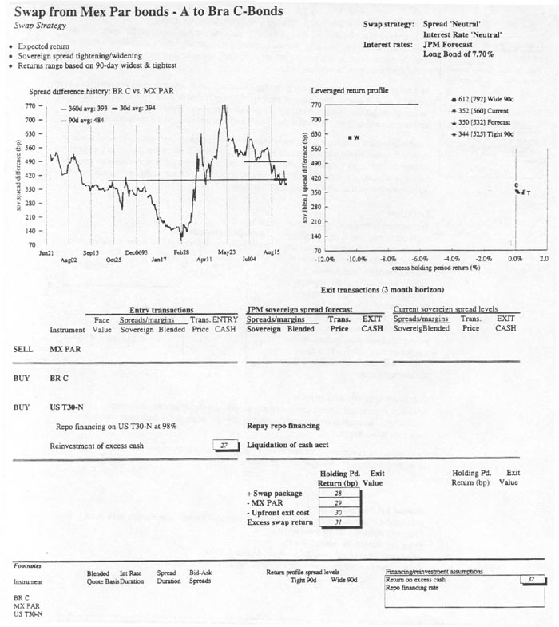

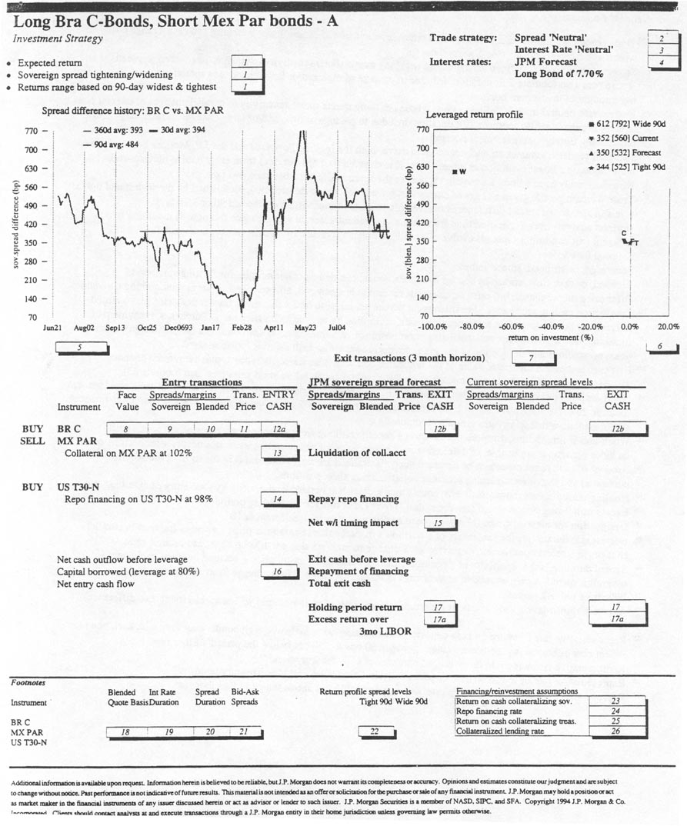

Trade Strategy
General Footnote;

¹ Trade comments summarizing the expected return, implicit spread tightening or widening and return range based on widest and tightest spreads (see also footnote 6).
² Spread-neutral trade is defined as one whose net (long minus short) sensitivity to changes in sovereign spreads at entry is zero (see also footnote 20); duration drift due to passage of time and/or large changes in spread may require rebalancing throughout investment horizon.
³ Interest rate-neutral trade is defined as one whose net (long minus short) sensitivity to parallel changes in interest rates at entry is zero (see also footnote 20); duration drift due to passage of time and/or large changes in rates may require rebalancing throughout investment horizon.
⁴ Standstill scenario assumes an unchanged yield curve; both the Implied Forwards and the J.P. Morgan Forecast scenarios assume a linear evolution in interest rates (i.e. constant # of bps per day) from entry date to horizon-end.
⁵ Historical analysis of a bond's sovereign spread or the spread difference between two bonds.
⁶ Trade's return profile given a range of changes in spreads (or spread differences), established by the widest and tightest levels in spreads or spread differences observed (daily close of business) over the last 90 or 360 days.
⁷ Horizon analysis over a specified time frame under a given interest rate scenario (see footnote 4) assuming two different exit conditions (spreads evolve as per J.P. Morgan's forecast, or spreads remain unchanged).
⁸ Original face value.
⁹ Sovereign, or stripped, spread in bps.
¹⁰ Blended, or cash flow, spread in bps for fixed-rate bonds; blended discount margin, for floating-rate bonds.
¹¹ Offer price on purchases, bid price on sales; the reverse at horizon-end, all expressed as per market quoting convention.
^{12a} Transaction cash requirements. For instrument purchases, equal to face value times transaction price plus accrued interest; for bonds quoted on an amortizing basis, multiplied by remaining balance ratio. Purchases, repayment of financing, and cash deposits collateralizing short positions are represented as cash outflows (negative sign); redemptions, borrowings and liquidation of margin accounts are shown as cash inflows (positive sign).
^{12b} Exit cash represents the future value of the liquidated positions after transaction costs, plus reinvested coupons.
¹³ The percent of a sovereign bond's market value left as initial collateral on short sales (see also footnote 23).
¹⁴ For short positions in U.S. Treasuries, the percent of the Treasury bond's market value left as initial collateral (see also footnote 25). For long positions in U.S. Treasuries, assumes that 98% of the value of the Treasury position is financed at representative financing rates (see also footnote 24).
¹⁵ When-and-if timing impact represents the timing benefit resulting from deferring purchases of w/i bonds until issuance; includes penalty, if applicable, of deferred receipt of proceeds for bonds whose issue date occurs after horizon-end.
¹⁶ Amount of cash requirements to be financed via collateralized lending; collateral is in the form of the securities purchased and the interest-earning accounts collateralizing short positions.
¹⁷ Holding period return (nonannualized); equals total exit cash at horizon-end divided by total entry cash, minus one.
^{17a} Excess of holding period return (see footnote 17) over Libor rate for the holding period.
¹⁸ Designation for blended quote [blended spread or discount margin) (see footnote 10).
¹⁹ Interest rate duration is the sensitivity of a position's market value (transaction price + accrued interest) to parallel changes in interest rates; herein expressed as % change in market value per 100-bp change in interest rates.
²⁰ Spread duration is the sensitivity of a position's market value (transaction price + accrued interest) to changes in sovereign spread; herein expressed as % change in market value per 100-bp change in sovereign spread.
²¹ Indicative bid-ask spreads.
²² Absolute spread levels used to determine return on investment for tightest and widest spread (or spread difference) levels.
²³ Representative rate of return on cash deposits collateralizing borrowed sovereign bonds; may vary with each bond to reflect cost of borrowing the bonds; ranges between 50 bps to 250 bps below the period's Libor rate.
²⁴ Representative financing rate on leveraged purchase of U.S. Treasury bonds.
²⁵ Representative rate of return on cash deposits collateralizing borrowed U.S. Treasury bonds.
²⁶ Representative collateralized lending rate, assumed to be 100 bps above the period's Libor rate.

Swap Strategy
General Footnotes

The Swap Strategy assumes the sale of an existing security, and the reinvestment of the proceeds in a package of assets whose interest rate and sovereign spread sensitivity at entry is similar. The graphs and line items on the Swap Strategy report are the same as the Investment Strategy report, with the exception of the following:

²⁷ If the cash proceeds from sale are more than (less than) the market value of the long position and the cost of Treasury positions, then the excess (shortfall) will be invested (financed). Investments occur at a representative reinvestment rate for the term; shortfalls are financed at a spread over term Libor.
²⁸ Nonannualized holding period return on the Swap package includes exit values of the sovereign and Treasury positions, the liquidation of any collateral or excess cash accounts, and the repayment of any borrowings.
²⁹ Nonannualized holding period return on the existing position had it been held throughout the investment horizon. The upfront exit cost of selling the existing position (see also footnote 21).
³⁰ The "pickup," or excess return recognized over the trade's horizon by swapping from the existing security to the Swap Package, expressed in bps.
³¹ Representative reinvestment rate for excess cash.

The short position is assumed to be executed through a repo sale of the long bond. Face values are determined by matching the interest rate dollar duration of the long bond to that of the Mexico Pars.

