Developling strategy for a not-so-global village
The idea of global economic convergence has proven to be a myth, making data gathering on emerging markets essential. Philip Parker points the way to information sources
Philip M. Parker is Eli Lilly Chair Professor of Innovation, Business and Society at Insead.

Back in the early 1980s, many argued that a globally standardized strategy was the future. Convergence and standardization went together. Why? Because consumer tastes and preferences were converging across regions, countries and economies. The idea was that companies should cut costs and conquer the world with global economies of scope, scale and branding. Geographic differences would disappear as managers focused on the global village. If you are still thinking this way, it is time to reconsider. The data are in, standardisation is out.
Eighty per cent of companies divide the world into three time zones: the Americas (Latin America being run out of Miami or New York); the Asia Pacific segment, encompassing Beijing, Sydney and everything between; and the Euro segment (Africa and the Middle East being handled out of London, Paris, Geneva or Athens). This allows managers to communicate within a segment in business hours.
What are the options? One might consider cultural segments (language, religion, ethnic groupings), economic segments (poor, less poor and affluent), levels of industrialisation or similar structures. Yet few regional manager would champion such a strategy for product development, pricing, communications or supply. Each region would need to depend on and co-ordinate with all others.
Economics tells us that segmentation in either quality or price leads to higher monopolistic profits when one company does it well and others stumble. One would never segment if all consumers or buyers had the same preferences and faced the same sup pliers. Arguments to globalise and standardise are based on a belief that markets are converging. Are they?

Convergence
In the 1980s and mid-1990s, managers saw Indonesia, Vietnam, India, Latin America and, to some extent, Africa as growth markets. It was thought that around half of the planet's population would shortly reach the standards of North America, northern Europe, Japan, Australia and New Zealand.
Emerging markets were ready to take, major products from developed markets and the demand would be explosive. These bad assumptions produced bad results. Companies that planned for convergence paid the price in excess capacity and devalued assets. Was this foreseeable? Yes, but only by accepting three economic regularities: income, consumption and supply divergence; spatial correlation; and physioeconomic forces.

Divergence dynamics
In the 1960s, some economists came to believe economies would converge in the long run. Evidence of convergence is seen, for example, between the economies of European countries after the second world war and that of the US (as measured in terms of income per capita, car ownership per capita and so on). When two countries converge to the same or similar level of economic behaviour or consumption, this is called "beta" convergence.
Based on theories of diminishing returns, among others, it was felt that highly developed countries would have slow growth rates, whereas poor countries would have high growth rates. Extrapolations over 30 to 50 years suggested that all countries would eventually have similar consumption patterns.
Since the 1970s, however, economists have come to recognise that not all countries are converging. They have also come to recognise that this phenomenon can be traced back over centuries. In fact, there has been a gradual and predictable divergence.
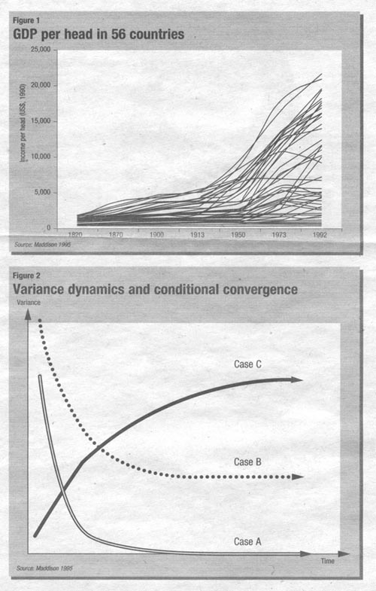
These two forms of convergence are represented in Figure 1. It shows that most economies had similarly low incomes per head before the Industrial Revolution. Academic Simon Kuznets and others have also shown the average person had a precarious, if not subsistence, standard of living.
Things started to change, however, in the 16th century, when Europe's income per head began to rise. After the Industrial Revolution began in Britain in the late 18th century, the pattern of divergence was large enough to be seen as a non-random event. Since the 1800s, rich countries have grown faster than many poor countries, causing global divergence. Today there are poor and wealthy countries, whereas 500 years ago there were really only poor countries. Beta convergence as conceived in the 1960s has not happened and does not appear to be happening.
In the 1980s, a new view of convergence came into vogue, called "sigma convergence" or "conditional convergence". In this view, countries form "convergence clubs". Members of each club converge with each other, but no two clubs will ever look alike,
In mathematical terms, this view holds that worldwide economic behaviour converges to a stationary level of "variance" or permanent divergence. Figure 2 illustrates various scenarios within this view. In the, case of absolute beta convergence, where all countries converge to the same level of consumption or supply, one will observe variances across countries falling to zero, as in Case A.
This has been shown to be the case, for infant mortality, death and birth rates, life expectancy and literacy. For these development indicators, variances were great 100 years ago, but today are small, with similar absolute levels being reached by all countries.
If variances fall, but do not reach zero, this indicates that countries are, not converging in an absolute sense, but that the variance is stabilising. Shown as Case B, therefore, the world began with high variance, but this narrows over time. In fact, long-run consumption per head across countries remains divergent. This case is not very common in economic data.
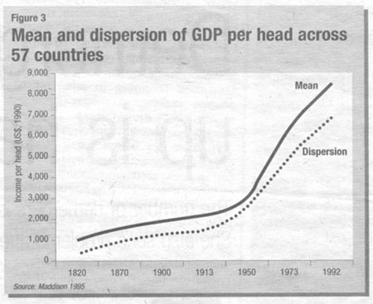
In Case C, the world starts in a convergent state (that is, all countries are equally poor), but over time diverges to a constant level of variance. Case C is observed today for economic behaviours involving consumption of goods and services. Figure 3, for example, plots the mean and variance of income per capita from the country data in Figure. 1. Dispersion has increased while income per capita has also generally increased on average.
Some countries, however, increased consumption dramatically, while others did not. Of the three convergence cases, Case C exists for virtually all economic activity, when measured per capita, irrespective of industry. However, it only exists when considering countries that span different geographic regions. For example, if we examine only countries in the Nordic region, Case A appears. If one adds southern European countries to these data, we observe Case C.
Today, economists are debating the conditions that lead to Case C. Clearly, the long-term dynamics of some countries lead to low levels of income or consumption, while others lead to high levels. What is it that makes a country permanently consume less than others? If we know the factors driving divergence, what are the growth implications for global companies segmenting by country?

Spatial correlation
A telltale sign of factors driving conditional convergence, or beta divergence, is the fact that economic indicators are spatially correlated. In other words, growth dynamics of neighbouring countries are not independent. Similarly, the economics of two adjacent locations seem to exhibit beta convergence in the long term—Case A in Figure 2.
This spatial correlation is not symmetric in all directions, however; growth patterns will be more similar among some neighbours than among others. Provided countries have similar political regimes, economic systems and absolute latitudes, all seem to converge to similar behaviour. However, if one takes countries along the same longitude, neighbours are less similar 'to each other than to countries an equal distance away along the same latitude.
Stated differently, countries of the same absolute latitude and political system have similar growth dynamics. In particular, the farther a country is from the equator (all other factors held constant), the higher its income and consumption per capita in the long run. This is called the "equatorial paradox". Exceptions to this rule are non-capitalist countries such as North Korea, countries extremely rich in resources such as Brunei or Kuwait, or strategic locations such as Singapore and Hong Kong.
The colder countries of the world (whether adjacent neighbours or not), seem to be converging to the same level of economic wealth and consumption. Absolute latitude, in fact, explains some 70 per cent of the cross-country variances in income per head and is the single most important factor explaining economic divergence compared with many other variables. Convergence clubs are, in fact "climatic clubs". This effect has been increasing since the second world war, especially as more countries adopt capitalist economic systems.
Why is this? First, it is clear that all value chains end with a consumer. All industrial products are transformed via manufacturing or some other value-enhancing process, which, in turn are transformed or distributed to end users. These users consume clothes, housing, food, entertainment, transportation and other goods (clothes, food and housing represent between 60 and 95 per cent of all things consumed on the planet). Countries that are hot all year round will, in the long term, consume less clothing, food, housing and energy.
While this view of conditional convergence may seem obtuse, it has secure roots in physics and its effects on human physiology. The world is not a set of countries, but climatic zones with varying resources bases and economic regimes.

Physioeconomic forces
Which countries will have faster economic growth in the long term? According to physioeconomics, high growth rates can be expected from countries that currently have low levels of consumption compared with other countries -in the same convergence club (that is, countries with similar climates and terrain, or similar natural resources). It is not appropriate, in this view, to compare France with Panama, given that the two countries are not members of the same convergence club. Rather, France should be compared only with countries in its convergence club (such as Germany or the UK), or having similar starting conditions (such as climatic or geographic conditions).

What to do about it
It appears that having a grasp of supply and demand differences across countries is necessary to divide global markets rationally. Unfortunately, the data to identify these differences are difficult to come by, especially if one needs very specific information across some 200 countries. Going global means research. This section describes how to gather global data and, market intelligence on countries outside the top 25 markets by following six steps.

Step 1: Report aggregators
Start with web-based aggregators and directories. These services typically do not publish -the reports they sell, but redistribute reports across some 100 publishers. From these, the user can often purchase only the paragraph or chapter of a report of interest. The advantage of these aggregators is that their studies go beyond Anglo-Saxon markets. A good list to start with includes:
www.commercial.ecnext.com;
www.marketresearch.com;
www.mindbranch.com;
http://nlresearch.northernlight.com/market_research.html;
www.profound.com.
Some of these sites require a subscription, while others can be freely searched. Some allow reports to be downloaded directly.
Some aggregators combine market research data with financial data:
www.hoovers.com;
www.tfsd.com;
www.multex.com;
www.xls.com.
All of the above should be searched. In addition, most countries have sites which aggregate or list market research, such as Chinaonline.com. These are too numerous to list here, but are only available for some countries. Add to this list the larger internet book retailers, because these are beginning to list such research on their sites, and e-book sellers, such as Mightywords.com (select business).

Step 2: Global publishers
A number of sources specifically cater to the global intelligence market by supplying research reports, benchmarks and data across most industries. Examples include:
www.eiu.com;
www.euromonitor.com;
www.icongroupedition.com (complementary culture data).
Serious business research libraries or business intelligence centres that are global or regional in focus tend to require subscriptions.

Step 3: Public sources
Public bodies are an excellent source of global data, though these cover only general demographic and economic data.
www.worldbank.org (select data);
www.cia.gov (select the world factbook);
www.imf.org (select country information);
www.wri.org (select publications).
Various agencies also sell data, such as the International Telecommunications Union (www.itu.org,, select databases).

Step 4: Global references
In addition to market reports and data from the above, much can be gleaned from news sources with a global perspective. These articles will often cover the activities of competitors across countries and are the sources for many of the reports that are for sale above. The following are a good start:
www.economist.com;
www.ftdynamo.com;
www.factiva.com (Reuters business briefing).
Downloading from these sources may require a corporate subscription.

Step 5: Specialists
The last step involves research specialists and boutiques, not all of which have placed their data or reports with the aggregators, but nevertheless sell global studies. These are typically specialised in a vertical market (such as chemicals or electronics), and, have created websites selling their research, such as Strategisgroup.com for telecommunications. Space limitations prevent a full listing here, though these publishers are generally listed as sources in the websites mentioned in Step 1.
Some aggregators focus on particular industries. For example, Allnetresearch.com focuses on internet research and Aktrin.com specialises in furniture.

The last step
The last step of the proem, of course, is analysing and synthesising data to generate a segmentation strategy. This will probably take a few weeks. The analysis would certainly focus on the similarities between markets, but also their substantial differences. Ignoring time zones, one can quickly surmise, for example, whether a strategy or competitive structure found in the Philippines is likely to arise in a similar fashion m West Africa or Latin America.
Uncovering such wisdom, however, may lead to problems. The hard part becomes matching this wisdom with the situation of your company. You may realise that segmenting by absolute latitude, income per capita, language or some other measure is the best strategy, but your company is organised by time zone and that only a central authority can co-ordinate an alternative approach. What regional manager will volunteer to change the status quo? The steps above will look trivial compared with managing that problem.

Further reading
* Kumets, S. (1971) Economic Growth of Nations, Cambridge, MA: Harvard University Press.
* Maddison, A. (1995) Monitoring the World Economy, Paris: Development Centre Studies, OECD.
* Parker, P.M. (2000) Physioeconomics: The Basis for Long-Run Economic Growth, Cambridge, MA MIT Press.
* Rothman, T. (19951) Instant Physics: from Aristotle to Einstein, and Beyond. New York: Byron Press.

