DBS Swap Partial Early Termination

Date: 11 -Mar-96 Q1292
To: Jim Webb
Long Term Capital Portfolio L.P.
FAX, (203) 861-7048

From- Craig Bergstrom
Morgan Stanley & Co. International Ltd
(212) 761-6352
FAX. (212) 761-0030

Begining: 11 -Jan-96 Spread A: 0.50%
Ending: 8-Mar-96 Spread B: 2.%
Day Count: 57 Sibor: 2.75%

Party A: MS1 Party B: Counterparties
Number of Shares., 168,000 Number of Shares: 168,000
Notional A- 1,780,800 Notional B: 3,124,800
DBS1 10.6 DBSf 1 18.6
DBS2 (net) 10.2333 DBSf2 (net) 19.3814
Dividends/share 0. Dividendstshare 0.
Spread A: (1,410) Spread B: 9,895
Notional Diff Finan: 5,BS2
Unwind Fee 402,367
Party A Pays 345,204 Party B Pays 141,170

Total Net Swap Value- 204,033 SGD

For Value:

Thank you, and best regards,
Morgan Stanley & Co. International Ltd

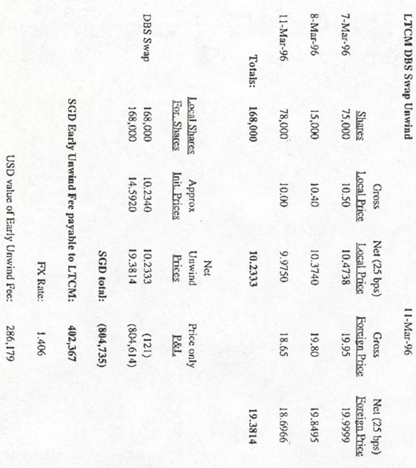

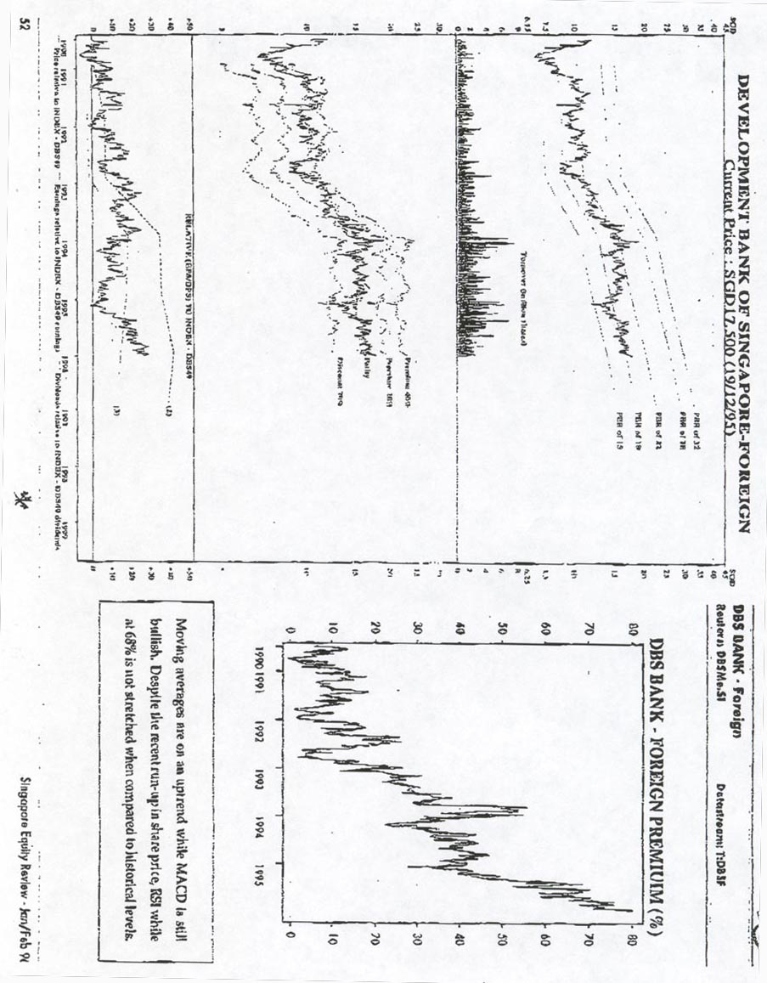

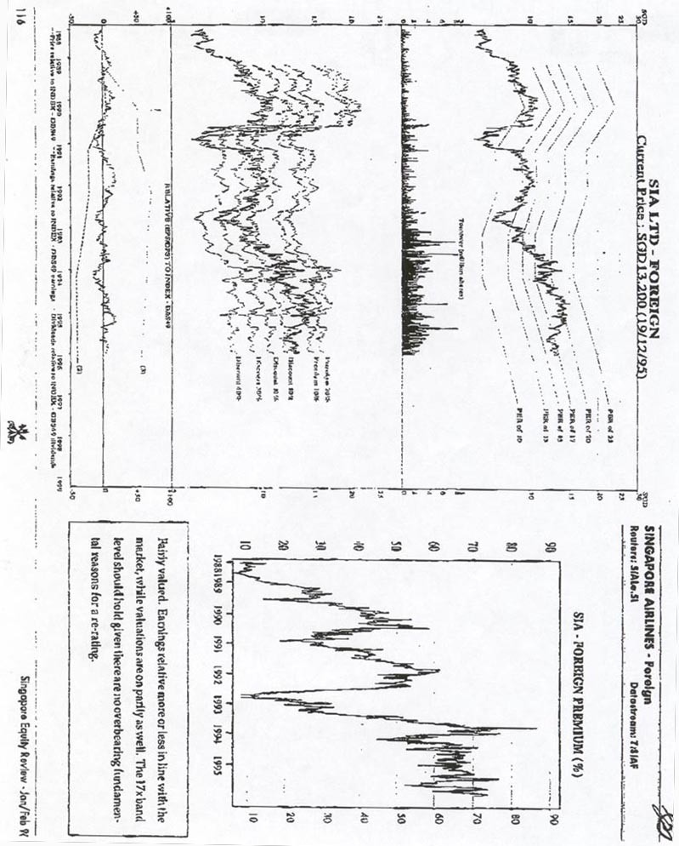

BZW Pacific Union
Private Limited
Foreign premium or local discount
Why pay less?

Of the listed companies on the Stock Exchange of Singapore, 17 countries have dual listings with the foreign share commanding a premium over the local share. In particular, the range of foreign premium on the banks have risen to a current high of 44.9%-73.6% from 12.3%-41.7% in end-1992. Since the foreign shares are not trading on excessive PE levels, we can only conclude that the local shares are sitting on deep discount at the moment.

- The expansion in foreign premium to record-breaking levels was precipitated by the decline in the local bank share prices in 1995. Local bank share prices declined by an average of 1.12% in end-1995 over end-1994 while the foreign average prices were up 14.0%

- Foreign premium is not expected to collapse overnight due to a proper regulatory framework and the lack of arbitrage opportunities. There is no provision for golden shares in the banks, and we do not expect the government to raise the foreign shareholding limit from the current 40% when its credibility is at stake. On their own, bank directors have the discretion to disallow transfers of local shares into foreign shares, thus closing the loophole for those who wish to ride on the premium for a quick profit.

- The level of foreign premium on the bank shares is increasingly irrelevant as long as the valuations on the foreign bank stocks are fairly- or under-valued. Assuming that the local share price remains constant and the foreign share is fully-valued in PE terms, then a theoretical range of critical level of premium could be as high as 62%-97%!

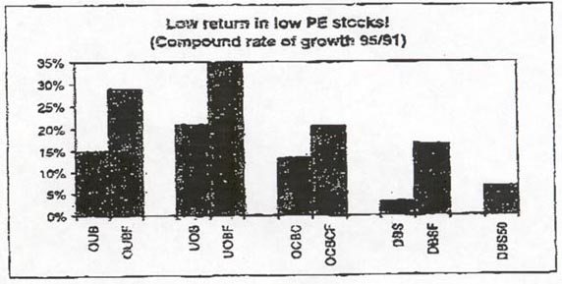

…but after the bull-run in 1993 because of
the higher return on the foreign shares

The next major uptrend in the foreign premium chart showed an interesting phenomena, where the premium expanded on the back of falling local share prices despite steady earnings growth prospects for the banks. This showed a switch in the demand for local shares into foreign shares, which enjoyed a higher variance of return because of the larger pool of investors in the foreign tranche relative to that in the local tranche.

The table below shows the lower rate of return on the local shares relative to the foreign shares. This shows that as long as the valuation on the foreign shares were attractive, the widening premium on the foreign shares was becoming an irrelevant decision.

Table on the local and foreign
share prices taken at year-end…

…shows the real currency is in
the foreign shares

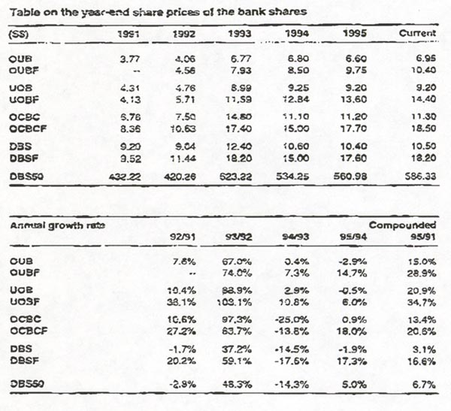

Any dip in the premium would trigger
a switch from local to foreign

Hence the real currency is in the foreign shares, by virtue of the relative outperformance and the low liquidity in the local bank shares. Over the medium to long term, rational expectations on the low returns will be built into the local share prices, which will ensure that foreign premium do not disappear, and that any dip in the foreign premium to below average would trigger a switch from local to foreign shares.

Critical range of the foreign
premium is 62%-97%

Critical level of foreign premium
If the banks’ foreign shares are valued on price earnings ratio, price to book ratio and earnings per share growth, then a critical level of the foreign premium could be defined as one where the foreign share price becomes over-valued or fully-valued on the PER band, assuming that the local share prices remain constant.

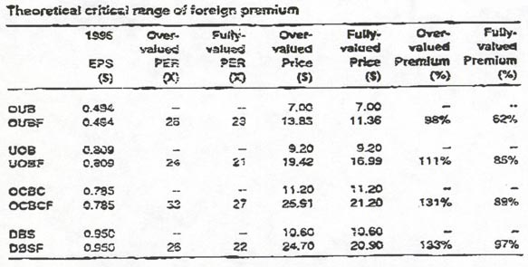

… assuming that foreign prices are fully-valued
on PE terms and local prices remain constant

The exercises above assumes that the local price in end-1996 is measured by the earnings growth of 1996 over 1995. On the other hand, the foreign share price is measured on a prospective 1996 PER basis, at the points where the shares are doomed as (I) expensive; or (II) fully-valued.

The idea above seems to indicate that the foreign bank shares are fully-valued when the foreign premium hit the range of 62%-97%. However, the psychological trauma that a foreign fund manager has to endure to buy the shares at this level suggests that the foreign share price may peak before this level is breached!

Collapse of foreign premium

Premium not likely to
collapse due to…

In a worst case scenario, the foreign premium on the banks could disappear if there is a change in the regulatory framework, or when arbitrage opportunities arise.

Changes in the regulatory framework could include:

… golden share theory…

- Assigning a golden share to the MAS. This is not likely to happen as three of the big four banks are privately-owned. As a matter of interest, Sing Tel has a 40% foreign limit despite the government owning one golden share in the company. 2

… raising foreign shareholding limit…

- Increasing the foreign shareholding limit to 49%. This is a viable option, except that the government would have done it in 1990 when it increased the limit from 20% to 40%. Also, the credibility of the government is at stake, particularly when it has been actively promoting Singapore’s fund management industry.

… or investing CPF funds in the local shares
to narrow the gap

- Investing domestic funds in local bank shares. This would amount to increasing the wealth of the bank shareholders at the expense of the taxpayers. Besides, the authorities has been encouraging the active management of the CPF funds by individuals and approved CPF unit trust fund managers. This indicates that the direction is clearly towards an active management of funds by the private sector, rather than discretionary use of CPF funds by the government.

Share price performance

Lack of arbitrage opportunities to
convert local into foreign shares

Meanwhile, the lack of arbitrage opportunities would prevent shareholders from switching from the local into foreign shares. The Directors of the local banks have the sole discretion to refuse to register any transfer of shares from local into foreign, including the cases where the foreign shares would be held as a nominee.

Periods of weak foreign premium

Premium may disappear on
near-bottom market conditions

The periods where the foreign shares traded at a discount relative to the local shares tended to coincide with the times of near-bottom market conditions.

Where the premium will head in the future will depend on market conditions. With the local course underpinned by sound economic fundamentals and the inflow of foreign institutional funds, the foreign premium is likely to remain steady or inch higher if valuations remain attractive.

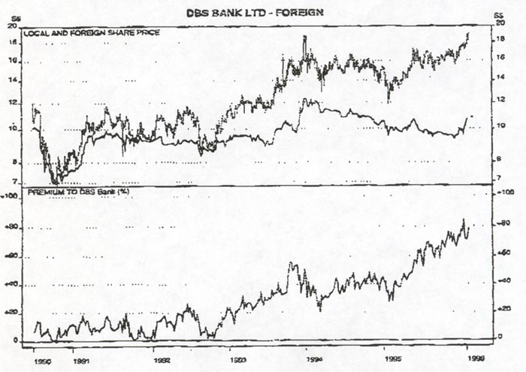

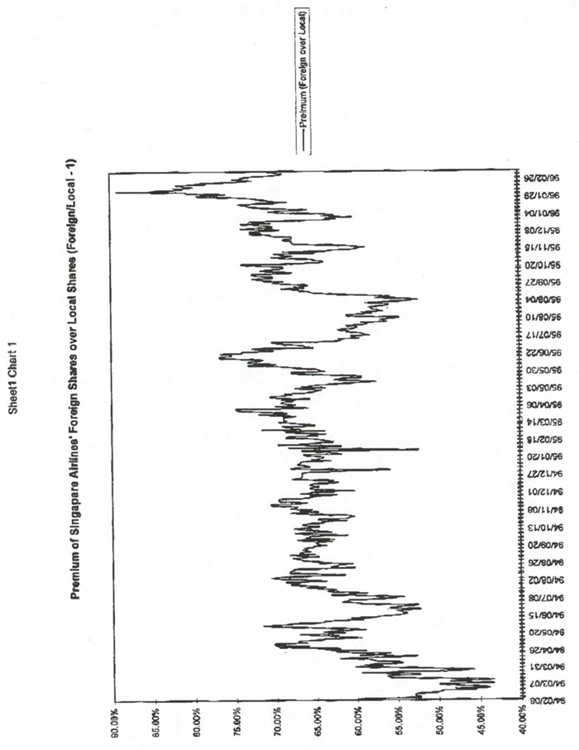
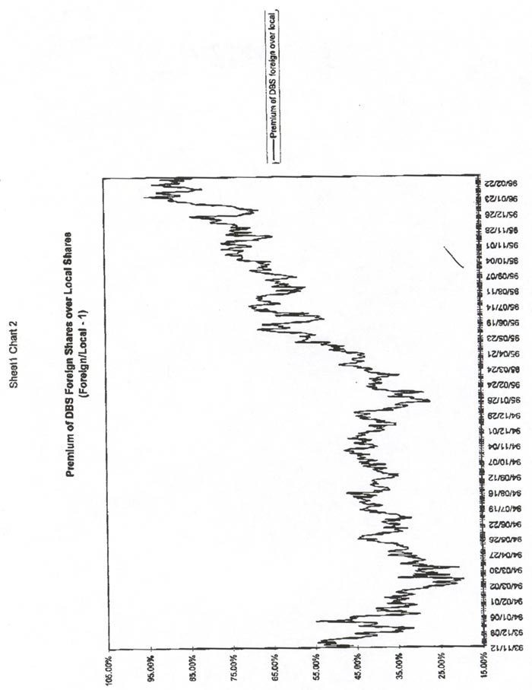

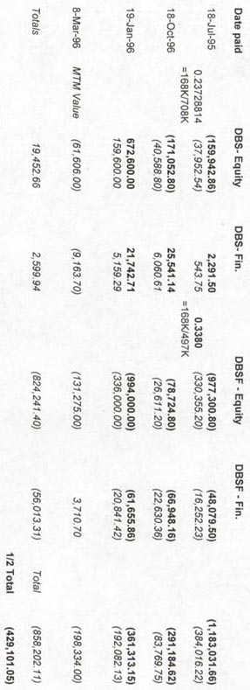

2 However, regulatory controls exist as the approval from the Monetary Authority of Singapore is needed for a single person to hold 5% or more of a Singapore-incorporated bank.

