The Cost of Capital: Misused, Misunderstood and Misapplied

Aswath Damodaran
April 2016

Abstract
There is no number in finance that is used in more places or in more contexts than the cost of capital. In corporate finance, it is the hurdle rate on investments, an optimizing tool for capital structure and a divining rod for dividends. In valuation, it plays the role of discount rate in discounted cash flow valuation and as a control variable, when pricing assets. Notwithstanding its wide use, or perhaps because of it, the cost of capital is also widely misunderstood, misestimated and misused. In this paper, I look at ten broadly held misconceptions about the cost of capital, how these misconceptions feed into investment mistakes and how to avoid them in practice.

What is the cost of capital? If you asked a dozen investors, managers or analysts this question, you are likely to get a dozen different answers. Some will describe it as the cost of raising funding for a business, from debt and equity. Others will argue that it is the hurdle rate used by businesses to determine whether to invest in new projects. A few may use it as a metric that drives whether to return cash, and if yes, how much to return to investors in dividends and stock buybacks. Many will point to it as the discount rate that is used when valuing an entire business and some may characterize it as an optimizing tool for the deciding on the right mix of debt and equity for a company. They are all right and that is the reason the cost of capital is the Swiss Army knife of Finance, much used and oftentimes misused.

The Mechanics
The cost of capital, in its most basic form, is a weighted average of the costs of raising funding for an investment or a business, with that funding taking the form of either debt or equity. The cost of equity will reflect the risk that equity investors see in the investment and the cost of debt will reflect the default risk that lenders perceive from that same investment. The weights on each component will reflect how much of each source will be used in financing the investment. Figure 1 captures the key ingredients.
Figure 1: Cost of Capital Ingredients
This relatively simple construct has estimation questions embedded in it, including how equity investors perceive risk and convert that risk into a required return and what lenders consider in making their judgments on the default spread. There are also questions about what tax rate, the effective or the marginal, to use in the assessment to best capture the tilt in the tax code towards debt.
If you make it through the mechanics of computing cost of capital, you will see it described as an opportunity cost, a discount rate and a hurdle rate for investments and it is all of the above depending upon where it is being used and by whom, as delineated in figure 2:
Figure 2: The Cost of Capital as Swiss Army Knife
For investors in companies, the cost of capital is an opportunity cost in the sense that it is the rate of return that they would expect to make in other investments of equivalent risk. For the companies themselves, it becomes a cost of financing, since they have to deliver returns that beat or at least match the cost of capital to keep investors happy. Finally, within the company, especially if it is in multiple businesses, the cost of capital can take the form of a hurdle rate on investments, though it can be different for different businesses, if they have different risk profiles.

The Misconceptions
While the cost of capital is the most studied, researched and analyzed number in all of finance, it remains the source of many misconceptions. These misconceptions, in turn, feed into valuation and corporate finance mistakes, some of monumental proportions.

Misconception 1: The cost of capital is the receptacle for all your hopes and fears
The misconception: Some analysts seem to regard the cost of capital, specifically, and discount rates, more generally, as receptacles for their fears about the future. Thus, when valuing a biotechnology company with products that are in the FDA pipeline, they feel the urge to increase the discount rate to reflect their fears of FDA rejection. Similarly, when valuing a Venezuelan company, where they fear that the company may be nationalized, they move the discount rate up to incorporate the fear of nationalization.
Reality: The cost of capital is a going concern construct and is thus ill-equipped to deal with discrete risks, including regulatory approval (for the biotechnology company), nationalization or default risk. Those risks are better captured either in the expected cash flows or as post-valuation probabilistic adjustments (using decision trees or scenario analysis). Thus, the value of a Venezuelan company that is exposed to nationalization risk can be estimated by first valuing the company as a going concern (with the cost of capital of a going concern), then estimating the probability and consequences of nationalization and estimating an expected value across the going concern and nationalization scenarios. In addition, the cost of capital for a company should reflect the risks that the marginal investor in the company sees in the investment, not what the managers see. In a private business, this may be an empty distinction since the owner is often the manager, but in a public company there can be a significant contrast between the two, since the marginal investor may (and often is) a diversified institutional investor and the manager may be over invested in the company.
Damage done: Making intuitive judgments about the cost of capital based upon perceived risk in the company can be dangerous, because you will tend to try to include both truncation and diversifiable risks in your estimate. That will lead you to undervalue companies that are over exposed to one or both of these risks, and especially so, if these companies are publicly traded.

Misconception 2: If you don’t believe in portfolio theory (and betas), you cannot compute a cost of capital.
The misconception: Over the last few decades, developments in portfolio theory have altered the way we estimate risk and compute the cost of capital. In addition to bringing in the notion of the diversified marginal investor and with it, a redefinition of rewarded risk (as only market or non-diversifiable risk), we have also shifted to price-based measures of risk. Thus, the beta in the capital asset pricing model is estimated by regressing past returns on a publicly traded stock against a market index and is used as a measure of market or non-diversifiable risk. There are many practitioners and academics who disagree with one or both building blocks of modern portfolio theory, and for good reasons. The mistake that they make is that they then proceed to abandon either all risk adjustment, using the argument that Warren Buffett uses the risk free rate in his valuation, or relay on arbitrary discount rates that reflect gut judgments rather than fundamental assessments of risk.
Reality: Even though you may disagree with the assumptions that the marginal investor is diversified and that risk is best measured using market prices, you do not have to throw the entire risk adjustment architecture. In figure 3, I list the alternatives that exist to traditional risk models in finance and how they can be used to replace a CAPM beta or a portfolio-theory based expected return:
Figure 3: Risk Measures – Alternatives
In summary, if your peeve is with the “diversified investor” assumption, you can shift to total risk measures, whereas if it is with the use of price-based risk measures, you can move on to accounting data or sector-based risk measures. You can even become model-agnostic and use implied costs of capital for sectors, where you compute the implied cost of capital for individual companies, based upon current market values and your estimates of expected cash flows, and use the sector averages for individual companies.
Damage done: In their zeal to abandon anything associated with modern portfolio theory, many practitioners have abandoned common sense. By not adjusting for risk in the discount rate and trying to incorporate it elsewhere, in the forms of large haircuts to cash flows and arbitrary margins of safety on value estimates, they often double count and triple count risk.

Misconception 3: If the risk free rate decreases (increases), the cost of capital should go down (up).
Misconception: Since both the cost of equity and debt are built on a base of a risk free rate, it seems logical that reducing (increasing) that risk free rate will reduce (increase) the cost of capital as well. That change in the cost of capital, if you hold cash flows static, will translate into changed valuations. It is this logic that seems to lie at the heart of the relentless push to “lower” interest rates on the part of central banks, eager to see more reinvestment and real growth in the economy.
Reality: It is very seldom that risk free rates move without anything else changing at the same time. In particular, as risk free rates changes, risk premiums on both equity and debt also change, resulting in costs of capital that can move unpredictably. This effect can be seen in figure 4, when I estimate the implied costs of equity for US stocks from 2000 to 2015, and break down these expected returns into risk free rates and equity risk premium components.
Figure 4

Note that while the risk free rate has decreased especially since the 2008 crisis, the implied cost of equity (the rate of return that investors demand for investing in stocks) has remained relatively sticky at about 8%. Put differently, the decrease in risk free rates has been offset by an increase in equity risk premiums over this period.
Damage done: If you use static risk premiums (based upon long historical time periods) and the only number that is dynamic in your cost of capital calculation is the risk free rate, your valuations will be inflated during low interest rate time periods (and everything will look cheap) and deflated during high interest rates periods (where nothing will look cheap).

Misconception 4: A company that is listed in an emerging market should have a higher cost of capital than one in a developed market.
Misconception: If there are more risks (micro and macro) from investing in emerging markets, it seems to follow that companies that are listed in these markets should have higher costs of capital than those listed in developed markets. This proposition gets even more heft when the cost of capital for an emerging market company is computed in the local currency, where risk free rates are often high. Thus, the cost of capital for an Indian company, in Indian rupees, will be higher than the cost of capital for a US company, in US dollars.
Reality: The first step in deconstructing costs of capital is separating currency effects from risk effects. In January 2016, the risk free rates in different currencies are listed in figure 5:

Note that the government bond rates are being adjusted for the sovereign default risk in the attached governments, to try to capture a risk free rate in each currency. To the extent that the variation in risk free rates across currencies come from differences in expected inflation, the cost of capital for any company (and not just an emerging market company) will be higher, if it is computed in a higher inflation rate currency. There is the additional component of country risk that can make equity risk premiums higher in some markets, as captured in figure 6:
Figure 6: Equity Risk Premiums around the Globe – January 2015
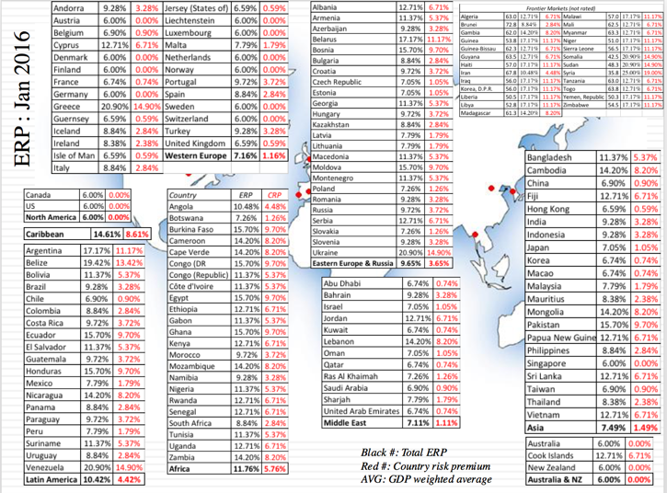
However, the exposure to Brazilian, Russian, Chinese or Indian country risk is not restricted to companies that are incorporated in these countries but to all companies that operate in these countries. To value Coca Cola (a US-incorporated firm) or Vale (a Brazil-based mining company), you should be looking at their operations (revenues or production) across countries and looking at a weighted average equity risk premium, as shown in Figure 7.
Figure 7: ERP for Companies – Vale & Coca Cola

Damage done: Attaching higher country risk premiums only to emerging market companies and ignoring them for developed market companies will result in the former being undervalued, especially when they derive large portions of their revenues in developed markets, and the latter being overvalued, when they are multinationals with significant emerging market exposure. These dangers are compounded by currency mismatches, where discount rates are estimated in one currency but the cash flows are estimated in a different one.

Misconception 5: A company should use its cost of capital as the required return (hurdle rate) on all investments
Misconception: The term cost of capital suggests that this a cost of financing, reflecting the costs faced by a company when it raises capital in the form of debt and equity from the market. It is therefore natural that many companies (and investors) seem to then consider this cost of capital as the discount rate that should be used to judge all investments, whether it be in internal projects, acquisitions or even cash.
Reality: The cost of capital is the opportunity cost for investing in assets/projects of equivalent risk. Thus, a food processing company that is considering acquiring a technology company cannot use its (a food processing) cost of capital as the discount rate in assessing the technology project. By the same token, an investment in cash, a close-to-riskless, liquid investment should be required to generate a much lower rate of return (akin to a risk free rate) to break even.
Damage done: When a company uses one cost of capital on all of its investments and is in multiple businesses, it will over invest in its riskiest business, with its safest business subsidizing that over investment. Not surprisingly, when doing acquisitions, it will find that riskier businesses look cheap and go on ill-fated value-destroying binges that over time.

Misconception 6: If a company earns a return on invested capital that is higher (lower) than its cost of capital, it has made good (bad) investments.
Misconception: Over the last three decades, the good news is that investors have taken to heart the lesson that growth creates value only when accompanied by excess returns. The bad news is that these excess returns are usually measured by comparing the return on invested capital (or return on capital employed) with the cost of capital. In both corporate finance and valuation, return on invested capital has therefore become the magic number, the number that separates good companies from bad and high values from low.
Reality: The return on invested capital is a useful number, but it is an accounting number, with operating income in the numerator and the book value of invested capital in the denominator. While holding all else constant, having a high return on invested capital is good news, there are numerous scenarios where this accounting return can be a misleading measure of investment quality, especially for companies with significant R&D spending, acquisitive firms and young businesses. Figure 8 lays out the limitations of return on capital as a measure of investment quality.
Figure 8: The Limitations of Return on Invested Capital
There are no easy fixes for most of these limitations. It does mean, though, that when doing valuation or corporate financial analysis, knowing last year’s return on capital is useful but not definitive, since it is your assessment of future returns that will drive value.
Damage done: The most rigid valuation models, especially with accounting roots, are built around returns on invested capital. These models use last year’s return on capital to develop fade factors for excess returns and estimate value as a function of those excess returns. Not surprisingly, these models work best for mature companies that have tangible asset bases and worst for young companies or companies in transition.

Misconception 7: The effect of increasing the debt ratio, on the cost of capital, is predictable.
Misconception: One of the enduring shortcomings of corporate finance classes is that by the end of these classes, you leave with one of two lessons. One is from the Miller Modigliani theorem, where a changing debt ratio has no effect on the cost of capital since whatever is gained by using debt (that debt is cheaper than equity) is exactly offset by what it costs you (in terms of more volatile equity earnings and higher equity risk). The other is that the tax code is tilted towards debt, giving you a tax benefit that will increase your value as you borrow more. In the half-baked version of adjusted present value (APV) used by many analysts, this translates into value always increasing with debt, as the tax benefits from debt are added to the unlevered firm value and bankruptcy costs are ignored.
Reality: Debt is a double edged sword, creating tax benefits for companies in most parts of the world but also increasing risk to equity investors (by making their earning streams more volatile) and default risk. The effects of increasing debt on the cost of capital are therefore unpredictable. More debt will always increase the cost of equity and the cost of debt, but may at least initially lower the cost of capital as the substitution effect (of substituting cheaper debt for more expensive equity) will exceed the risk effect (of increasing both costs). Figure 9 illustrates the trade off on debt and the effect on the cost of capital.
Figure 9: Changing Debt and Cost of Capital
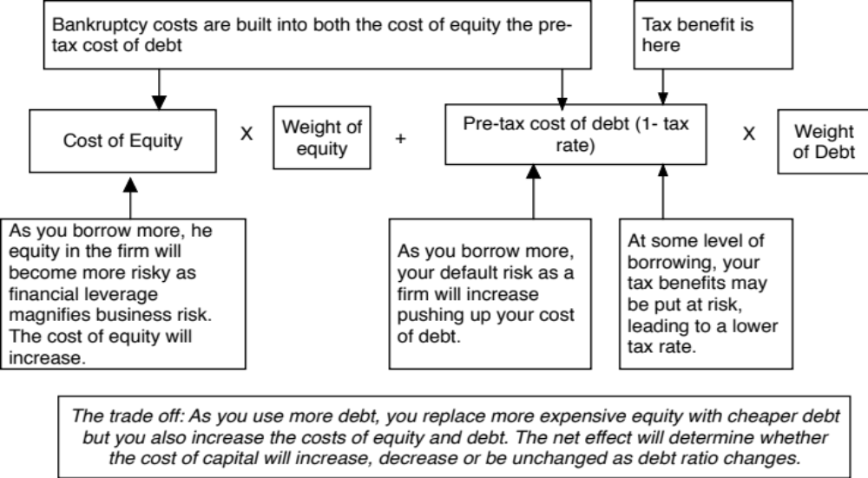

Damage done: Both misconceptions, i.e., that the cost of capital never changes as debt ratios increase, and that the cost of capital always decreases as you borrow more can distort valuation, the first because it yields discounted cash flow valuations that are invariant to the effects (positive and negative) of debt and the second because it consistently over estimates values for firms with debt.

Misconception 8: Small companies should have higher costs of capital than large companies
Misconception: The notion that small companies are riskier than large companies is intuitive to most analysts and that notion gets empirical backing from the well-chronicled small cap premium uncovered by researchers since the 1970s. As a consequence, it has become standard practice to adjust the costs of equity for small companies by adding an extra 3-4% to conventional risk and return models.
Reality: The small cap premium does exist, if you look at US stock market history going back to 1927, but it is not only much weaker in other global market but it has also disappeared in the US, post 1981, as evidenced in figure 10:
You could challenge even the intuition of small caps being risky by noting that many of the risks that smaller companies are exposed to are diversifiable (and are thus not an issue in portfolios of these companies), discrete (which can be better captured probabilistically in the cash flows) or associated with illiquidity (which are often adjusted for in post-valuation discounts). The continued and almost unquestioning use of the small cap premium in valuation practice is a testimonial to the fact that bad practices in valuation, once established, endure without being challenged.
Damage done: Adding an extra unwarranted risk premium to the discount rate when valuing small companies will unfairly reduce their value. If the justification for the premium is that small companies are less liquid and the valuation also incorporates an illiquidity discount, there is double counting of risk.

Misconception 9: The cost of capital cannot change over time.
Misconception: In most discounted cash flow valuations, the cost of capital is estimated once, up front, and then viewed as a constant, a number that never changes even as you anticipate significant changes in growth and cash flows for the company over time. This may also explain why analysts are focused on getting the inputs into the cost of capital calculation “right”, because they are locked into those inputs forever. Not surprisingly, debates about what beta is the right one and whether to use an actual or a target debt ratio consume energy and time.
Reality: The cost of capital is an annual number, more akin to a forward rate in fixed income math, than a constant. Consequently, you are not only allowed to revisit your estimates for each of the inputs (betas, risk premiums and even the risk free rate) over time but are required to do so, for consistency. Put simply, if you are valuing a money-losing, high growth company that you see becoming a more mature money-making, slow growth company over time, you should be changing your cost of capital over time to reflect those operating changes.
Damage done: Locking in the cost of capital at your starting value will lead you to misvalue companies where you see large changes in operating characteristics over time. You will tend to undervalue young, money-losing companies, if you leave the cost of capital at its prevailing value (risky equity, with little or no debt). By the same token, you will overvalue companies whose existing costs of capital are low but not sustainable, either because the company has access to subsidized debt or is protected from competition.

Misconception 10: The cost of capital is the most important number in a discounted cash flow valuation.
Misconception: The very fact that you are reading this article may be an indication that we have lost perspective in valuation. The discount rate, for better or worse, has become the most researched (much of academic valuation theory is about risk premiums, betas and required rates of return), the most discussed (occupying significant portions of valuation conference schedules) and the most written about (think of what proportion of valuation books are dedicated to it) component in discounted cash flow valuation. In practice, a disproportionately large amount of time in valuation is spent finessing discount rates and debating what risk premiums to use. In contrast, the drivers of cash flows, which include revenue growth, margins and excess returns are given short shrift.
Reality: At the risk of stating the obvious, the value of a company is a function of its expected cash flows and its discount rate, not just its discount rate. In my experience, big mistakes in valuation come more from getting expected cash flows wrong and less from discount rates mistakes. If you bring in the construct of a corporate life cycle, the relative importance of cash flows and discount rates vary across the life cycle. For young companies, it is your forecasts of revenue growth, operating margins and survival risk that drive value, not what cost of capital you estimate for the company. As companies mature, it is true that the effect of the cost of capital increases, but there is an offsetting factor to consider. While revenue growth and margins can vary widely across companies, the cost of capital for companies falls into a tight range. At the start of 2016, for instance, I estimated the costs of capital for all publicly traded companies in the US and figure 11 contains the distribution:
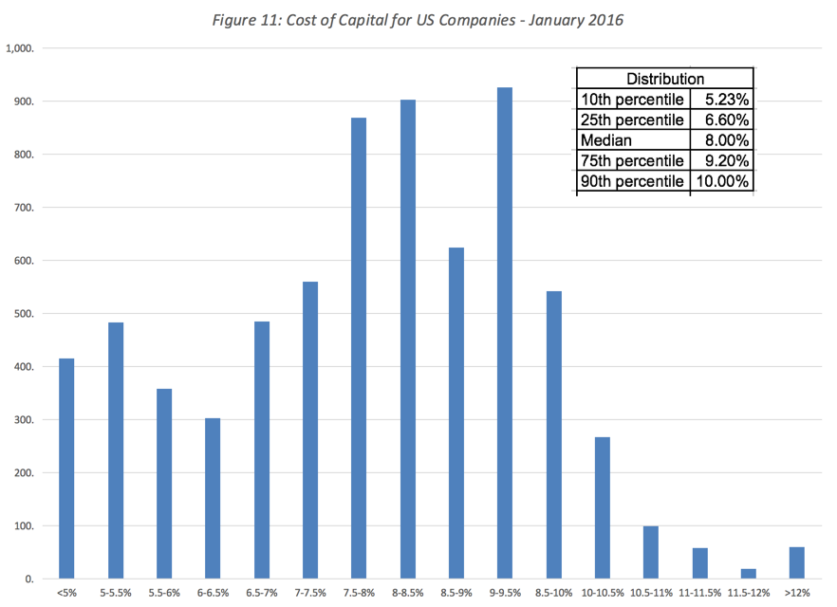
Note that almost half of US companies have costs of capital ranging from 6.6% to 9.2% and that the median company’s cost of capital is 8%. If you have a mature company to value, using the 8% cost of capital as your discount rate will probably yield a value very close to what you would have obtained with a more precisely estimated cost of capital. Alternatively, if you are valuing a risky, growth company, starting with a cost of capital of 10% or even 11% and moving that cost of capital towards 8% will get you close enough to fair value, without having go through the specifics of estimating the cost of capital.
Damage done: If you had unlimited time and resources to do valuations, you could afford to spend as much time as you want estimating betas, risk premiums and costs of capital. Unfortunately, though, time is a constraint and the time that is spent on estimating discount rates is time that is not spent on better estimating cash flows.

Conclusion
The cost of capital is ubiquitous in finance, showing up in almost every dimension of corporate finance, driving investing decisions, determining financing choices and affecting dividend policy and in intrinsic valuation, as the discount rate to adjust cash flows for risk and time value. That said, it is often mangled and misused in practice and this paper is my attempt to make sense of the most common misconceptions that bedevil cost of capital estimates.

