General Queueing Formulae
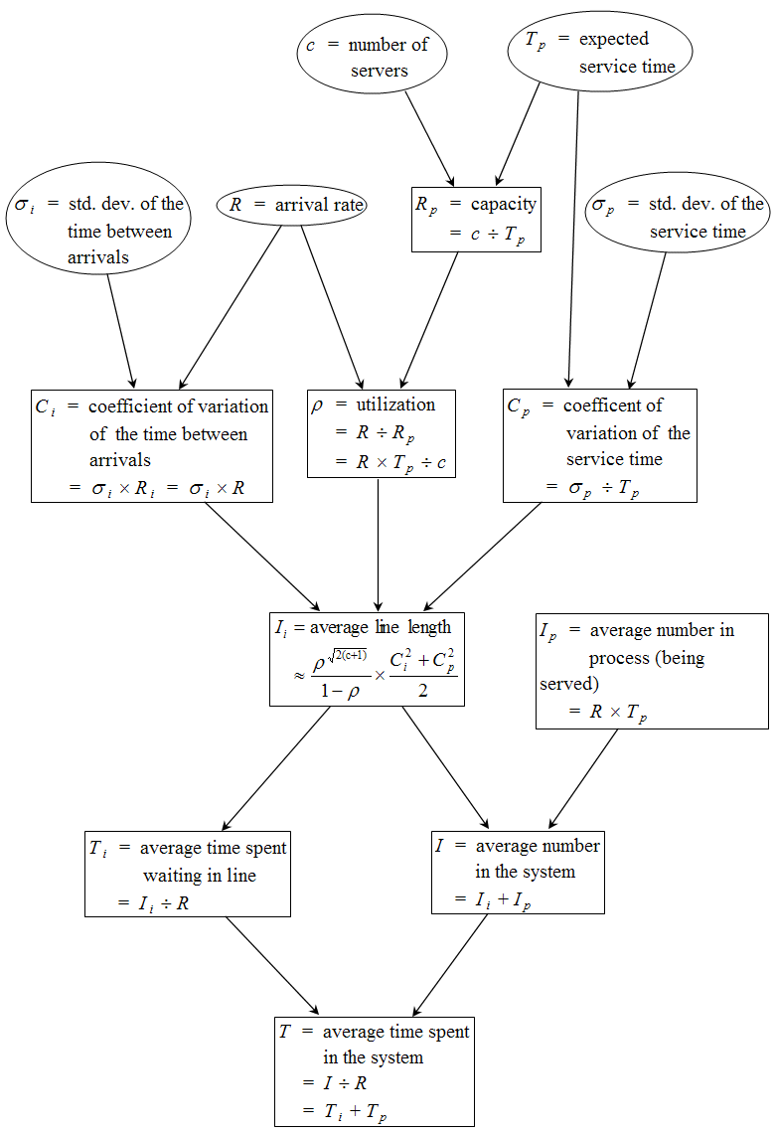

Thanks to Larry Robinson, Johnson Graduate School of Management, Cornell University

