Documenting Excel Calculations in Word
Microsoft Excel (along with other comparable spreadsheet software applications) is a very useful tool for performing data analysis, but it is not an especially good medium for communicating the conclusions of analysis. Nor is it a good medium for describing the thought process and rationale behind one’s analytical approach.
This document is intended to illustrate some tricks that will be useful in documenting Excel spreadsheet analyses in Microsoft Word, a much better medium for written communication. The methods discussed here are also applicable to Microsoft PowerPoint, which is useful for visual aids to accompany a live oral presentation.
Sample Problem: The accompanying table shows test scores of the forty students in a class. Find the mean and standard deviation for this population.
54 | 56 | 56 | 59 | 60
62 | 62 | 66 | 67 | 68
68 | 70 | 70 | 73 | 73
73 | 75 | 77 | 78 | 79
79 | 81 | 81 | 82 | 83
83 | 85 | 86 | 86 | 88
89 | 89 | 90 | 90 | 91
93 | 93 | 94 | 95 | 98
First, note that it is easy to copy a Word table like these data into Excel. Select the table, and press Crtl+C. Switch to Excel with Alt+Tab, and press Ctrl+V:
Now calculate your answers using the appropriate Excel functions (in this case, AVERAGE and STDEVP).
If you copy your spreadsheet with Ctrl+C and paste it into Word with Ctrl+V, it will look like this:
54 | 56 | 56 | 59 | 60 | Average | 77.55
62 | 62 | 66 | 67 | 68 | Standard Deviation | 12.11
68 | 70 | 70 | 73 | 73
73 | 75 | 77 | 78 | 79
79 | 81 | 81 | 82 | 83
83 | 85 | 86 | 86 | 88
89 | 89 | 90 | 90 | 91
93 | 93 | 94 | 95 | 98
The trouble is, this doesn’t show the formula used to get the answers. The reader can’t audit the calculations (or, on an exam, give partial credit for a wrong answer that resulted from a relatively minor mistake).
To do a good job of documenting your spreadsheet in Word or PowerPoint, you first need to insert comments, or otherwise display the formula you used.
To insert a comment for the AVERAGE calculation, first select the cell containing the formula:
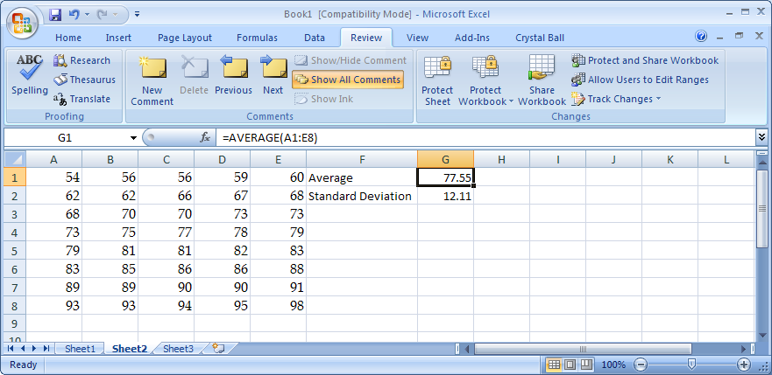
In the formula bar, select the formula itself, copy it with Ctrl+C, and then hit the Esc key. The text of your formula is now on the Windows clipboard.
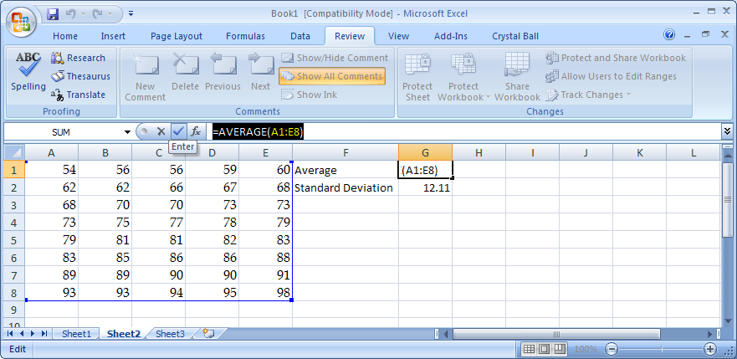
While you still have the formula cell selected, go to the Review tab and choose New Comment.
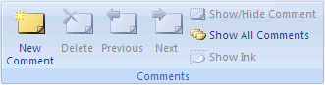
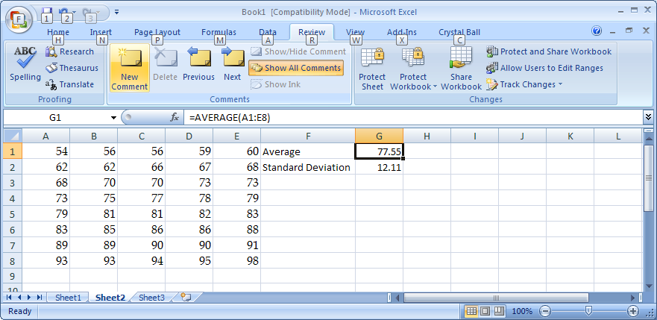
Press Ctrl+V to paste your formula into the comment.
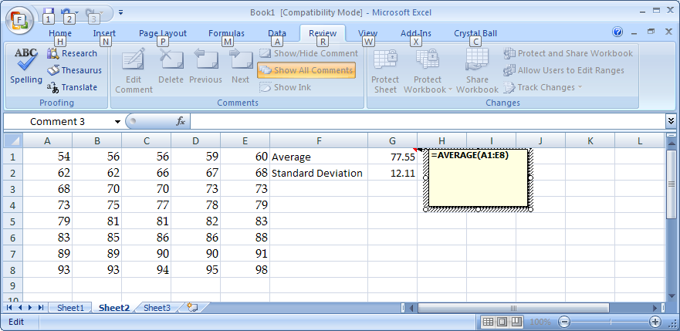

Note: You can download a macro that will do all of this automatically at:
<www.columbia.edu/~dj114/autoformulabox.htm>
Comments can be made to appear in the spreadsheet or hidden, with only a red triangle in the corner of the cell indicating that a hidden comment is there. Show the comments using the Show/Hide Comment button (or Show All Comments) on the Review tab. You can also right-click the cell and then click Show/Hide Comment on the shortcut menu.
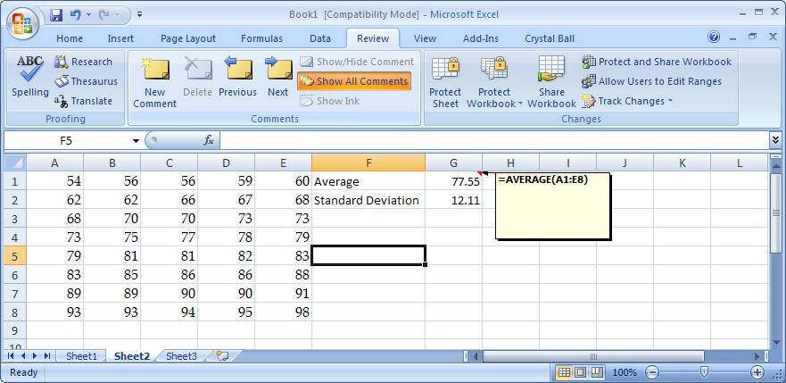

Unfortunately, the spreadsheet will still not copy and paste into Word with the comment showing unless we make some changes in the page setup. Moreover, the formula comment is not useful unless the reader can see where the cells are that are referenced in the formula.
To make these changes in Excel 2007, go to the Page Layout tab. In the Page Setup group, click the dialog box launcher next to Page Setup.
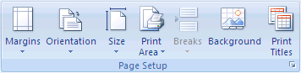
Under the “Sheet” tab, select “Gridlines”, “Row and Column Headings”, and “Comments — As Displayed on Sheet”.
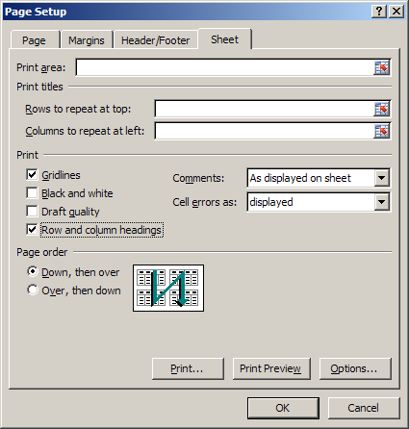

Now, select the desired range in the spreadsheet. Under the Home tab, select Paste – As Picture – Copy As Picture:
You’ll be offered a choice between “As Shown On Screen” and “As Shown When Printed”. Choose “As Shown When Printed”.
Switch to Word with Alt+Tab
From the Word Home tab, select Paste -- Paste Special — Picture (Windows Metafile).

