LP Practice Problems
1. Furnco manufactures desks and chairs. Each desk uses 4 units of wood, and each chair uses 3 units of wood. A desk contributes $40 to profit, and a chair contributes $25. Marketing restrictions require that the number of chairs produced be at least twice the number of desks produced. There are 20 units of wood available.
Using the graph below, determine a production plan that maximizes Furnco’s profit.
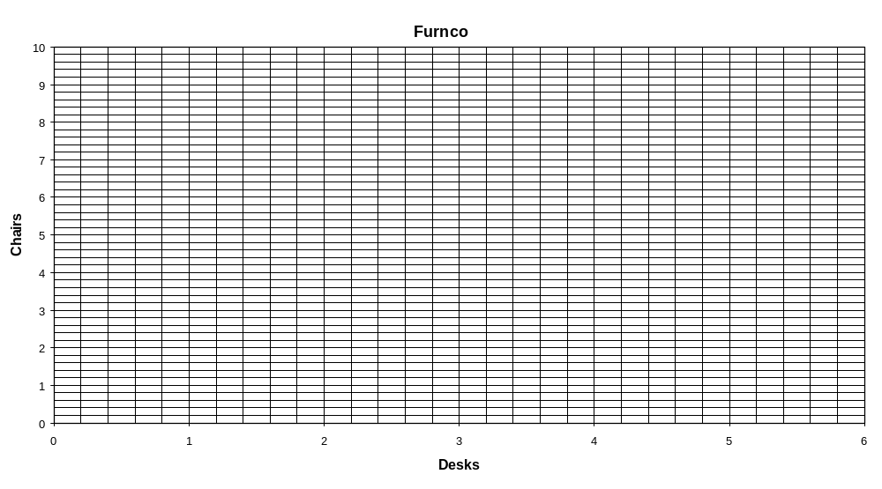

- Draw isoprofit lines where the total profit equals 125, 150, 175, and 200.

- Determine a daily production plan that maximizes total profit.

- What is the optimal total profit?

2. A farmer in Iowa owns 45 acres of land. She is going to plant each acre with wheat or corn. Each acre planted with wheat yields $200 profit; each with corn yields $300 profit. The labor and fertilizer used for each acre are given in the table below. 100 workers and 120 tons of fertilizer are available.
 | Wheat | Corn
Labor | 3 workers | 2 workers
Fertilizer | 2 tons | 4 tons
Using the graph below, determine the planting scheme that will maximize profit for the farmer.
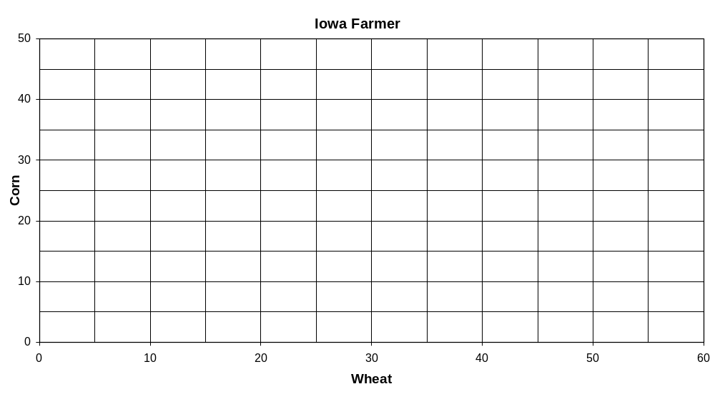

- Draw isoprofit lines where the total profit equals $6,000, $8,000, $10,000, and $12,000.

- Shade in the feasible region.

- Determine the planting scheme that maximizes total profit.

- What is the optimal total profit?

3. A bank is attempting to determine where its assets should be invested during the current year. At present, $500,000 is available for investment in bonds, home loans, auto loans, and personal loans. The annual rates of return on each type of investment are known to be the following: bonds, 10%; home loans, 16%; auto loans, 13%; and personal loans, 20%. To ensure that the bank’s portfolio is not too risky, the bank’s investment manager has placed the following three restrictions on the bank’s portfolio:
- The amount invested in personal loans cannot exceed the amount invested in bonds.
- The amount invested in home loans cannot exceed the amount invested in auto loans.
- No more than 25% of the total amount invested may be in personal loans.
Below are various elements of the Excel model used to solve the problem: the spreadsheet model, the Solver parameters, the Solver options, the answer report and the sensitivity report.

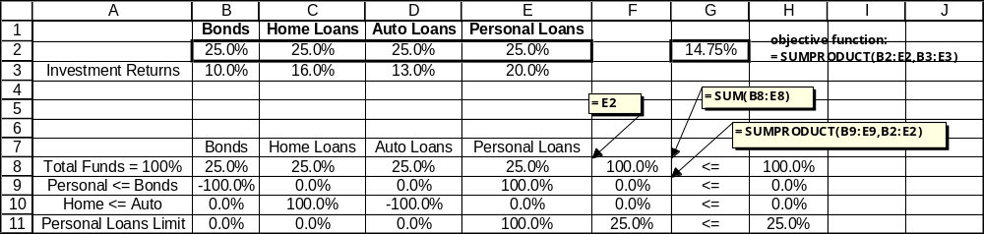

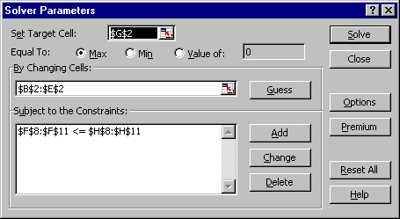
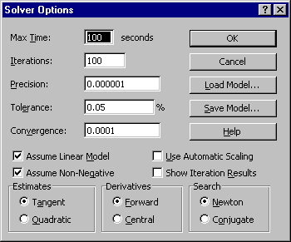

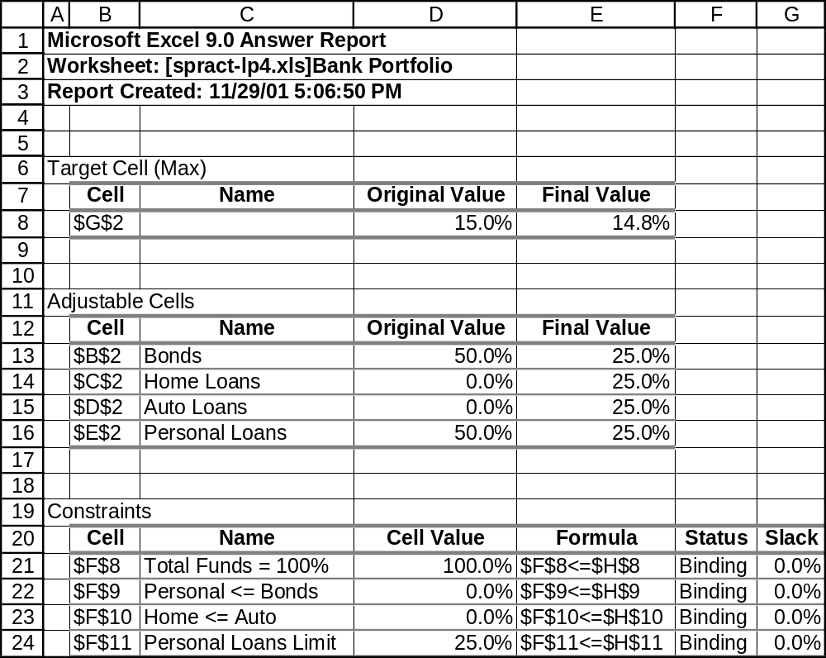

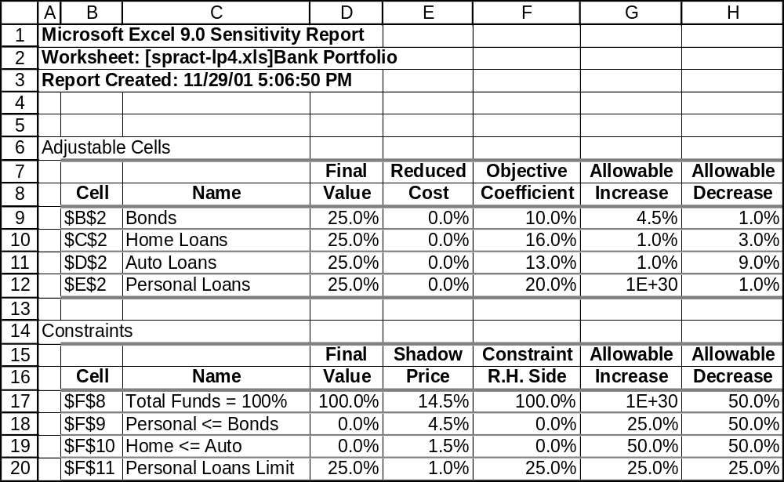

- What is the optimal allocation of funds to the various investment types?

- What is the expected return on investment from the optimal portfolio?

- What would be the improvement in the return on investment if the limit on the total amount invested in personal loans were increased to 30%?

- If the return on bonds increases from 10% to 13%, what will happen to the optimal allocation of funds?

4. Sunco Oil manufactures three types of gasoline (gas 1, 2, and 3). Each type is produced by blending three types of crude oil (crude 1, crude 2, and crude 3). Sunco can purchase up to 5,000 barrels of each type of crude daily.
The selling price per barrel of gasoline and the purchase price per barrel of crude oil are given in Table 4.1 below.
 | Selling Price per Barrel |  | Purchase Price per Barrel
Gas 1 | $70 | Crude 1 | $45
Gas 2 | $60 | Crude 2 | $35
Gas 3 | $50 | Crude 3 | $25
Table 4.1
The three types of gasoline differ in their octane rating and their sulfur content. The crude oil blended to form gas 1 must have an average octane rating of at least 10 and contain at most 1% sulfur. The crude oil blended to form gas 2 must have an average octane rating of at least 8 and contain at most 2% sulfur. The crude oil blended to form gas 3 must have an average octane rating of at least 6 and contain at most 1% sulfur. The octane rating and sulfur content of the three types of crude oil are given in Table 4.2 below.
 | Octane Rating | Sulfur Content
Crude 1 | 12 | 0.5%
Crude 2 | 6 | 2.0%
Crude 3 | 8 | 3.0%
Table 4.2
It costs $4 to transform 1 barrel of oil into 1 barrel of gasoline, and Sunco’s refinery can produce up to 14,000 barrels of gasoline daily. Sunco’s customers require the following amounts of each gasoline: gas 1, 3000 barrels per day; gas 2, 2000 barrels per day; gas 3, 1000 barrels per day. The company considers it an obligation to meet these demands.
Sunco also has the option of advertising to stimulate demand for its products. Each dollar spent daily in advertising a particular type of gas increases the daily demand for that type of gas by 10 barrels. For example, if Sunco decides to spend $20 daily in advertising gas 2, the daily demand for gas 2 will increase by 200 barrels. Below are the answer report and the sensitivity report from a Solver optimal solution to this problem.
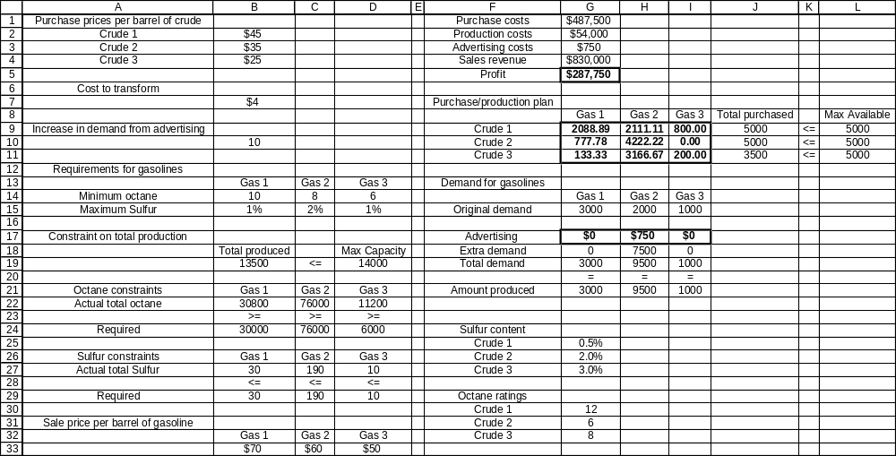

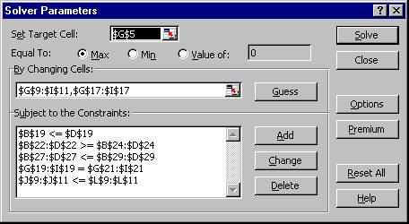

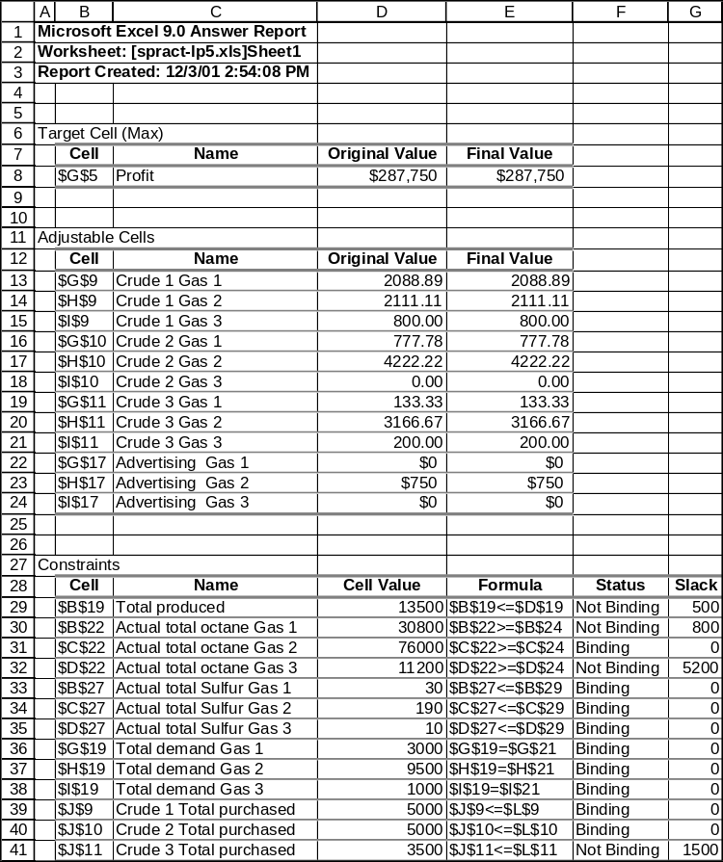

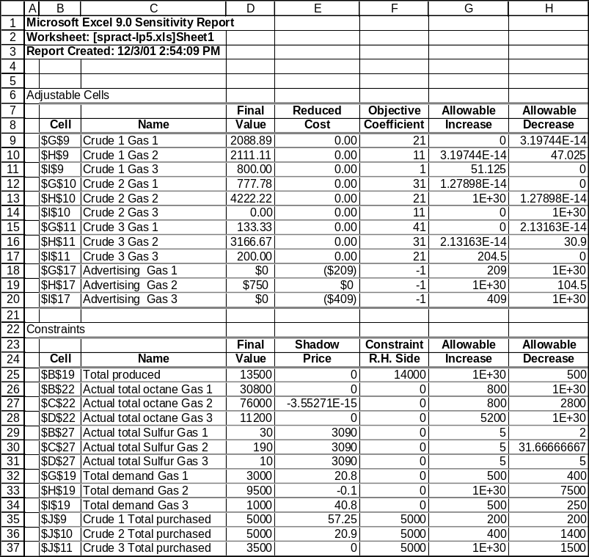
- What is the optimal amount of profit for Sunco?

- How much of Crude Oil 2 should Sunco purchase?

- How much of the Crude Oil 2 will be used to make Gas 3?

- The marketing director insists that Sunco needs to spend $500 advertising Gas 1. What will this do to the net profit?

- 500 barrels of Crude Oil 2 are available on the spot market. How much should Sunco offer per barrel for this commodity?

- Assuming that the seller agrees to Sunco’s price, how many barrels of Crude Oil 2 should they buy?

- 500 barrels of Crude Oil 3 are available on the spot market. How much should Sunco offer per barrel for this commodity?

- Assuming that the seller agrees to Sunco’s price, how many barrels of Crude Oil 3 should they buy?

Based on problems 3.3, 3.5, 4.20, and 4.27 (pp. 89-144) in Practical Management Science, by Wayne Winston and S. Christian Albright.

