Southern Tier Airport
The frustration with air travel in New York State’s Southern Tier has been building for years. Several small cities (most notably Elmira, Ithaca, and Binghamton) have their own small airports, segmenting regional demand such that each city is able to support only a handful of flights per day. Further, U. S. Airways virtually monopolizes these small markets, charging high prices for even short hauls. Many residents are forced to drive to Syracuse, Rochester, or even Scranton in order to find a convenient — or reasonably priced — flight.
The Proposed Southern Tier Regional Airport (STRA) is designed to take over demand from all three small airports. Located in Spencer (see the map in Exhibit 1), STRA would be less than 25 miles away from any of these airports. Moneys from the $214 billion Building Efficient Surface Transportation and Equity Act (BESTEA), passed by the 105th Congress, would be used to build a new two-lane highway connecting Spencer to Exit 54 of NY State Route 17 (designated to become US Interstate 86), as well as to upgrade NY State Route 96 between Owego and Ithaca (passing through Spencer). Demand for this new airport was expected to be drawn from as far away as Bath and Hammondsport to the West, Penn Yan, Trumansburg and Ithaca to the North, Sayre to the South, and even Bainbridge and Sidney to the East. Several major corporations (most notably IBM and Corning) and medical centers (in Sayre and Elmira) were expected to support substantial numbers of business travelers.
The impetus for STRA was drawn from Connecticut’s successful (and larger) Bradley International Airport, which serves several nearby cities, including Hartford and Springfield, Massachusetts. By expanding the population base using this airport, they found that it was possible to attract a larger number of airlines, increasing the numbers of both daily flights and destinations served, while lowering costs as a result of increased competition. And while the passenger transit time is expected to increase substantially for Southern Tier residents, at an average of 40 minutes it will still be far less than for most metropolitan areas.
One of the countless planning decisions that need to be made concerns the placement of two security checkpoints in the main hallway leading to the concourse. The original design calls for placing one on either side of the ten-meter-wide hallway, allowing departing customers to leave through the center (as shown in Exhibit 2). Because both the parking facilities and airline check-in stations are balanced on either side of the main hallway, the two checkpoints would be equally used. During either of the two peak demand periods (6:30 — 9:00 AM and 4:00 — 6:30 PM), a total of 250 passengers are expected to pass through these two checkpoints to catch a departing flight. At other times of the day, demand would be much lower, although at least one checkpoint must always be in operation while STRA is open (5:00 AM — 1:00 AM).
Following the increased security measures taken in response to the attack on the World Trade Center on September 11, 2001, the time required to pass through security checkpoints has increased sharply. It now takes an average of one minute to process a passenger through a security checkpoint. The actual time is fairly skewed; it is usually quite low (around 20 — 30 seconds), but it can be very long on occasion. The two most common causes of delay are the more-or-less randomly chosen exhaustive searches, and alerts from the heightened sensitivity of the walk-through metal detector (which require at least an additional walk-through and sometimes a detailed search with a “hand wand” metal detector). Delays of several minutes sometimes result from suspicious X-ray images of the carry-on luggage, which require thorough hand inspection. Taking these unusual long delays into account, the standard deviation of the process time is 1.2 minutes (higher than the mean).
Although most passengers have adjusted to the impositions resulting from the increased security, there is always a subset of the passenger population for whom a delay of even a minute or two will cause them to miss their flight. It’s cold comfort to point out to them that they should have arrived at STRA earlier. It would be preferable for them to arrive at that conclusion themselves, rather than offering the opportunity of blaming their missed flight on the delay at the security checkpoint.
A concern has been raised about the proposed security configuration, shown in Exhibit 2. Because deplaning passengers will leave the airport through the middle of the corridor, it is practically impossible for passengers to join the “other” line, or to jockey between them in response to delays. Thus, it may be entirely possible for one checkpoint to be backed up while the other is idle. To avoid this situation, an alternative security configuration, shown in Exhibit 3, has been proposed. By placing the two checkpoints next to each other, in the middle of the corridor, the departing passengers would be able to first available security checkpoint. The downside is that deplaning passengers would use either of two smaller paths on either side of the corridor; security staff would need to monitor both paths to prevent people from bypassing the security checkpoint, a slightly more difficult task.
At this point no one had a good grasp of whether or not delays are likely to be a problem during the two peak demand periods, or which of the two security checkpoint configurations is preferable.

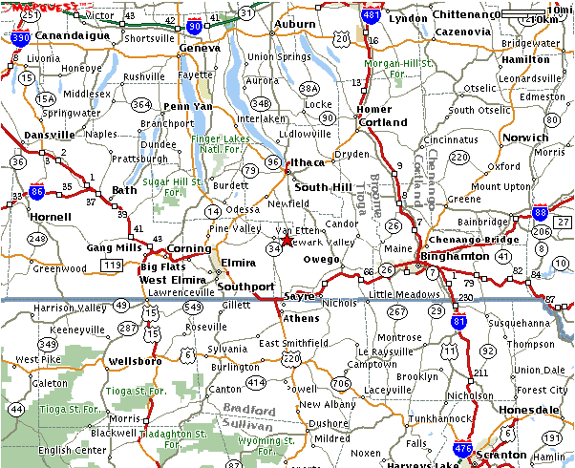
Proposed Airport Location
Exhibit 1: Map of the Southern Tier Region

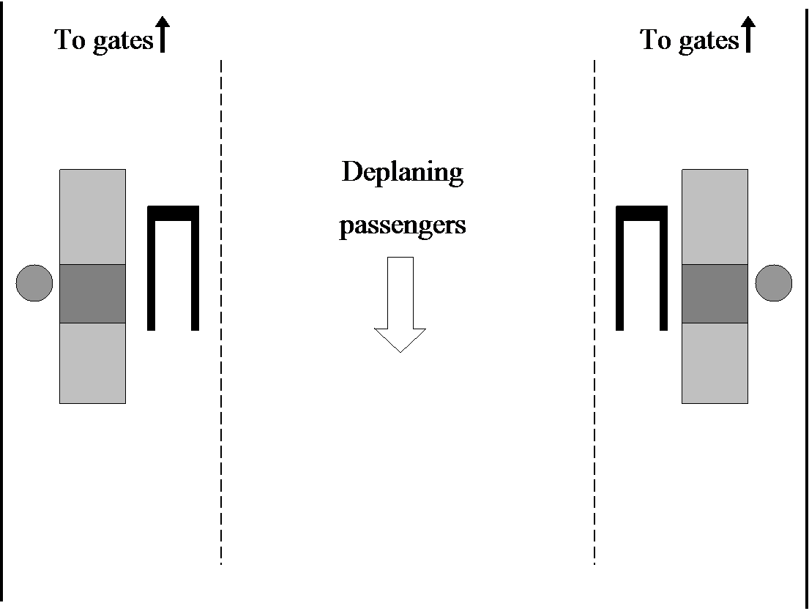 | 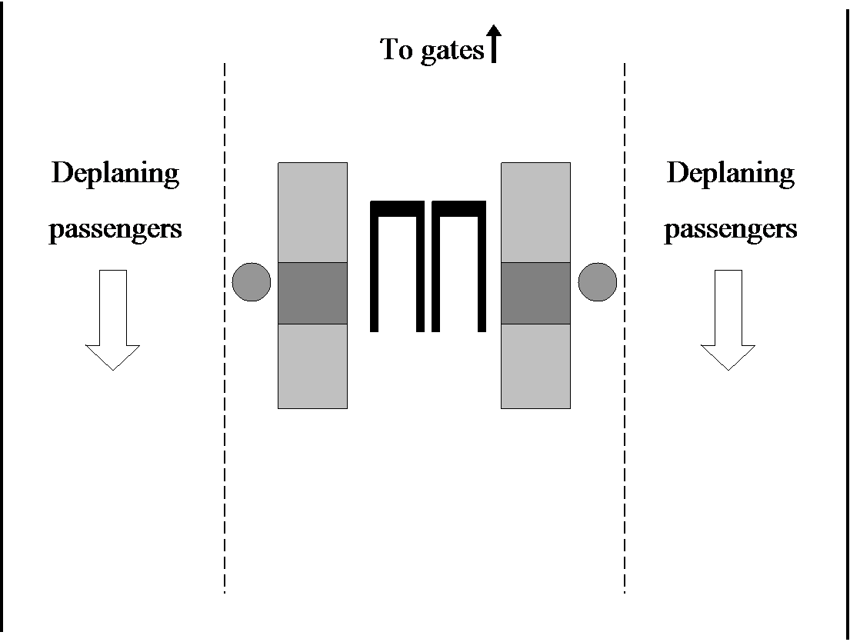
Exhibit 2: Two separated checkpoints | Exhibit 3: Two checkpoints with a single queue

Copyright © 2001 by Lawrence W. Robinson to serve as the basis for class discussion, rather than to illustrate either effective or ineffective handling of an administrative situation.

