MORTGAGE BACKED SECURITIES

Fall 2000

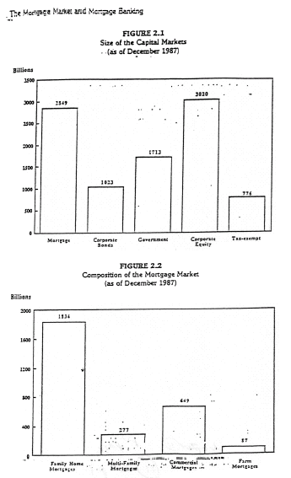

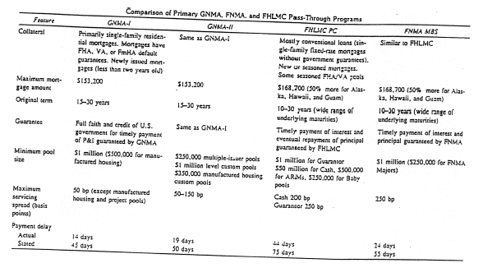
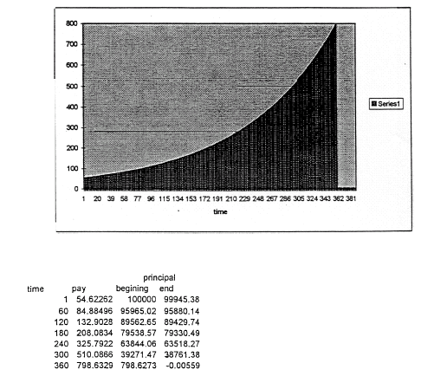

PRICING OF GINNY MAES

STEP 1 Estimate of interest rate paths

.

.
.
.
.
.

.

(Paths must be arbitrage-free and result in positive interest rates.)

STEP 2 Estimate prepayment at each node

- Generally use historical data.

- Prepayment not rational function of interest rate.

- Bond Rate

- Relationship between Bond Rate and "New" Mortgage Rate

- Remaining Maturity

- Prior Path

- Season

- Home Turnovers

- Note for mortgages not path independent.

STEP 3 Estimate cash flows.

Cash flows include prepayment and principal and interest.

STEP 4 Discount at Treasury spot curve

If no spread, this would give average market value. Generally believe spread. Thus discount so that model price fits actual price on average.

(1+r+Δ)

Δ is OAS

Do so fits on average in order to spot "mispriced bonds."

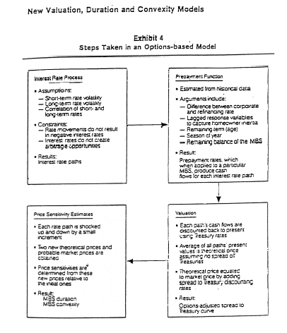

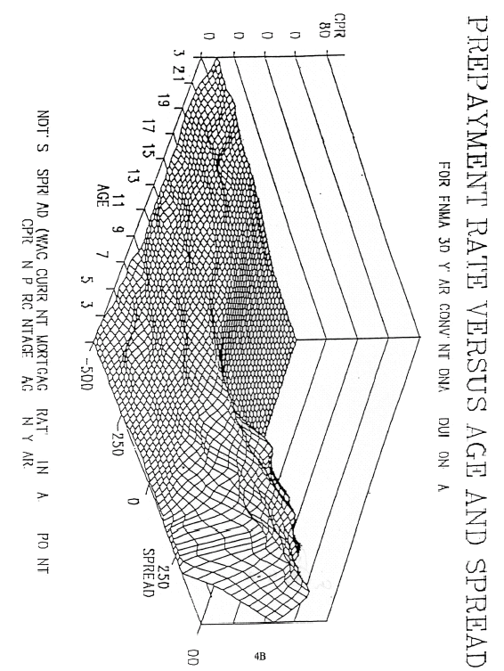

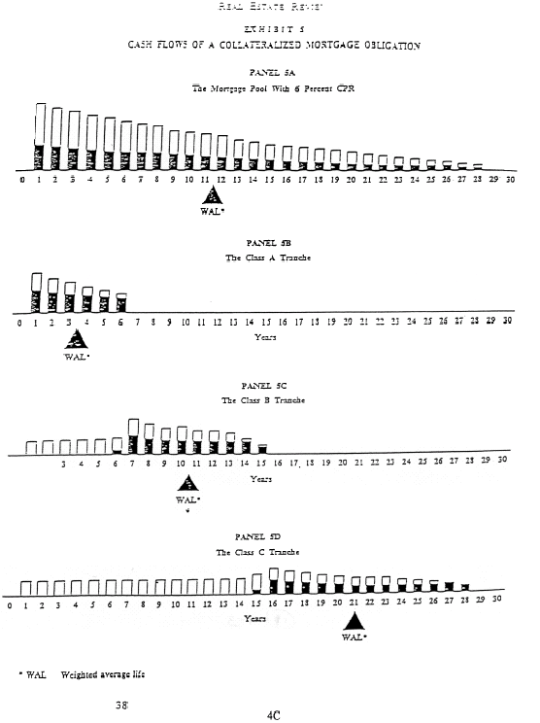

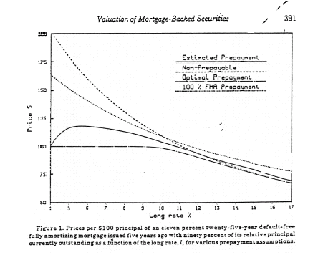

Splitting mortgage payments into more valuable payment patterns

CMO

Simplest CMO splitting into multiple groups by payment

Example 1:

- $100 million Ginny Mae

- Split into three tranches

- A gets all principal payment until $40 million paid

B gets all principal payment after $40 million paid and before $70 million paid

C gets remainder

- All tranches receive same interest rate
Example 2:

Unequal interest payments.

- $100 million issue paying nine percent

- B-1 receives 3% interest and principal of $50 million

- B-2 receives 6% interest and principal of %50 million

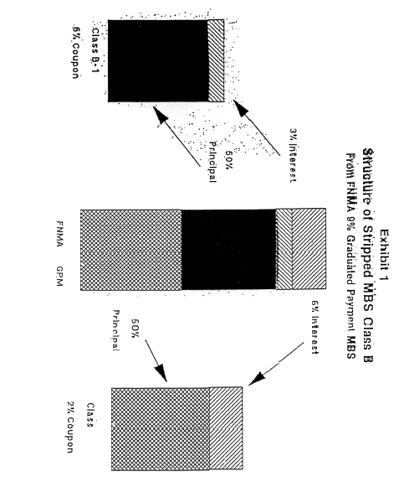

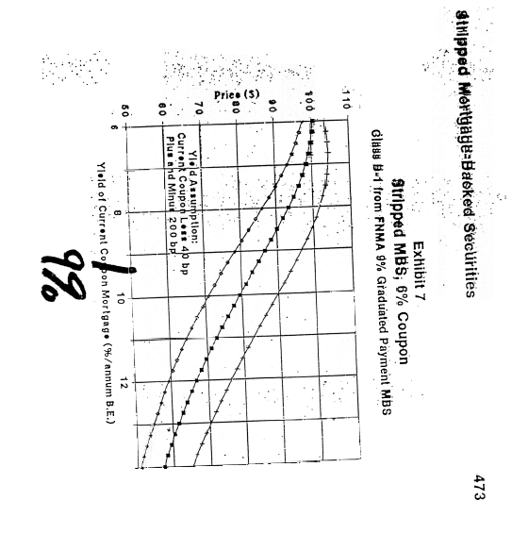

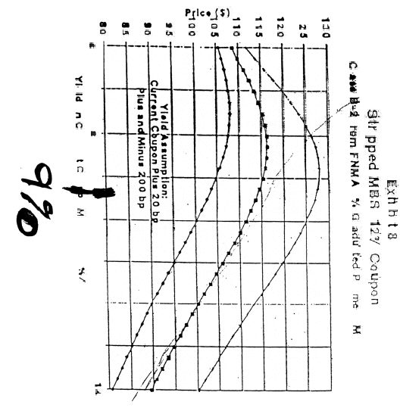

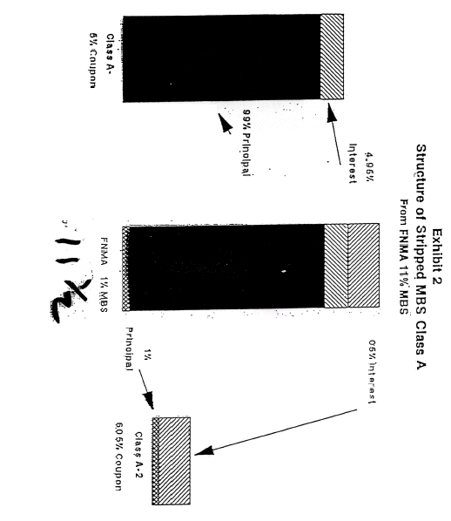

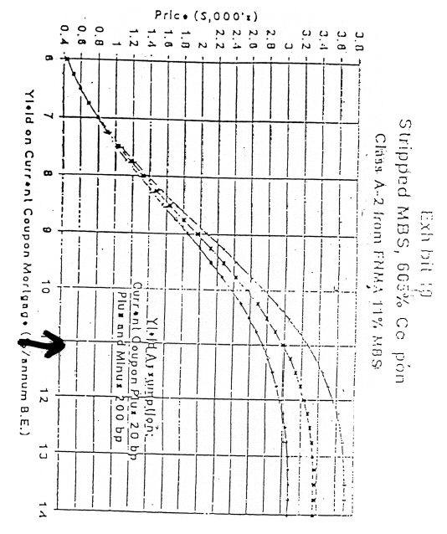

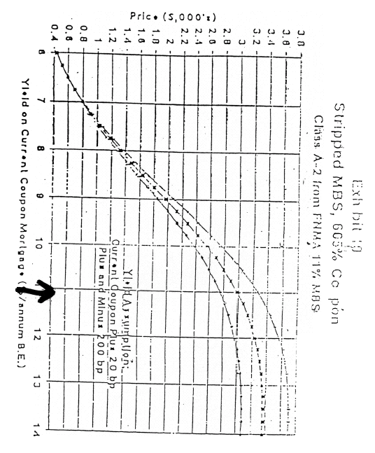

Mortgage

Assume for illustration annual payments

1,000,000 principal
4 years
.094626 rate
31,180.86 payment
.50 probability

Spot Rates

 |  |  |  |  |  | 18.879
 |  |  |  | 14.624
 | 11.0999 |  |  |  | 12.935
8 |  |  |  | 8.893
 |  | 5.544 |  |  |  | 7.288
 |  |  |  | 3.448
 |  |  |  |  |  | 1.924

Mortgage Value

 |  |  | 26,229.18
 |  | 50,687.58
 | 75,476.03 |  | 27,609.67
102,413 |  | 54,656.35
 | 83,374.41 |  | 29,062.81
 |  | 58,687.58
 |  |  | 30,592.43

100,000 | 72,281.73 | 54,508.35 | 28,485.40

