PROTECTING AGAINST TERM

STRUCTURE SHIFTS

(INVESTMENT MANAGEMENT WITH LIABILITY STREAM)

September 2002

BASIC IDEA

1 Manager is concerned with Liability Stream.

2. Concern is to maximize net worth.

Major Tools

(1) Cash flow matching or dedication

(2) Sensitivity matching or Immunization

CASH FLOW MATCHING

Observe liability stream L₁, L₂,L_{3,}..., L_{T}

EXACT MATCHING
Cash flow

Minimize Cost

Subject to

1. Meet Cash Flows

2. Do not issue Bonds

Let

1. P_{i} is Price of Bond i

2. N_{i} is Number of Bonds of Type i Purchased

3. L_{t} is Liabilities in Time t

4. r is Short term Interest Rate

5. cf(it) is Cash Flow of Bond i in Period t.
Interest or principal and interest

6. S_{t} is Amount Invested in Short Term Bond in Period t

MINIMIZE

$$\sum{{}_{i}}N_{i}P_{i}$$

SUBJECT TO

$$\begin{aligned} 1\text{.} \sum{N_{i}}\text{cf}(\text{it})+S_{\text{t-1}}(\text{1+r})−L_{t}−S_{t}\text{ = 0 all t} \\ \\ \text{ 2}\text{.}{\text{ N}}_{\text{i }}\underline{}\text{ 0 all i} \\ \\ \text{ 3}\text{.}{\text{ S}}_{\text{t }}\underline{}\text{ 0 all t} \\ \\ \text{ 4}\text{.}{\text{ S}}_{\text{-1}}=\text{ 0} \\ \end{aligned}$$

RISKS OF CASH FLOW MATCHING

1. Reinvestment Risk

2. Risk of disappearing security

a. Call

b. Sinking fund

c. Default

Immunization

1. Assume a manager is responsible for designing a portfolio that will have sufficient cash flows to meet a liability L_{t} is liability in period t.
Thus liabilities are L₁, L₂, L_{3,} L₄

2. Sensitivity matching involves finding a Portfolio that

a) at equilibrium prices the Portfolio costs the same as the Liability

b) the value of the asset portfolio and Liability portfolio move in tandem

3. Need measures of how value of portfolio changes given change in factor or factors effecting it.

Choices

(1) Duration
(2) Coefficients of factor model

Types of Duration measures

(1) Analytical
(2) Numerical
(3) Time Series Estimation
ANALYTICAL

SENSITIVITY

MEASURES
ANALYTICAL
MODELS OF SENSITIVITY TO
INTEREST RATE CHANGE

1. MACAULAY CHANGE IN
YIELD

2. MACAULAY/FISHER AND WEIL ADDITIVE
CHANGE

3. BIERWAG AND KAUFMAN MULTIPLICATIVE

4. BIERWAG ADDITIVE PLUS
MULTIPLICATIVE

5. KHANG SHORT MORE
THAN LONG

6. COX, INGERSOLL AND ROSS SHORT GAUSS
MARKOV AND
EXPECTATIONS THEORY

7. BRENNAN AND SCHWARTZ SHORT AND LONG
MARKOV AND
EXPECTATIONS
THEORY
I. MAUCAULAY [D_{i}]
$$\frac{\frac{{\text{dP}}_{0}}{d(\text{1+r})}}{P_{0}}=\frac{\text{-1}}{\text{1+r}} [\sum{{}_{t}}\frac{\frac{\text{tcf}(t)}{(\text{1+r})^{t}}}{P_{0}}]$$
$$\text{\% price change = }\frac{{\text{dP}}_{0}}{P_{0}}\text{ = -}D_{1} \frac{d(\text{1+r})}{(\text{1+r})}$$
$$\text{= MINUS }{\text{DURATION}}_{1}\text{ x \%change in }(\text{1+r})$$
$$\frac{{\text{dP}}_{0}}{d(\text{1+r})}=\frac{\text{-1}}{\text{1+r}}\sum{{}_{t}}\frac{\text{tcf}(t)}{(\text{1+r})^{t}}$$
$$\frac{{\text{dP}}_{0}}{d(\text{1+r})}=\frac{\text{-C}}{(\text{1+r})^{2}}+\frac{\text{-2C}}{(\text{1+r})^{3}}+\frac{\text{-3C}}{(\text{1+r})^{4}}+\text{.}\text{.}\text{.}+\frac{(\text{C+100})(\text{-N})}{(\text{1+r})^{\text{N+1}}}$$

Modified Duration

$$\frac{{\text{dP}}_{o}}{P_{o}}\text{ = -}D_{1}^{M}{\text{ dr where D}}_{1}^{M}\text{ = }\frac{D_{1}}{\text{1 + r}}$$

Price change per interest rate change

$${\text{dP = -D}}_{1}^{M}\text{P dr}$$

- Modified Duration useful when worried about riskiness of different positions.

- Price change when hedging.

- If use different r’s on different bonds such as yield to maturity, then duration is not additive.
General Principles

(1) The lower the interest rate,
the longer the duration.

(2) The lower the coupon rate,
the longer the duration.

(3) The greater the maturity,
the longer the duration in general.

Estimated Original dr
= - (Duration)(P₀) ----

Price Price 1+r

$$P_{0}+\text{dP}=P_{0}−D_{1}\frac{\text{dr}}{1+r}P_{0}$$

EXAMPLE 1

Interest Rate 10%

Coupon 10%

Principal 100

Maturity 15 years

Semi-Annual
Payment

Price $100

Duration 8.07 years
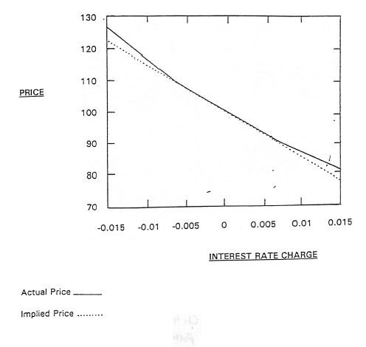

CHANGE IN  INTEREST RATE | INTEREST  RATE | TRUE  PRICE | ESTIMATED  PRICE
-0.015 | 0.035 | 127.588 | 123.059
-0.014 | 0.036 | 125.429 | 121.521
-0.013 | 0.037 | 123.322 | 119.984
-0.012 | 0.038 | 121.264 | 118.447
-0.011 | 0.039 | 119.254 | 116.91
-0.01 | 0.04 | 117.292 | 115.372
-0.009 | 0.041 | 115.376 | 113.835
-0.009 | 0.042 | 113.504 | 112.298
-0.007 | 0.043 | 111.675 | 110.761
-0.006 | 0.044 | 109.889 | 109.223
-0.005 | 0.045 | 108.144 | 107.686
-0.004 | 0.046 | 106.44 | 106.149
-0.003 | 0.047 | 104.774 | 104.612
-0.002 | 0.048 | 103.146 | 103.074
-0.001 | 0.049 | 101.555 | 101.537
0 | 0.05 | 100 | 100
.001 | 0.051 | 98.48 | 98.463
0.002 | 0.052 | 96.994 | 96.926
0.003 | 0.053 | 95.542 | 95.388
0.004 | 0.054 | 94.122 | 93.851
0.005 | 0.055 | 92.733 | 92.314
0.006 | 0.056 | 91.375 | 90.777
0.007 | 0.057 | 90.047 | 89.239
0.008 | 0.058 | 88.748 | 87.702
0.009 | 0.058 | 87.478 | 86.165
0.01 | 0.06 | 86.235 | 84.628
0.011 | 0.061 | 85.019 | 83.09
0.012 | 0.062 | 83.83 | 81.553
0.013 | 0.063 | 82.666 | 80.016
0.014 | 0.064 | 81.527 | 78.479
0.015 | 0.065 | 80.412 | 76.941

EXAMPLE 2

Coupon vs. Pure Discount:

Coupon 10%

Maturity 10 years

Initial Price $100

Annual Payments

Interest Rate 10%

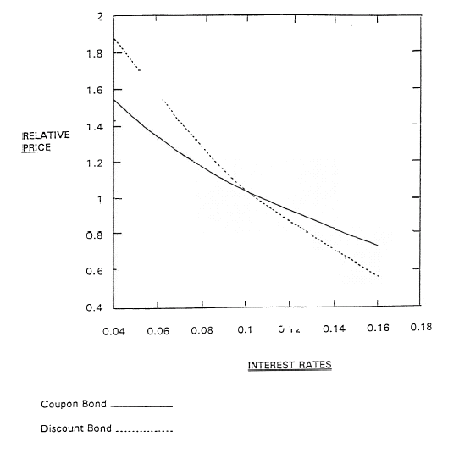

II. MACAULAY/FISHER AND WEIL [D₂]
$$P_{0}\text{ = }\frac{C}{({\text{1+r}}_{\text{01}})}\text{ + }\frac{C}{({\text{1+r}}_{\text{01}})({\text{1+r}}_{\text{12}})}\text{ + }\frac{C}{({\text{1+r}}_{\text{01}})({\text{1+r}}_{\text{12}})({\text{1+r}}_{\text{23}})}\text{ + }\text{.}\text{.}\text{.}$$

ASSUME
$$\frac{{\text{dp}}_{0}}{d({\text{1+r}}_{\text{01}})}\text{ = }\frac{\text{-C}}{{({\text{1+r}}_{\text{01}})}^{2}}\text{ + }\frac{\text{-C}}{({\text{1+r}}_{\text{01}})^{2}({\text{1+r}}_{\text{12}})}\text{ + }\text{-C}\frac{\frac{d({\text{1+r}}_{\text{12}})}{d({\text{1+r}}_{\text{01}})}}{({\text{1+r}}_{\text{01}})({\text{1+r}}_{\text{12}})^{2}}$$
$$\frac{d({\text{1+r}}_{\text{N-1N}})}{({\text{1+r}}_{\text{N-1N}})}\text{ = }\frac{d({\text{1+r}}_{\text{01}})}{({\text{1+r}}_{\text{01}})}$$
$$=\frac{\text{-1}}{({\text{1+r}}_{\text{01}})}\sum{{}_{t}}\frac{t(\text{CF})(t)}{\prod{{}_{\text{i=1}}^{t}}(\text{1+}r_{\text{i-1,i}})}$$
$$\frac{{\text{dP}}_{0}}{d({\text{1+r}}_{\text{01}})}\text{ = }\frac{\text{-C}}{({\text{1+r}}_{\text{01}})^{2}}\text{ + }\frac{\text{-2C}}{({\text{1+r}}_{\text{01}})^{2}({\text{1+r}}_{\text{12}})}\text{ + }\frac{\text{-3C}}{({\text{1+r}}_{\text{01}})^{2}({\text{1+r}}_{\text{12}})({\text{1+r}}_{\text{23}})}\text{ + }\text{.}\text{.}\text{.}$$

$$\frac{{\text{dP}}_{0}}{P_{0}}\text{ = -}$$
$$\frac{{\text{dP}}_{0}}{P_{0}}\text{ = -}D_{2} \frac{d({\text{1+r}}_{\text{01}})}{({\text{1+r}}_{\text{01}})}$$
% CHANGE
IN PRICE = [ MINUS DURATION ] X[ % CHANGE IN ( 1 + r₀₁ )]

EXAMPLE 3

Coupon 10% (semi-annual)

Principal $100

Maturity 15 years

Duration 6.527

Initial Price $740.27

Yield Curve
(see attached)

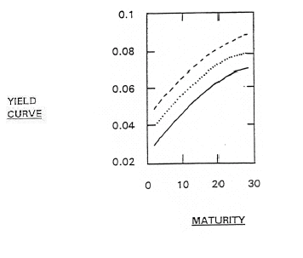
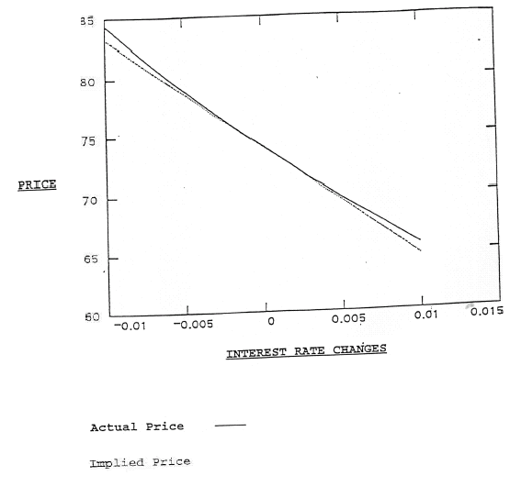

INTEREST RATE CHANGE | TRUE | DURATION
x | p(x) | newprice (x)
-0.01 | 84.381 | 83.28
-0.009 | 83.244 | 82.351
-0.008 | 82.131 | 81.421
-0.007 | 81.041 | 80.491
-0.006 | 79.975 | 79.561
-0.005 | 78.931 | 78.632
-0.004 | 77.909 | 77.702
-0.003 | 76.908 | 76.772
-0.002 | 75.928 | 75.842
-0.001 | 74.968 | 74.912
0 | 74.027 | 73.983
0.991 | 73.106 | 73.053
0.002 | 72.204 | 72.123
0.003 | 71.32 | 71.193
0.004 | 70.453 | 70.264
0.005 | 69.604 | 69.334
0.006 | 68.772 | 68.404
0.007 | 67.957 | 67.474
0.008 | 67.157 | 66.544
0.009 | 66.373 | 65.615
0.01 | 65.605 | 64.685

EXAMPLE 4

Coupon 5%

Principal $100

Maturity 30 years

Annual Interest

Duration 13.054

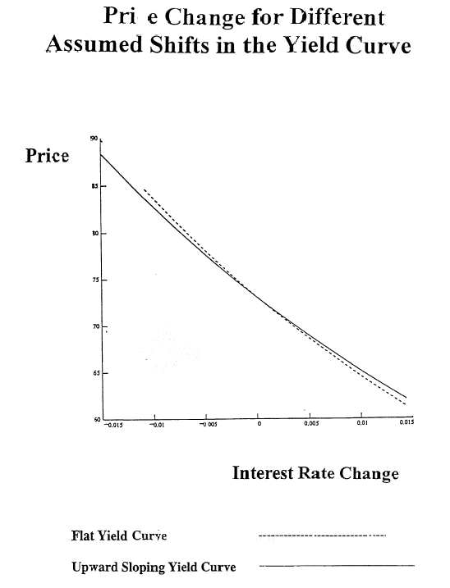

Adding additional terms (convexity)

The formula for the first three terms in a MacLaurin series expansion of a function f(X + h) in the region of h as h approaches zero is

Where the prime denotes derivatives. Define P(r) as the price of a bond at an interest rate r. Then, writing the price of the bond
$$f(\text{X + h})\text{ = f}(X)\text{ + }\frac{\text{df}(X)(h)}{1}\text{ + }\frac{{\text{df}}^{2}(X)(h)^{2}}{\text{2 : 1}}\text{ + }\text{.}\text{.}\text{.}$$
at a new interest rate (r + h) using the series expansion results in

$${P(\text{r + h})\text{ = P}(r)\text{ + \{}P}^{'}(r)\text{h + 1/2P}\text{ \backslash ( r \backslash ) \{h\} rSup \{ size 8\{2\} \} \} \{}$$

The price of the bond is

$$P_{0}\text{ = }\sum{{}_{\text{t = 1}}^{T}}\frac{\text{cf}(t)}{(\text{1 + r})^{t}}$$
Then the first derivative with respect to (1 + r) is

$$\frac{{\text{dp}}_{0}}{d(\text{1 + r})}\text{ = }\sum{{}_{\text{t = 1}}^{T}}\frac{\text{-tcf}(t)}{(\text{1 + r})^{t}} \frac{1}{\text{1 + r}}$$
and the second derivative is

$$\frac{d^{2}P_{0}}{d(1+r)^{2}}=\sum{\frac{t(t+1)\text{cf}(t)}{(1+r)^{t}}} \frac{1}{(1+r)^{2}}$$

This second derivative is called convexity.

return = $\frac{P(r+h)−P(r)}{P(r)}=−D_{i}Δ_{i}+1/2C_{i}(Δ_{i})^{2}$

$$D=\left[\sum{\frac{\text{tC}(t)}{{\left(1+r\right)}^{t}}}\right]P_{0}$$

$$C_{i}=\left[\sum{\frac{t(t+1)C(t)}{(1+r)^{t}}}\right]÷P_{0}$$

$$Δ_{i}=\frac{d(1+r)}{(1+r)}$$

→ Note convexity is positive gives higher return under all changes.

→ Consider two bonds with same duration and different convexity assume C_{A} > C_{B}. Does A give higher return?

→ Answer: If it did, we would have dominance. Thus return without yield curve shift must be higher for B.

EXAMPLE 5

Coupon 10%

Maturity 15 years

Principal $100

Price $100

Yield curve flat 10%

Duration 8.07

Convexity 96.59

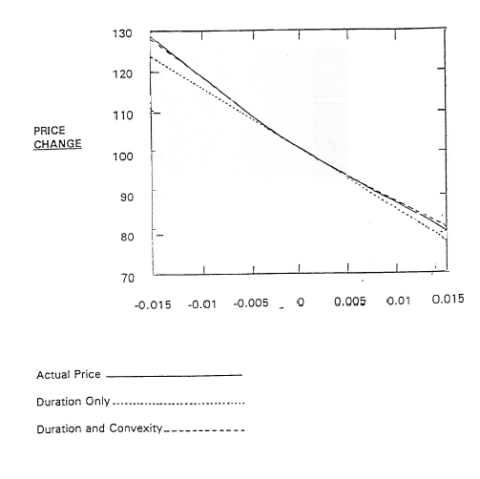

R (x) | p (x) | new price (x) | newprice2 (x)
0.035 | 127.588 | 122.059 | 127.001
0.036 | 125.429 | 121.521 | 124.956
0.037 | 123.322 | 119.984 | 122.946
0.038 | 121.264 | 118.447 | 120.97
0.039 | 119.254 | 116.91 | 119.03
0.04 | 117.292 | 115.372 | 117.125
0.041 | 115.376 | 113.835 | 115.255
0.042 | 113.504 | 112.298 | 113.419
0.043 | 111.674 | 110.761 | 111.619
0.044 | 109.889 | 109.223 | 109.854
0.045 | 108.144 | 107.686 | 108.124
0.046 | 106.44 | 106.149 | 106.429
0.047 | 104.774 | 104.612 | 104.769
0.048 | 103.146 | 103.074 | 103.145
0.049 | 101.555 | 101.537 | 101.555
0.05 | 100 | 100 | 100
0.051 | 98.48 | 98.463 | 98.48
0.052 | 96.994 | 96.926 | 96.996
0.053 | 95.542 | 95.388 | 95.546
0.054 | 94.122 | 93.851 | 94.131
0.055 | 92.733 | 92.314 | 92.752
0.056 | 91.375 | 90.777 | 91.407
0.057 | 90.047 | 89.239 | 90.098
0.058 | 88.748 | 97.702 | 88.824
0.059 | 87.478 | 86.165 | 87.584
0.06 | 86.235 | 84.628 | 86.38
0.061 | 85.019 | 83.09 | 85.211
0.062 | 83.83 | 81.553 | 84.076
0.063 | 82.666 | 80.016 | 92.977
0.064 | 81.527 | 78.479 | 91.913
0.065 | 80.412 | 76.941 | 80.884

MEASURING

SENSITIVITY

NUMERICALLY

Numerical Estimation of Duration

t | $$r_{\text{00}t}$$ | $$r_{\text{00}t}^{'}$$
1 | 10 | 11
2 | 11 | 12
3 | 12 | 13
4 | 13 | 14
5 | 14 | 15

$$\frac{ΔP}{P}=−\text{D dr}$$

$$P=\frac{5}{(1\text{.}\text{05})}+\frac{5}{(1\text{.}\text{055})^{2}}+\frac{5}{(1\text{.}\text{06})^{3}}+\frac{5}{(1\text{.}\text{065})^{4}}+\frac{\text{105}}{(1\text{.}\text{07})^{5}}$$

$$P^{'}=\frac{5}{(1\text{.}\text{055})}+\frac{5}{(1\text{.}\text{06})^{2}}+\frac{5}{(1\text{.}\text{065})^{3}}+\frac{5}{(1\text{.}\text{07})^{4}}+\frac{\text{105}}{(1\text{.}\text{075})^{5}}$$

By definition:

$$\frac{P^{'}−P}{P}=\text{ fraction change in price}$$

Calculation Duration

P = 92.202

$$P^{'}=\text{90}\text{.}\text{2817}$$

$$\frac{P^{'}−P}{P}=−\text{.}\text{021}$$

dr = .01

Duration = 2.1

Two Factor Example

Assume two key rates

- six-month rate

- ten-year rate

Estimate Functional Relationship

${Δr}_{\text{001}}=\text{1 }Δr_{\text{001}}+0Δ{\text{ r}}_{\text{020}}$

${Δr}_{\text{002}}=\text{.}8Δ{\text{ r}}_{\text{001}}+\text{.}\text{05}Δ{\text{ r}}_{\text{020}}$

${Δr}_{\text{003}}=\text{.}4Δ{\text{ r}}_{\text{001}}+\text{.}1Δ{\text{ r}}_{\text{020}}$

${Δr}_{\text{004}}=\text{.}1Δ{\text{ r}}_{\text{001}}+\text{.}\text{15 }{Δr}_{\text{020}}$

${Δr}_{\text{005}}=\text{.}\text{05}Δ{\text{ r}}_{\text{001}}+\text{.}\text{20}Δ{\text{ r}}_{\text{020}}$

t | $$r_{\text{00t}}$$ | $$r_{{\text{00t}}^{′}}$$ | $r_{{\text{00}t}^{″}}$
1 | 10 | 11 | 10
2 | 11 | 11.8 | 11.05
3 | 12 | 12.4 | 12.10
4 | 13 | 13.1 | 13.15
5 | 14 | 14.05 | 14.20

$$\frac{ΔP}{P}=−D_{1}{\text{ dr}}_{1}−D_{2}{\text{ dr}}_{2}$$

$P=\frac{5}{(1\text{.}\text{05})}+\frac{5}{(1\text{.}\text{055})^{2}}+\frac{5}{(1\text{.}\text{06})^{3}}+\frac{5}{(1\text{.}\text{065})^{4}}+\frac{\text{105}}{(1\text{.}\text{07})^{5}}$

$$P^{'}=\frac{5}{(1\text{.}\text{055})}+\frac{5}{(1\text{.}\text{059})^{2}}+\frac{5}{(1\text{.}\text{062})^{3}}+\frac{5}{(1\text{.}\text{0655})^{4}}+\frac{\text{105}}{(1\text{.}\text{07025})^{5}}$$

$$P^{''}=\frac{5}{(1\text{.}\text{05})}+\frac{5}{(1\text{.}\text{05525})^{2}}+\frac{5}{(1\text{.}\text{0605})^{3}}+\frac{5}{(1\text{.}\text{06575})^{4}}+\frac{\text{105}}{(1\text{.}\text{071})^{5}}$$

→ P = 92.202

$P^{'}=\text{92}\text{.}\text{028}$

$P^{''}=\text{91}\text{.}\text{835}$

$$\frac{P^{'}\text{ - P}}{P}\text{ = - 0}\text{.}\text{0019}$$

$$\frac{P^{''}\text{ - P}}{P}\text{ = - }\text{.}\text{0040}$$

D₁ = .19

D₂ = .40
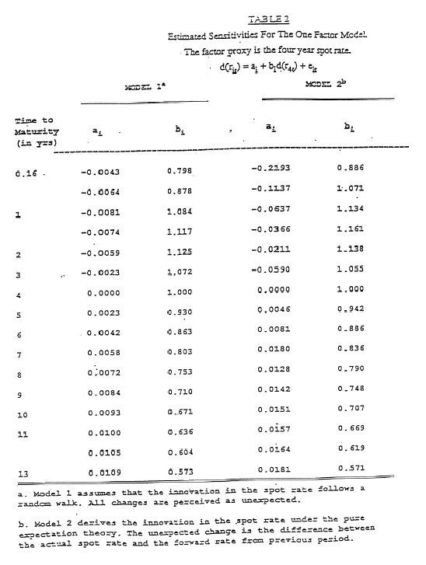
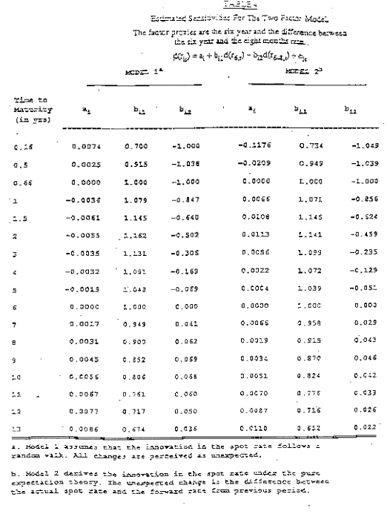

COMMENTS

1) The advantage of Numerical calculation of duration lies in determining the duration for bonds with option features. One can numerically value the options at both sets of spot rates and then determine the price changes including the change in the value of the option.

2) The other consideration is that charges in spot rates are linked. The above assumption of a constant 1% change for all spots is unrealistic.

3) If one believed two factors one would obtain a D₁ and D₂ for each factor

TIME SERIES ESTIMATION

Total  Return = | Expected  Return +  Due to  Passage of  Time | Sensitivityto Unex-  pected  Term  Structure Shifts | Unexpected  Term +  Structure  Shifts | Random  Error

$$r_{\text{it}}\text{ = }{\overline{r}}_{i}\text{ - }d_{i}(\frac{\text{dr}}{\text{1+r}})\text{ + }ε_{i}$$
Note:

(1) In stock area estimate directly

(2) In bonds D changes over time but can do for spots(unchanged duration), and build up to coupon bonds. Above is a "factor model."

Duration on portfolio is weighted average of duration bonds comprising it.

empirical duration = Σ X_{i} D_{i}

where D_{i} for each pure discount bond

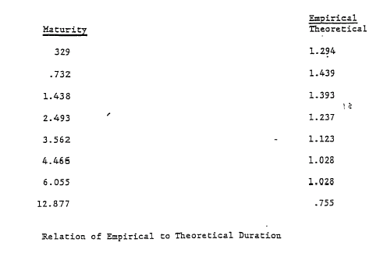

Immunization

(1) Protecting against shifts in spot rates

a. D_{A} = D_{L}
b. D_{A} = D_{L} C_{A} = C_{L}
c. D_{A1} = D_{L1} D_{A2} = D_{L2}

(2) If PV (assets) > PV (Liabilities) immunization involves scaling

$$D_{A}=\frac{L}{A}D_{L}$$
Note:

Exact match portfolios are of course immunized.

Sensitivity Cash flow
Matching vs Matching

1. If all bonds fairly priced always cash flow match.

2. Must have sufficient mispricing to justify
sensitivity.

3. Often optimum to do both.

I. Terms

a. Duration

b. Cash flow matching

c. Sensitivity matching

II. Concepts

a. Risks of cash flow matching

b. Risks of sensitivity matching

c. Analytical duration measures

d. Numerical duration measures

e. What affects duration

f. Convexity

III. Calculations

a. Various duration and convexity measures

Problem

1. Assume a bond has been semi-annual payments of $5 and a life of four years. What is its duration with a flat yield curve of 8%?

Answer:

Price of bond is $106.73, which is the present value of cash flows.
$\text{Duration} \text{ = }\frac{\frac{\text{1/2 }×\text{ 5}}{(1\text{.}\text{04})}\text{ + }\frac{\text{1 }×\text{ 5}}{(1\text{.}\text{04})^{2}}\text{ + }\frac{\text{3/2 }×\text{ 5}}{(1\text{.}\text{04})^{3}}\text{ + }\text{.}\text{.}\text{.}\text{ + }\frac{\text{4 }×\text{ 105}}{(1\text{.}\text{04})^{8}}}{\text{106}\text{.}\text{73}}\text{ = 3}\text{.}\text{42}$

