What Matters for
Emerging Equity Market
lnvestments

By Geert Bekaert, Claude B. Erb, Campbell R. Harvey, Tadas E. Viskanta

Regulatory changes, currency devaluations, failed economic plans, coups, and other national financial shocks are notoriously difficult to predict, and may have disastrous consequences for global portfolios. These features often define the difference between investment in the capital markets of developed versus emerging economics.
Research on emerging markets has suggested three market characteristics: high average returns, high volatility and low correlations both across the emerging markets and with developed markets. Indeed, the lesson of volatility was learned the hard way by many investors in December 1994 when the Mexican stock market began a fall that would reduce equity value in U.S. dollars by 80% over the next three months.
But we have learned far more about these fledgling markets. First, we need to be careful in interpreting the average performance of these markets. Errunza and Losq [1985] and Harvey [1995] point out that the International Finance Corporation (IFC) backfilled some of the index data, resulting in a survivorship bias in the average returns. In addition, the countries that are currently chosen by the WC are the ones that have a proven track record. This selection of winners induces another type of selection bias.
Final.ly, Coetzmann and Jorion [1996] detail a re-emerging market bias. Some markets, like Argentina, have a long history beginning in the last half of the nineteenth century. At one point in the 1920's, Argentina's market capitalization exceeded that of the U.K., but this market submerged. To sample returns from 1976 (as the IFC does), measures only the "re-emergence" period. A longer horizon mean, in this case, would be lower than the one calculated from 1976.
This insight is consistent with out-of-sample portfolio simulations carried out by, Harvey [1993] indicating that performance of a dynamic strategy is affected by the initial five years. It must also be realized that exposure as measured by the IFC is not necessarily attainable for world investors because of investment restrictions, high transaction costs, poor liquidity, and so forth (see Bekaert and Urias (1996]).
Second, we have learned that emerging market returns are more predictable than developed market returns. Harvey [1995] details much higher explanatory power for emerging equity markets than developed market returns. The sources of this predictability could be time-varying risk exposures and/or time-varying risk premiums, such as in Ferson and Marvey’s [1991, 1993] studies of U.S. and international markets. Predictability could also be induced by fundamental inefficiencies.
In many countries, predictability is of a remarkably simple form: autocorrelation. For example, Harvey [19951 details a 0.25 autocorrelation coefficient for Mexico in a sample that ends in June 1992. An investor who followed a strategy based on autocorrelation in this country would have lost 35% like everyone else in December 1994, although the investor would have been completely out of the market in the next three months (or short if possible). Momentum appears to be important for many of these markets.
Third, we have learned that the structure of the returns distribution is potentially unstable. Bekaert, Erb, Harvey, and Viskanta [1996] present evidence that the distribution of emerging equity market returns is different in the 1990s from the 1980s. Garcia and Ghysels [1997] reject the structural stability of the prediction regressions presented in Harvey [1995]. These regressions allow for the influence of both local and world information.
Bekaert and Harvey [1995, 1997a] present a model that explains the results of Ghysels and Garcia. The Bekaert and Harvey model allows for the relative influence of local and world information to change through time. They hypothesize that as a market becomes more integrated into world capital markets, the world information becomes relatively more important. Bekaert and Harvey [1997a] find that the changing relative importance of world information also influences volatility.
Fourth, the Bekaert and Harvey [1997a] framework suggests that the increasing influence of world factors on emerging expected returns may manifest itself in increased correlation with developed market benchmarks.
The goal of this article is to explore cross-sectional determinants of emerging markets market strategies. We begin by examining some of the issues involved in using emerging market equity data. These issues include investability, survivorship, and non-normality. We then investigate a wide variety of cross-sectional strategies.
We attempt to answer the question of what matters in emerging equity market investing. We try to link the cross-section of expected returns to political, economic, and financial risk, as well as a number of fundamental attributes, such as price to book value.
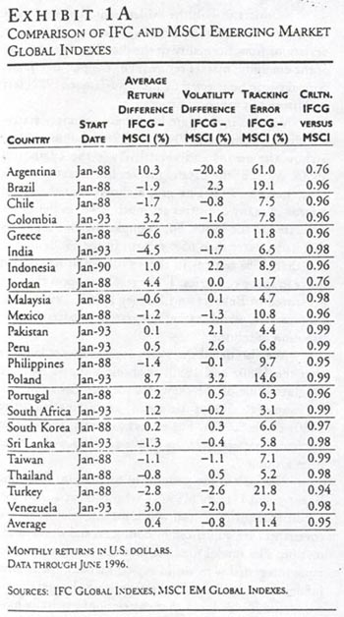

THE CHALLENGES OF
EMERGING MARKET DATA

WHICH EMERGING MARKET BENCHMARKS
SHOULD BE USED?

The three main sources of emerging market benchmarks are the International Finance Corporation (IFC), Morgan Stanley Capital International (MSCI), and ING Barings' Emerging Markets Indices (BEMI). All provide country benchmark indexes that are based on a value weighted portfolio of a subset of stocks that account for a substantial amount of the market capitalization within each emerging market.
The IFC produces two types of indexes: global (IFCG), and investable (IFCI). For nine countries, data exists back to 1976. Currently, the IFC provides data on twenty-seven countries.¹ MSCI also produces both an emerging markets global (EMG) index and an emerging markets free index (EMF), which resembles the IFCI. ING Barings focuses only on investable indexes.
We focus on the global indexes. Part of the interest in studying emerging markets is the impact that capital market liberalizations have on the returns. Hence, we study markets before and after they are accessible to international investors.²
IFC, MSCI, and ING Barings all use a different hierarchical processes in the company selection for their indexes. MSCI follows the same technique that it uses in its popular developed country benchmarks. First, the market is analyzed from the perspective of capitalization and industry categories. Next, a target of 60% coverage of the total capitalization of each market, with industry weightings approximating the total market's weightings, is established. Finally, companies are selected based on liquidity, float, and cross-ownership to fulfill these goals.
The IFC'S order of preference is: size, liquidity, and industry. The IFC targets primarily the largest and most actively traded stocks in each market, with a goal of 60% of total market capitalization at the end of each year. As a second objective, the index targets 60% of the trading volume during the year. Industry is of tertiary priority.
ING Barings' indexes focus on foreign institutional investability for the global emerging markets. Its indexes include only the most accessible securities in the twenty markets it tracks. As a result, there are many fewer securities tracked by BEMI than MSCI and IFC.³ Aside from investability, the primary factor for both company and country selection is liquidity. ING Barings considers other factors, including frequent financial reporting and the availability of high quality data.
Although there are some hierarchical differences in the structure of construction, there is little difference in the behavior of the IFCG and the EMG. Exhibit 1A details the difference between the IFCG and the EMG returns over identical samples for each index. The data are available through June 1996. Of the twenty-two countries where there are MSCI and IFC data, the returns indexes have greater than 94% correlation. The volatility differences arc quite small—as is the tracking error of the two indexes.⁴
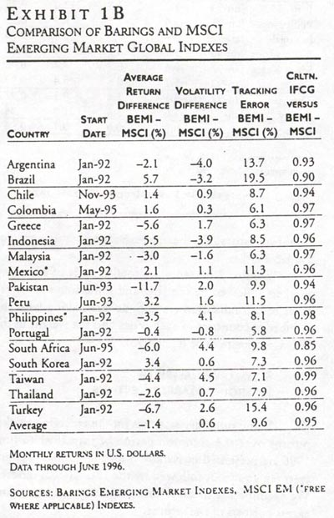
The only country where substantial deviations occur is Argentina. The IFC index produces a 10.3% lower average return and 20.8% less volatility. For this country, the correlation between the IFC index and the MSCI index is only 76%. Much of the tracking error in this case is due to 1988-1989 data. When we redo the comparison for Argentina beginning in January 1990, the tracking error drops from 61.9% to 10.6%. The correlation increases from 76% to 99%. There is no difference in the mean returns and little difference in the volatilities. Hence, even for Argentina, there does not appear to be a substantive difference between the MSCI
Exhibit 1B examines the differences between the MSCI free and the BEMI investable indexes. The average tracking error is 9.6%. The countries with the highest tracking errors are Argentina, Brazil, and Turkey. Nevertheless, the correlation of the indexes averages 95% and is above 94% in fourteen of the seventeen countries.
Exhibit 1C measures the differences between the Barings; and IFC investables. The tracking error is slightly less thin the BEMI—MSCI Free, at 9.4%. The average correlation of the indexes is 96%. There are only three countries of eighteen that have correlations less than 94%.
The IFC family of indexes presents the longest history, so we choose to focus on it. In addition, we study total market returns measured in U.S., dollars. The local currency returns are not, in general, available to international investors. Furthermore, hedged returns are not available either.
Exhibit 2 presents the total sample of emerging markets followed by the IFC and some summary measures of capitalization (in U.S. dollars), along with the number of countries in each index and the weight in the IFC Composite as of June 1996.
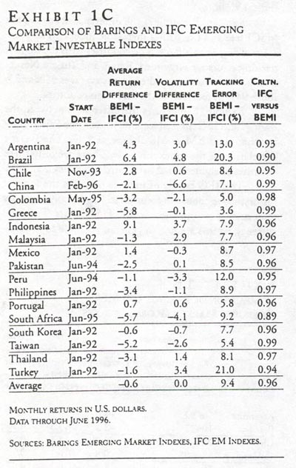
SUMMARY ANALYSIS OF
EMERGING MARKET RETURNS

Some summary statistics for the emerging market returns over the common period of July 1991 to June 1996 are presented in Exhibit 3 for the sample of twenty-seven countries.followed by the IFC Global indexes. We examine the mean returns, volatility, skewness, and excess kurtosis of the returns.
Consistent with the evidence in Harvey [1995] and Bekaert and Harvey [1997a], there are significant deviations from normality in the distributions of many of the emerging market returns. For the past five years, normality can be rejected by the Bera-Jarque [1982] test in thirteen of twenty countries.
We also investigate how -these summary statistics change from the 1980s to the 1990s. Exhibits 4 and 5 show the means and volatilities in the 1980s and 1990s. Most of the capital market liberalizations took place before 1992. The graph shows that the mean returns in many countries are much lower in the 1990s compared to the 1980s. For example, the four countries that had greater than 65% returns in the 1980s all had less than 25% returns in the 1990s. Volatility is also lower in many countries. These results support the idea presented in Bekaert and Harvey (1995, 1497a] that time-varying world market integration impacts the distribution of returns.
We also detail the skewness and excess kurtosis over the 1980s and 1990s. Exhibit 6 shows that the absolute value of the skewness parameter has shrunk for many (twelve of nineteen) countries from the 1980s to the 1990s. For excess kurtosis, there is no particular pattern over the 1980s and 1990s as is clear from Exhibit 7.
We look at the patterns in correlations following Bekaert and Harvey [1997a], who present a model of conditional correlation in which means, volatilities, and covariances are influenced by both local and world information. The model predicts that as a market becomes more integrated with world capital markets, the relative influence of world and local information changes.
Exhibit 8 shows that correlations generally have increased over the longer horizon. Correlations have increased in eleven of nineteen countries, remained the same in six countries, and decreased in only two countries. This suggests that the benefits of diversification have decreased for many emerging markets, although correlations are still sufficiently low to attract most global portfolio investors.
The betas presented in Exhibit 9 mimic the correlations. For many countries, the beta with respect to the MSCI-All Countries index has increased from the 1980s to the 1990s. This suggests that country returns are more affected by world market returns, which is consistent with the impact of the degree of capital market integration detailed in Bekaert and Harvey [1995, 1997a].

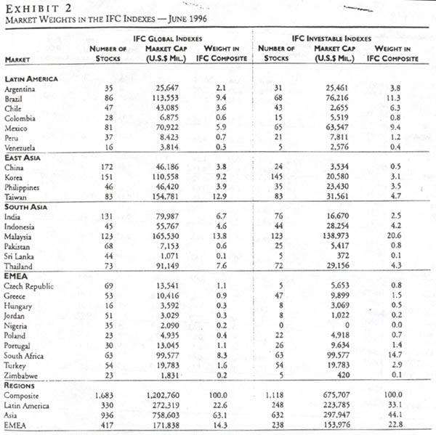

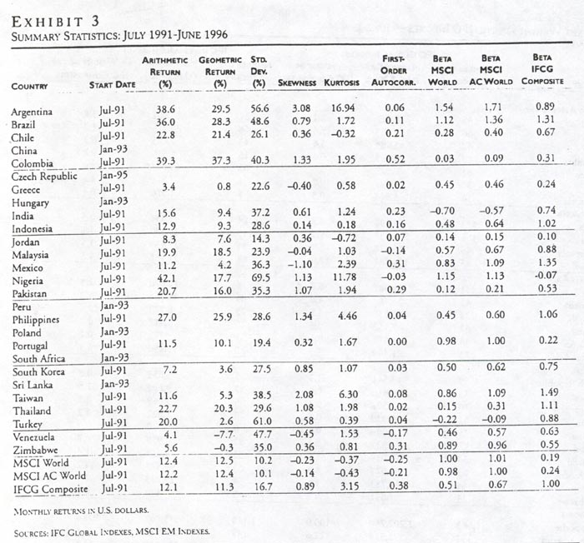

CROSS-SECTIONAL
PORTFOLIO STRATEGIES FOR
EMERGING MARKET RETURNS

ASSET PRICING THEORY AND
EMERGING MARKET RETURNS

Risk is notoriously difficult to measure in emerging market returns. A simple implementation of the Capital Asset Pricing Model (CAPM) of Sharpe [1964] and Lintner [1965] is problematic. In these markets, there is little relation between the risk measured by the CAPM and expected-returns.
Consider Exhibit 10, which plots the average returns versus beta against the World-All Countries index over the 1980s and the 1990s. (The betas over the past five years, July 1991 to June 1996, are presented in Exhibit 3.) In the 1980s, there is a positive relation between beta and average returns. The t-statistic on the beta coefficient is 1.5, which is marginally significant at conventional levels.
The beta-average returns relation appears stronger over the 1990s. However, as is obvious from exhibit 10, there is one influential observation—Poland—that has a high average return and very high beta. If the average returns are regressed on the betas, the t-statistic is 3.2 and the R-square measure is 27%. When Poland is removed from the analysis, the t-statistic drops to 0.4, and the R-square is 0%.
The failure of the CAPM to explain emerging market returns could be interpreted in a number of ways. First, following Roll and Ross [1994] and Kandel and Stambaugh [1995], the benchmark world portfolio may not be mean-variance efficient. Second, perhaps a multi-factor representation, following Merton [1973], Ross [1976] and Chen, Roll, and Ross [1986], is more appropriate for emerging markets. Third, following Ferson and Harvey [1991], an examination of average returns and average risk could be misleading if the risk and expected returns change through time. Finally, the CAPM is not the appropriate framework if these markets are not integrated into world capital markets. In integrated capital markets, projects of identical risk command identical expected returns, irrespective of domicile (see Stulz [1981a, 1981b], Solnik [1983], Campbell and Hamao [1992], Chan, Karolyi, and Stulz [1992], Heston, Rouwcnhorst, and Wessels [1995], Bekaert [1995], Harvey [1991, 1995], and Bekaert and Harvey [1995]).
It is likely that many of these markets are not fully integrated into world capital markets. As a result, the beta suggested by the CAPM may not be that useful in explaining the cross-section of average returns. Indeed, in completely segmented capital markets, the volatility is the correct measure of risk.
The relation between average returns and volatility is detailed in Exhibit 11. Similar to the beta graph, there is a positive relation that is now significant at conventional levels of confidence (R-square is 33% in the 1980s and 36% in the 1990s). Note that even among the segmented markets, the relation between volatility and expected returns may appear weak because the premium accorded to-volatility could vary across countries (see Bekaert and Harvey [1995]).
We examine two attributes based on asset pricing theory in our portfolio strategies: the trailing three-year beta against the MSCI-All Countries index, and the trailing three year conditional volatility. If markets are perfectly integrated and a world version of the CAPM holds, higher-beta countries should earn higher expected returns. If markets are perfectly segmented and a local version of the CAPM holds, higher-volatility countries should have higher expected returns, assuming that risk aversion is the same across countries.
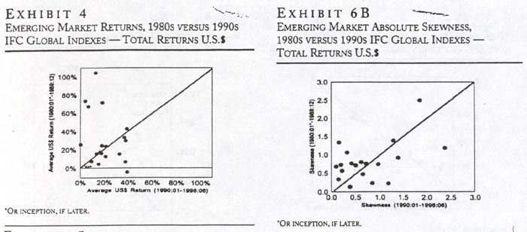

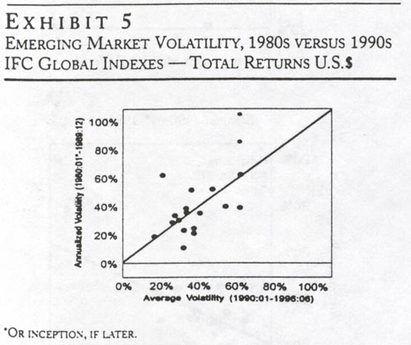

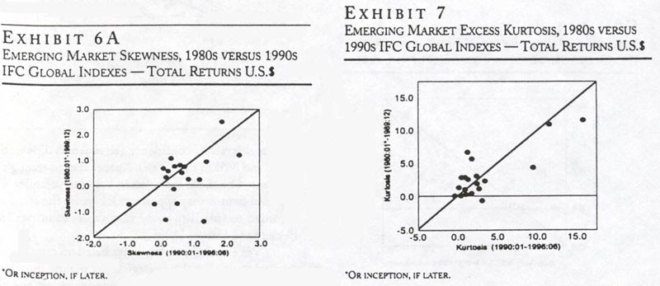

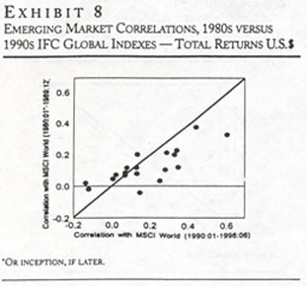  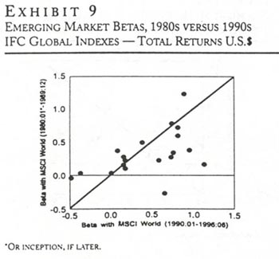 | 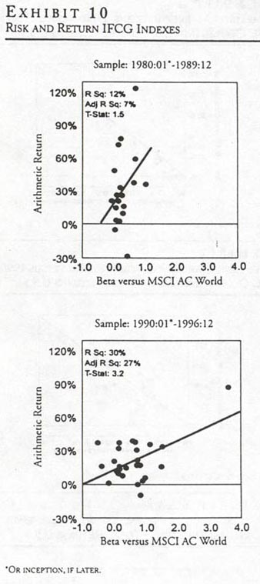

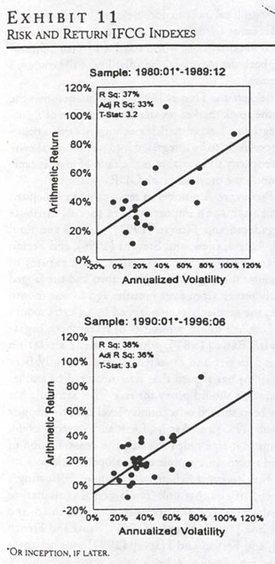

ALTERNATIVE RISK ATTRIBUTES

Following Ferson and Harvey [1994], Erb, Harvey, and Viskanta [1995a, 1996b], and others, we examine the relation between some country-specific risk attributes and the distribution of returns. We group these attributes into several categories.
Survey-Based Measures. The first measure is Institutional Investor's country credit rating (IICCR). Institutional Investor country credit ratings are based on a survey of leading international bankers who are asked to rate each country on a scale from zero to 100 (where 100 represents the maximum credit worthiness). Institutional Investor averages these ratings, giving more weight to respondents with higher worldwide exposure and more sophisticated country analysis systems. These ratings have appeared in the March and September issues of Institutional Investor since 1979, and now cover over 135 countries. For additional details see Erb, Harvey, and Viskanta (1996a].
Whenever a survey or expert panel is used to rate creditworthiness, it is hard to exactly define the parameters taken into account. At any given time, an expert's recommendation will be based upon the factors that the expert feels are relevant. In one recent survey, for example, the most important factors for assessing emerging markets' credit rating were 1) debt service, 2) political outlook, 3) economic outlook, 4) financial reserves/current account, and 5) trade balance/foreign direct investment.
The next four measures are from Political Risk Services' International Country Risk Guide. They include a political risk index (ICRGP), economic risk index (ICRGE), financial risk index (ICRGF), and the composite risk index (ICRGC). The political index is studied in Harlow [1993] and Diamonte, Liew, and Stevens [1996]. Erb, Harvey, and Viskanta [1996b] examine the information in all four of the ICRG risk indexes.
On a monthly basis, ICRG uses a blend of quantitative and qualitative measures to calculate these risk indexes. Five financial factors, thirteen political, and six economic factors are used. Each factor is assigned a numerical rating within a specified range. A higher score represents lower risk, for additional details see Erb, Harvey, and Viskanta [1996b].
The composite index is simply a linear combination of the three subindexes. The political risk is weighted twice as much as either financial or economic risk. ICRG, as well as many other providers, thinks of country risk as being composed of two primary components: ability to pay, and willingness to pay. Political risk is associated with a willingness to pay, while financial and economic risk are associated with an ability to pay.
We also include Euromoney’s Country Credit Risk (EMCCR). Euromoney’s rating system is based on both qualitative and quantitative methods. The political component is a qualitative survey of experts. The economic component is quantitative and based on Euromoney's global economic projections. The financial component is also quantitative and based on 1) debt indicators, 2) debt in default or rescheduled, 3) credit rating (Moody's or Standard & Poor's), 4) access to bank finance, 5) access to short-term financing, and 6) access to international bond and syndicated loan markets.
Macroeconomy. The survey-based measures indirectly gauge future macroeconomic conditions in each country. One of the primary economic measures that influences these ratings is the inflationary environment. Ferson and Harvey [1993, 1994] argue that asset exposure versus world inflation helps explain both the cross-section and time series of expected returns in eighteen developed markets. Erb, Harvey, and Viskanta (1995b] examine the interaction of inflation and asset returns in emerging markets.
We use a trailing six-month measure of inflation represented by the consumer price index reported in the International Financial Statistics data base of the International Monetary Fund. In the case of Taiwan, whom is not a member of the IMF, we use inflation reported in its national accounts.
Demographics. Bakshi and Chen [19941 propose a life cycle investment hypothesis. Younger investors have more of a demand for housing than for equities. As age increases, more investment is allocated to the stock market. As a result, a rise in average age should be accompanied by a rise in the stock market. Bakshi and Chen [1994] find support for this hypothesis using U.S. data.
Erb, Harvey, and Viskanta [1996c] find that average age growth explains the risk premiums in a number of developed countries. We examine three variables: population growth, average age and average age growth. All this information is based on annual statistics compiled by the United Nations.
Market Integration. Bekaert and Harvey [1997a] argue that the size of the trade sector as a proportion of the total economy is a reasonable proxy for the openness of both the economy and the investment sector. They use exports plus imports divided by gross domestic product (GDP) as an instrument for market integration. This variable, along with other proxies for market integration, is used in a function that assigns time-varying weights to world versus local information. Bekaert and Harvey find that increases in this ratio are associated with the increased importance of world relative to local information for both the mean and the volatility of the country's stock returns.
Bekaert and Harvey [1997a] also suggest that the size of the stock market proxies for the degree of financial integration. Larger market size suggests that a country is more likely to be integrated into world capital markets. We specify this variable as the ratio of market capitalization to the previous year's GDP
Persistence. A number of researchers have pointed to momentum as an important firm specific attribute (see Jegadeesh and Titman [1993], Conrad and Kaul [1996], Asness, Liew, and Stevens [1996], and Ferson and Harvey [1997]). We examine two measures of momentum: the lagged monthly return and the lagged quarterly return from four months ago to one month ago, i.e., the quarterly return lagged by an extra month.
Size. We follow a number of researchers, beginning with Banz [1981], who document a relation between firm size and expected returns. Recently, Berk [1995, 1996] has argued that size measured by market capitalization should proxy for risk. This attribute has recently been studied on a country level basis by Keppler and Traub [1993] and Asness, Liew, and Stevens [1996], who find that size helps explain the cross-section of expected returns in a sample of developed markets.
Fundamental Valuation Measures. Following a number of articles that link "fundamental attributes" to asset valuation (see, for example, Chan, Hamao, and Lakonishok [1991], Keppler (1991], Fama and French [1992], and Ferson and Harvey [1994]), we use three valuation ratios: price-to-book value, price-to-earnings, and price-to-dividend.
Value-weighted indexes of company-level data are produced by the IFC. Ferson and Harvey [1997] show that some of these ratios, most notably price-to-book, appear to capture information regarding changing risk in a sample of twenty-one developed countries. In addition, sudden changes in these ratios may also reflect changes in the degree of market integration (see Bekaert and Harvey [1997b]). A change in the marginal investor from domestic to international could lead to a change in the fundamental valuation ratios and a change in the riskiness.
Summary Statistics. Some summary measures for many of these attributes are included in Exhibit 12. The March 1996 value of the attribute is reported. In the lower panel, the rank-order correlation of all the attributes is reported. Most of the correlations follow from intuition.
Consider the ICRG indexes. These indexes are highly correlated with the Euromoney and Institutional Investor country credit risk measures. All the survey measure are negatively correlated with inflation (high inflation means low rating). The most negative correlation with inflation is found for the ICRG economic risk index.
Average age is positively correlated with the survey risk indexes, indicating that low average age is associated with a low rating. Size is positively related to the ICRG ratings (smaller markets appear riskier). There is also a positive relation between the size of the trade sector and the ICRG ratings. The lowest correlations are found for the ICRG indexes and the fundamental attributes.

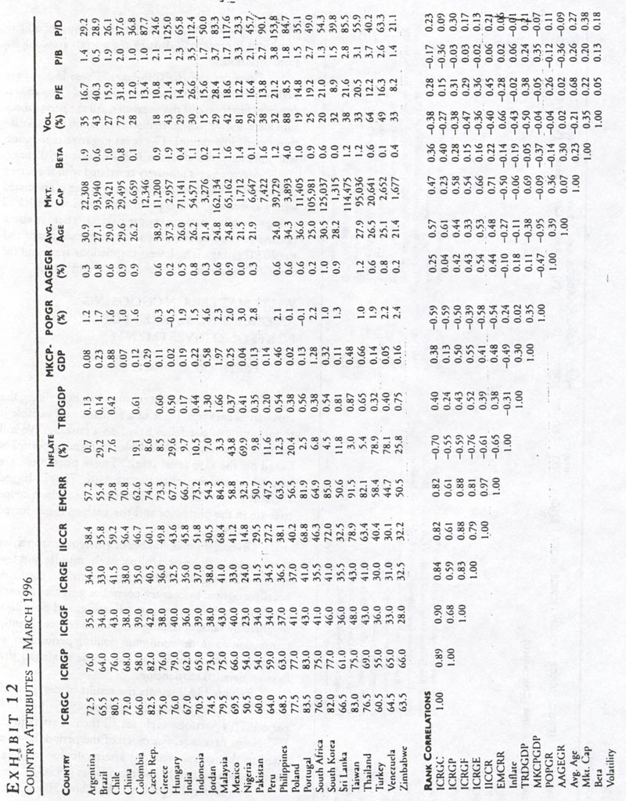
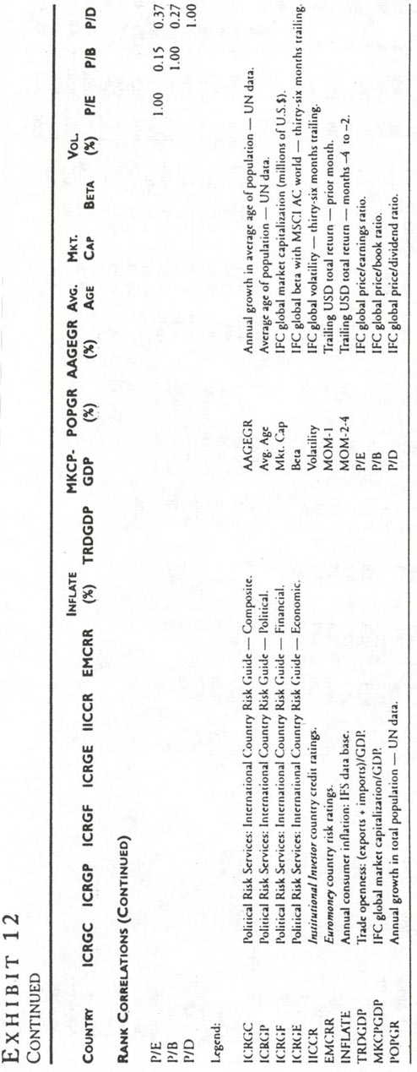
WHAT MATTERS IN CHOOSING
AN EMERGING MARKET FOR
PORTFOLIO INVESTMENT?

PORTFOLIO APPROACH

A commonly used technique in examining the cross-sectional importance of a fundamental variable is to form unique portfolios based on a ranking. We will examine the country risk variables by forming portfolios based on the risk level itself. These portfolios are investable with respect to the attribute. That is, lagged attribute information is used to determine which countries are in the portfolios and the analysis is conducted out of sample.
Given the small number of emerging markets, we examine only three portfolios: high, middle and low attribute. In each case, we track the returns to portfolios equally weighted by country, portfolios weighted by each country's equity market capitalization, and portfolios weighted by value of trading volume. To reduce potential transaction costs, the minimum holding period that we consider is quarterly. We also examine strategies that have semiannual rebalancing.
Exhibit 13A presents the results of the quarterly portfolio strategies over the January 1985-June 1996 period. This portfolio includes all the countries in the IFC global data base. For much of the period, however many of the returns were not attainable due to investment restrictions (see Bekaert and Urias [19961).
To address this problem, Exhibit 13B examines the same strategies evaluated over the past five years. In the late 1980s and early 1990s, most of these markets experienced substantial liberalizations. Exhibits 13C and 13D display the same strategies with semiannual rebalancing. Exhibits 13E and 13F examine quarterly and semiannual strategies over the past five years using only the investable indexes.

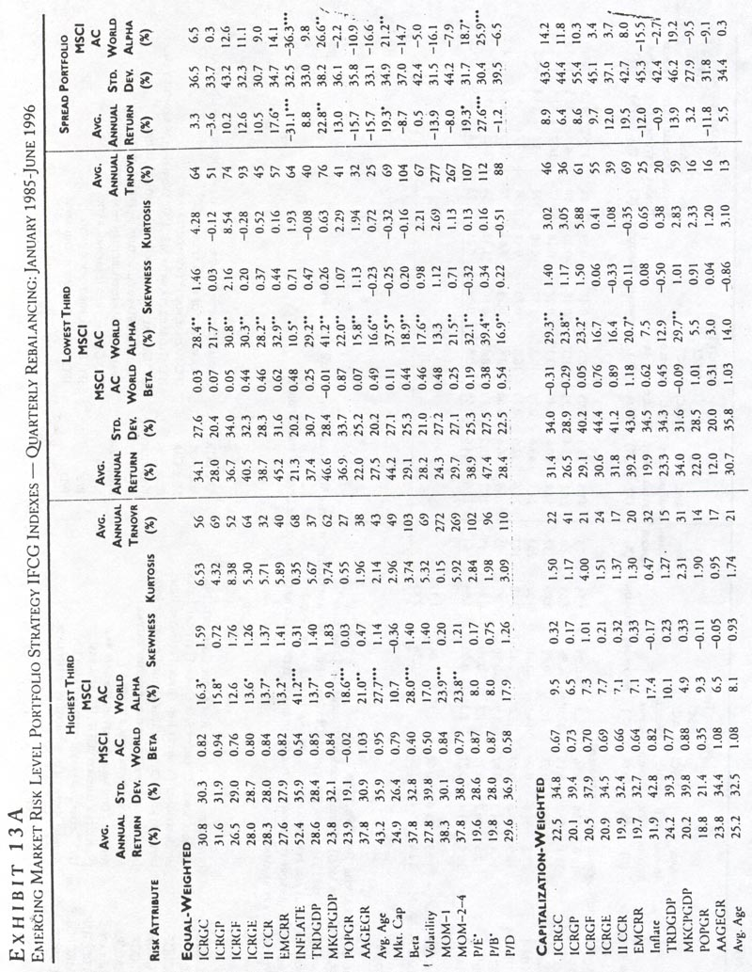

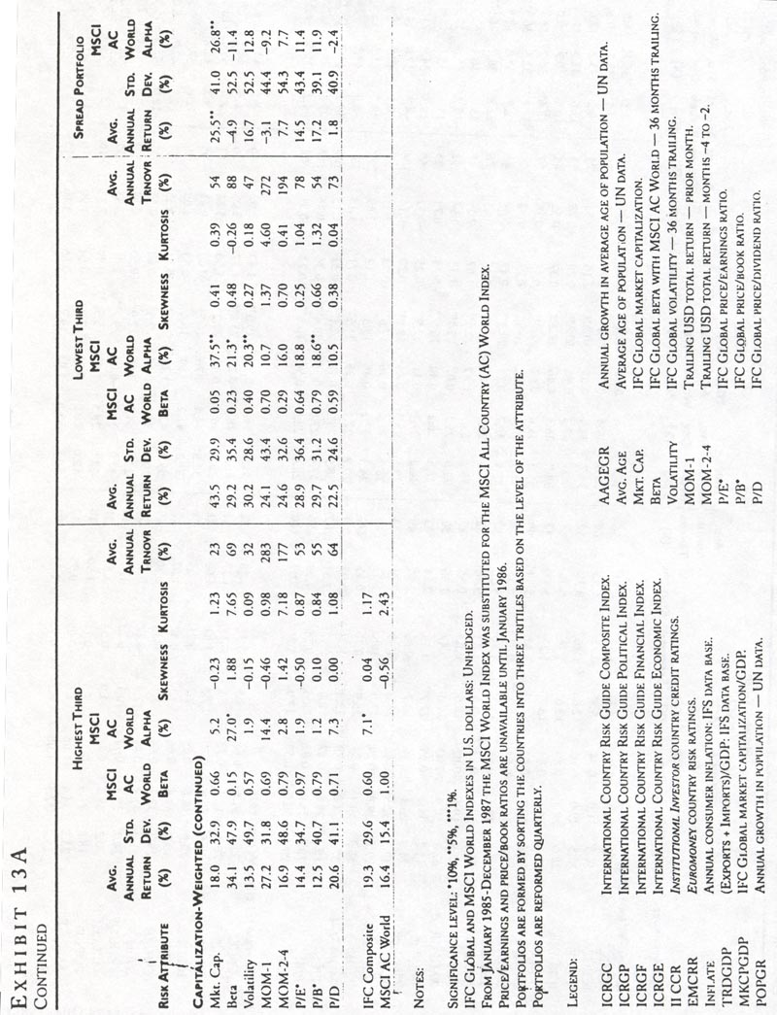

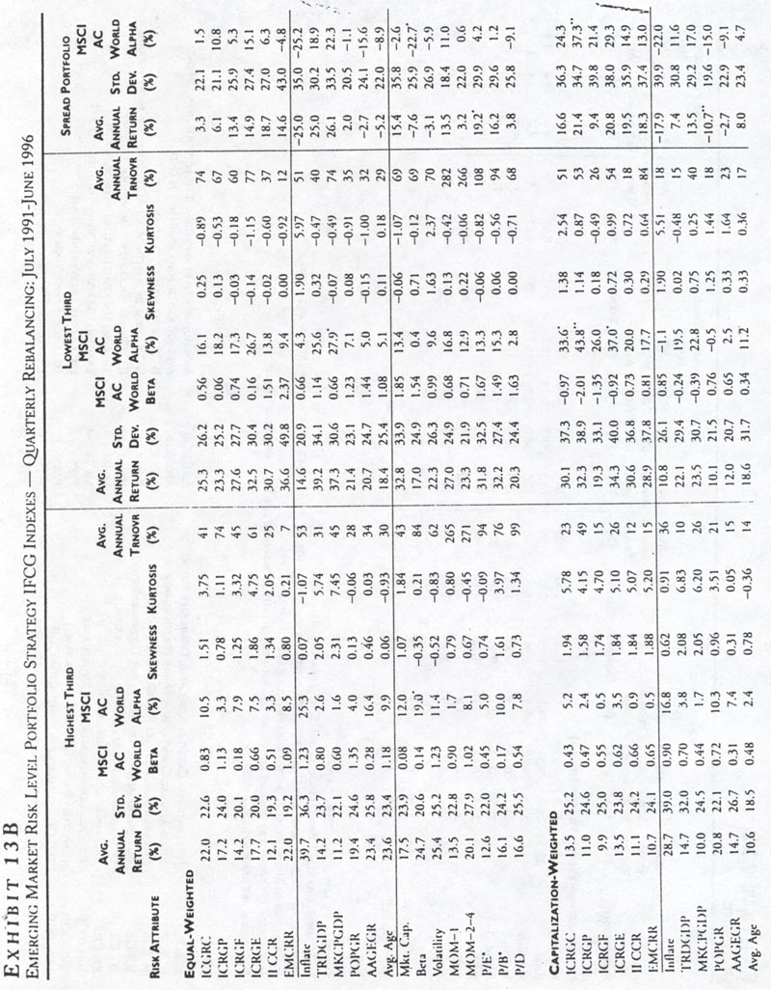

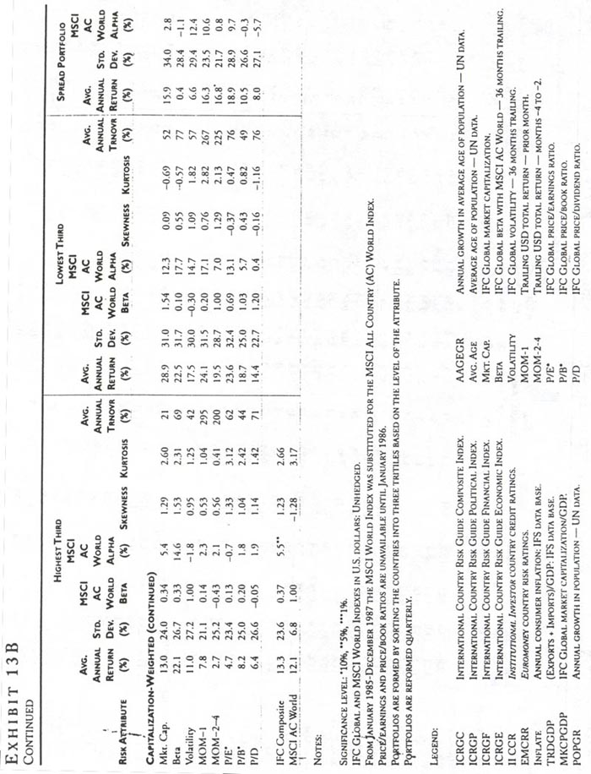

The very last column in each table reports the abnormal excess return with respect to the MSCI-AC portfolio. The annualized abnormal returns are large in absolute magnitude for many of the attributes.
ICRG. Consider the results for the ICRG Composite index (ICRGC). With equal weighting, the high rating portfolio averages 30.8% annual return with 30.3% volatility. The low rating portfolio has both higher returns, 34.1%, and lower volatility of 27.6%. The alpha measure is 6.5% on an annual basis.
The results are even more impressive with the capitalization weights. The alpha increases to 14.2%. The most impressive results occur over the past five years (Exhibit 13B), where the alpha is 24.3% for the ICRGC.⁵ Similar results are documented for the semiannual holding periods in Exhibits 13C and 13D.
The investable strategies detailed in Exhibits 13E and 13F also indicate that there is information in the risk ratings. In all three portfolio weighting schemes and over both rebalancing rules, the ICRG earns positive abnormal returns. Interestingly, the ICRGC composite is not even the most successful attribute. The ICRG economic risk and political risk attributes consistently produce higher abnormal returns. These results are consistent with those presented in Erb, Harvey, and Viskanta [1996b].
Institutional Investor and Euromoney. Both the Institutional Investor and the Euromoney credit ratings provide less impressive discrimination between high and low-expected return securities. None of the abnormal returns are significantly different from zero, and the performance deteriorates in the past five years.
For example, the EMCCR provides impressive abnormal performance in the overall period (14.4% alpha with equal weighting). In the past five years, the abnormal returns are negative, largely due to non-investable countries.
4 Exhibits 13E and 13F show that the EMCCR generates 18.8%, 13.8%, and 22.0% alpha for equalweighted, capitalization-weighted, and liquidity-weighted strategies with quarterly rebalancing.
Inflation. Inflation appears be an important instrument in portfolio selection. In this case, the highattribute portfolio has much higher expected returns than the low-attribute portfolio. In contrast to some of the ICRG results, however, the high-attribute portfolio has much higher volatility than the low-attribute portfolio. The high minus low equally weighted portfolio results in an alpha of 36.3% for the full period and 25.2% for the past five years. The alphas arc smaller for the capitalization weighted portfolios but still large compared to other attributes. In addition, the results arc robust to less frequent rebalancing. Finally, inflation is an important attribute in all the investable strategies.
Trade Sector. Trade as a proportion of GDP has some ability to distinguish between high and low expected returns. Countries with small trade sectors have higher expected returns than countries with large trade sectors. This is consistent with the Bekaert and Harvey [1997b] idea that the size of the trade sector proxies for market integration. In addition, the beta of the low-attribute portfolio may be low because the market is not integrated.
The size of the trade sector attribute produces a 12.6% alpha in the full period with the equally weighted portfolio and 18.9% over the last five years. The alphas are lower for the capitalization weighted portfolio strategies. The alphas are also low for the investable strategies in Exhibits 13E and 13F.
Market Size. Market size-to-GDP provides significant information regarding portfolio performance. This is consistent with the arguments of Bekaert and Harvey [1997b] that the size of the equity market relative to economic activity is an important indicator of financial market integration. For the equally weighted portfolios and quarterly rebalancing, the alpha is 26.6% in the overall period and 22.3% in the last five years. The value-weighted portfolios produce equally impressive results. In the overall period, the alpha is 18.7% and in the last five years 21.6%. The investable alphas are 10.0%, 1.3%, and 14.6% for the three weighting schemes.
Market size itself provides less information regarding portfolio performance. This contrasts with the results of Asness, Liew, and Stevens [1996] for developed countries. For equally weighted portfolios, the low minus high size portfolio produces a 22.1% alpha in the overall period but -2.6% in the last five

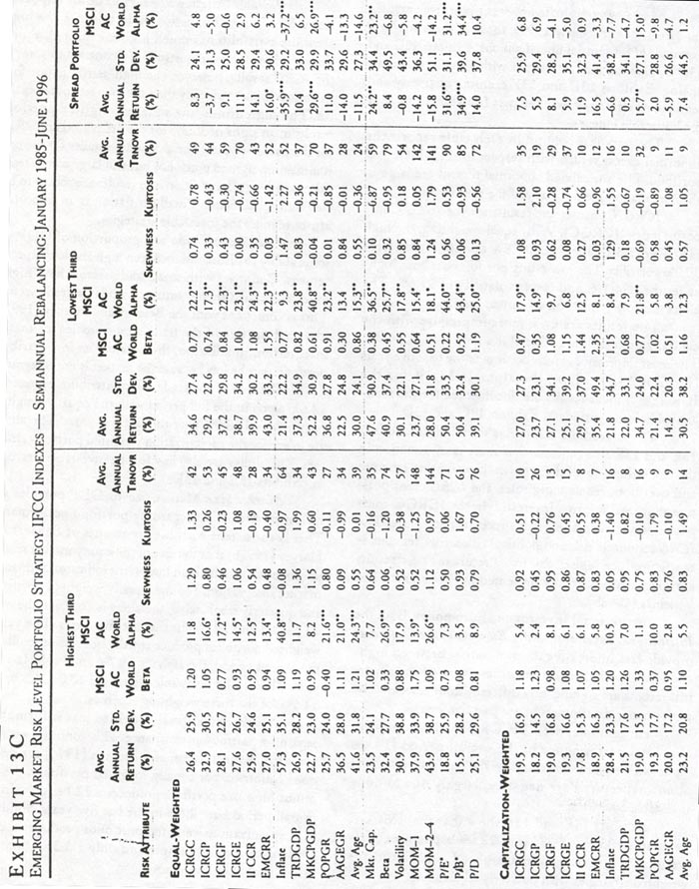

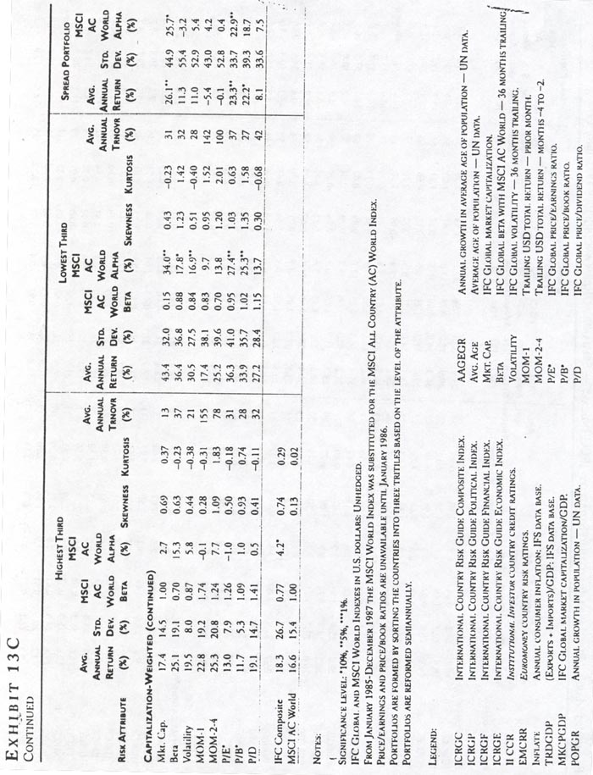

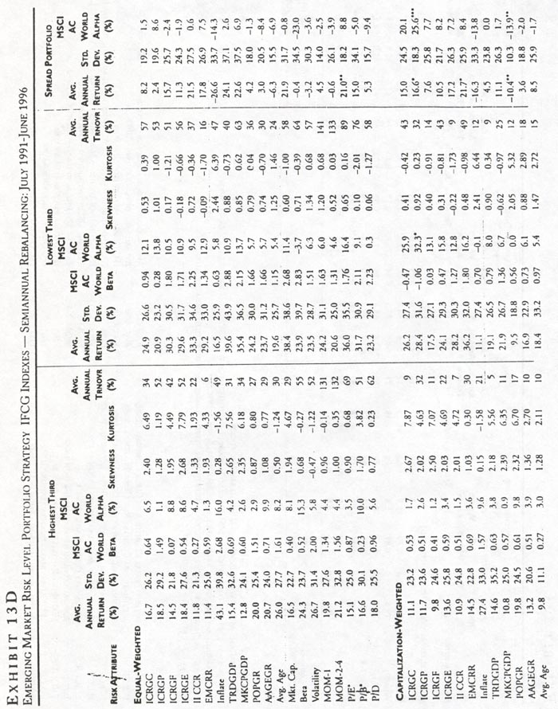

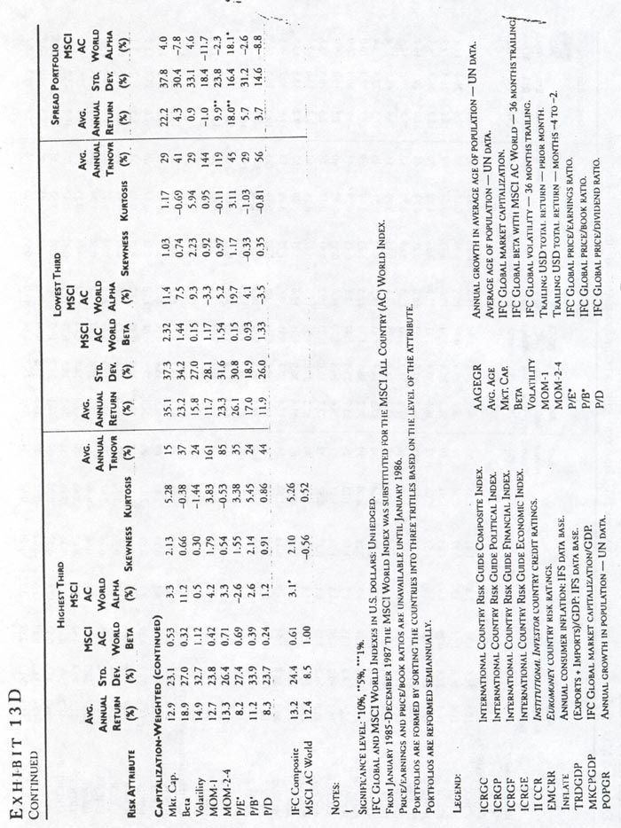

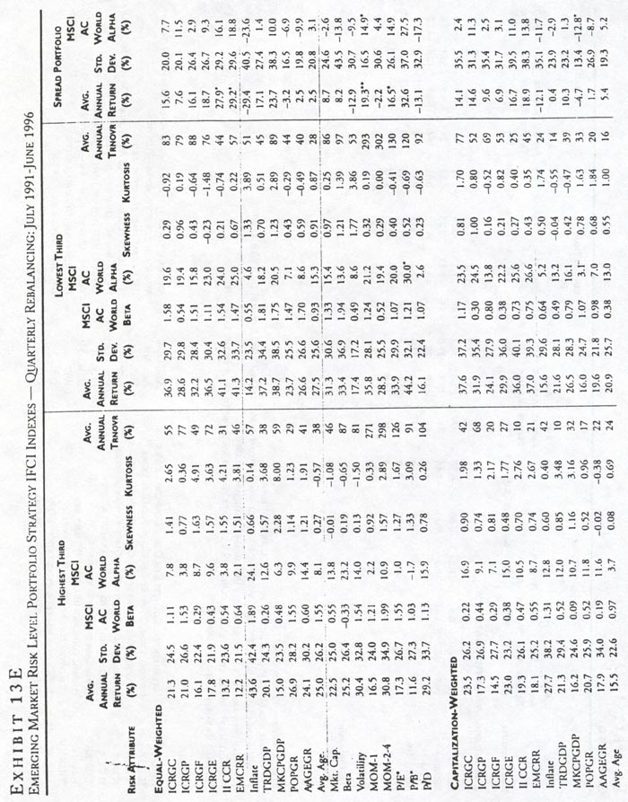

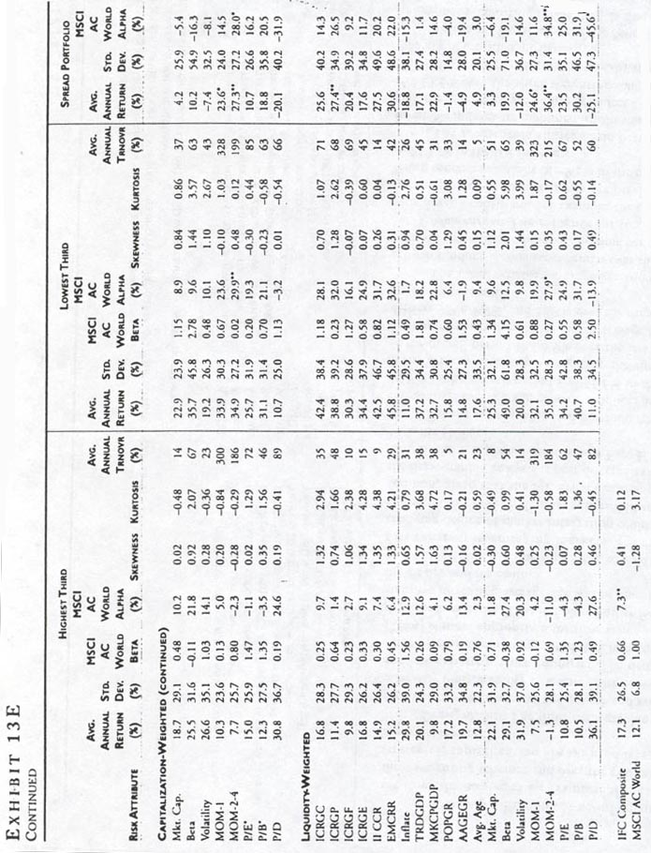


years. Similarly, the capitalization-weighted portfolios produce a 22.1% alpha over the full sample and only a 3.3% abnormal return in the last five years.
Market capitalization has no information when the investable strategies are examined. For each of the three weighting schemes and over the two rebalancing strategies, capitalization always produces negative abnormal returns.
Demographics. The three demographic variables, population growth, average age growth and average age, offer only limited ability to discriminate between high and low-expected return countries. The demographic asset pricing theory presented in Chen and Bakshi [1994] is most appropriate for time series analysis of developed countries. That is, holding other factors constant, an increasing average age will be associated with higher demand for equities.
It is difficult, if not impossible, to hold other factors constant in emerging markets. For example, a changing degree of market integration could confound the relation between demographics and returns. In addition, given that the age dynamics are predictable, the demographic analysis is best directed at explaining long-horizon expected returns (see Erb, Harvey, and Viskanta [1996c]).
For the equally weighted portfolio strategy, low minus high average age growth produces an alpha of 10.9% in the overall period and 15.6% in the last five years. With capitalization-weighting, the alpha is 9.3% in the overall period and 6.9% over the last five years. Examining the investable strategies, average age growth delivers 9.9%, 8.7%, and 19.4% over the three quarterly weighting schemes.
The other variables, average age and population growth produce inconsistent results over the different portfolio formation techniques and time periods.
Momentum. The evidence for the momentum variables is inconsistent. For example, the capitalization weighted strategy that examines the previous month's return produces an alpha of -9.8% in the overall period and 10.3% in the last five years.
The momentum strategies do better when the investable indexes are examined. In the quarterly strategies, the relative lagged return produces 14.9%, 14.5%, and 11.6% over the three weighting schemes. Importantly, this strategy induces dramatically more turnover than any of the other attributes.

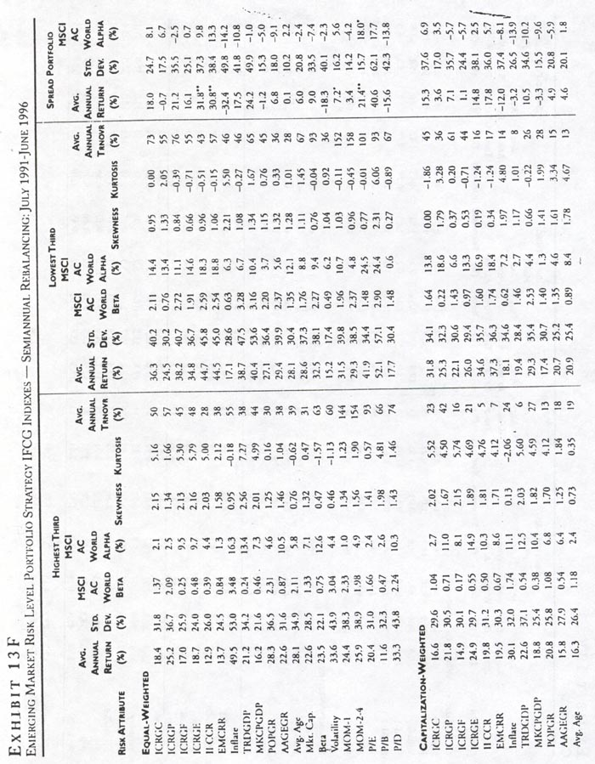

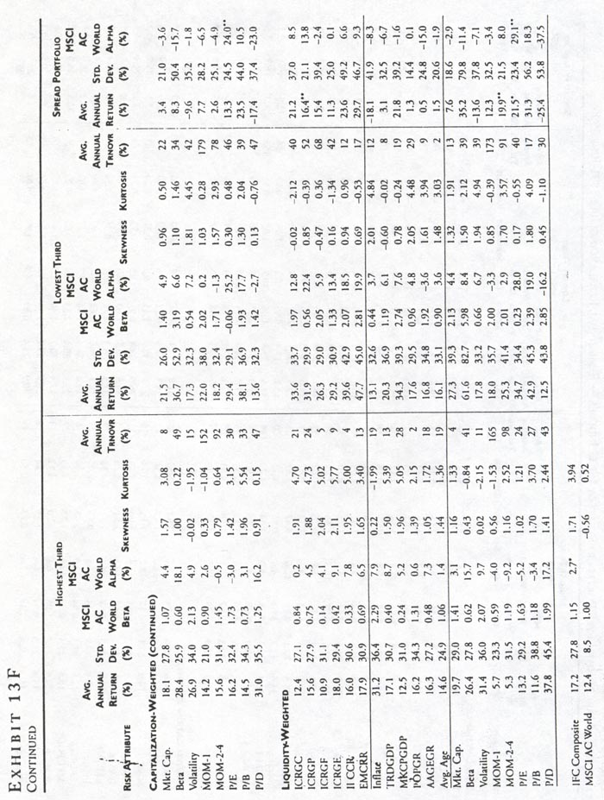


Valuation. The final set of attributes involves the traditional accounting ratios. While dividend yields (DP) are available on all the indexes one year after the market enters the IFC data, the price-to-book (PB) and price-to-earnings (PE) ratios are available only from January 1986. Hence, the evaluation of the PB and PE ratios is over a different sample from all the other portfolio simulations.
Of the three accounting attributes, PE produces the most consistent results. For equally weighted strategies, the alpha for the overall period is 18.7% and 4.2% in the last five years. For the capitalization-weighted strategies, the alpha for the overall period is 10.9% and 8.9% in the last five years. With the investables, the quarterly strategies produce 14.9%, 16.2%, and 25.0% over the three weighting methods.
The portfolio results for PB and PD arc inconsistent across portfolio weighting schemes using the global data. With the investable strategies, however, low minus high PB produces more impressive results than low minus high PE. As would be expected, the portfolio's strategy needs to be reversed for dividend yield. The high minus low PD produces consistently high abnormal performance over each of the investable strategies.
Asset Pricing Theory. Exhibits 13 to 13F also presents results based on two risk attributes implied by asset pricing theory: the trailing three-year beta, and the trailing three-year volatility. The beta is measured against the MSCI-all countries world index; it is a valid risk measure only if these markets are integrated into world capital markets.
The results are intriguing. In the global strategies, the low minus high beta portfolio always earns a negative return—which is what one would expect from asset pricing theory. It is important to note that the "betas" of the investment strategies (buy low-beta portfolios or buy high-beta portfolios) are not that different, however.
At first, this appears puzzling. Remember, a trailing beta is used to form the portfolio. The beta of the portfolio is not the weighted sum of the individual country betas because the portfolio is based on an out-of-sample use of the trailing betas. Similar results are observed in the investable strategies.
Volatility also has some ability to distinguish between high and low expected returns. In the global strategies, the high minus low volatility strategies produce positive excess returns for the equally-weighted portfolios and negative excess returns for the capitalization-weighted portfolios. In the investable strategies, the excess returns are positive for equal-weighted, capitalization-weighted, and liquidity-weighted strategies.
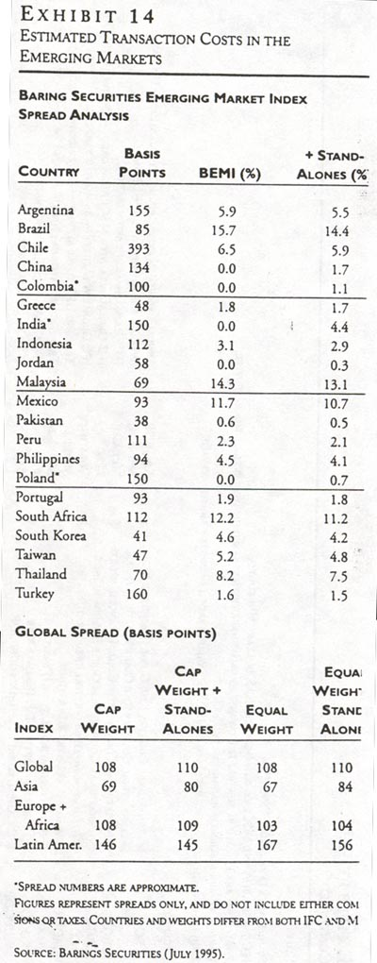
Summary. The results suggest that there are a number of useful attributes to differentiate among countries that will experience high and low expected returns. It is likely, as argued in Ferson and Harvey [1994,1997], that these attributes are related to risk. Unfortunately, determining the appropriate measure of risk is difficult in emerging markets.

TRADING EMERGING MARKET PORTFOLIOS

The cost of trading is high in emerging markets. Exhibit 14 presents estimates of transaction costs from Barings Securities. The percent spread calculation is the difference between the offer and bid price divided by the average of the offer and bid price. Barings uses the midpoint in the divisor in order to avoid the problems caused by large fluctuations in the current price.
The percent spreads in Exhibit 14 are based on snapshots of individual stocks during the weeks of July 17 and July 24, 1995. The country spreads are calculated by capitalization-weighting the percentage spreads of the individual firms within each country.
The percentage spreads are, in many countries, much larger than one would expect in developed markets. The spread in Chile is close to 400 bp. In both Argentina and Turkey, the percentage spread is more than 150 bp. These high transaction costs reinforce the need to minimize trading. Indeed, many investment managers do not practice active stock selection strategies in emerging markets because of the massive transaction costs. "Active" management in emerging markets is often interpreted in the context of country selection rather than stock selection.
While the portfolio analysis in Exhibits 13A to 13F does not explicitly account for transaction costs, we do include a measure of average turnover. Approximate transaction costs can be estimated with the turnover data. Assume that one-way transaction costs are 200 bp for each country. If a portfolio experiences 100% turnover, this would imply that the average return should be adjusted down by 400 bp.
The highest turnover is found with the momentum strategies. The turnover is so high that it is unlikely that these strategies could be successfully implemented in the form specified here. The lowest turnover is found with the demographic variables. This is not unexpected, given that the data is available only annually, and there is little variation over the years.
The most impressive ratios of low-high portflolio returns to turnover are found for the survey risk attributes, and the market integration- measures, trade-to-GDP and market capitalization-to-PDR

CONCLUSIONS

Our aim is to explore what matters for emerging market investment. The traditional beta risk paradigm is problematic in emerging markets because a number of the markets are unlikely fully integrated into world capital markets. Indeed, in a completely segmented market, country variance (which is usually considered idiosyncratic) is the appropriate measure of risk.
We explore a group of risk attributes that have been successfully applied in developed markets. These attributes include traditional risk attributes like beta and volatility as well as a wide range of country characteristics including political risk, inflation, demographics, market integration and fundamental values. We find that a number of these attributes, such as the International Country Risk Guide's Composite Risk, trade-to-GDP, and earnings-to-price, are useful in identifying high-and low-expected return environments.

ENDNOTES

Some of the results in this article were presented at the conference on The Future of Emerging Market Capital Flows at New York University, May 23-24,1996.
¹The IFC announced on June 20, 1996, that seventeen new emerging markets were to be added September 30, 1996
²0ver the July 1989-June l996 period, the correlation between the IFC and MSCI EMF indexes is 92%. Over the July 1991-March 1996 period, the correlation is 98%. The correlation between the EMG (EMF) and the MSCI world-all countries is 45%.
³Thc IFCI index includes 1,116 securities, MSCI 868, and BEMI 417 as of May 1996.
⁴Tracking error, in this case, is the standard deviation of the difference between the index returns.
⁵Some caution needs to be exercised in interpreting the "alpha" as in abnormal return. The abnormal return depends on the benchmark. We also report the average returns and volatility of the I FC index, 13.3% and 23.6%. An alternative comparison would be to compare the Sharpe ratios of the investment strategies to the Sharpe ratio of the IFC composite.

REFERENCES

Asness, Cliff S., John X Liew, and Ross L. Stevens. "Parallels Between the Cross-Sectional Predictability of Stock and Country Returns." Working paper, Goldman Sachs Asset Management, New York, 1996.

Bakshi, Gurdip S., and Zhiwu Chen. 'Baby Boom, Population Aging, and Capital Markets." Journal of Business, 67 (1994), pp. 165-202.

Banz, Rolf W. "The Relationship Between Return and Market Value of Common Stocks." Journal of Financial Economics. 9 (1981), pp. 3-18.

Bekaert, Geert. "Market Integration and Investment Barriers in Emerging Equity Markets. " World Bank Economic Review, 9 (1995), pp. 75-107.

Belmert, Geert, Claude Erb, Campbell R. Harvey, and Tadas Viskanta."The Behavior of Emerging Market Returns."In Edward Altman, Richard Levich, and Jianping Mei, eds., The Future of Emerging Market Capital Flows. Amsterdam: Kluwer, 1996.

Bekaert, Geert, and Campbell R. Harvey. "Emerging Equity Market Votatility." Journal of Financial Economics, 43, 1 (1997a), pp. 20-78.

——. "Foreign Speculators and Emerging Equity Markets." Working paper, Duke University and Stanford University, 1997b.

——. "Time-Varying World Market Integration." Journal of Finance, 50 (1995), pp. 403-444.

Bekaert, Geert, and Michael Urias. "Diversification, Integration and Emerging Market Closed End Funds." Journal of Finance, 51 (1996), pp.835-868.

Berk, Jonathan. "A Critique of Size Related Anomalies." Review Of Financial Studies, 8 (1995), pp. 275-286.

Berk, Jonathan. "An Empirical Re-Examination of the Relation Between Firm Size and Return." Working paper, University of British Columbia, 1996.

Campbell, John Y., and Yasushi Hamao. "Predictable Bond and Stock Returns in the United States and Japan: A Study of Long-Term Capital Market Integration." Journal of Finance, 47 (1992), pp. 13-70.

Chan, K.C., Yasushi Hamao, and Josef Lakonishok. "Fundamentals and Stock Returns in Japan." Journal of Finance, 46 (1991), pp. 1739-1744.

Chan, K.C., G. Andrew Karolyi, and Rene Stulz. "Global Financial Markets and the Risk Premium on U.S. Equity." Journal of Financial Economics, 32 (1"2), pp. 137-168.

Chen, Nai-fu, Richard R. Roll, and Stephen A. Ross. "Economic Forces and the Stock Market." Journal of Business, 59 (1986), pp. 383-403.

Diamonte, Robin, John M. Liew, and Ross L. Stevens. "Political Risk in Emerging and Developed Markets." Financial Analysts Journal, 1996.

Erb, Claude B., Campbell R. Harvey, and Tadas E. Viskanta. "Country Risk and Global Equity Selection." Journal of Porfolio Management, 21 (Winter 1995a), pp. 74-83.

——. "Demographics and International Investment." Financial Analysts Journal, 1996c.

——. "Expected Returns and Volatility in 135 Countries." Journal of Portfolio Management, 1996a, pp. 32-48.

——. "Inflation and World Equity Selection." Financial Analysts Journal, November-December 1995b, pp. 28-42.

——. "Political Risk, Economic Risk and Financial Risk." Financial Analysts Journal, November-December 1996b, pp. 29-46.

Errunza, Vihang R., and Etienne Losq. "The Behavior of Stock Prices on LDC Markets." Journal of Banking and Finance, 9 (1985), pp.561-575.

Fama, Eugene F., and Kenneth French. "The Cross-Section of Expected Stock Rcturns."Journalo(Finance, 59 (1992), pp. 427-465.

Ferson, Wayne E., anil Campbell R. Harvey. 'An Exploratory Investigation of the Fundamental Determinants of National Equity Market Returns." In Jeffrey Frankel, ed., The Internationalization ofEquicy Markets. Chicago: Oniversity of Chicago Press, 1994, pp. 59-138.

——. 'Fundamental Determinants of International Equity Returns: A Perspective on Conditional Asset Pricing."Journal ofBanking and Finance, 1997.

——. 'The Risk and Predictability of International Equity Rem=." Review offinancial Studies, 6 (1993), pp. 527-566.

——. 'The Variation of Economic Risk Premiums." Journal of Political Economy, 99 (1991), pp. 285-315.

Garcia, Reni, and Eric Ghysels. "Structural Change and Asset Pricing in Emerging Markets." Working paper, Université de Montreal, 1997.

Goetzmann, William N., and Philippe Jorion. "Re-Emerging Markets." Working paper, Yale University, 1996.

Harlow, W. Van. Political Risk and Asset Markets. Fidelity Investments Monograph, 1993.

Harvey, Campbell R. "Portfolio Enhancement Using Emerging Markets and Conditioning Information." In Stijn Claessens and Shan Gooptu, eds., Portfolio Investment in Developing Countries. Washington: The World Bank Discussion Series, 1993, pp. 110-144.

——. "Predictable Risk and Returns in Emerging Markets." Review of Financial Studies, 8 (1995), pp. 773-816.

——. "The World Price of Covariance Risk." Journal of Finance, 46 (1991), pp. 111-157.

Heston, Steven L., K. Geert Rouwenhorst, and Roberto E. Wessels. "Capital Market Integration and the International Cost of Funds." Journal of Empirical Finance, 2 (1995), pp. 173-198.

Jegadeesh, Narasimhanand, and Sheridan Titman. "Returns to Buying Winners and Selling Losers: Implications for Stock Market Efficiency." Journal of Finance, 48 (1"3), pp. 65-92.

Keppler, A. Michael. "The Importance of Dividend Yields in Country Selection." Journal of Portfolio Management, Winter 1991, pp. 24-29.

Kepplcr, A. Michael, and Heydon D. Traub. "The Small Country Effect: Small Markets Beat Large Markets." Journal of Investing, Fall 1993, pp. 17-24.

Lintner, John. "The Valuation of Risk Assets and the Selection of Risky Investments in Stock Portfolios and Capital Budgets." Review of Economics and Statistics, 47 (1965), pp. 13-37.

Merton, Robert C. "An Intertemporal Capital Asset Pricing Model. " Econometrica, 41 (1973), pp. 867-887.

RoU, Richard, and Stephen A. Ross. "On the Cross-Sectional Relation Between Expected Returns and Betas." Journal of Finance, 49 (1994), pp. 101-121.

Ross, Stephen A. "The Arbitrage Theory of Capital Asset Pricing." Journal of Economic Theory, 13 (1976), pp. 341-360.

Sharpe, Williarn. "Capital Asset Prices: A Theory of Market Equilibrium Under Conditions of Risk." Journal of Finance, 19 (1964), pp. 425-442.

Solnik, Bruno. "International Arbitrage Pricing Theory." Journal of Finance, 38 (1983), pp. 449-457.

Stulz, René. "On the Effects of Barriers to International Investment." Journal of Finance, 36 (1981a), pp. 923-934.

——. "A Model of International Asset Pricing." Journal of Financial Economics, 9 (1981b), pp. 393-406.

