Twin Deficit or Twin Divergence?
Fiscal Policy, Current Account, and Real Exchange Rate in the USa

Soyoung Kimb Nouriel Roubinic
Department of Economics Stern School of Business
University of Illinois-Urbana-Champaign New York University

February 2003

______________________________________________________________________________

Abstract

In spite of the concerns about “twin deficits” (fiscal and current account deficits) for the U.S., empirical evidence suggests that “twin divergence” is a more regular feature of the data: when the fiscal accounts worsen, the current account improves and vice versa. We thus study empirically the effects of fiscal policy (government budget deficit shocks) on the current account and the real exchange rate mostly for the flexible exchange rate regime period. Based on VAR models, “exogenous” fiscal policy shocks are identified after controlling the business cycle effects on fiscal balances. In contrast to the predictions of the most theoretical models, the results suggest that an expansionary fiscal policy shock (or a government budget deficit shock) improves the current account and depreciates the real exchange rate for the flexible exchange rate regime period. The private saving rises and the investment falls contribute to the current account improvement while the nominal exchange rate depreciation (as opposed to the price level changes) is mainly responsible for the real exchange rate appreciation. The twin divergence of fiscal balances and current account balances is also explained by the prevalence of output shocks; output shocks, more than fiscal shocks, appear to drive the current account movements and its comovements with the fiscal balance.

Key Words: Real Exchange Rate, Current Account, Government Budget Deficit, Fiscal Policy, VAR

______________________________________________________________________________

1. Introduction
The issue of the relation between fiscal policy, the current account, and the real exchange rate is of great analytical and empirical interest. From the theoretical point of view, a large set of models suggests that a fiscal expansion would lead to a worsening of the current account and an appreciation of the real exchange rate. And the prime empirical example of such a relation is usually observed to be the experience of the U.S. with “twin deficits” in the first half of the 1980s. As Figures 1 and 2 show, in that period a fiscal expansion (in the form of lower tax rates and higher military spending) as well as the early 1980s recession lead to large and growing budget deficits that were associated with an appreciation of the US dollar real exchange rate and a sharp worsening of the current account. More recently, the concerns about “twin deficits” have reemerged in 2001-2002 when a major worsening of the U.S. fiscal balance (a 5% turnaround since the surpluses of 2000) has been associated with a large and worsening current account balance (now reaching almost 5% of GDP).
But even the U.S. experience is more complex than the simple idea that fiscal deficits lead to current account deficits and real appreciation while fiscal contractions lead to real depreciation and current account improvement. For one thing, most of the worsening of the fiscal deficit in the early 1980s was due to the 1980-82 recession; overall public savings started to improve (as a share of GDP) starting in 1983 while the current account worsened mainly from 1982 and until 1986 when investment rates recovered after the slump of the 1980-82 recession. Also, in the 1989-1991 period the current account improved while the fiscal balance tended to worsen again. More importantly, between 1992 and 2000, the US fiscal balance dramatically improved from negative savings equal to 4-5% of GDP to positive savings equal to 2.5% of GDP; in the same period the current account worsened from about 1% of GDP to over 5% of GDP. Also, during the same period in which the fiscal balance was improving, the US dollar was appreciating in real and nominal terms (figure 2), contradicting the implication of most theories suggesting that fiscal contractions will be associated with a weakening of the currency.
Of course, the lack of strong positive correlation between budget deficits and current account deficits may be explained by many factors. Two of them are analytically and empirically crucial:
- During economic recessions (booms) output falls (rises) and the fiscal balance worsens (improves); at the same time during such recessions (booms), the current account improves as the fall in output leads to a fall in investment that is sharper than any change in private and national savings. Thus, the current account will improve (worsen) as the fiscal balance worsens (improves). Thus, one should not expect “twin deficits” during such recessions (booms) but rather “twin divergence”. And indeed, at business cycle frequencies, most of the divergent movements of the fiscal balance and current account can be explained by these cyclical fluctuations of output.
- If there is a technological shock, such as the New Economy or IT boom of the 1995-2000 period in the U.S., there will be an investment boom that will tend to worsen the current account. At the same time this economic boom will lead to an improvement of the fiscal balance (given automatic stabilizers in the tax and spending side). This may be the reason why the current account worsened in the US in the 1990s while the fiscal balance was improving.
A third factor, relevant to a large open economy such as the United States, is that a fiscal expansion may lead to an increase in real interest rate, such as the one observed in the US in the early 1980s and this increase in real interest rate may crowd out private investment while at the same time stimulating private savings. Thus, a worsening of the fiscal balance may not worsen the current account dollar per dollar if the increase in real interest rates reduces investment and increases private savings.
Of course the effects of fiscal deficits on the current account depends on the nature of the fiscal imbalance. For example, in a simple theoretical model in which Ricardian equivalence holds, a cut in lump sum taxes and the ensuing fiscal deficit would not affect the current account as the private savings increase will offset the fiscal deficit but investment will be unchanged. Conversely, a transitory increase in government spending will increase both the fiscal deficit and the current account deficit (a case of twin deficits). And a permanent increase in government spending will have no effects on the current account while its effects on the fiscal balance will depend on whether the extra spending is financed right away with taxes (in which case the fiscal balance is unchanged) or whether it is financed with debt (future taxes) in which case the fiscal balance worsens. Thus, fiscal deficit may or may not lead to current account deficits (the “twin deficit” phenomenon) depending on the nature and persistence of the fiscal shock.
While the idea of twin deficits is now partially discredited after the “twin divergence” in the 1990s (with the current account being in growing deficit and the fiscal balance going from deficit to a growing surplus), the experience of the US after the bursting of the IT and New Economy bubble in 2000-2002 suggests that one may want to worry again about the “twin deficit” phenomenon. In fact, since the middle of 2000 while the investment rate has sharply fallen following the bust of the IT bubble, the US current account deficit has kept on growing and was equal to about 5% of GDP in 2002. So while one could have argued that the current account deficit of the 1990s was “good” as it was driven by an investment boom (whose share in GDP rose by 5% in the 1990s), the latest persistence and worsening of the current account is now driven again by the emerging fiscal imbalance: after reaching a record surplus of 2.5% of GDP in 2000, the public savings have sharply worsened during the 2001-2002 economic contraction and are now close to a deficit of about 2.5% of GDP in 2002. Thus, a 5% of GDP turnaround in fiscal balances between 2002 and 2002 explains why the current account has not improved (but actually worsened by about 1% of GDP) in spite of the sharp fall in investment rates (about 4% of GDP in the latest contraction). So, the “good” current account deficits of the 1990s (driven by an investment boom) are now being replaced by the reemergence of the “bad” twin deficits (current account deficits driven by fiscal deficits).
To assess more formally these issues, in this paper we will present an empirical analysis of the relation between the fiscal balance, the current account and the real exchange rate for the US in the post- Bretton Woods period. The analysis will be performed through a VAR approach. One new and interesting, and somewhat paradoxical result of our study is that, while most economic theories suggest that a fiscal expansion should be associated with a worsening of the current account and an initial appreciation of the real exchange rate, our empirical results suggest the opposite: fiscal expansions and fiscal deficits are associated with an improvement of the current account and a real depreciation. Quite surprisingly, this current account improvement occurs even after we control for the effects of the business cycle when an economic expansion improves the fiscal balance but worsens the current account. Thus, even “exogenous” fiscal shocks seem to be associated with an improvement of the current account. It looks like a combination of factors such as: 1) a fall (increase) in investment driven by crowding- out (crowding-in) caused by changes in real interest rates following fiscal shocks and, 2) a partial Ricardian movement in private savings can account for the paradoxical negative correlation between “exogenous” fiscal shocks and the current account.
For what concerns the counter-intuitive effect of fiscal policy on the real exchange rate, we also provide some explanations of this phenomenon. As Figure 1 shows, the early 1980s is the only period in which a fiscal expansion was associated with a real appreciation. The fiscal contraction and return to budget surpluses in the 1990s was associated with a stronger, not weaker dollar, while the recent weakening of the dollar in 2002 has been observed in a period when budget deficits have reemerged in a major way. Thus, the conventional wisdom that fiscal deficits lead to real appreciation has to be reassessed. One interpretation is that fiscal deficits that are associated with investment crowding out reduce the long run rate of productivity growth of the economy and thus lead to a weakening of the value of the currency. Moreover, the buildup of foreign liabilities associated with persistent current account deficits driven by fiscal deficits may eventually become unsustainable. Indeed, by end of 2001, the US was the largest net debtor in the world with net foreign liabilities close to 25% of GDP. And current account deficits of the order of 5% per year would double that debt to GDP ratio to 50% in five years time. Thus, a reduction in the US current account deficit may be necessary to make this debt dynamics sustainable and this would require a real depreciation of the US dollar such as the one that we have started to observe since early 2002.
There are some other empirical studies in this area but most of them do not cover the 1990s. First, there are simulation exercises that use large scale structural models that employ different version of the Mundell-Fleming-Dornbusch model (for example, studies in Bryant, Hooper, and Mann (1988), and Taylor (1993)) or that use calibrated dynamic stochastic general equilibrium models (for example, Baxter (1995), Kollmann (1998), Betts and Devereux (2000b), and McKibbin and Sachs (1991)). However, most models in these studies are based on a large number of identifying restrictions so that the evidence may not serve as data-oriented empirical evidence. Second, a few studies such as Ahmed (1986, 1987) examine the long run relation between the government spending and the current account. They employ a single equation method that examines the current relation of the variables with data at annual frequency. However, the evidence is limited in that they did not consider any dynamic interactions between variables and in that they did not examine the issue at higher frequency. Third, a few studies use VAR models that employ minimal identifying restrictions and that do not depend on specific theoretical models (for example, Clarida and Prendergast (1999) and Rogers (1999)). However, these studies examine the effects on the real exchange rate only. Further they did not investigate the effects on the real exchange rate in detail. In contrast, this paper documents some data-oriented, detailed, empirical evidence on the effects of fiscal policy on the current account and the real exchange rate, using a VAR model that allows dynamic interactions among variables, and that employs minimal identifying restrictions which do not depend much on a specific theoretical model.
The paper is structured as follows. Section 2 presents a survey of the theoretical and empirical literature on the link between fiscal policy, the current account and the real exchange rate. Section 3 provides the empirical evidence for the US based on a simple data analysis. Section 4 discusses more formal empirical evidence based on VAR models. Finally, section 5 presents some concluding remarks.

2. Survey of the Theoretical and Empirical Literature
In this section we present a survey of the theoretical and empirical literature on the link between fiscal policy, the current account and the real exchange rate.
2.1. Theoretical Literature
While there is a wide range of models on this subject, the basic analytical results in most models suggest that a fiscal expansion/deficit is likely to lead to a worsening of the current account and the appreciation of the real exchange rate, with the exception of a few cases to be discussed below.
The starting point of the analysis is an infinite horizon endowment economy model of a small open economy with one internationally traded good and no capital account restrictions (as in Sachs (1984)). Note that in the endowment economy, the current account is reduced to national saving. In such a world Ricardian equivalence holds: a cut in lump sum taxes would not affect the current account as private savings will increase to offset the fiscal deficit. But a transitory increase in government spending will increase both the fiscal deficit and the current account deficit (a case of twin deficits). Instead, a permanent increase in government spending will have no effects on the current account while its effects on the fiscal balance will depend on whether the extra spending is financed right away with taxes (in which case the fiscal balance is unchanged) or whether it is financed with debt (future taxes) in which case the fiscal balance worsens. In this one good world, there is no effect of fiscal policy on the real exchange rate as PPP holds.
If agents are non-Ricardian either because of OLG considerations or non-operational bequest motives, the effects discussed above marginally change in their quantitative effects but the qualitative results remains essentially the same with two partial exceptions:
- the effects of transitory reduction in lump-sum taxes that now will increase consumption and worsen the current account as agents are not fully Ricardian (twin deficit).
- the effects of permanent increase in government spending that now will not lead to a one to one reduction in private consumption as some of the tax burden of higher government spending will now be borne by future generations, and lead to a current account worsening (twin deficit if debt financing).
Note that even in these two cases, a fiscal expansion/deficit leads to a current account deficit, if any.
In the above flexible price one good model where the purchasing power parity holds, the real exchange rate does not change. If we introduce two goods in this world where the current account is still equal to national savings as there is no investment (see for example the treatment in Frenkel and Razin (1996)), a fiscal spending increase will now have similar effects on the current account as public savings fall while private savings do not change. In this case, the exchange rate will appreciate under one crucial assumption: i.e. that the marginal propensity to consume imported goods is higher for the private sector than for the public sector. If these propensities were equal to each other the real exchange rate would not change. This crucial assumption that the government spends relatively more on domestic goods than on imported goods is justified by the empirical evidence that governments tend to buy more (relative to private consumers) of non-traded goods or traded goods that are produced at home. Given this assumption, an increase in public spending falls relatively more on domestic goods and leads to an increase in their relative price, i.e. a real appreciation.
It is interesting to note that this implication of simple optimizing models – i.e. that a fiscal expansion worsens the current account and appreciates the real exchange rate – is common to standard Keynesian models such as the Mundell-Fleming model and its rational expectations variants (as in Dornbusch (1976)). In those models, the simplifying assumption that it is often made (though not necessary) is that all the government spending demand falls on the domestic good (an extreme version of the assumption of a higher marginal propensity to consume domestic goods by the government). Thus, in those models a fiscal expansion leading to a budget deficit (regardless of whether the shock is transitory or permanent) leads to a worsening of the current account and an impact and permanent real appreciation of the exchange rate. Further, even without such an assumption, typical one-good traditional model equipped with sticky price predicts that a fiscal expansion appreciate the real exchange rate by appreciating the nominal exchange rate. Thus, both optimizing models and “ad-hoc” models reach the same conclusion that generally fiscal expansions are associated with a real appreciation and a worsening of the current account; in optimizing models, in some specific cases the current account may not worsen and the real exchange may depreciate.
Introducing investment in these optimizing models complicates things a little bit as now it is hard to find closed form solutions and one may have to rely on calibration exercises. But the qualitative nature of the results does not change: fiscal expansions will tend to worsen the current account and appreciate the real exchange rate (see Frenkel and Razin (1996), Baxter (1995) and Kollmann (1998)).
In calibrated real business cycle models (as in Baxter (1995) and Kollmann (1998)), the results on the effects of a fiscal shock (a government spending increase) depend on the international asset market structure (i.e. whether asset markets are complete or not), on whether the shock is transitory or permanent, and on whether labor supply is fixed or variable, and on whether the country is large or small. While the current account is equal to national saving in the endowment economy, here investment is another important consideration and labor input and output can be endogenously determined. First, the wealth effect of government spending shocks (a fall in wealth) tends to decrease consumption as in the endowment economy model, but also increases labor supply, which increases output and investment. Second, the interest rate effect (an increase in the interest rate), which is especially strong for the large open economy case, also tends to decrease consumption but increase labor supply, output, and investment. However, the increase in the interest rate may reduce investment since the opportunity costs of investment rises.
Overall, output tends to increase and consumption tends to decrease, so that private saving tends to increase. Investment effect is more ambiguous: if labor input is fixed, then investment would decreases due to the interest rate increase (as in Kollmann (1998)), but if labor input is variable, then investment may increase (as in Baxter (1995)). At any rate, although private saving tends to increase, and investment may increase, still such effects are not large enough to fully offset the budget deficit caused by the government spending shocks, so that the current account worsens.
It is notable that the negative current account effect does not depend on the persistency of the fiscal shock, i.e. the worsening of the current account following the fiscal deficit is independent of the persistence of the spending shock. While the consumption effect of the fiscal shock is larger the more permanent the shock is, the investment effect through labor supply changes is also larger when the shock is more permanent. So, while private savings increase more when the shock is permanent, the investment rate increases more when the shock is more persistent. Thus, on net the current account effects of the fiscal shock is somewhat independent of its persistence: in Baxter (1995), a one dollar transitory increase in government spending increases the budget deficit by about 90 to 97 cents and worsens the current account by about 50 cents regardless of the persistence of the spending shock. While these results are obtained in a one-good model, when the model is extended to multi-goods, a government spending expansion leads, in addition to a current account deficit, to the appreciation of the real exchange rate.
Consider next the effects of tax policy (a reduction in distortionary tax rates that are financed by lump-sum tax in the future) on the current account (Baxter (1995)). If the tax rate reduction is more persistent/permanent, the positive investment effects (because labor input increases through the interest rate and the wage effects) of the tax cut dominate and the country runs a current account deficit. But if the tax cut is very transitory the investment effects are minimal while intertemporal substitution effects associated with the labor input response become dominant. As individuals work more when the transitory tax cut is in effect, while they smooth consumption over the infinite horizon, a transitory tax cut increases private savings by more than the fall in public savings and the current account improves. But as the tax cut becomes more persistent, the investment effects dominate and the current account worsens (see Baxter (1995)). Kollmann (1998) also shows that a permanent tax rate cut worsens the current account in the short run both under the complete market and bonds-only economy. Although a tax rate cut is likely to be persistent in the real world and revenue neutral tax rate changes may not be often observed in practice, temporary tax rate changes can improve the current account at least in theory.
A further set of results on the open economy effects of fiscal policy have been found in the recent New Open Economy Macroeconomics (NOEM) models of Obstefeld and Rogoff (1995) and Betts and Devereux (2000a), that do not consider investment in the model. While a transitory fiscal expansion leads to a worsening of the current account, consistent with previous results, the effects on the exchange rate are more ambiguous. In some cases the nominal and real exchange rate may depreciate. The intuition for the result is as follows: in a large economy a fiscal expansion will lead to an increase in the real interest rate; this, in turn, will lead to a fall in private consumption. But since the demand for money depends on private consumption, a fall in consumption will lead to a depreciation of the nominal, and thus real exchange rate with sticky price. Note however that the non-traditional results on the effect of fiscal policy on the nominal and real exchange rate depend on two factors:
- These NOEM models assume that the marginal propensity to import of governments is the same as the one of the private sector. Thus, these models eliminate the channel through which most previous models (optimizing, RBC and traditional Keynesian) obtain a real appreciation.
- The functional form for the money demand is peculiar as it depends on private consumption. If money demand depended on government consumption too or on income, the traditional result on the effects of fiscal policy on the nominal and real exchange rate would obtain.
Note also that in NOEM models, permanent government spending increases may be associated with an improvement of the current account. The reason is as follows: when a permanent spending increase occurs, Ricardian effects lead to a one-to-one fall in consumption. Thus, the current account would not change as in the previous models, other things being equal. However, a spending increase in these sticky price models tends to stimulate output in the short run as output is demand determined. So, while the increase in government spending would worsen the current account, the corresponding fall in private consumption as well as the increase in output tend to improve the current account. But if the spending shock is transitory, the traditional result of a worsening of the current account following the fiscal expansion emerges again.
Note also early NOEM models have been usually solved analytically by assuming a simple structure. Although some recent NOEM such as Chari, Kehoe, and McGrattan (2002) and Kollmann (2001) discuss various implications of these models under a more general setup by calibration/simulation, those studies mostly focus on the effects of monetary shocks, and there is lack of detailed studies on the effects of fiscal policy. The effects of fiscal policy on the current account and the real exchange rate in calibrated versions of these NOEM models are still waiting to be analyzed.
While a broad range of model suggests that a fiscal expansion should be associated with a nominal and real appreciation of the exchange rate, there are a number of conceptual reasons why a fiscal expansion would be associated with nominal depreciation, possibly even in the short run. First, the usual assumption is that the fiscal expansion is bond financed. But if the fiscal expansion is financed by current and/or expected future monetization, the fiscal deficit may lead to a currency depreciation. Second, under conditions of high public debt, a persistent fiscal expansion may lead to an unsustainable public debt accumulation that increases the country’s default risk premium. If the risk premium goes up, the nominal exchange rate will depreciate. Third, in a variant of the second argument, increases of the stock of public debt in portfolio models with imperfect asset substitutability would also lead to an equilibrium depreciation of the currency as the risk premium on the asset depends on its outstanding supply that increase with fiscal deficits. Fourth, a persistent fiscal expansion leads to current account deficits that over time may have to be reversed. So, while a fiscal expansion may lead to a short run nominal and real appreciation, over time a real depreciation becomes necessary to achieve external balance and avoid an unsustainable build-up of foreign debt. One may, however, wonder about the importance of these arguments, especially the first three, for the United States as monetization risks are not large and as default risk is small in the US case. The fourth argument may be more appropriate but it only implies a medium-long term real depreciation following a fiscal expansion; in the short-run the currency appreciates.
In summary, a broad range of models, traditional Keynesian models, optimizing RBC models and New Open Economy Macro models, tend to give a similar implication: a transitory fiscal expansion is likely to lead to a fiscal deficit, a current account deficit, and an appreciation of the real exchange rate in the short run. The effects on the real exchange rate may be reversed in the long run and even the current account may revert over time to insure the solvency of the country’s external liabilities. But the impact and short-term effects of the fiscal shock are likely to be a worsening of the current account and a real appreciation. One important exception is: optimizing RBC models like Baxter (1995) suggest that a transitory tax rate cut can lead to current account improvement though intertemporal substitution effects that lead private saving to respond more than the initial government deficit. Simple NOEM models like Obstfeld and Rogoff (1995) also suggest that permanent government spending shocks may lead to a short-run demand-driven increase and tilt in the net output that, ceteris paribus, improves the current account and depreciates the real exchange rate, but empirical assessment of the effects of fiscal policy in more realistic NOEM models (for example, with investment) has not be systematically performed yet.

2.2. Empirical Literature
The empirical literature on the effects of fiscal policy in open economy is somewhat limited. While there are several recent empirical VAR studies on the effects of fiscal policy on output, employment and interest rates in closed economies (see Fatas and Mihov (2001), Blanchard and Perotti (2000), Mountford and Uhlig (2002), Edelberg, Eichenbaum, and Fisher (1999), and Burnside, Eichenbaum, and Fisher (2000)), VAR studies of the effects of fiscal policy on the current account and the real exchange rate are more limited. A few VAR studies examine effects of fiscal policy shocks or aggregate demand shocks in open economies, but they mostly do not explicitly discuss the effects of fiscal policy on the real exchange rate and the current account. Below, we summarize a few studies that are related to the effects on the real exchange rate.
Clarida and Gali (1994) estimate a structural VAR model to account for the factors determining the real exchange rate of the U.S. against four advanced economies (Germany, Japan, Canada and Britain); they identify supply, demand, and monetary shocks based on the prediction of the Mundell-Fleming-Dornbusch model on the long run effects of these structural shocks. They find that demand shocks, to national savings and investment, explain the largest part of the variance of the real exchange rate while the contribution of supply shocks is very small. These demand shocks represent shocks to the demand for the domestic absorption relative to foreign absorption and they can be partly interpreted as fiscal shocks. The qualitative and dynamic responses found in this study seem to match quite well the prediction of sticky price models such as the Mundell-Fleming-Dornbusch, for example, a positive demand shock tends to appreciate the real exchange rate.
Rogers (1999) constructs a larger VAR model that explicitly considers a fiscal variable, government spending, for the U.S.-U.K, by extending and modifying Clarida and Gali (1994)’s model using annual data. He finds that fiscal and productivity shocks explain only a small fraction (4 to 26%) of the variance of the real pound-dollar rate; monetary shocks appear to be much more important (with a contribution to variance of 19 to 60%). The effects of the permanent shocks to government spending on the real exchange rate are reported to be insignificant.
Clarida and Pendergast (1999) consider the effects of structural fiscal shocks using annual data. They use the data on structural primary budget balance that is constructed by excluding the business cycle components from primary fiscal balance. Then, they study the effects of shocks to structural primary budget balance on the real exchange rate in the G3 countries (US, Japan and Euroland) in the VAR setup. They find that, at first and for several years after the fiscal expansion, the real exchange rate appreciates. However, at some point, the path of the real exchange rate reverses: the real exchange rate depreciates even relative to its level prevailing before the fiscal shock. This path is consistent with the view that a temporary fiscal expansion should eventually be reversed as the government intertemporal budget constraint implies that a fiscal expansion should be followed by a fiscal contraction.
Some studies empirically examined the relationship between the government spending and the current account using a single equation method, to test the implication of the intertemporal model of the current account. Ahmed (1986) looks at a very long horizon of two hundred years of British economic history, with annual frequency, and tests the hypothesis that transitory fiscal shocks (identified mostly as war episodes where government spending is temporarily high) lead to current account deficits as predicted by the standard intertemporal model of the current account (Sachs (1984, 1985)). He finds strong evidence that, during wars, budget deficits sharply increase and the trade balance goes into a deficit. This is not surprising as episodes where there is a sharp and temporary spike in government spending should lead, via consumption smoothing, to large budget deficit and current account deficits.
A final set of empirical studies of the effects of fiscal policy includes large-scale econometric models of the global economy. A good overview of the results of twelve of these models is in Bryant et al. (1993). These econometric models, even those that introduce feature such as optimizing agents and rational expectations, are large scale variants of the Mundell-Fleming-Dornbusch model. Thus, their empirical implications and results tend to follow those of this analytical model: fiscal expansions are found to worsen the current account and appreciate the real exchange rate at least in the short and medium run.
In the next section, we move to our empirical analysis of the link between fiscal policy, the current account and the real exchange rate for the United States in the post-Bretton Woods period. While we concentrate on the flexible exchange rate period, we also consider the effects of fiscal policy in the Bretton Woods period of fixed exchange rates.

3. Preliminary Data Analysis
Before examining the effects of fiscal policy or government budget deficit shocks on the current account and the real exchange rate in VAR models, we present the basic data properties and some basic regression results that help to understand the comovements between government budget deficit, the current account and the real exchange rate.
Figure 1 shows the current account and its various components including government saving (or negative of government budget deficit or government budget balance) of the U.S. (as % of GDP) for the recent floating exchange rate regime (1973-2002:3). The current account is often called net foreign investment, and is equal to the difference between saving and investment in theory, though non-negligible size of statistical discrepancy is found in the actual data. Saving is further divided into private saving and government saving (or government budget balance or negative of the government budget deficit). Government saving can be further divided into government net interest payments and government primary budget balance (or negative of the government primary budget deficit). That is,

(1) Current Account = Saving – Investment + Statistical Discrepancy
= Private Saving – Government Primary Budget Deficit + Government Net Interest
Payments + Investment + Statistical Discrepancy

The above identity is often used as the basis for the “twin deficit hypothesis” or a positive relation between current account and government saving (or a positive relation between current account deficit and government budget deficit or a negative relation between current account and government budget deficit). That is, for given private savings and investment, government saving and current account should move together or an increase in government deficit leads to a worsening of the current account. From Figures 1, we find such a positive relation in the early 1980s when the current account worsening occurred in a period of large fiscal deficits and, partially again, recently (2000-2002) when the government budget went into a deficit and the current account worsened relative to its already high deficit. However, in other periods in the sample, such a positive relation is hard to find, and the correlation seems to be rather negative. To confirm such an observation from the graph, Table 1 reports the correlation between the current account and the government saving over the whole sample period. The correlation is –0.30, which confirms that the government budget and the current account do not move to the same direction in general; “twin divergence” rather than “twin deficit” is a regular pattern of the data over the whole sample period. The correlation between the current account and the primary government budget balance is even more negative, -0.50.
One reason that the current account and the government saving do not have a positive relation may be due to the cyclical nature of the government saving and the current account. Output increases (falls) during economic booms (recessions) may improve (worsen) the government budget but worsen (improve) the current account. It is well-known that the government budget, especially the revenue part, is pro-cyclical. In addition, both traditional current account or trade balance theory and the modern international business cycle theory based on productivity shocks such as Backus, Kehoe, and Kydland (1992) and Mendoza (1991) predict a counter-cyclical behavior of the current account; in the former, domestic boom (recession) increases (or decreases) the import and worsens (improve) the current account or trade balance, while a positive (negative) persistent productivity shock increases (decreases) investment strongly and worsens (improve) the current account.
Such a story may explain the episode of 1990s. A prolonged boom following positive productivity shocks may improve the government budget but worsens the current account in the 1990s, which generates a negative correlation between the government budget and the current account. Therefore, one might argue that once we control the cyclical nature of the government budget and the current account, a positive relation between the current account and the government saving can be revealed; that is, non-cyclical, structural government budget deficit may worsen the current account, consistent with the twin deficit hypothesis and the main predictions of various theories on the effects of government budget deficit reviewed in Section 2.
To investigate such a possibility more formally, we run a set of regressions. First, we regress the government budget deficit on the cyclical components of output, to extract “cyclical” and “non-cyclical or structural” components of the government budget deficit as in the following.
(2) $\text{GOV}=α_{1}+β_{1}{\text{GDPC}}_{t}+e_{\text{1,t}}$
where GOV is the government budget deficit (% of GDP) – the negative of government saving -- and GDPC is the cyclical component of GDP. To construct GDPC, we use two methods, H-P filtered output, and the deviation of actual GDP data from the potential GDP data (from Congressional Budget Office). The fitted values of the government budget deficit in the regression are regarded as the cyclical components of the government budget deficit while the residuals are regarded as the structural components. Next, we regress the structural government budget deficit constructed from the first regression and cyclical output on the current account.
(3) ${\text{CUR}}_{t}=α_{2}+β_{2}{\tilde{e}}_{\text{1,t}}+β_{3}{\text{GDPC}}_{t}+e_{\text{2,t}}$
where CUR is the current account (% of GDP) and ${\tilde{e}}_{\text{1,t}}$ is the fitted value of the residuals in the regression (2) or the non-cyclical, structural government budget deficit. In this regression, we can thus examine the relationship between the government budget and the current account after controlling the cyclical nature of the government budget deficit and the current account; this is represented by the parameter β₂. We also use the primary government budget deficit as an alternative measure of government deficit.
Table 2 reports the results. In the first regression, we can see that the government budget deficit and the government primary budget deficit are significantly counter-cyclical; an increase in cyclical output decreases the government budget deficit in all cases. In the second regression, we observe that the current account is counter-cyclical (an increase in cyclical output worsens the current account. Therefore, we can infer that cyclical fluctuations are likely to generate a negative correlation between the government budget deficit and the current account deficit.
More importantly, in the second regression, we observe that the (structural) government budget deficit and current account deficit are not positively related even after controlling for the cyclical components of the fiscal balance. An increase in the (structural) government budget deficit is associated with an improvement of the current account in three of four cases (β₂ is positive), and the results are statistically significant in three out of four cases. In the other one case, the coefficient is near zero and statistically insignificant. Also, note that the correlation between the structural government saving and the current account is still negative (Table 1) in most cases, though it is a smaller (in absolute value) than the correlation between the overall government budget and the current account. Overall, the results suggest that even after controlling for the cyclical components that may generate a negative correlation, government savings and the current account are negatively related, which is inconsistent with the “twin deficit” hypothesis. Further, if we treat the structural government saving as exogenous, we can further conclude that an increase in the government budget deficit leads to an improvement of the current account, which contradicts to the predictions of standard theories as reviewed in Section 2.1.
Figure 2 shows (log of) the real effective exchange rate of the U.S. against the major industrial countries (note that an increase is a depreciation), and government saving (% of GDP). It is not so easy to find a clear comovement pattern of the real exchange rate and the government budget. Though we find a positive correlation in the early 1980s when the real exchange rate appreciated and the government saving declined, we find a negative correlation in the 1990s when the real exchange rate appreciates but the government saving increases; and again a negative correlation in 2000-2002 when the fiscal balance sharply worsened and the real exchange rate started to depreciate. The small correlation coefficients (Table 1) reflect such a mixed comovement pattern; the correlation of the real exchange rate and the government budget, and that of the real exchange rate and the primary government budget are -0.08 and 0.03, respectively.
We further run regressions to control the cyclical components as we did for the relationship between the current account and the government budget deficit.
(4) ${\text{RER}}_{t}=α_{2}+β_{2}{\tilde{e}}_{\text{1,t}}+β_{3}{\text{GDPC}}_{t}+e_{\text{2,t}}$
where RER is the real exchange rate. Table 3 presents the results. The cyclical output tends to be positively related to the real exchange rate, though it is not significant. Since the government saving is also pro-cyclical as discussed, the relationship between the government saving and the real exchange rate is likely to become more negative after controlling the cyclical components. To confirm this conjecture, the correlation between the structural government saving and the real exchange rate is more negative than the correlation between the government saving and the real exchange rate. Also, we find that the real exchange rate and the structural government budget have a negative relationship in the regression (β₂ is negative), and it is statistically significant in two out of four cases. Therefore, we can conclude that the real exchange rate and the structural government saving have a negative relationship, if any, after controlling the cyclical components. If the structural government budget is assumed to be exogenous, we may conclude that an increase in the structural government budget deficit depreciates the real exchange rate. The results are surprising since the prediction of the standard theories is the opposite as reviewed in Section 2.1.

4. Effects of Government Budget Deficit Shocks
In the previous section, we examined the relationship between the government budget deficit, the current account, and the real exchange rate, based on relatively simple data analysis, and documented a surprising result; the government budget deficit improves the current account and depreciate the real exchange rate, even after controlling the business cycle effects, contrary to the predictions of most theoretical models. In this section, we further examine the relationship using a more formal empirical model.
The analysis in the previous section provides some important insights, but limited in various aspects. Previous analysis provides one way to extract non-cyclical, exogenous parts of government budget deficit (“structural budget deficit”), but limited in that only contemporaneous information on cyclical output is used. In addition, previous analysis only examines the contemporaneous relation among variables, without considering dynamic interactions. As a result, the previous analysis is limited in discussing the full dynamic causal relationship regarding the effects of (exogenous) government budget deficit shocks on the current account and the real exchange rate. In this section, we develop a more systematic and complete way of addressing such questions, using the structural VAR model. Our framework utilizes the information on various macro variables, their interactions, and dynamic relationship, to construct the exogenous part of government budget deficit, and to analyze the effects of exogenous government budget deficit shocks on the current account and the real exchange rate.
4.1. VAR modeling
We assume that the economy is described by a structural form equation

G(L)y_{t} = e_{t} (5)

where G(L) is a matrix polynomial in the lag operator L, y_{t} is an n×1 data vector, and e_{t} is an n×1 structural disturbance vector. e_{t} is serially uncorrelated and var(e_{t})=Λ. Λ is a diagonal matrix where diagonal elements are the variances of structural disturbances, so structural disturbances are assumed to be mutually uncorrelated.
We can estimate a reduced form equation (VAR)

y_{t} = B(L)y_{t-1} + u_{t}, (6)

where B(L) is a matrix polynomial in lag operator L and var(u_{t})= Σ.
There are several ways of recovering the parameters in the structural-form equation from the estimated parameters in the reduced-form equation. The identification schemes under consideration impose restrictions on contemporaneous structural parameters only. Let G₀ be the contemporaneous coefficient matrix in the structural form, and let G⁰(L) be the coefficient matrix in G(L) without the contemporaneous coefficient G₀. That is,

G(L) = G₀+ G⁰(L). (7)

Then, the parameters in the structural-form equation and those in the reduced-form equation are related by

B(L) = - G₀⁻¹ G⁰ (L), (8)

In addition, the structural disturbances and the reduced-form residuals are related by

e_{t}= G₀u_{t}, (9)

which implies

Σ=G₀⁻¹ΛG₀⁻¹. (10)

In the method proposed by Sims (1980), identification is achieved by Cholesky decomposition of the reduced-form residuals, Λ. In this case, G₀ becomes triangular so that a recursive structure, that is, the Wold-causal chain, is assumed. In a general, nonrecursive, modeling strategy suggested by Blanchard and Watson (1986), Bernanke (1986), and Sims (1986), maximum likelihood estimates of Λ and G₀ can be obtained only through the sample estimate of Σ. The right-hand side of the equation (10) has n×(n+1) free parameters to be estimated. Since Σ contains n×(n+1)/2 parameters, by normalizing n diagonal elements of G₀ to 1’s, we need at least n×(n-1)/2 restrictions on G₀ to achieve identification. In this generalized, structural VAR approach, G₀ can be any structure (non-recursive). In this paper, the recursive modeling is used mostly.
4.2. Basic Identification Scheme
The basic model includes five variables, {RGDP, GOV, CUR, RIR, RER}, where RGDP is the log of real GDP, GOV is the government budget related variables (% of GDP), CUR is the current account (% of GDP), RIR is the 3-month real interest rate, and RER is the log of the real exchange rate (an increase is a depreciation). GOV, CUR, and RER are the main variables of our interests. In the basic model, the primary government budget deficit is used as GOV. RGDP is the key macro variables showing the general economic performance, and is included to control the cyclical components of the government budget deficit. RIR is also an important macro variable that may provide an important clue on the transmission of the fiscal policy, and that may be related to monetary policy actions which we also would like to control for.
Our basic identification scheme uses a recursive model in which the ordering of the variables is {RGDP, GOV, CUR, RIR, RER}, where the contemporaneously exogenous variables are ordered first. In the model, the (exogenous) government deficit shocks are extracted by conditioning on the current and lagged RGDP and all other lagged variables. We condition on the current RGDP since government budget (deficit) is likely to be endogenously affected by the current level of general economic activities within a quarter. In particular, government revenue part such as sales tax is very likely to depend on the current level of economic activities within a quarter. This assumption is supported by Blanchard and Perotti (1999) that used information on institutional details, and found a non-zero contemporaneous effect of output on net tax. In addition, since we use the ratio of the government primary budget deficit to GDP ratio, the government budget deficit shocks may be subject to current cyclical components of GDP unless we control for the current GDP. On the other hand, the government budget deficit may also depend on the lagged level of various variables, for example, some government revenue part such as income tax may depend on the lagged level of economic activities. However, we do not condition on current variables other than RGDP, considering non-trivial decision lags of fiscal policy. That is, conditioning on current real GDP is essential to control the current endogenous reactions of government primary deficit to current economic activities while not conditioning on other current variables is reasonable to identify exogenous or discretionary changes in the government deficit since such changes are less likely to depend on other current variables due to the decision lags of fiscal policy.
The estimation period is for the recent floating exchange rate regime period (1973-2002:1). Quarterly data is used. A constant term is included in the model. In addition to the basic identification scheme, we experiment with various alternative identification schemes. We report those results in Section 5.
4.3. Basic results
Figure 3 shows the impulse responses of each variable to each structural shock over four years, with one standard error bands (68% probability bands). The names of structural shocks are denoted at the top of each column and the responding variables are denoted at the far left of each row. The second column shows the impulse responses of each variable to the government budget deficit shocks that are of our main interests. The same scale is applied to graphs in each row, to easily compare the size of each variable’s responses under different structural shocks.
The impulse responses of the government budget deficit shocks to each structural shock suggest that our empirical model takes account of the substantial endogeneity of the government budget deficit, especially the business cycle components of the fiscal balance. From the second row of Figure 3, we can infer that the exogenous component of the government budget deficit movements is relatively small since the movements of the government budget deficit due to the non-government budget deficit shocks are far larger than those due to the government budget deficit shocks. The forecast error variance decomposition of the government budget deficit provides a more clear evidence of this; the contribution of (exogenous) government budget deficit shocks to government budget deficit fluctuations is only about one-third. That is, the exogenous part is only one-third of total government budget deficit movements.
The effects of output (RGDP) shocks are worth considering with attention. They explain about a half of the government budget deficit movements, which is even larger than the contribution of the government budget deficit shocks. In response to a positive output shock, the government budget deficit decreases (or the government budget improves) for a few years, consistent with the automatic-stabilization role of government budget or the pro-cyclical behavior of government budget. In response to a positive output shock, the current account worsens, the real exchange rate appreciates, and the real interest rate increases. This counter-cyclical current account movement is consistent with both traditional and modern theories of the current account. In terms of the former, an increase in output increases the demand for foreign goods and worsens the current account. In terms of the latter, the output shocks may be regarded as a productivity shock; a positive persistent productivity shock may increase investment strongly and worsen the current account, which generates a counter-cyclical behavior of current account, as suggested by Mendoza (1991) and Backus, Kehoe, and Kydland (1992). An increase in the real interest rate is also a likely response to a positive, persistent productivity shock (for example, see King and Rebelo (1999)). The real exchange rate appreciation is also consistent with theoretical models (for example, see Finn (1999)). Overall, the impulse responses are consistent with the idea that output fluctuations generate a negative/divergent comovement between the current account and the government saving: a positive output shock worsens the current account while improving the fiscal balance. In addition, these results suggest that our model properly accounts for the endogenous current account and government deficit movements (especially those driven by business cycle fluctuations of output), which supports our framework in examining the causal relation between the exogenous budget deficit shocks and the current account.
Now we turn to our main focus, the effects of government deficit shocks. In response to a positive government deficit shock, output increases persistently and the real interest rate increases, consistent with the standard theory. On the other hand, the effects on the current account and the real exchange rate are quite surprising. The current account improves for about a year, which is significant. The real exchange rate depreciates persistently; the impact and the short-run effects are significant, though the long run effect is not statistically significant. These effects on the current account and the real exchange rate are the opposite to the standard prediction of the most theoretical models.
We also try to infer the persistence of the shocks from the impulse responses of the government budget deficit since the predictions of the theoretical models are sometime different depending on the persistence of the shocks. About 50% of the initial increase in the budget deficit dissipates in about four quarters (that is, half life is about four quarters) and about 75% dissipates in six or seven quarters. It is roughly the persistence of AR-1 process with a 0.8 AR-1 coefficient. Therefore, fiscal shocks seem to be quite persistent, although clearly less persistent than a unit root case.
We also provide a brief interpretation of the effects of other structural shocks, although it is not easy to interpret other structural shocks. A positive shock to the real interest rate appreciates the real exchange rate, which is consistent with the theoretical implications of a real interest parity condition. To some extent, the real interest rate shocks may be proxying for monetary policy shocks since the monetary authority can be viewed as controlling the short-term real interest rate by changing the nominal interest rate given the inflation rate (as in sticky price models). The impulse responses to real interest rate shocks are consistent with such an interpretation; a monetary contraction (an increase in the real interest rate) leads to an output fall that increases the government deficit, and a real exchange rate appreciation. The current account response, a short-run improvement and a long-run worsening, is also similar to the effects of monetary policy shocks in the previous studies such as Kim (2001); short-run income absorption effect and long run expenditure switching effect based on the traditional sticky price model and the interplay of saving and investment based on the intertemporal model can explain the current account dynamics, as interpreted by Kim (2001). On the other hand, a positive shock to the real exchange rate (depreciation) improves the current account, which is consistent with the expenditure-switching effect.
Finally, we examine what types of shocks may generate the “twin deficit” phenomenon and the positive relation between the government budget deficit and the real exchange rate appreciation, observed in historical episodes such as the first half of the 1980s. As discussed, they are clearly neither output nor government budget shocks. The real interest rate shocks, which may be partly interpreted as monetary shocks, may generate “twin deficit” in the medium and the long run. The real exchange rate shocks and the current account shocks also appear to generate such a relation in the short run, although very weakly.
4.4. Effects on Components
In the previous section, we found a surprising result; government deficit shocks improve the current account and depreciate the real exchange rate. This section further investigates why and how such effects are found, by investigating the effects on the detailed components of the current account and the real exchange rate.
First, we examine how each component of the current account responds. We extended the basic model to include another variable, {RGDP, GOV, CUR, CURA, RIR, RER} where CURA is a component of the current account. By dividing investment into government investment and private investment, equation (1) becomes

(11) Current Account = Private Saving – Primary Government Budget Deficit
– Government Net Interest Payments + Private Investment
+ Government Investment + Statistical Discrepancy

Based on equation (11), we use private saving, private investment, government investment, statistical discrepancy, and government net interest payments (all as % of GDP) in turn as CURA (note that primary government budget deficit is already included in the system as GOV). In addition, to further infer why private saving changes, we include consumption and net tax (as % of GDP), which are components of private saving, in turn as CURA. Second, we replace the real effective exchange rate in the basic model with the nominal effective exchange rate to examine the role of nominal exchange rate changes in deriving the real exchange rate movements (compare to the role of price changes).
Figure 4 reports the results. In response to government deficit shocks (government saving decreases), private saving increases to almost fully compensate the government saving decrease. That is, a strong “Ricardian” effect is found, but such an effect is partial: consumption increases a bit in the short run and the private saving increase is smaller than the government deficit increase. In addition, government deficit shocks crowd out private investment in the short run, which may be a result of an increase in the real interest rate. Overall, the private saving increase and the private investment increase outweigh the government deficit increase in the short run. As a result, the current account improves in the short-run. Other components such as government net interest payments and statistical discrepancy do not change much.
On the other hand, we can see that the nominal exchange rate also depreciates. Further, the nominal and real exchange rate responses are very similar, especially in the short-run. Therefore, we can infer that the short-run real exchange rate depreciation following the government deficit shocks is mostly due to the nominal exchange rate depreciation, and the price stickiness may play an important role.
4.5. Components of Government Budget
Using the basic model, we examined the effects of government budget deficit shocks. However, each component of the government budget may have different effects. In particular, the expenditure and revenue sides may have different effects, and examining the effects of each side separately may be worthwhile. As discussed in Section 2.1, the effects of shocks to government purchases and government net transfer (or government net tax) on the current account can be at times different, although both may increase the government deficit. For example, international RBC models (see Baxter (1995)) suggest that a temporary tax rate cut may improve the current account; thus, we need to test whether separate shocks to government spending and net taxes can explain the paradoxical results found above. Thus, in this section, we examine the effects of government spending and government net transfer (or net tax), separately.
First, we examine the effects of government spending or government purchase shocks. A few past studies such as Blanchard and Perotti (1999), Edelberg, Eichenbaum, and Fisher (1999), Ramey and Shapiro (1997), and Fatas and Mihov (2001) examined the effects of government spending or purchase shocks. Blanchard and Perotti (1999) assumed that government spending is contemporaneously exogenous to other non-government variables in the system, by carefully examining details on the US institutional information. By referring to Blanchard and Perotti (1999), Fatas and Mihov (2001) also assumed that government spending is contemporaneously exogenous to other variables in the system. Following these studies, we assume that government spending is contemporaneously exogenous to other variables in the system. Also note that these studies used the real value of government spending instead of the ratio of government spending to GDP. Therefore, we use the model, {GOV, RGDP, CUR, RIR, RER} where the real government spending is used as GOV. In addition, we use the direct extension of our basic model, {RGDP, GOV, CUR, RIR, RER} where the government spending as % of GDP is used as GOV. In this model, we order RGDP first since the ratio of government spending to GDP might be subject to current cyclical GDP movements and we would like to control the current cyclical components. As the measure of government spending, we use two measures – government consumption only and government consumption and investment.
Second, we examine the effects of net transfer shocks (or a negative of net tax shocks). We use the net transfer shocks instead of net tax shocks for easy comparison with other results since the government budget deficit shocks, the government spending shocks, and the net transfer shocks are likely to increase the government budget deficit. As in our basic model, we assume that net transfer is contemporaneously affected by RGDP, that is, {RGDP, GOV, CUR, RIR, RER}. We experiment with the real net transfer and the ratio of net transfer to GDP.
The results on the effects of the net transfer and the government purchase shocks are reported in Figure 5. The effects of the net transfer shocks are similar to the effects of the government budget deficit, though the effects of the net transfer shocks are slightly weaker; A positive net transfer shock improves the current account temporarily and depreciates the real exchange rate. We further examine the components of the current account to infer why the current account improves. The results are similar to the basic model. Consumption increases a bit temporarily, and private saving increases to offset most of the government deficit while investment falls. This result is not fully consistent with the analytical results that a temporary tax rate cut leads to current account surplus (as in Baxter (1995)); in Baxter, investment does not change much but private saving increases more than government deficit.
Next, the direction of the effects of the government purchase shocks on the real exchange rate and the current account is similar to that of the government budget deficit shocks, but the effect is stronger in most cases, especially over the long-run; a positive government purchase shock improves the current account persistently and significantly, and depreciates the real exchange rate persistently. This is not consistent with RBC calibrated models where a government spending shocks worsens the current account regardless of whether the shock is transitory or permanent. We also examine the components of the current account to infer why the current account improves. Again, the basic results are similar. Private savings increase modestly while investment falls; these combined effects are larger than the government deficit increase. Compared to international RBC models (e.g. Baxter (1995)), the puzzle in our impulse responses is that investment responds as if the shock was temporary while private saving responds as if the shock was very persistent; in those models, a persistent government spending shock would increase private saving and investment strongly while a temporary government spending shocks would not increase both strongly. Also, the positive effects of fiscal shocks on the current account are stronger for the case of spending shocks than in the case of tax shock, a result again at odds with RBC calibrated models. A more careful look on the results show that, in the case of government spending shocks, the short run increase in private savings is modest while most of the improvement of the current account is driven by the sharp fall in investment; over time the further improvement of the current account is driven by an even larger contraction of investment and a larger increase in saving as well as an observed reduction in net taxes following the positive spending shock. Thus, dynamically the spending shock has some features of a cut in taxes, which may explain the positive response of the current account over time, and the stronger effect of the government spending shocks.
Overall, the government spending shocks and the government net transfer shocks improve the current account and depreciate the real exchange rate, consistently with the results for the government budget deficit shocks. We further showed that the current account improvement is due to both a fall in investment and a private saving increases. These results are not easily explained by existing analytical models.
4.6. Variance Decomposition and Historical Decomposition
In Tables 5 and 6, we report the forecast error variance decomposition of the current account and the real exchange rate. The numbers in parentheses are standard errors. It is interesting that the government deficit shocks explain quite a small part of the current account and the real exchange rate fluctuations. The government deficit shocks explain less than 10% of the current account fluctuations at all horizons and less than 5% of the real exchange rate fluctuations at all horizons.
Figure 6 reports the historical decomposition of the current account, the real exchange rate, and the government deficit over the whole sample period. The base projection is calculated at the initial date of each estimation. The first row in each figure displays the forecast error of each series, and the other rows display the proportion of the forecast error that each structural shock explains. Each column of graphs has the same scale. Consistent with the variance decomposition results, the government deficit shocks do not explain much of the current account and the real exchange rate movements in any historical episodes.
For example, when we look at the early 1980s in more detail, the forecast errors of CUR tend to decrease but the forecast errors of GOV (or government deficit) tend to increase in the first row of Figure 6, so that a negative correlation between CUR and GOV is found. However, GOV shocks do not contribute almost at all to changes in the forecast errors of CUR and GOV during that period. If anything, other shocks such as RIR and RER shocks seem to generate such a negative correlation during that period. Therefore, this statistical analysis suggests that the government deficit shocks do not seem to be the main reason for the twin deficit phenomenon found in the early 1980s, in contrast to the popular notion of the twin deficit hypothesis that the government deficit generated the current account deficit in the early 1980s.
This historical decomposition also confirm that, in several episodes in the 1970s, 1980s and 1990s output shocks were associated with a divergence of the current account and the fiscal balance. The variance and historical decompositions also confirm that output shocks have a greater role than fiscal shocks in explaining the comovements of the current account and the fiscal balance.

5. Extended Experiments
5.1. Alternative Definitions of Variables, Alternative Identification Schemes, and Extended Models
We examine the robustness of the main results in various aspects. First, we examine whether our results are robust under different definitions of government budget deficit or balance. In the basic model, we used the primary government budget deficit. Now we use alternative definitions such as the government budget deficit (government net interest payments are added to the primary government budget deficit, “Gov Bud Def”), the government net borrowing (the government budget deficit plus consumption of fixed capital and net capital transfers received minus gross investment and net purchases of nonproduced assets, “Gov Net Bor”), the real value of the primary government budget deficit (instead of the ratio to GDP, “Real Gov Pr Bud Def”), the structural primary government budget deficit (that is constructed in Section 2, “St Gov Pr Bud Def 1” for the measure using H-P filtered output, “St Gov Pr Bud Def 2” for the measure using the deviation from the potential output).
Second, we use alternative definitions of the real exchange rate: the real exchange rates from International Financial Statistics, based on CPI (“RER(CPI, IFS)”), unit labor cost (“RER(Unit Labor Cost, IFS)”), whole sale price index (“RER(WPI, IFS)”), and the real exchange rate from Federal Reserve Board based on all countries (“RER(All Countries, FED)”).
Third, we consider two alternative identifying assumptions. One, the information on the current real interest rate is used to identify the government budget deficit shocks, by changing the ordering of the basic model to {RGDP, RIR, GOV, CUR, RER} (“RIR included”). There might be some endogenous components of government budget deficit, which reacts to the economic condition that is not captured by the current RGDP movements but by the real interest rate (for example, the monetary policy stance). Two, we consider the ordering of {GOV, RGDP, CUR, RIR, RER} (“RGDP excluded”) to allow the possibility that the government budget deficit shocks may affect the real economy contemporaneously.
Fourth, we consider other methods to calculate the (ex-ante) real interest rate. One, as in the basic method, we assume that the log of the price level follows the five variable VAR process, but we use CPI as the price level, instead of the GDP deflator (“RIR(CPI)”). Two, we assume that the inflation rate follows the random walk process (“RIR(RW,CPI)” for using CPI inflation rate, and “RIR(RW,PGDP)” for using GDP deflator inflation rate).
Figure 7 shows the results. At the top of each graph, we first note the responding variable name, and the model name. For example, “CUR, Gov Bud Def” is the responses of the current account in the model using government budget deficit (instead of government primary budget deficit), and “CUR, RIR(CPI)” is the response of the current account in the model using the real interest rate based on CPI inflation.
In all cases, the current account improves and the real exchange rate appreciates in the short run and the effects are significant. In many cases, the real exchange rate appreciation is significant even in the long run. In addition, an increase in the real interest rate is found, which is consistent with the previous result.
5.2. Further Experiments on Components of Government Budget
In Section 4.4., we examined the effects of two components of government budget (spending and net taxes), but the models included only one component each time. In this section, we construct models that include both components. In addition, we evaluate the effects of government spending shocks based on the model that uses dummy variables to identify government spending shocks (as in some recent studies of the effects of fiscal policy).
First, we consider the model with both government spending and net tax as a direct extension of the previous models. To be consistent with above models, we consider {GOV1, RGDP, GOV2, CUR, RIR, RER} where we use the real government spending as GOV1 and the real government net transfer as GOV2 and {RGDP, GOV1, GOV2, CUR, RIR, RER} (“Recur”) where we use the ratio of government spending to GDP as GOV1 and the ratio of government tax to GDP as GOV2.
Second, we consider a non-recursive identification scheme (“Non-R”) in which government spending and net transfers are included separately. One drawback of the previous recursive models is that the recursive structure cannot allow contemporaneous feedback relations between output and government deficit. In this non-recursive model, we allow the contemporaneous effects of government spending and net transfers to output as well as the contemporaneous effect of output to net transfers. {GOV1, GOV2, RGDP, CUR, RIR, RER} are included in the model, where the real government spending is used as GOV1 and the real net transfer is used as GOV2. The structure of the model is similar to Blanchard and Perotti (1999). The exact identification scheme is reported in Appendix.
Third, some past studies used the dummy variables to identify the government purchase shocks. Ramey and Shapiro (1997) used a “narrative approach” to isolate three arguably exogenous events of large military buildups (the Korean War, the Vietnam War, and the Carter-Reagan buildup - 1950:3, 1965:1, 1980:1), and regard them as the dates when exogenous shocks to government purchases occurred. Built on Ramey and Shapiro (1997), Edelberg, Eichenbaum, and Fisher (1999) construct a VAR model and identify exogenous shocks to government purchases with dummy variables of Ramey-Shapiro episodes. They include four basic variables in the model, the log of real GDP, the three month Treasury bill rate, the log of the producer price index of crude fuel, the log level of the Ramey-Shapiro measure of real defense purchases, and an additional variable of interests. We use Edelberg, Eichenbaum, and Fisher’s model to examine the effects of government purchase shocks on the current account. We include two more variables, the government purchase and the current account, in addition to the four basic variables used by Edelberg, Eichenbaum, and Fisher (1999). The government purchase is included to infer the nature of the shocks by examining the responses of the government purchase, and the current account is included to examine the effects of the shocks on the current account, which is the main issue in this paper. The estimation period (1948-1996) is the same as Edelberg, Eichenbaum, and Fisher (1999).
Figure 8 reports the results of the other experiments. The first two columns show the results from the recursive model of {RGDP, GOV1, GOV2, CUR, RIR, RER} where we use the ratio of government spending to GDP as GOV1 and the ratio of net transfer to GDP as GOV2. The next two columns show the results from the non-recursive model; GOV1 and GOV2 indicate the real government spending and the real net transfer, respectively. The final column shows the results from Edelberg, Eichenbaum, and Fisher’s model (‘EEF’). For the first four columns, we note the name of responding variables at the far left. For the last column, the names of responding variables are at the top of each graph.
In most cases, the short-run current account improvement and the short-run real exchange rate depreciation are found. As in the previous models, the effects of government spending shocks are larger and more persistent than the effects of net transfer shocks. In Edelberg, Eichenbaum, and Fisher’s model, the current account worsens in the first period, but this seems to be due to the initial decrease in the government purchase (shown in the first row). From the next period, the government purchase starts to increase, and the current account also starts to improve. Therefore, the results seem to be consistent with those in other models: the government purchase shocks improve the current account strongly and persistently.
We also estimate the role of government spending shocks and net transfer shocks in explaining the current account and the real exchange rate fluctuations in the two models that include both government spending shocks and net transfer shocks. In these two models, the sum of the contribution of net transfer shocks and government purchase shocks to the current account and the real exchange rate is about 10-20%, which is larger than the role of government deficit shocks in the basic model. That is, by including the government purchase and net transfer shocks separately, the contribution of government actions that change the government budget increases. However, the effects of shocks to each component to the current account and the real exchange rate are qualitatively not much different.
5.3. Fixed Exchange Rate Regime
We examine the effects of government deficit shocks in the fixed exchange rate regime period (1951-1970). We dropped the real exchange rate from the basic model since the nominal exchange rate is almost fixed during the period, and the real effective exchange rate is not available for the whole period. We report the results in Figure 9. The effect of the primary government budget deficit shocks on the current account is different; now the primary budget deficit shocks worsen the current account.
We also extend the model to include each component of the current account, in order to examine why the results are different from those of the flexible exchange rate regime. Qualitative results for each component are similar to those of the flexible exchange rate regime. That is, the private saving increases and private investment increases. However, those responses are weaker than in the flexible exchange rate regime case, so that they do not fully offset the decrease in the government deficit. In particular, the private saving response is smaller than that in the flexible exchange rate regime.
The fact that fiscal expansions in the fixed rate period tend to be associated with current account deficits while they tend to be associated with surpluses in the flexible rate period could be due to two potentially alternative explanations: either the exchange rate regime matters or the nature and size of the fiscal shocks may be different in the fixed rate period compared to the flexible one.
First, the difference in the nature of budget deficit shocks might be important. The persistence of the budget deficit shocks is weaker in the fixed exchange rate regime period; by the fourth quarter, about 75% of initial increase in the budget deficit is dissipated. In addition, a reversal of the budget deficit is found about one and a half to two and a half years after the shock. Such nature of budget deficit shocks may be due to two sharp and temporary spike in government spending (the Korean War and the Vietnam War) during the fixed exchange rate regime period. Such temporary spikes in government spending is more likely to lead to current account deficit. As discussed in Section 2.1., in the basic endowment economy model where Ricardian Equivalence holds, a temporary government spending shocks is more likely to generate “twin deficit” than a permanent shock since a permanent shock would not change the current account. In addition, as also discussed in Section 2.1., in the NOEM model such as Obstfeld and Rogoff (1995), a temporary (government spending) shock is more likely to lead to a current account worsening. Therefore, a less persistent or more temporary nature of budget deficit shocks in the fixed exchange rate regime might explain the results.
On the other hand we cannot exclude the possibility that the exchange rate regime may also matter. When a fiscal shock occurs the nominal exchange rate (and thus for a while the real one, when prices are sticky) is unchanged under fixed rates. However, under flexible exchange rates, the evidence suggests that a nominal and real depreciation occurs, which may generate an expenditure switching effect. Thus, the improvement in the current account observed in the data in the flexible exchange rate period may have in part to do with the response of the exchange rate to the fiscal shocks.

6. Conclusion
In this paper, we examined the effects of government deficit shocks on the current account and the real exchange rate in the US mostly for the flexible exchange rate regime period, based on VAR models. The empirical model identifies the government budget deficit shocks, after controlling for the sources of endogenous government budget movements (such as cyclical fluctuations of output).
The empirical results suggest that the government deficit shocks improve the current account and depreciate the real exchange rate in the short run, although most theoretical models predict the opposite. This finding is robust in various aspects – alternative measures of government deficit, alternative identifying assumptions, various components of government budget (for example, government spending or government net tax), and so on.
Detailed empirical analysis further shows that the current account improvement is due to a partial Ricardian behavior of private saving (that is, private saving increases) and to a fall in investment (likely to be due to the increase in the real interest rate) while the real exchange rate depreciation is mainly due to nominal exchange rate depreciation. In fact, some analytical models suggest that government budget deficit shocks may lead to a current account improvement (especially when there are net tax shocks), but existing theories cannot fully match the detailed evidence presented in this paper. Future theoretical research that tries to match the empirical findings of this paper as well as future empirical studies that try to further highlight the transmission mechanism should be fruitful.
The results also suggest that “twin divergence” rather than “twin deficits” seem to be the most regular pattern in the data. A divergent movement of the fiscal balance and the current account is what one should expect when there are cyclical shocks to output and/or productivity shocks. And indeed most of the comovements of the fiscal and current account balance seem to be driven by such output/productivity shocks. But “twin divergence” occurs even when we consider “exogenous” fiscal shocks. While the contribution of exogenous fiscal shocks to the current account is small, compared to that of output shocks, the results suggest that one should rethink analytically how fiscal policy affects the current account.

Appendix. Non-Recursive Model

The non-recursive identification scheme (in Section 5.2.) is presented by the following equations (based on equations (1) and (3)).

References
Ahmed, S., 1986, Temporary and permanent government spending in an open economy: Some evidence for the United Kingdom, Journal of Monetary Economics 17, 197-224.
Ahmed, S., 1987, Government Spending, the balance of trade and the terms of trade in British history, Journal of Monetary Economics 20, 195-200.
Baxter, M., 1995, International trade and business cycles, in: Grossmann, G.M., Rogoff, K., eds., Handbook of International Economics, Vol. 3 (Amsterdam: North Holland) 1801—1864.
Backus, D., Kehoe, P., Kydland, F., 1992, International real business cycles, Journal of Political Economy 100, 745—775.
Betts, C. and M.B. Devereux, 2000a, The international effects of monetary and fiscal policy in a two-country model, in: G.A. Calvo, R. Dornbusch, and M. Obstfeld, eds., Money, capital mobility: Essays in honor of Robert A. Mundell (MIT Press, Cambridge, MA).
Betts, Carolina and Michael B. Devereux, 2000b, Exchange rate dynamics in a model of pricing-to-market, Journal of International Economics 50, 215-244.
Blanchard, O., and R. Perotti , 1999, An Empirical Characterization of the Dynamic Effects of Changes in Government Spending and Taxes on Output, NBER Working Paper 7269.
Burnside, C., M. Eichenbaum, and J.D.M. Fisher, 2000, Assessing the Effects of Fiscal Shocks, NBER Working Paper No. 7459
Bryant, R., P. Hooper and C. Mann, eds. 1988, Empirical macroeconomics for independent economies (Brookings, Washington D.C).
Christiano, L., Eichenbaum, M., Evans, C., 1999, Monetary policy shocks: What have we learned and to what end? in: Taylor, J.B., Woodford, M. (Eds.), Handbook of Macroeconomics, Vol. 1A, North-Holland, Amsterdam, pp. 65-148.
Clarida, R. and M. Gali, 1994, Sources of real exchange rate fluctuations: How important are nominal shocks, Carnegie-Rochester Series on Public Policy 41, 1-56.
Clarida, R. and J. Prendergast, 1999, Fiscal Stance and the Real Exchange: Some Empirical Evidence, NBER Working Paper No. 7077
Chari, V.V., P.J., Kehoe, and E.R. McGrattan, 2002, Can sticky price models generate volatile and persistent real exchange rates? Review of Economic Studies 69 (3), 533-563.
Dornbusch, R., 1976, Expectations and exchange rates dynamics, Journal of Political Economy 84, 1161-76.
Edelberg, W., M. Eichenbaum, and J.D.M. Fisher, 1999, Understanding the Effects of a Shock to Government Purchases, Review of Economic Dynamics 2, 166-206
Fatas A., and I. Mihov, 2001, The Effects of Fiscal Policy on Consumption and Employment: Theory and Evidence, CEPR Working Paper No. 2760.
Frenkel, J.A. and A, Razin, 1996, Fiscal Policies and Growth in the World Economy, third edition, The MIT Press, Cambridge, MA.
Finn, M.G., 1999, An equilibrium theory of nominal and real exchange rate comovement, Journal of Monetary Economics 44, 453-375.
Kim, S., 1999, Do monetary policy shocks matter in the G-7 countries? Using common identifying assumptions about monetary policy across countries, Journal of International Economics 48, 387-412.
Kim, S., 2001, International Transmission of U.S. Monetary Policy Shocks: Evidence from VAR’s, Journal of Monetary Economics, Vol. 48(2), 339-372
Kim, S. and N. Roubini, 2000, Exchange rate anomalies in the industrial countries: A solution with a structural VAR approach, Journal of Monetary Economics 45, 561-586.
Kollmann, R., 1998, U.S. Trade Balance Dynamics: the Role of Fiscal Policy and Productivity Shocks and of Financial Market Linkages", Journal of International Money and Finance, Vol. 17, pp.637-669.
Kollmann, R., 2001, Explaining International Comovements of Output and Asset Returns: The Role of Money and Nominal Rigidities, Journal of Economic Dynamics and Control (25)10, pp. 1547-1583.
Mendoza, E., 1991, Real Business Cycles in a Small Open Economy, American Economic Review, Vol. 81 (4) pp. 797-818.
Mountford, A. and H. Uhlig, 2002, What are the effects of fiscal policy shocks? Tilburg University. Center for Economic Research Discussion paper 2002-31
McKibbin, S.J. and J.D. Sachs, 1991, Global linkages: Macroeconomic interdependence and cooperation in the world economy (Brookings Institution, Washington D.C.).
Obstfeld, M. and K. Rogoff, 1995, Exchange rate dynamics redux, Journal of Political Economy 103, 624-660.
Ramey, V. and Shapiro, M., 1997, Costly Capital Reallocation and the Effects of Government Spending, in Carnegie Rochester Conference on Public Policy
Rogers, J.H., 1999, Monetary Shocks and Real Exchange Rates, Journal of International Economics 49, pp. 269-288
Sims, C.A. and T. Zha, 1996, Does monetary policy generate recessions?: Using less aggregate price data to identify monetary policy, Working paper (Yale University, CT).
Taylor, J.B., 1993, Macroeconomic policy in a world economy: From econometric design to practical operation (W. W. Norton & Company, New York, NY).

Table 1. Correlation
 | Correlation with CUR | Correlation with RER
Government Saving/GDP | -0.30 | -0.08
Primary Government Saving/GDP | -0.50 | 0.03
Structural Gov Sav (HP Filtered GDP) | -0.22 | -0.18
St Gov Sav (Dev from Potential GDP) | 0.01 | -0.27
St Pr Gov Sav (HP Filtered GDP) | -0.44 | -0.05
St Pr Gov Sav (Dev from Pot GDP) | -0.28 | -0.11
* CUR is the current account (% of GDP), RER the real exchange rate.

Table 2. Regression Results: Government Budget Deficit and Current Account

(1) GOV: Government Budget Deficit, GDPC: H-P Filtered Output

$$\text{GOV}=1\text{.}{\text{88}}^{\text{**}}−0\text{.}{\text{64}}^{\text{**}}{\text{GDPC}}_{t}+e_{\text{1,t}}{\text{, CUR}}_{t}=−1\text{.}{\text{24}}^{\text{**}}+0\text{.}{\text{18}}^{}{\tilde{e}}_{\text{1,t}}−0\text{.}{\text{21}}^{}{\text{GDPC}}_{t}+e_{\text{2,t}}$$
(0.16) (0.10) (0.13) (0.07) (0.08)

(2) GOV: Government Budget Deficit, GDPC: Deviation of Actual Output from Potential Output

$${\text{GOV}=1\text{.}{\text{29}}^{\text{**}}−0\text{.}{\text{64}}^{\text{**}}{\text{GDPC}}_{t}+e_{\text{1,t}}{\text{, CUR}}_{t}=−1\text{.}{\text{48}}^{\text{**}}−0\text{.}\text{01 \{}\tilde{e}}_{\text{1,t}}−0\text{.}{\text{26}}^{\text{**}}{\text{GDPC}}_{t}+e_{\text{2,t}}$$
(0.14) (0.05) (0.14) (0.09) (0.05)

(3) GOV: Primary Government Budget Deficit, GDPC: H-P Filtered Output

$$\text{GOV}=−0\text{.}{\text{88}}^{\text{**}}−0\text{.}{\text{61}}^{\text{**}}{\text{GDPC}}_{t}+e_{\text{1,t}}{\text{, CUR}}_{t}=−1\text{.}{\text{24}}^{\text{**}}+0\text{.}{\text{40}}^{\text{**}}{\tilde{e}}_{\text{1,t}}−0\text{.}{\text{21}}^{\text{**}}{\text{GDPC}}_{t}+e_{\text{2,t}}$$
(0.15) (0.09) (0.12) (0.07) (0.08)

(4) GOV: Primary Government Budget Deficit, GDPC: Deviation of Actual Output from Potential Output

$$\text{GOV}=−1\text{.}{\text{45}}^{\text{**}}−0\text{.}{\text{62}}^{\text{**}}{\text{GDPC}}_{t}+e_{\text{1,t}}{\text{, CUR}}_{t}=−1\text{.}{\text{48}}^{\text{**}}+0\text{.}{\text{35}}^{\text{**}}{\tilde{e}}_{\text{1,t}}−0\text{.}{\text{26}}^{\text{**}}{\text{GDPC}}_{t}+e_{\text{2,t}}$$
(0.12) (0.05) (0.13) (0.10) (0.05)

* The numbers in parentheses are standard errors. ‘**’ and ‘*’ imply that the estimated coefficient is significant at 1% and 5% levels, respectively.

Table 3. Regression Results: Government Budget Deficit and Real Exchange Rate

(1) GOV: Government Budget Deficit, GDPC: H-P Filtered Output

$${\text{RER}}_{t}=−\text{454}\text{.}{\text{85}}^{\text{**}}+1\text{.}{\text{17}}^{}{\tilde{e}}_{\text{1,t}}+1\text{.}\text{02}{\text{GDPC}}_{t}+e_{\text{2,t}}$$
(1.04) (0.59) (1.02)

(2) GOV: Government Budget Deficit, GDPC: Deviation of Actual Output from Potential Output

$${\text{RER}}_{t}=−\text{454}\text{.}{\text{28}}^{\text{**}}+2\text{.}{\text{19}}^{\text{**}}{\tilde{e}}_{\text{1,t}}+0\text{.}\text{62}{\text{GDPC}}_{t}+e_{\text{2,t}}$$
(1.10) (0.74) (0.43)

(3) GOV: Primary Government Budget Deficit, GDPC: H-P Filtered Output

$${{\text{RER}}_{t}=−\text{454}\text{.}{\text{28}}^{\text{**}}+1\text{.}\text{02 \{}\tilde{e}}_{\text{1,t}}+0\text{.}\text{62}{\text{GDPC}}_{t}+e_{\text{2,t}}$$
(1.14) (0.87) (0.45)

(4) GOV: Primary Government Budget Deficit, GDPC: Deviation of Actual Output from Potential Output

$${{\text{RER}}_{t}=−\text{454}\text{.}{\text{85}}^{\text{**}}+0\text{.}\text{37 \{}\tilde{e}}_{\text{1,t}}+1\text{.}\text{02}{\text{GDPC}}_{t}+e_{\text{2,t}}$$
(1.06) (0.65) (0.66)

* The numbers in parentheses are standard errors. ‘**’ and ‘*’ imply that the estimated coefficient is significant at 1% and 5% levels, respectively.

Table 4. Forecast Error Variance Decomposition of GOV

Horizon \ shocks | RGDP | GOV | CUR | RIR | RER
4 quarters | 52.2 (9.4) | 40.2 (9.0) | 1.8 (1.6) | 2.2 (1.3) | 3.7 (3.2)
8 quarters | 53.6 (11.3) | 32.5 (9.9) | 3.2 (2.8) | 6.2 (4.5) | 4.5 (3.8)
12 quarters | 49.6 (12.0) | 30.2 (9.8) | 4.5 (3.8) | 9.5 (6.4) | 6.2 (4.8)
16 quarters | 46.5 (12.4) | 28.3 (9.4) | 4.9 (4.2) | 10.9 (7.2) | 9.3 (7.2)

Table 5. Forecast Error Variance Decomposition of CUR

Horizon \ shocks | RGDP | GOV | CUR | RIR | RER
4 quarters | 23.8 (9.5) | 6.4 (4.9) | 64.2 (9.4) | 1.8 (1.8) | 3.8 (3.4)
8 quarters | 22.1 (10.4) | 5.0 (3.5) | 44.0 (10.6) | 2.7 (2.4) | 26.1 (10.6)
12 quarters | 18.6 (10.5) | 4.0 (2.7) | 28.4 (9.2) | 5.5 (4.3) | 43.5 (12.8)
16 quarters | 19.5 (12.1) | 3.5 (2.6) | 21.4 (8.0) | 8.4 (6.3) | 47.1 (14.0)

Table 6. Forecast Error Variance Decomposition of RER

Horizon \ shocks | RGDP | GOV | CUR | RIR | RER
4 quarters | 7.9 (6.2) | 3.3 (3.1) | 4.9 (4.5) | 17.9 (8.6) | 66.1 (9.8)
8 quarters | 15.8 (10.6) | 3.4 (3.6) | 6.5 (6.3) | 19.5 (10.1) | 54.8 (13.0)
12 quarters | 23.1 (14.4) | 3.7 (3.9) | 7.5 (7.3) | 19.5 (10.5) | 46.1 (15.4)
16 quarters | 27.8 (16.6) | 4.1 (4.2) | 7.9 (7.6) | 18.7 (10.4) | 41.4 (16.3)

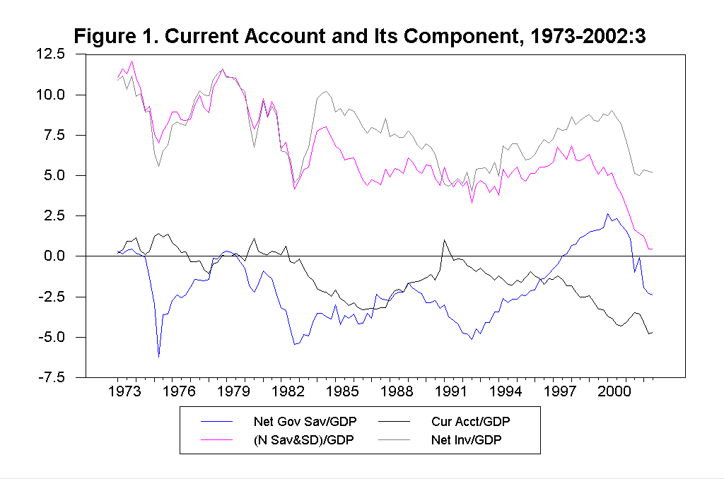
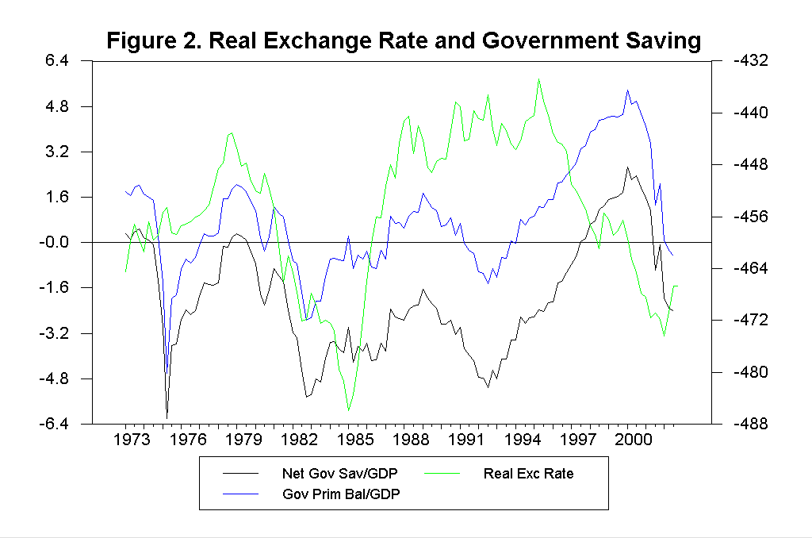
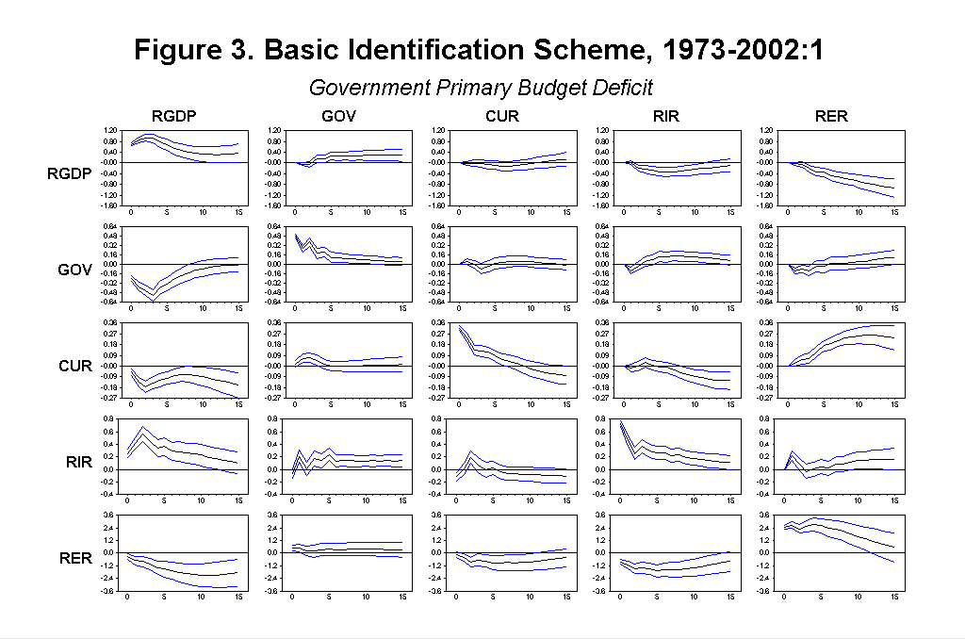
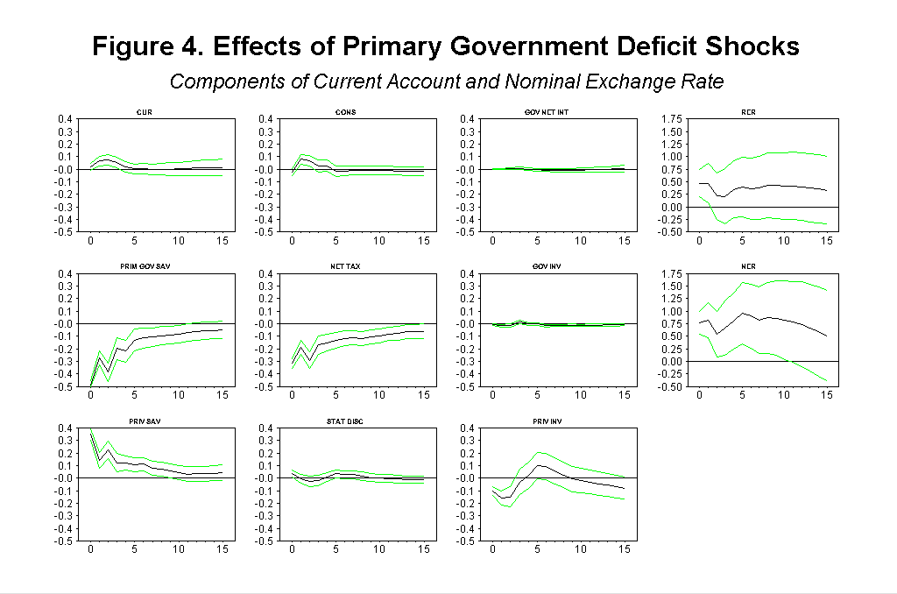
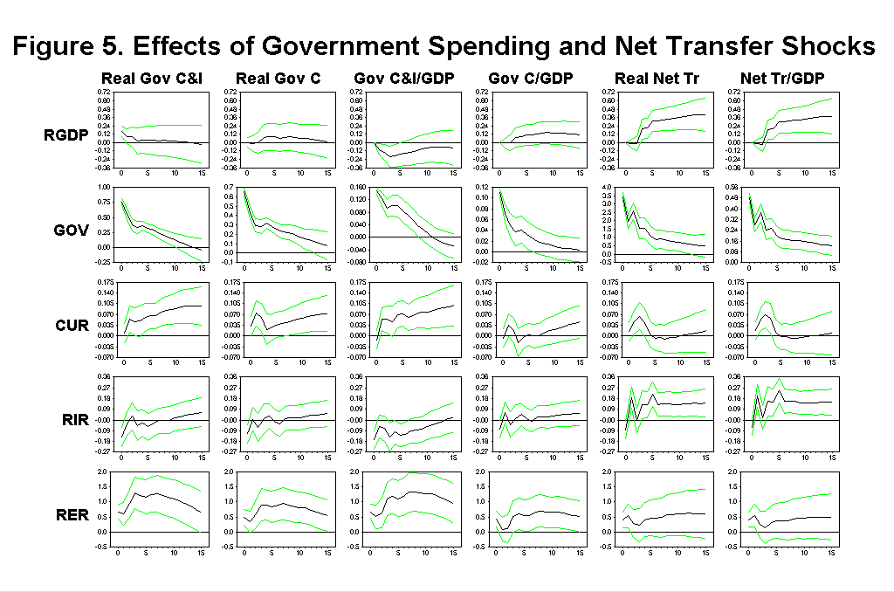
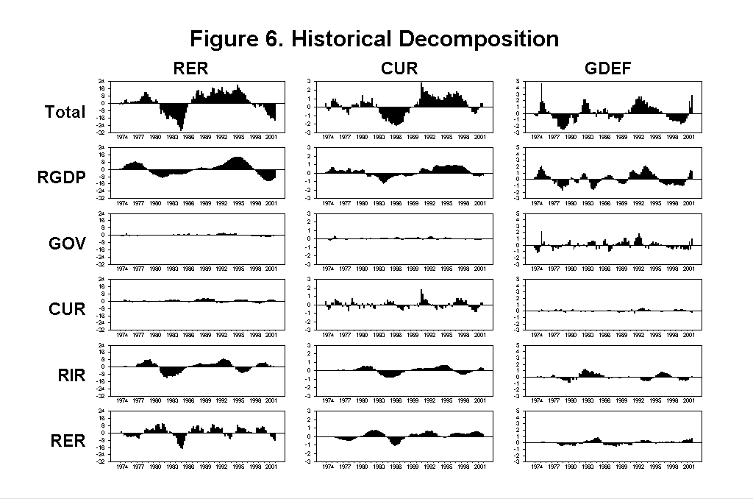
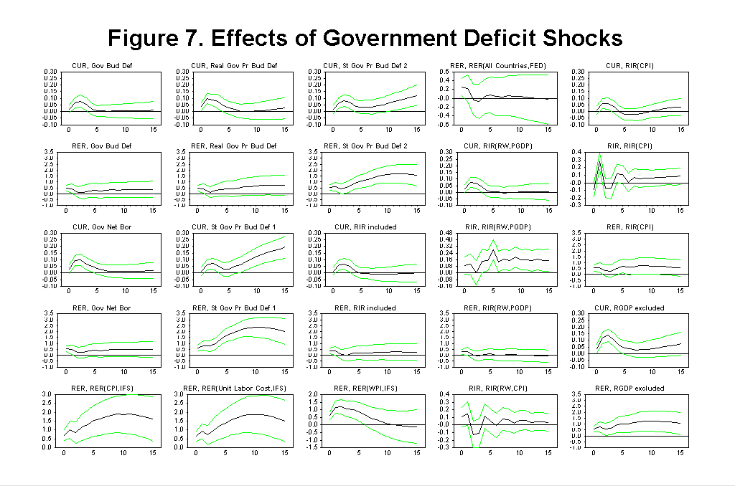
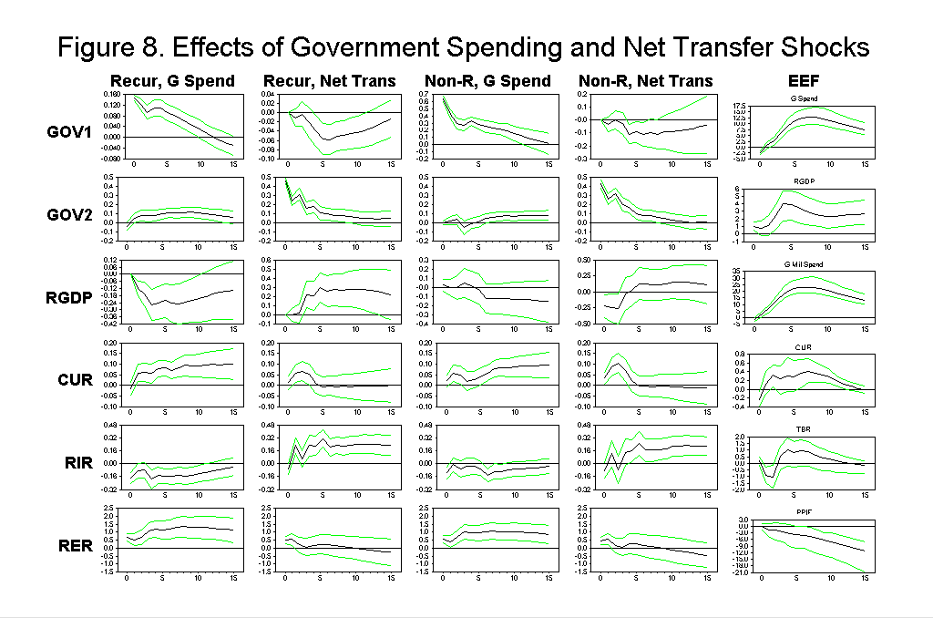
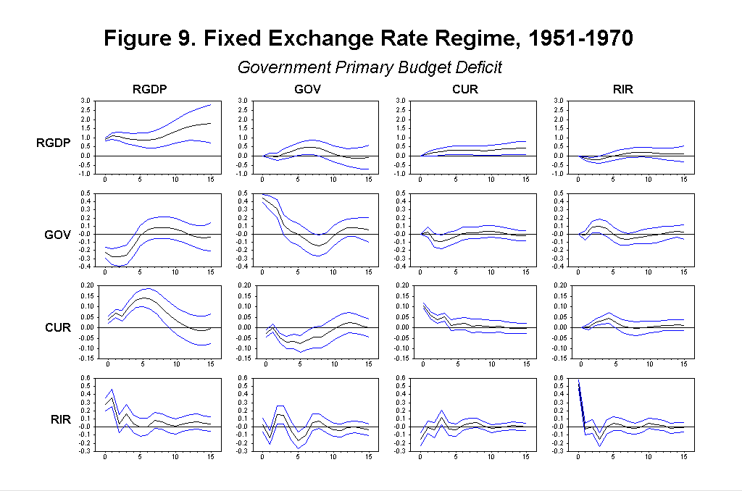

a We thank Michele Cavallo and Fabrizio Perri for useful discussions. The usual disclaimer applies.
b 225 DKH, 1407 W. Gregory Dr., Urbana, IL 61801, Telephone: 217-356-9291, Fax: 217-333-1398, E-mail: kim11@uiuc.edu
c Department of Economics, KMC 7-83, Stern School of Business, New York University, 44 West 4th, Street, New York, NY 10012, Telephone: 212-998-0886; Fax: 212-995-4218, E-mail: nroubini@stern.nyu.edu
Figure 1 shows current account/GDP and government saving/GDP in percentage terms (the left scale) and the log of real effective exchange rate against major industrial countries (the right scale). Note that an increase in the real exchange rate is a depreciation.
Note that in this economic contraction in 2000-2002, private savings (including the statistical discrepancy) are effectively unchanged as a share of GDP; thus the 1% of GDP worsening of the current account is fully explained by a fall in investment rate of 4% more than compensated by a 5% of GDP fall in public savings.
On the other hand, a reduction in lump sum taxes will lead to no change in the real exchange rate or the current account if private consumers are Ricardian as consumption would not change and private saving would increase to match the fall in public savings. If consumers are not Ricardian, the current account worsens as consumption increases and the real exchange rate may depreciate as the relative demand for imported goods increases (as long as the marginal propensity to import of the private sector is larger than that of the government).
Note that the wealth effect is not an important consideration for the small open economy with complete market case.
A fall in wage tends to decrease labor, but such effects are smaller than the other two effects. On the other hand, the wage fall decrease consumption as in the case of wealth and interest rate effect. See Baxter (1995).
A tax rate reduction can be permanent if lump-sum taxes are increased to maintain the total value of revenues constant.
As prices are sticky in the short run, nominal and real exchange rates commove together in the short run.
And in versions of these models with investment, at the same time investment tends to be crowded out and fall thus tending to improve the current account.
Betts and Devereux (2001b) examined the effects of government spending shocks in the model with investment by calibrating the model including investment, and found a similar result.
See Pesenti et al. (2002) as a recent study on the issue.
The data up to 2002:1 is used for most estimations.
These simple regressions are meant to capture the basic features of the data and their comovements. In the next section we present a formal econometric analysis based on a VAR approach.
For simplicity, I present the model without the vector of constants. Alternatively, we can regard each variable as a deviation from its steady state.
To construct the ex ante real interest rate, we subtract the expected quarterly inflation rate from three-month treasury bill rate. To construct the expected quarterly inflation rate, we assume that the log of GDP deflator follows a five variable VAR process (with 4 lags) that includes three-month treasury bill rate, log of M2, log of GDP deflator, log of real GDP, and the government deficit to GDP ratio. The VAR process is estimated for the 1972-2001:1 period. The basic results are similar when we use CPI instead of GDP deflator. The basic results are also similar when we use other methods such as assuming a random work inflation rate, and when we include the nominal interest rate instead of the real interest rate in the basic model. Refer to Section 5.1 for some results of these experiments.
Note that we order CUR first, and then RIR and RER, by assuming that real sector variable, CUR, is contemporaneously exogenous to financial sector variables, RIR and RER, following Sims and Zha (1996), Kim (1999), and Kim and Roubini (2000). Regardless of the ordering among CUR, RIR, and RER, the effects of government deficit shocks on those variables are the same (Refer to Christiano, Eichenbaum, and Evans (1999)).
To be consistent with the current breakdown, output is defined as GDP, and net tax is defined as GDP minus private consumption and net private saving.
International RBC models for large open economy model with fixed labor input such as Kollmann (1998) might explain the results under temporary shocks (although Kollmann (1998) did not experiment with temporary shocks), since investment may decrease due to an increase in the real interest rate and private saving responses may offset the government deficit. On the other hand, at first look, the results do not seem to be fully consistent with the NOEM models since output effects of government spending shocks do not seem to be strong and the government spending shocks do not seem to be very much persistent.
These impulse responses are available upon request.
This fall in taxes over time following a positive spending shock may seem unusual as government spending shocks should eventually lead to an increase in net taxes to satisfy the intertemporal budget constraint of the government. But in several historical episodes, the Reagan build-up and the recent post 9/11 defense build-up, tax rates were reduced while the spending build-up occurred. Only over the long-run, a primary adjustment often becomes necessary to avoid an excessive government debt build-up.
We used real measures, instead of the ratio to GDP, since the identifying assumption becomes more reasonable for the real measures. At any rate, the results are similar even when we use the ratio to GDP.
We use the real defense purchase from CITIBASE since we could not obtain the measure of Ramey and Shapiro.
Note that the effects on the current account and the real exchange rate are very similar in the model of {GOV1, RGDP, GOV2, CUR, RIR, RER } where we use the real government spending and the real net transfer.
We estimate the model from 1957 to 1970 for which the nominal effective nominal exchange rate is available, but the model is not well identified in that the error bands turn out to be huge, probably due to very small changes in the nominal exchange rate. The quarterly real effective exchange rates are available only from 1970’s.
We also estimated the model similar to Edelberg, Eichenbaum, and Fisher (1999), as discussed in Section 5.2, for the fixed exchange rate regime period, and found that the current account worsens.

