Assignment 1. Solutions
I. Paradigm: Your article

II. Distribution theory.
1. E[y|x]=α+βx where β = Cov(x,y)/Var(x) = 3/5 and α=μ_{y} - βμ_{x} 1 – 2(3/5) = -1/5
2. E[y|x,z] = α+γ₁x+γ₂z where (γ₁,γ₂)
= [Var(x,z)]⁻¹Cov[(x,z),y]
= =
and α=μ_{y} - γ₁μ_{x} - γ₂μ_{z} = 1 – 2(16/26) – 4(-1/26)
3. Var(y|x) = Var(y) - βCov(x,y) = 2 – (3/5)3 = 1/5
4. Corr²(x,y) = [Cov(x,y)]²/[Var(x),Var(y)] = 3²/(2×5) = 9/10
5. Corr²(y,E[y|x]) = Corr²[y,α+βx] = Corr²(y,βx)
Correlation is unaffected by scaling of the variables, so this is 9/10 again.
6. Corr²(y,E[y|x,z]) = Corr(y,α+γ₁x+γ₂z)
= Cov²[y,γ₁x+γ₂z] / [Var(y)Var(γ₁x+γ₂z)
=[γ₁Cov(y,x)+γ₂Cov(y,z)]² / [Var(y) Var(γ₁x+γ₂)]
=[(16/26)3 – (1/26)1]² / [2 × (16/26)²5 + (-1/26)²6 + 2(16/26)(-1/26)2]
= .9038 > Corr²(y,E[y|x]) as expected

III.Model Building
1. 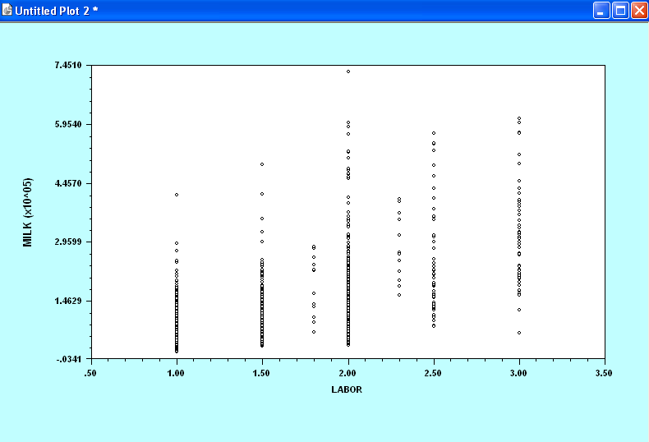
2. This was not really simple, but here are the conditional means; milk is divided by 100000 to make the numbers easier to read.
create;group=1*(labor=1)+2*(labor=1.5)+3*(labor=1.8)+
4*(labor=2)+5*(labor=2.3)+6*(labor=2.5)+
7*(labor=3)$
hist;rhs=group$
crea;q=milk/100000$
matrix;list;gxbr(labor,q,group)$
Matrix Result has 7 rows and 2 columns.
1 2
+----------------------------
1| 1.00000 .79209
2| 1.50000 1.12629
3| 1.80000 1.81736
4| 2.00000 1.46642
5| 2.30000 2.80102
6| 2.50000 2.25633
7| 3.00000 3.02742

3. The data may suggest that more labor is associated with more milk. But, without more cows, this theory won’t get very far. The intervening variable must be cows, and both labor and milk are growing because farms that have more people will generally have more cows.

IV. Distribution theory.
a. The joint is the product of the marginal times the conditional.
f(x,y) = f(y|x)f(x) =
b. f(y) is obtained by integrating x out of f(x,y).
This is a gamma integral. The general results is
In the integral above, b+1 is y+1 and a is β+θ. Note that Γ(y+1) = y!. Plug these into the density and simplify and the result emerges:
c. f(x) = θexp(-θx). You can obtain E[x] and Var[x] = E[x²] – (E[x])² using gamma integrals, and the result above.
d. The various means, variances and covariances are obtained above. Just plugging into the formulas:
E[y] = E[βx] = βE[x] = B/θ.
Var[y] = E(Var[y|x] ) + Var[E[y|x] E[y|x] = Var[y|x] = βx, so
= E[βx] + Var[βx] = βE[x] + β²Var[x] = β/θ + β²/θ²
Covar(x,y) = Cov[x,E[y|x]] = βVar[x] = β/θ²

