Appendix
D
Large Sample Distribution Theory
D.1. Introduction
Most of this book is about parameter estimation. In studying that subject, we will usually be interested in deternining how best to use the observed data when choosing among competing estimators. That, in turn, requires us to examine the sampling behavior of estimators. In a few cases, such as those presented in Appendix C and the least squares estimator considered in Chapter 3, we can make broad statements about sampling distributions that will apply regardless of the size of the sample. But, in most situations, it will only be possible to make approximate statements about estimators, such as whether they improve as the sample size increases and what can be said about their sampling distributions in large samples as an approximation to the finite samples we actually observe. This appendix will collect most of the formal, fundamental theorems and results needed for this analysis. A few additional results will be developed in the discussion of time series analysis later in the book.
D.2. Large-Sample Distribution Theory
In most cases, whether an estimator is exactly unbiased or what its exact sampling variance is in samples of a given size will be unknown. But we may be able to obtain approximate results about the behavior of the distribution of an estimator as the sample becomes large. For example, it is well known that the distribution of the mean of a sample tends to approximate normality as the sample size grows, regardless of the distribution of the individual observations. Knowledge about the limiting behavior of the distribution of an estimator can be used to infer an approximate distribution for the estimator in a finite sample. To describe how this is done, it is necessary, first, to present some results on convergence of random variables.
D.2.1. Convergence in Probability
Limiting arguments in this discussion will be with respect to the sample size n. Let x_{n} be a sequence random variable indexed by the sample size.
Definition D.1: Convergence in Probability. The random variable x_{n} converges in probability to a constant c if for any positive ε.
Convergence in probability implies that the values that the variable may take that are not close to c become increasingly unlikely as n increases. To consider one example, suppose that the random variable x_{n} takes two values, 0 and n, with probabilities 1 – (1/n) and (1/n), respectively. As n increases, the second point will become ever more remote from any constant but, at the same time, will become increasingly less probable. In this example, x_{n} converges in probability to 0. The crux of this form of convergence is that all mass of the probability distribution becomes concentrated at points close to c. If x_{n} converges in probability to c, then we write
plim x_{n} = c. (D-1)
We will make frequent use of a special case of convergence in probability, convergence in mean square or convergence in quadratic mean.
Theorem D.1: Convergence in Quadratic Mean. If x_{n} has mean μ_{n} and variance such that the ordinary limits of μ_{n} and are c and 0, respectively, then x_{n} converges in mean square to c, and
plim x_{n} = c.
A proof of this result can be based on a useful theorem.

Theorem D.2: Chebychev’s Inequality. If x_{n} is a random variable and c and ε are constants, then Prob(|x_{n} – c| > ε) ≤ E[(x_{n} – c)²]/ε².
To establish this inequality, we use another result [see Goldberger (1991, p. 31)].
Theorem D.3: Markov’s Inequality. If y_{n} is a nonnegative random variable and δ is a positive constant, then Prob[y_{n} ≥ δ] ≤ E[y_{n}]/δ. Proof: E[y_{n}] = Prob[y_{n} < δ]E[y_{n} | y_{n} < δ] + Prob[y_{n} ≥ δ]E[y_{n} | y_{n} ≥ δ]. Since y_{n} is nonnegative, both terms must be nonnegative, so E[y_{n}] ≥ Prob[y_{n} ≥ δ] E[y_{n} | y_{n} ≥ δ]. Since E[y_{n} | y_{n} ≥ δ] must be greater than or equal to δ, E[y_{n}] ≥ Prob[y_{n} ≥ δ]δ, which is the result.
Now, to prove Theorem D.1., let y_{n} be (x_{n} – c)² and δ be ε² in Theorem D.3. Then, (x_{n} – c)² > δ implies that |x_{n} – c| > ε. Finally, we will use a special case of the Chebychev inequality, where c = μ_{n}, so that we have
(D-2)
Taking the limits of μ_{n} and in (D-2), we see that if
(D-3)
then plim x_{n} = c.

We have shown that convergence in mean square implies convergence in probability. Mean-square convergence implies that the distribution of x_{n} collapses to a spike at plim x_{n}, as shown in Figure D.1.
EXAMPLE D.1 Mean Square Convergence of the Sample Minimum in Exponential Sampling As noted in Example 4.3, in sampling of n observations from a exponential distribution, for the sample minimum x₍₁₎,
and
Therefore,
plim x₍₁₎ = 0.
Note, in particular, that the variance is divided by n². Thus, this estimator converges very rapidly to 0.
Convergence in probability does not imply convergence in mean square. Consider the simple example given earlier in which x_{n} equals either 0 or n with probabilities 1 – (1/n) and (1/n). The exact expected value of x_{n} is 1 for all n, which is not the probability limit. Indeed, if we let Prob(x_{n} = n²) = (1/n) instead, the mean of the distribution explodes, but the probability limit is still zero. Again, the point
x_{n} = n² becomes ever more extreme but, at the same time, becomes ever less likely.
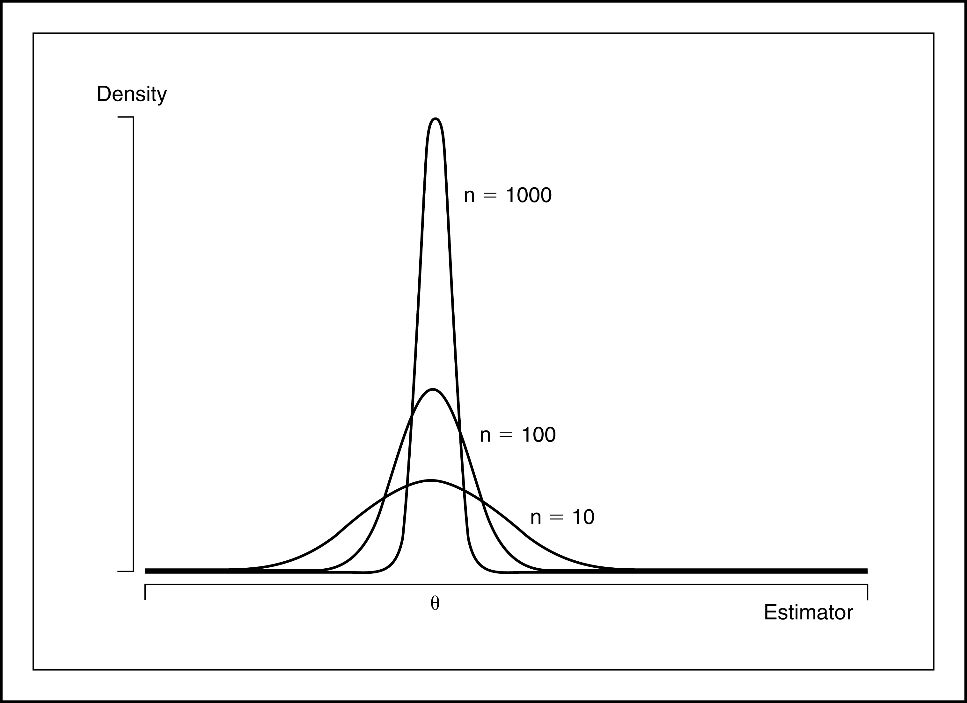
FIGURE D.1 Quadratic Convergence to a Constant, θ.
The conditions for convergence in mean square are usually easier to verify than those for the more general form. Fortunately, we shall rarely encounter circumstances in which it will be necessary to show convergence in probability in which we cannot rely upon convergence in mean square. Our most frequent use of this concept will be in formulating consistent estimators.
Definition D.2: Consistent Estimator. An estimator of a parameter θ is a consistent estimator of θ if and only if
(D-4)
Theorem D.4: Consistency of the Sample Mean. The mean of a random sample from any population with finite mean μ and finite variance σ² is a consistent estimator of μ.
Proof: E[] = μ and Var[] = σ²/n. Therefore, converges in mean square to μ, or plim
Theorem D.4 is broader than it might appear at first.
Corollary to Theorem D.4: Consistency of a Mean of Functions. In random sampling, for any function g(x), if E[g(x)] and Var[g(x)] are finite constants, then
(D-5)
Proof: Define y_{i} = g(x_{i}) and use Theorem D.4.

EXAMPLE D.2 Estimating a Function of the Mean. In sampling from a normal distribution with mean μ and variance 1, and
(See Section 3.4.4 on the lognormal distribution.) Hence,
D.2.2. other forms of convergence and Laws of large numbers
Theorem D.4 and the corollary given above are particularly narrow forms of a set of results known as laws of large numbers that are fundamental to the theory of parameter estimation. Laws of large numbers come in two forms depending on the type of convergence considered. The simpler of these are “weak laws of large numbers” which rely on convergence in probability as we defined it above. “Strong laws” rely on a broader type of convergence called almost sure convergence. Overall, the law of large numbers is a statement about the behavior of an average of a large number of random variables.

Theorem D.5: Khinchine’s Weak Law of Large Numbers: If x_{i}, i = 1,...,n is a random (i.i.d.) sample from a distribution with finite mean E[x_{i}] = μ, then
plim = μ..
Proofs of this and the theorem below are fairly intricate. Rao (1973) provides one.

Notice that this is already broader then Theorem D.4, as it does not require that the variance of the distribution be finite. On the other hand, it is not broad enough, since most of the situations we encounter where we will need a result such as this will not involve i.i.d. random sampling. A broader result is

Theorem D.6: Chebychev’s Weak Law of Large Numbers: If If x_{i}, i = 1,...,n is a sample of observations such that E[x_{i}] = μ_{i} < ∞ and Var[x_{i}] = σ_{i}² < ∞ such that → 0 as n → ∞ then plim( - ) = 0.

There is a subtle distinction between these two theorems that you should notice. The Chebychev theorem does not state that converges to , or even that it converges to a constant at all. That would require a precise statement about the behavior of . The theorem states that as n increases without bound, these two quantities will be arbitrarily close to each other - that is, the difference between them converges to a constant, zero. This is an important notion that enters the derivation when we consider statistics that converge to random variables, instead of to constants. What we do have with these two theorems is extremely broad conditions under which a sample mean will converge in probability to its population counterpart. The more important difference between the Khinchine and Chebychev theorems is that the second allows for heterogeneity in the distributions of the random varaibles that enter the mean.
In analyzing time series data, the sequence of outcomes is itself viewed as a random event. Consider, then, the sample mean, . The preceding results concern the behavior of this statistic as n → ∞ for a particular realization of the sequence ,...,. But, if the sequence, itself, is viewed as a random event, then limit to which converges may be also. The stronger notion of almost sure convergence relates to this possibility.

Definition D.3: Almost Sure Convergence. The random variable x_{n} converges almost surely to the constant c if and only if

Almost sure convergence differs from convergence in probability in an important respect. Note that the index in the probability statement is ‘i,’ not ‘n.’ The definition states that if a sequence converges almost surely, then there is an n large enough such that for any positive ε the probability that the sequence will not converge to c goes to zero. This is denoted x_{n} x. Again, it states that the probability of observing a sequence that does not converge to c ultimately vanishes. Intuitively, it states that once the sequence x_{n} becomes close to c, it stays close to c.
From the two definitions, it is clear that almost sure convergence is a stronger form of convergence.

Theorem D.7: Convergence Relationship. Almost sure convergence implies convergence in probability. The proof is obvious given the statements of the definitions. The event described in the definition of almost sure convergence, for any i > n, includes i = n, which is the condition for convergence in probability.

Almost sure convergence is used in a stronger form of the law of large numbers:

Theorem D.8: Kolmogorov’s Strong Law of Large Numbers: If x_{i}, i = 1,...,n is a sequence of independently distributed random variables such that E[x_{i}] = μ_{i} < ∞ and Var[x_{i}] = σ_{i}² < ∞ such that < ∞ as n → ∞ then
x_{n} - 0.

The variance condition is satisfied if every variance in the sequence is finite, but this is not strictly required; it only requires that the variances in the sequence increase at a slow enough rate that the sequence of variances as defined is bounded. The theorem allows for heterogeneity in the means and variances. If we return to the conditions of the Khinchine theorem, i.i.d. sampling, we have a corollary:

Corollary to Theorem D.8: Kolmogorov’s Strong Law of Large Numbers: If x_{i}, i = 1,...,n is a sequence of independent and identically distributed random variables such that E[x_{i}] = μ < ∞ and E[|x_{i}|] < ∞ then x_{n} - μ 0.

Finally, another form of convergence encountered in the analysis of time series data is convergence in rth mean:

Definition D.4: Convergence in rth Mean: If x_{n} is a sequence of random variables such that E[|x_{n}|^{r}] < ∞ and , then x_{n} converges in rth mean to c. This is denoted x_{n} c.

Surely the most common application is the one we met earlier, convergence in means square, which is convergence in the second mean. Some useful results follow from this definition:

Theorem D.9: Convergence in Lower Powers. If x_{n} converges in rth mean to c then x_{n} converges in sth mean to c for any s < r. The proof uses Jensen’s Inequality, Theorem D.11. Write = < and the inner term converges to zero so the full function must also.

Theorem D.10: Generalized Chebychev’s Inequality. If x_{n} is a random variable and c is a constant such that with E[|x_{n} - c|^{r}] < ∞ and ε is a positive constant, then Prob(|x_{n} – c| > ε) ≤ E[|x_{n} – c|^{r}]/ε^{r}.

We have considered two cases of this result already, when r = 1 which is the Markov inequality, Theorem D.3 and r = 2, which is the Chebychev inequality we looked at first in D.2.

Theorem D.11: Convergence in rth mean and Convergence in Probability. If x_{n} c, for any r > 0, then x_{n} c. The proof relies on Theorem D.9. By assumption, so for some n sufficiently large, < ∞ . By Theorem D.9., then, Prob(|x_{n} – c| > ε) ≤ E[|x_{n} – c|^{r}]/ε^{r} for any ε > 0. The denominator of the fraction is a fixed constant and the numerator converges to zero by our initial assumption, so Prob(|x_{n} – c| > ε) = 0, which completes the proof.
One implication of Theorem D.10 is that although convergence in mean square is a convenient way to prove convergence in probability, it is actually stronger than necessary, as we get the same result for any positive r.
Finally, we note that we have now shown that both almost sure convergence and convergence in rth mean are stronger than convergence in probability; each implies the latter. But they, themselves, are different notions of convergence, and neither implies the other.
Definition D.5: Convergence of a Random Vector or Matrix. Let x_{n} denote a random vector and X_{n} a random matrix, and c and C denote a vector and matrix of constants with the same dimensions as x_{n} and X_{n}, respectively. All of the preceding notions of convergence can be extended to (x_{n},c) and (X_{n},C) by applying the results to the respective corresponding elements.
D.2.3. Convergence of functions
A particularly convenient result is the following.
Theorem D.12: Slutsky Theorem. For a continuous function g(x_{n}) that is not a function of n,
(D-6)
The Slutsky theorem highlights a comparison between the expectation of a random variable and its probability limit. Theorem D.12 extends directly in two important directions. First, though stated in terms of convergence in probability, the same set of results applies to convergence in rth mean and almost sure convergence. Second, so long as the functions are continuous, the Slutsky Theorem can be extended to vector or matrix valued functions of random scalars, vectors, or matrices. The following describe some specific applications. Suppose that g(x_{n}) is a concave function. Then, the following theorem holds.
Theorem D.13: Jensen’s Inequality. If g(x_{n}) is a concave function of x_{n}, then g(E[x_{n}]) ≥ E[g(x_{n})].
Therefore, although the expected value of a function of x_{n} may not equal the function of the expected value⎯it exceeds it if the function is concave⎯the probability limit of the function is equal to the function of the probability limit. (See Section 3.3 for an application.)
The generalization of Theorem D.7 to a function of several random variables is direct, as illustrated in the next example.

EXAMPLE D.3 Probability Limit of a Function of and s²: In random sampling from a population with mean μ and variance σ², the exact expected value of will be difficult, if not impossible, to derive. But, by the Slutsky theorem,
Some implications of the Slutsky theorem are now summarized.

Theorem D.14: Rules for Probability Limits. If x_{n} and y_{n} are random variables with plim x_{n} = c and plim y_{n} = d, then
plim(x_{n} + y_{n}) = c + d, (sum rule) (D-7)
plim x_{n}y_{n} = cd, (product rule) (D-8)
plim x_{n}/y_{n} = c/d if d ≠ 0. (ratio rule) (D-9)
If W_{n} is a matrix whose elements are random variables and if plim W_{n} = Ω, then
(matrix inverse rule) (D-10)
If X_{n} and Y_{n} are random matrices with plim X_{n} = A and plim Y_{n} = B, then
plim X_{n}Y_{n} = AB. (matrix product rule) (D-11)

D.2.4. Convergence to a random variable
The preceding has dealt with conditions under which a random variable converges to a constant, for example, the way that a sample mean converges to the population mean. In order to develop a theory for the behavior of estimators, as a prelude to the discussion of limiting distributions, we now consider cases in which a random variable converges not to a constant, but to another random variable. These results will actually subsume those in the preceding section, as a constant may always be viewed as a degenerate random variable, that is one with zero variance.
Definition D.6: Convergence in Probability to a Random Variable. The random variable x_{n} converges in probability to the random variable x if for any positive ε.
As before, we write plim x_{n} = x to denote this case. The interpretation (at least the intuition) of this type of convergence is different when x is a random variable. The notion of closeness defined here relates not to the concentration of the mass of the probability mechanism generating x_{n} at a point c, but to the closeness of that probability mechanism to that of x. One can think of this as a convergence of the CDF of x_{n} to that of x.

Definition D.7: Almost Sure Convergence to a Random Variable. The random variable x_{n} converges almost surely to the random variable x if and only if

Definition D.8: Convergence in rth mean to a Random Variable. The random variable x_{n} converges in rth mean to the random variable x if and only if
. This is labeled x_{n} x. As before, the case r = 2 is labeled convergence in mean square.
Once again, we have to revise our understanding of convergence when convergence is to a random variable.

Theorem D.15: Convergence of Moments. Suppose x_{n} x and E[|x|^{r}] is finite. Then, = E[|x|^{r}].

Theorem D.15 raises an interesting question. Suppose we let r grow, and suppose that x_{n} x and, in addition, all moments are finite. If this holds for any r, do we conclude that these random variables have the same distribution? The answer to this longstanding problem in probability theory - the problem of the sequence of moments - is no. The sequence of moments does not uniquely determine the distribution. Although convergence in rth mean and almost surely still both imply convergence in probability, it remains true, even with convergence to a random variable instead of a constant, that these are different forms of convergence.

D.2.5. Convergence in Distribution: Limiting Distributions

A second form of convergence is convergence in distribution. Let x_{n} be a sequence of random variables indexed by the sample size, and assume that x_{n} has cdf F_{n}(x).
Definition D.9: Convergence in Distribution. x_{n} converges in distribution to a random variable x with cdf F(x) if at all continuity points of F(x).
This statement is about the probability distribution associated with x_{n}; it does not imply that x_{n} converges at all. To take a trivial example, suppose that the exact distribution of the random variable x_{n} is
As n increases without bound, the two probabilities converge to , but x_{n} does not converge to a constant.
Definition D.10: Limiting Distribution. If x_{n} converges in distribution to x, where F(x_{n}) is the cdf of x_{n}, then F(x) is the limiting distribution of x. This is written
The limiting distribution is often given in terms of the pdf, or simply the parametric family. For example, “the limiting distribution of x_{n} is standard normal.”
Convergence in distribution can be extended to random vectors and matrices, though not in the element by element manner that we extended the earlier convergence forms. The reason is that convergence in distribution is a property of the CDF of the random variable, not the variable itself. Thus, we can obtain a convergence result analogous to that in definition D.9. for vectors or matrices by applying defintion to the joint CDF for the elements of the vector or matrices. Thus, x_{n} x if and likewise for a random matrix.

EXAMPLE D.4 Limiting Distribution of t_{n–1} Consider a sample of size n from a standard normal distribution. A familiar inference problem is the test of the hypothesis that the population mean is zero. The test statistic usually used is the t statistic:
where
The exact distribution of the random variable t_{n–1} is t with n – 1 degrees of freedom. The density is different for every n:
(D-12)
as is the cdf, This distribution has mean 0 and variance
(n – 1)/(n – 3). As n grows to infinity, t_{n–1} converges to the standard normal, which is written

Definition D.11: Limiting Mean and Variance. The limiting mean and variance of a random variable are the mean and variance of the limiting distribution, assuming that the limiting distribution and its moments exist.

For the random variable with t[n] distribution, the exact mean and variance are 0 and n/(n – 2), whereas the limiting mean and variance are 0 and 1. The example might suggest that the limiting mean and variance are 0 and 1, that is, that the moments of the limiting distribution are the ordinary limits of the moments of the finite sample distributions. This situation is almost always true, but it need not be. It is possible to construct examples in which the exact moments do not even exist, even though the moments of the limiting distribution are well defined. Even in such cases, we can usually derive the mean and variance of the limiting distribution.
Limiting distributions, like probability limits, can greatly simplify the analysis of a problem. Some results that combine the two concepts are as follows.

Theorem D.16: Rules for Limiting Distributions.
1. If and plim y_{n} = c, then
(D-13)
which means that the limiting distribution of x_{n}y_{n} is the distribution of cx. Also,
(D-14)
(D-15)
2. If and g(x_{n}) is a continuous function, then g(x_{n}) g(x). (D-16)
This result is analogous to the Slutsky theorem for probability limits. For an example, consider the t_{n} random variable discussed earlier. The exact distribution of is F[1, n]. But as n → ∞, t_{n} converges to a standard normal variable. According to this result, the limiting distribution of will be that of the square of a standard normal, which is chi-squared with one degree of freedom. We conclude, therefore, that
F[1, n] chi-squared [1]. (D-17)
We encountered this result in our earlier discussion of limiting forms of the standard normal family of distributions.
3. If y_{n} has a limiting distribution and plim(x_{n} – y_{n}) = 0, then x_{n} has the same limiting distribution as y_{n}.

The third result in Theorem D.16 combines convergence in distribution and in probability. The second result can be extended to vectors and matrices.

EXAMPLE D.5. The F distribution. Suppose that t_{1,n} and t_{2,n} are a K×1 and an M×1 random vector of variables whose components are independent with each distributed as t with n degrees of freedom. Then, as we saw in the preceding, for any component in either random vector, the limiting distribution is standard normal, so for the entire vector, t_{j,n}z_{n}, a vector of independent standard normally distributed variables. The results so far show that

Finally, a specific case of result 2 in Theorem D.16 produces a tool known as the Cramér -Wold device.

Theorem D.17: Cramer - Wold Device. If x_{n} x, then c′x_{n} c′x for all conformable vectors c with real valued elements.

By allowing c to be a vector with just a one in a particular position and zeros elsewhere, we see that convergence of in distribution of a random vector x_{n} to x does imply that each component does likewise. But, this is not sufficient.
D.2.6. Central limit theorems
We are ultimately interested in finding a way to describe the statistical properties of estimators when their exact distributions are unknown. The concepts of consistency and convergence in probability are important. But the theory of limiting distributions given earlier is not yet adequate. We rarely deal with estimators that are not consistent for something, though perhaps not always the parameter we are trying to estimate. As such,
if plim then
That is, the limiting distribution of is a spike. This is not very informative, nor is it at all what we have in mind when we speak of the statistical properties of an estimator. (To endow our finite sample estimator with the zero sampling variance of the spike at θ would be optimistic in the extreme.)
As an intermediate step, then, to a more reasonable description of the statistical properties of an estimator, we use a stabilizing transformation of the random variable to one that does have a well-defined limiting distribution. To jump to the most common application, whereas
we often find that
where f(z) is a well-defined distribution with a mean and a positive variance. An estimator which has this property is said to be root-n consnstent. The single most important theorem in econometrics provides an application of this proposition. A basic form of the theorem is as follows.
Theorem D.18: Lindberg–Levy Central Limit Theorem (Univariate). If x₁, . . . , x_{n} are a random sample from a probability distribution with finite mean μ and finite variance σ² and then
A proof appears in Rao (1973, p. 127).
The result is quite remarkable as it holds regardless of the form of the parent distribution. For a striking example, return to Figure C.2. The distribution from which the data were drawn in that figure does not even remotely resemble a normal distribution. In samples of only four observations the force of the central limit theorem is clearly visible in the sampling distribution of the means. The sampling experiment Example D.5 shows the effect in a systematic demonstration of the result.
The Lindberg–Levy theorem is one of several forms of this extremely powerful result. For our purposes, an important extension allows us to relax the assumption of equal variances. The Lindberg–Feller form of the central limit theorem is the centerpiece of most of our analysis in econometrics

EXAMPLE D.6 The Lindberg-Levy Central Limit Theorem: We’ll use a sampling experiment to demonstrate the operation of the central limit theorem. Consider random sampling from the exponential distribution with mean 1.5 - this is the setting used in Example C.4. The density is shown below
We’ve drawn 1,000 samples of 3, 6, and 20 observations from this population and computed the sample means for each. For each mean, we then computed z_{in} = where i = 1,...,1,000 and n is 3, 6 or 20. The three rows of figures show histograms of the observed samples of sample means and kernel density estimates of the underlying distributions for the three samples of transformed means.

Theorem D.19: Lindberg–Feller Central Limit Theorem (with Unequal Variances). Suppose that {x_{i}}, i = 1, . . . , n, is a sequence of independent random variables with finite means μ_{i} and finite positive variances Let
and
If no single term dominates this average variance, which we could state as lim_{n→∞} and if the average variance converges to a finite constant, then
In practical terms, the theorem states that sums of random variables, regardless of their form, will tend to be normally distributed. The result is yet more remarkable in that it does not require the variables in the sum to come from the same underlying distribution. It requires, essentially, only that the mean be a mixture of many random variables, none of which is large compared with their sum. Since nearly all the estimators we construct in econometrics fall under the purview of the central limit theorem, it is obviously an important result.
Proof of the Lindberg-Feller theorem requires some quite intricate mathematics [see Loeve (1977) for example] that are well beyond the scope of our work here. We do note an important consideration in this theorem. The result rests on a condition known as the Lindeberg condition. The sample mean computed in the theorem is a mixture of random variables from possibly different distributions. The Lindeberg condition, in words, states that the contribution of the tail areas of these underlying distributions to the variance of the sum must be negligible in the limit. The condition formalizes the assumption in Theorem D.12 that the average variance be positive and not be dominated by any single term. (For a nicely crafted mathematical discussion of this condition, see White (1999, pp. 117-118.) The condition is essentially impossible to verify in practice, so it is useful to have a simpler version of the theorem which encompasses it.

Theorem D.20: Lyapounov Central Limit Theorem. Suppose that {x_{i}}, is a sequence of independent random variables with finite means μ_{i} and finite positive variances such that E[|x_{i} - μ_{i}|^{2+δ}] is finite for some δ > 0. If is positive and finite for all n sufficiently large, then
This version of the central limit theorem requires only that moments slightly larger than 2 be finite.
Note the distinction between the laws of large numbers in Theorems D.5 and D.6 and the central limit theorems. Neither assert that sample means tend to normality. Sample means (that is, the distributions of them) converge to spikes at the true mean. It is the transformation of the mean, that converges to standard normality. To see this at work, if you have access to the necessary software, you might try reproducing Example 4.14 using the raw means, . What do you expect to observe?
For later purposes, we will require multivariate versions of these theorems. Proofs of the following may be found, for example, in Greenberg and Webster (1983) or Rao (1973) and references cited there.
Theorem D.18a: Multivariate Lindberg–Levy Central Limit Theorem. If x₁, . . . , x_{n} are a random sample from a multivariate distribution with finite mean vector μ and finite positive definite covariance matrix Q, then
where
The extension of the Lindberg–Feller theorem to unequal covariance matrices requires some intricate mathematics. The following is an informal statement of the relevant conditions. Further discussion and references appear in Fomby, Hill, and Johnson (1984) and Greenberg and Webster (1983).
Theorem D.19A: Multivariate Lindberg–Feller Central Limit Theorem. Suppose that x₁, . . . , x_{n} are a sample of random vectors such that E[x_{i}] = μ_{i}, Var[x_{i}] = Q_{i}, and all mixed third moments of the multivariate distribution are finite. Let
We assume that
where Q is a finite, positive definite matrix, and that for every i,
We allow the means of the random vectors to differ, although in the cases that we will analyze, they will generally be identical. The second assumption states that individual components of the sum must be finite and diminish in significance. There is also an implicit assumption that the sum of matrices is nonsingular. Since the limiting matrix is nonsingular, the assumption must hold for large enough n, which is all that concerns us here. With these in place, the result is
D.2.7. The delta method
At several points in Chapter 3, we used a linear Taylor series approximation to analyze the distribution and moments of a random variable. We are now able to justify this usage. We complete the development of Theorem D.5 (probability limit of a function of a random variable), Theorem D.8 (2) (limiting distribution of a function of a random variable), and the central limit theorems, with a useful result that is known as “the delta method.” For a single random variable (sample mean or otherwise), we have the following theorem.
Theorem D.21: Limiting Normal Distribution of a Function. If and if g(z_{n}) is a continuous function not involving n, then
(D-18)
Notice that the mean and variance of the limiting distribution are the mean and variance of the linear Taylor series approximation:
The multivariate version of this theorem will be used at many points in the text.
Theorem D.21A: Limiting Normal Distribution of a Set of Functions. If z_{n} is a K × 1 sequence of vector-valued random variables such that and if c(z_{n}) is a set of J continuous functions of z_{n} not involving n, then
(D-19)
where C(μ) is the J × K matrix ∂c(μ)/∂μ′. The jth row of C(μ) is the vector of partial derivatives of the jth function with respect to μ′.
D.3. Asymptotic Distributions
The theory of limiting distributions is only a means to an end. We are interested in the behavior of the estimators themselves. The limiting distributions obtained through the central limit theorem all involve unknown parameters, generally the ones we are trying to estimate. Moreover, our samples are always finite. Thus, we depart from the limiting distributions to derive the asymptotic distributions of the estimators.
Definition D.12: Asymptotic Distribution. An asymptotic distribution is a distribution that is used to approximate the true finite sample distribution of a random variable.
By far the most common means of formulating an asymptotic distribution (at least by econometricians) is to construct it from the known limiting distribution of a function of the random variable. If
then approximately, or asymptotically, which we write as
The statement “ is asymptotically normally distributed with mean μ and variance σ²/n” says only that this normal distribution provides an approximation to the true distribution, not that the true distribution is exactly normal.
EXAMPLE D.7 Asymptotic Distribution of the Mean of an Exponential Sample. In sampling from an exponential distribution with parameter θ, the exact distribution of is that of θ /(2n) times a chi-squared variable with 2n degrees of freedom. The asymptotic distribution is N[θ, θ²/n]. The exact and asymptotic distributions are shown in Figure D.3 for the case of θ = 1 and n = 16.
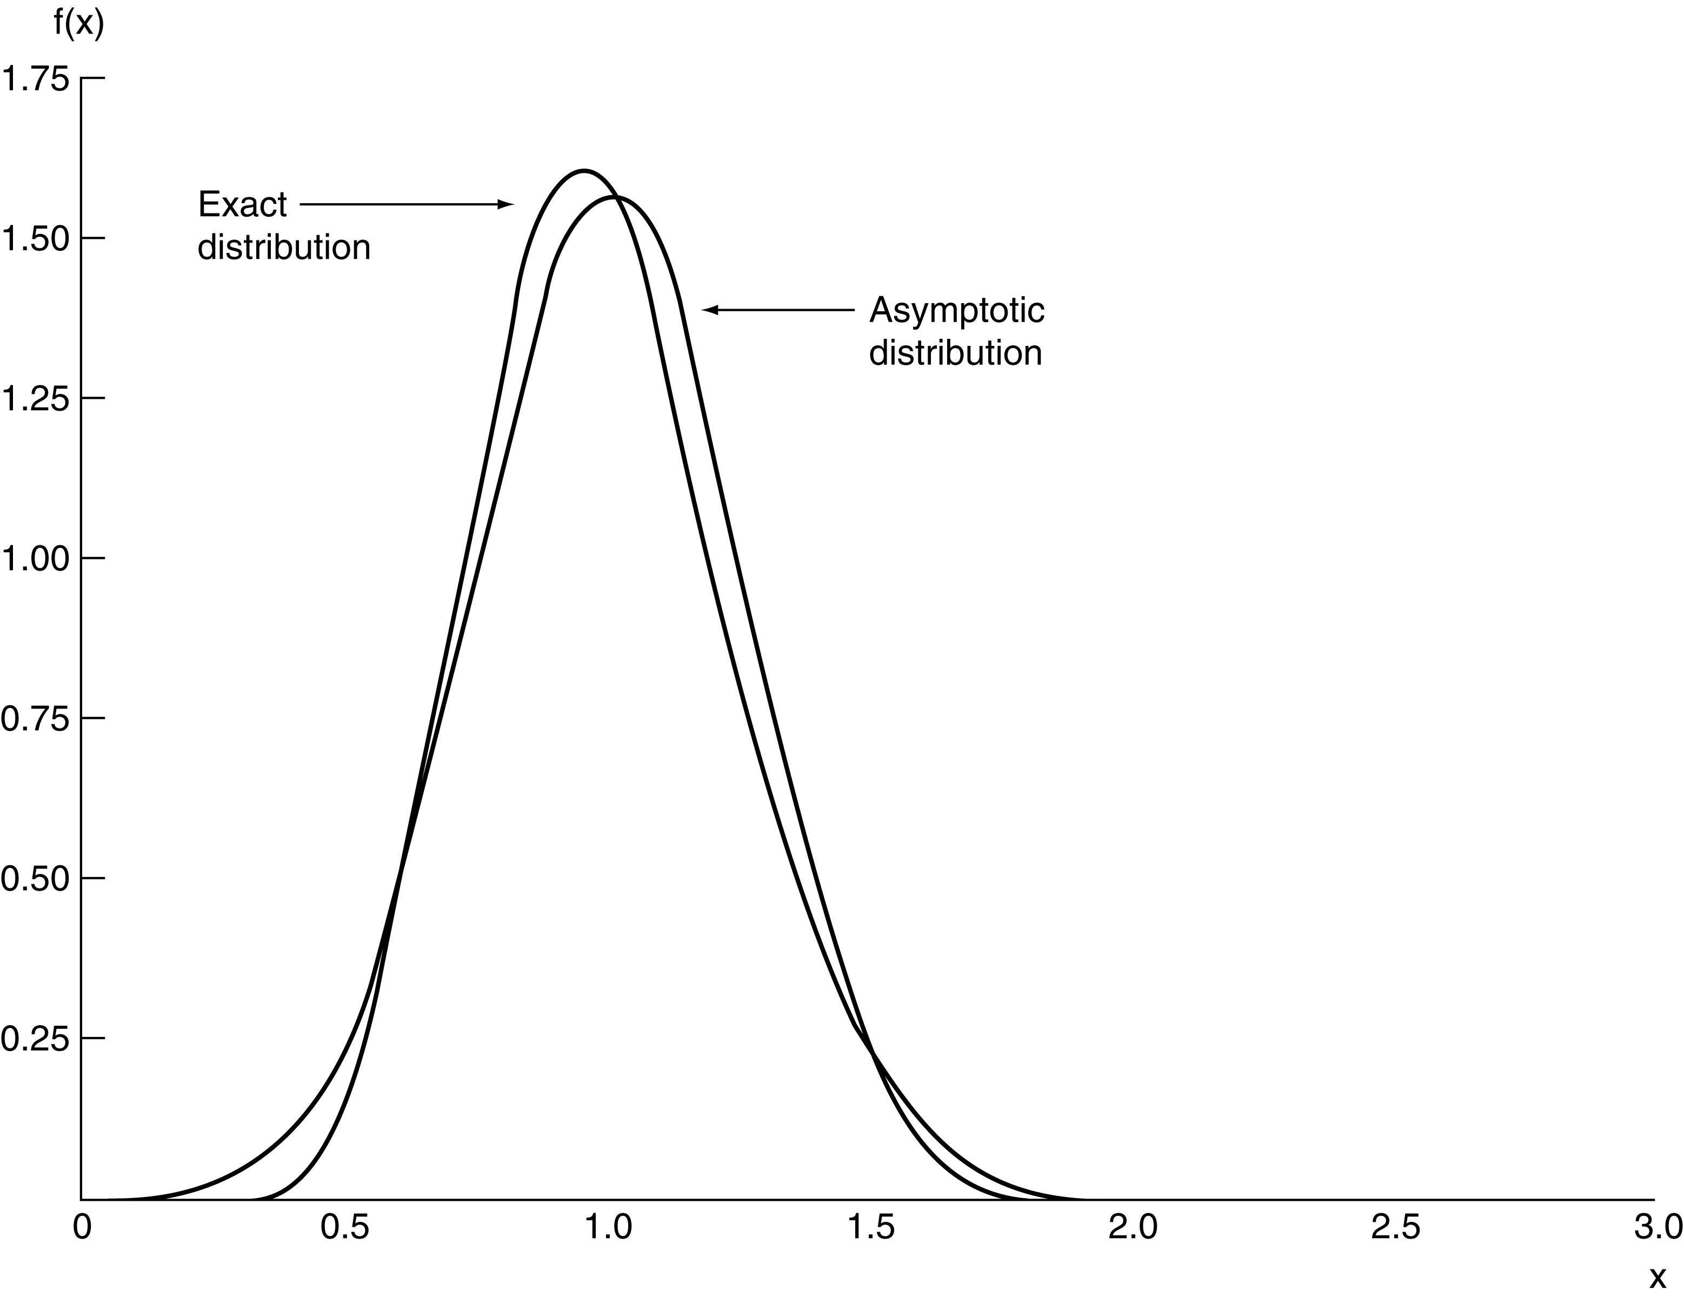
Figure D.3 True Versus Asymptotic Distribution.
Extending the definition, suppose that is an estimator of the parameter vector θ. The asymptotic distribution of the vector is obtained from the limiting distribution:
(D-20)
implies that
(D-21)
This notation is read “ is asymptotically normally distributed, with mean vector θ and covariance matrix (1/n)V.” The covariance matrix of the asymptotic distribution is the asymptotic covariance matrix and is denoted
Note, once again, the logic used to reach the result; (4-35) holds exactly as n → ∞. We assume that it holds approximately for finite n, which leads to (4-36).
Definition D.13: Asymptotic Normality and Asymptotic Efficiency. An estimator is asymptotically normal if (4-35) holds. The estimator is asymptotically efficient if the covariance matrix of any other consistent, asymptotically normally distributed estimator exceeds (1/n)V by a nonnegative definite matrix.
For most estimation problems, these are the criteria used to choose an estimator.

EXAMPLE D.8 Asymptotic Inefficiency of the Median in Normal Sampling In sampling from a normal distribution with mean μ and variance σ², both the mean and the median M_{n} of the sample are consistent estimators of μ. Since the limiting distributions of both estimators are spikes at μ, they can only be compared on the basis of their asymptotic properties. The necessary results are (D-22)
Therefore, the mean is more efficient by a factor of π/2. (But, see Example 5.3 for a finite sample result.)
D.3.1. Asymptotic Distribution of a Nonlinear Function
Theorems D.13 and D.14 for functions of a random variable have counterparts in asymptotic distributions.

Theorem D.22: Asymptotic Distribution of a Nonlinear Function. If and if g(θ) is a continuous function not involving n, then If is a vector of parameter estimators such that and if c(θ) is a set of J continuous functions not involving n, then, where C(θ) = ∂c(θ)/∂θ′.

EXAMPLE D.9 Asymptotic Distribution of a Function of Two Estimators
Suppose that b_{n} and t_{n} are estimators of parameters β and θ such that
Find the asymptotic distribution of c_{n} = b_{n}/(1 – t_{n}). Let γ = β/(1 – θ). By the Slutsky theorem, c_{n} is consistent for γ. We shall require
Let Σ be the 2 × 2 asymptotic covariance matrix given previously. Then the asymptotic variance of c_{n} is
which is the variance of the linear Taylor series approximation:
D.3.2. Asymptotic Expectations
The asymptotic mean and variance of a random variable are usually the mean and variance of the asymptotic distribution. Thus, for an estimator with the limiting distribution defined in
the asymptotic expectation is θ and the asymptotic variance is (1/n)V. This statement implies, among other things, that the estimator is “asymptotically unbiased.”
At the risk of clouding the issue a bit, it is necessary to reconsider one aspect of the previous description. We have deliberately avoided the use of consistency even though, in most instances, that is what we have in mind. The description thus far might suggest that consistency and asymptotic unbiasedness are the same. Unfortunately (because it is a source of some confusion), they are not. They are if the estimator is consistent and asymptotically normally distributed, or CAN. They may differ in other settings, however. There are at least three possible definitions of asymptotic unbiasedness:
- The mean of the limiting distribution of is 0.
- lim_{n→∞} E[] = θ. (D-23)
- plim θ_{n} = θ.
In most cases encountered in practice, the estimator in hand will have all three properties, so there is no ambiguity. It is not difficult to construct cases in which the left-hand sides of all three definitions are different, however. There is no general agreement among authors as to the precise meaning of asymptotic unbiasedness, perhaps because the term is misleading at the outset; asymptotic refers to an approximation, whereas unbiasedness is an exact result. Nonetheless, the majority view seems to be that (2) is the proper definition of asymptotic unbiasedness. Note, though, that this definition relies on quantities that are generally unknown and that may not exist.
A similar problem arises in the definition of the asymptotic variance of an estimator. One common definition is
(D-24)
This result is a leading term approximation, and it will be sufficient for nearly all applications. Note, however, that like definition 2 of asymptotic unbiasedness, it relies on unknown and possibly nonexistent quantities.

EXAMPLE D.10 Asymptotic Moments of the Sample Variance
The exact expected value and variance of the variance estimator
(D-25)
are
(D-26)
and
(D-27)
where μ₄ = E[(x – μ)⁴]. [See Goldberger (1964, pp. 97–99).] The leading term approximation would be
D.4. Sequences and the Order of a Sequence
This section has been concerned with sequences of constants, denoted, for example c_{n}, and random variables, such as x_{n}, that are indexed by a sample size, n. An important characteristic of a sequence is the rate at which it converges (or diverges). For example, as we have seen, the mean of a random sample of n observations from a distribution with finite mean, μ, and finite variance, σ², is itself a random variable with variance We see that as long as σ² is a finite constant, is a sequence of constants that converges to zero. Another example is the random variable x_{(1),n}, the minimum value in a random sample of n observations from the exponential distribution with mean 1/θ defined in Example 4.10. It turns out that x_{(1),n} has variance 1/(nθ)². Clearly, this variance also converges to zero, but, intuition suggests, faster than σ²/n does. On the other hand, the sum of the integers from 1 to n, S_{n} = n(n + 1)/2, obviously diverges as n → ∞, albeit faster (one might expect) than the log of the likelihood function for the exponential distribution in Example 4.6, which is log As a final example, consider the downward bias of the maximum likelihood estimator of the variance of the normal distribution, c_{n} = (n – 1)/n, which is a constant that converges to 1. (See Examples 4.4 and 4.19.)
We will define the rate at which a sequence converges or diverges in terms of the order of the sequence.
Definition D.14: Order n^{δ}. A sequence c_{n} is of order n^{δ}, denoted O(n^{δ}), if and only if plim (1/n^{δ})c_{n} is a finite nonzero constant.
Definition D.15: Order less than n^{δ}. A sequence c_{n}, is of order less than n^{δ}, denoted o(n^{δ}), if and only if plim(1/n^{δ})c_{n} equals zero.
Thus, in our examples, is O(n⁻¹), Var[x_{(1),n}] is O(n⁻²) and o(n⁻¹), S_{n} is O(n²) (δ = +2 in this case), log L(θ) is O(n) (δ = +1), and c_{n} is O(1) (δ = 0). Important particular cases that we will encounter repeatedly in our work are sequences for which δ = 1 or –1.
The notion of order of a sequence is often of interest in econometrics in the context of the variance of an estimator. Thus, we see in Section 4.4.3 that an important element of our strategy for forming an asymptotic distribution is that the variance of the limiting distribution of is O(1). In Example 4.17, the variance of m₂ is the sum of three terms that are O(n⁻¹), O(n⁻²), and O(n⁻³). The sum is O(n⁻¹), because nVar[m₂] converges to μ₄ – σ⁴, the numerator of the first, or leading term, whereas the second and third terms converge to zero. This term is also the dominant term of the sequence. Finally, consider the two divergent examples in the preceding list. S_{n} is simply a deterministic function of n that explodes. However, log L(θ) = n log θ – θΣ_{i}x_{i} is the sum of a constant that is O(n) and a random variable with variance equal to n/θ. The random variable “diverges” in the sense that its variance grows without bound as n increases.
D.5. Summary
This appendix focused on three central concepts for the behavior of statistics in large samples. Convergence to a constant means that the sampling distribution of the statistic has collapsed to a spike over that constant. This is a desirable feature of an estimator. We can use this property of consistency to state that the estimator improves as the amount of sample information (number of observations) increases. We then considered convergence in distribution. The sampling distributions of some statistics are functions of the sample size, but these distributions do not collapse to a spike. Rather, they converge to a particular distribution whose features are known. The central limit theorems which provide these results are used in forming approximations to large sample distributions which can be used in the finite sampling situations in applied research. These results are also essential in the formulation of hypothesis testing procedures.

Key Terms and Concepts

Almost sure convergence
Asymptotic distribution
Asymptotic efficiency
Asymptotic normality
Asymptotic properties
Asymptotic variance
Central limit theorem
Chebychev inequality
Consistency
Convergence in mean square
Convergence in probability
Convergence in rth mean
Convergence to a random
variable
Delta method
Finite sample properties
Jensen’s inequality
Khinchine theorem
Law of large numbers
Lindberg-Feller theorem
Lindberg-Levy theorem
Limiting distribution
Order less than
Order of a sequence
Probability limit
Quadratic mean
Root-n consistency
Slutsky theorem
Stabilizing transformation
Time series

Exercises
6. Based on a sample of 65 observations from a normal distribution, you obtain a median of 34 and a standard deviation of 13.3. Form a confidence interval for the mean. [Hint: Use the asymptotic distribution. See Example 4.15.] Compare your confidence interval with the one you would have obtained had the estimate of 34 been the sample mean instead of the sample median.
7. The random variable x has a continuous distribution f(x) and cumulative distribution function F(x). What is the probability distribution of the sample maximum? [Hint: In a random sample of n observations, x₁, x₂, . . . , x_{n}, if z is the maximum, then every observation in the sample is less than or equal to z. Use the cdf.]
15. Testing for normality. One method that has been suggested for testing whether the distribution underlying a sample is normal is to refer the statistic
L = n[skewness²/6 + (kurtosis – 3)²/24]
to the chi-squared distribution with two degrees of freedom. Using the data in Exercise 1, carry out the test.

A comprehensive summary of many results in large-sample theory appears in White (1999). The results discussed here will apply to samples of independent observations. Time series cases in which observations are correlated are analyzed in Chapters 17 and 18.
See, for example, Maddala (1977a, p. 150).
For proofs and further discussion, see, for example, Greenberg and Webster (1983).
See, for example, Maddala (1977a, p. 150).
See, for example, Theil (1971, p. 377).
Many studies of estimators analyze the “asymptotic bias” of, say, as an estimator of a parameter θ. In most cases, the quantity of interest is actually plim See, for example, Greene (1980b) and another example in Johnston (1984, p.312).
Kmenta (1986, p.165).

